

Classification and Standards
For
Quartz Surfacing Material ISFA 3-01 (2013)

Published by:

INTERNATIONAL SURFACE FABRICATORS ASSOCIATION
2400 Wildwood Road
Gibsonia, PA 15044 USA

Phone: 1-412-487-3207
Fax: 1-412-487-3269

©2013 by International Surface Fabricators Association

Prologue

This Prologue is for informational purposes and is not part of the ISFA 3-01 (2013) Standard.

In 1998, the International Solid Surface Fabricators Association (ISSFA) Specification Committee was formed and charged with the responsibility of creating a standard for solid surface. Its purpose was to clarify and simplify the choice and specification of solid surface materials by providing a common yardstick to measure performance and properties. Since that time, other decorative surfacing products have become increasingly utilized by ISFA member companies and the industry as a whole. The original ISSFA name was modified to keep pace with the needs of our industry and its members and is now the International Surface Fabricators Association (ISFA). In 2011, as part of the ISFA mission to provide knowledge and education concerning all aspects of our industry, ISFA began work on a quartz standard that would be a companion to the original ISSFA 2-01 standard for solid surfacing.

The result is this document, ISFA 3-01 (2013) Classification and Standards for Quartz Surfacing Material.

The properties of quartz surfacing have made it one of the fastest growing products used in both residential kitchen and bath and commercial bathroom and food preparation areas. As quartz surfacing is indeed a hard, non-porous material, it ranks with solid surfacing and stainless steel in resistance to fungal and bacterial growth. Simple cleaning procedures remove food stains, markers, crayons and a wide variety of other potential stains while never needing a sealer or top coat.

This standard addresses the performance and properties of quartz surfacing as a material with particular emphasis on characteristics that are meaningful for a high quality end product.

This standard will be reviewed periodically by ISFA and revised if necessary. Comments for proposed improvement of this standard are solicited and welcomed. Proposed improvements to this standard should be forwarded to:
Director of Technical Services ISFA 2400 Wildwood Road
Wildwood, PA 15044 USA Email: standards@isfanow.org Phone: 1-412-487-3207
Fax: 1-412-487-3269

A list follows of the organizations and individuals who participated in the 2013 canvass by responding with comments in writing. The organizations contacted that failed to respond are not included in this list. Those listed may not concur with the final recommendation of the specification committee.
Basix Mac McCall
DuPont Building Innovations Michael A. Banks
Fujiashi Products Ltd Leonard R. Elbon
Imbotec Group John Imbault
Individual Larry Cox
LG Hausys… Jim Rogers
Wilsonart International John Snow



International Surface Fabricators Association Classification and Standards for
Quartz Surfacing Material

TABLE OF CONTENTS

PAGE Forward 1
Section 1 GENERAL
  - Scope 2
  - Definition 2
  - Types & Descriptions 2
    - Slabs 2
    - Blanks 2
    - Thin Format 2
  - Fire Rating 3
Section 2 APPLICATIONS
  - Introduction 4
    - Horizontal 4
    - Vertical 4
    - Wet 4
    - Exterior 4
Section 3 REFERENCED STANDARDS
  - Referenced Standards 5
    - American Society for Testing and Material 5
    - National Electrical Manufacturers Association 6
    - International Surface Fabricators Association 6
    - Technical Association of the Pulp and Paper Industry 6
Section 4 PERFORMANCE PROPERITES AND VALUES
  - Performance Values… 7
  - Standard Laboratory Conditions… 8
Appendix - Section 5 TEST METHODS
  - Surface Preparation Procedure 9
    - Scope 9
    - Materials 9
    - Test Procedure 9
  - Consistency of Color 9
    - Scope 9
    - Test Apparatus and Materials 9
    - Test Specimens… 10
    - Test Procedure 10
    - Test Report… 10
Figure 5-1,Seamed Specimens 11
Figure 5-2, Square Specimens 11
  - Cleanability/Stain Resistance 11
    - Scope 11
    - Test Apparatus and Materials 11
    - Test Specimen… 12
    - Test Reagents 12
    - Test Procedure 13
    - Test Report 14
  - Flatness of Slabs 15
    - Scope 15
    - Test Apparatus 15
    - Test Specimen 16
    - Test Procedure 16
    - Test Report 16
  - Visual Defects 16
    - Scope 16
    - Test Apparatus 16
    - Test Specimen 17
    - Test Procedure 17
    - Test Report 17
  - Impact Resistance ½ lb. (228.6g) Ball 18
    - Scope 18
    - Test Apparatus and Material 18
    - Test Specimen 18
    - Test Procedure 18
Figure 5-3, Free Fall Test Stand 20
Figure 5-4, Sample Clamping Jig Stand 21
Figure 5-5, Sample Marking 22
    - Test Report 22
  - Light Resistance 22
    - Scope 22
    - Modifications 22
    - Test Report 23
  - Boiling Water Resistance 23
    - Scope 23
    - Modifications 23
    - Test Report… 23
  - High Temperature Resistance 23
    - Scope 23
    - Modifications… 23
    - Test Report… 23

ISFA 03-01 (2013)

Forward
This ISFA quartz surfacing material standard publication is intended for use by architects, specifiers, manufacturers, fabricators, installers and consumers of products manufactured and fabricated of quartz surfacing materials.

The test methods and minimum performance values presented have been related as closely as possible to end-use applications. The fabrication method and technique employed may have a bearing on product performance and service. Consult ISFA, the specific manufacturer and your fabricator for application, fabrication and installation criteria.

The performance requirements include, but are not limited to, impact resistance, flexural strength, stain resistance, water resistance, chemical resistance, fungal resistance and thermal expansion properties.

Where values are given in both metric and U.S. customary units, the metric units are to be regarded as the standard.

International Surface Fabricators Association’s (ISFA’s) information is intended for guidance purposes only and individuals must refer to the manufacturer’s or supplier’s stated warranty associated with sale and purchase of specific products. ISFA does not manufacture or sell products and cannot and does not warrant specific results or outcomes with respect to fabrication, installation or usage of products.

Section 5 ISFA QT Test Methods is included as a reference for specific details regarding the testing processes and has been adapted from the original ISSFA SST Test Methods. In cases where manufacturers report results from test procedures not referenced in this document, consult the manufacturer.

Section 1: General

Scope

This standards publication covers the performance of quartz surfacing products. The standard is intended to be a guide to architects, specifiers, manufacturers, fabricators, installers, and to educate consumers about minimum requirements of quartz surfacing materials.

Definition

Quartz surface materials generally consist of natural quartz particles, reacted monomers and resins, pigments and various performance-enhancing additives manufactured as slabs of various specific calipers. Quartz surface materials are solid, non-porous and homogeneous and exhibit strength, hardness and durability. Generally, quartz surfacing is available in thicknesses of 1.2cm, 1.5cm, 2cm and 3cm, although other gauges are possible. The ability to seam quartz surface materials allows for a variety of built-up edges and seams for joining slabs and shaped goods in a myriad of combinations.

Types and Descriptions

The following types and descriptions of quartz surface slabs are covered in this standard. The different types are engineered to meet specific needs based on aesthetics, performance, economy, and use. Consult ISFA and the manufacturer for application, fabrication and installation criteria. Materials must meet or exceed performance standards within its category or type as set forth in this document.

Slabs

Standard Type quartz surface slabs are designed for horizontal, vertical, wet, and dry applications. Standard Type quartz surface slabs are typically available in thicknesses of 1.2cm, 1.5cm, 2cm and 3cm.

Blanks

Blanks Type quartz surface products are similar to Standard Type, however, the configuration of the slabs may be altered to meet specific aesthetic, cost or design requirements. This generally involves fabrication and finishing of edges at the manufacturing facility.

Thin Format

Thin Format Type quartz surface products are similar to Standard Type in composition. The thickness of Thin Format Type is less than 1.2cm. Due to their thickness, they are

normally used in vertical applications or as floor tiles. Thin Format Type quartz surface products may not be suitable for certain applications.

Fire and Smoke Rating

This standard does not characterize fire and smoke rating. Fire and smoke rating characteristics for these products should be reported in accordance with the procedures established by code specifying agencies. Consult the manufacturer for specific information.

Section 2: Applications

Introduction
Quartz surface products typically exhibit characteristics that set them apart from other surfacing products. The ability to seam quartz surface products in an inconspicuous manner allows for: built-up edges in a variety of thicknesses; smooth, cleanable and difficult to detect seams; and the ability to join slabs and shaped goods in a myriad of combinations. The homogeneous nature of quartz surface products allows the material to be cut, shaped and polished while maintaining the same surface appearance. This same composition allows for a scratch and stain resistant surface. This section will provide typical applications for quartz surface products. For all applications, consult ISFA and the manufacturer for fabrication and installation criteria.

Horizontal
Quartz surface slabs can be fabricated into countertops for both commercial and residential applications. They are typically fabricated using 2cm or 3cm nominal thickness slabs. A variety of edge details are possible including shaped and polished edges in 2cm and 3cm, plus laminated edges, commonly 2cm slabs with a 2cm lamination. Support requirements are generally minimal with 2cm and 3cm products. Consult the manufacturer for specific recommendations for countertops and seams.

Vertical
Quartz surface slabs can also be applied in a variety of vertical applications. Typically, all quartz surface types can be used in vertical applications such as tub and shower walls, wainscoting and other decorative or functional vertical applications. For recommendations for the installation of vertical panels, refer to guidelines published by the Marble Institute of America and the Tile Institute. Thicker gauges of quartz surfacing require specific engineered techniques, including mechanical fasteners, for vertical applications. Some thinner gauge products may be installed using various adhesives.

Wet
The non-porous nature of quartz surface products allows them to be installed in wet applications. Typical wet area uses are tub and shower walls, tub surrounds, fountains, functional planters, and vanity and kitchen bowls. The performance properties and testing of shaped goods are not covered under this standard.

Exterior
Quartz surface material has been used for some exterior applications. Performance criteria in this document are not necessarily intended for exterior applications. In all cases of exterior use, consult the manufacturer for suitability and appropriate techniques for fabrication, installation and maintenance.

Section 3: Referenced Standards

Referenced Standards
In this publication, reference is made to the standards listed below. Copies are available from the indicated sources.

American Society for Testing and Materials 100 Barr Harbor Drive
W. Conshohocken, PA 19428-2959 Phone: 610-832-9585

ASTM C97 / C97M - 09 Standard Test Methods for Absorption and Bulk
Specific Gravity of Dimension Stone

ASTM C170 / C170M - 09 Standard Test Method for Compressive Strength of
Dimension Stone

ASTM C482 - 02(2009) Standard Test Method for Bond Strength of
Ceramic Tile to Portland Cement Paste

ASTM C501 - 84(2009) Standard Test Method for Relative Resistance to
Wear of Unglazed Ceramic Tile by the Taber Abraser

ASTM C531 - 00(2012) Standard Test Method for Linear Shrinkage and
Coefficient of Thermal Expansion of Chemical- Resistant Mortars, Grouts, Monolithic Surfacings, and Polymer Concretes

ASTM C1026 - 13 Standard Test Method for Measuring the Resistance of Ceramic Tile to Freeze-Thaw Cycling

ASTM C1028 - 07e1 Standard Test Method for Determining the Static
Coefficient of Friction of Ceramic Tile and Other Like Surfaces by the Horizontal Dynamometer Pull- Meter Method

ASTM D790 - 10 Standard Test Methods for Flexural Properties of Unreinforced and Reinforced Plastics and Electrical Insulating Materials

ASTM G21 - 09 Standard Practice for Determining Resistance of Synthetic Polymeric Materials to Fungi

    - National Electrical Manufacturers Association 1300 N. 17th Street
Rosslyn, VA 22209
Phone: 800-854-7179

NEMA LD 3 (2005) High-Pressure Decorative Laminates

    - International Surface Fabricators Association 2400 Wildwood Road
Gibsonia, PA 15044
Direct: 412-487-3207
Fax: 412-487-3269
Email: info@isfanow.org

ISFA QT 1.1-13 Surface Preparation Procedure

ISFA QT 2.1-13 Consistency of Color

ISFA QT 3.1-13 Cleanability/Stain Resistance

ISFA QT 4.1-13 Flatness of Slabs

ISFA QT 5.1-13 Visual Defects

ISFA QT 6.1-13 Impact Resistance 226.8 g (½ lb.) Ball

ISFA QT 7.1-13 Light Resistance

ISFA QT 8.1-13 Boiling Water Resistance

ISFA QT 9.1.13 High Temperature Resistance

Technical Association of the Paper and Pulp Industry 15 Technology Parkway South
Norcross GA 30092. United States. (800) 332-8686 (770)-209-7256

TAPPI T 564- sp11 Transparent Chart for the Estimation of Defect Size

Section 4: Performance Properties and Values

Performance Values

All quartz surfacing materials, regardless of their type must meet the minimum properties shown in Table 1. Slabs and Blanks Type products must also meet the minimum property requirements shown in Table 2.

Table 1: Performance Properties

Performance Properties of Quartz Surface | All Types | Test Method
Fungal Resistance* | No Growth | ASTM G 21
Consistency of Color* | Pass | ISFA QT 2.1-13
Cleanability/Stain Resistance* | ≤ 52 | ISFA QT 3.1-13
Visual Defects* | Pass | ISFA QT 5.1-13
Light Resistance * | No Effect | ISFA QT 7.1-13  NEMA LD3-3.3
Boiling Water Resistance** | No Effect | ISFA QT 8.1-13  NEMA LD3-3.5
High Temperature Resistance** | No Effect | ISFA QT 9.1-13  NEMA LD3-3.6
*To be tested without substrate
**Thin Format grade to be tested with substrate

The following table lists engineering property requirements for Slabs and Blanks Type quartz surfacing material.

Table 2: Engineering Properties

Engineering Properties | Slabs and Blanks Type | Test Method
Hardness | ≥ 6 | Mohs Hardness Scale
Density/Specific Gravity | ≥ 2200 kg/m³ | ASTM C97-09
 | ≥170 Mpa (24,600 psi) | ASTM C170-09
Compressive Strength (Wet) | ≥ 160 Mpa (23,200 psi) | ASTM C170-09
Freeze Thaw Resistance | Unaffected 15 Cycles | ASTM C 1026-13
Slip Resistance | ≥ 0.45 Wet, ≥ 0.60 Dry | ASTM C 1028-07
Linear Thermal Expansion mm./mm./°C | ≤ 3.60 x 10⁵ mm./mm. °C  (2.00 x 10⁵ in./in.°F) | ASTM C531-000(2012)
Flexural Strength | ≥ 34.48 Mpa (5000 psi) | ASTM D 790-10
Flexural Modulus | ≥ 10,000 Mpa (1.45 Mpsi) | ASTM D 790-10
Abrasion Resistance | ≥ 135 | ASTM C 501
Flatness of Slabs | ≤ 1.6 mm (0.063 in.) | ISFA QT 4.1-13
Impact Resistance | Pass at 1525 mm (60 in.) | ISFA QT 6.1-13
Water Absorption | ≤ 0.12% | ASTM C97/C97M-09
Bond Strength | ≥ 1.38Mpa (200 psi) | ASTM C482-02(2009)

Since some Blanks and Thin Format products are designed for specific applications and end uses, applicable performance properties may vary. Consult the manufacturer for information.

The engineering properties of Thin Format Type materials may be dependent on the substrate type and the adhesive process. Consult the manufacturer and fabricator for directions for the correct methods and requirements of substrate application.

Standard Laboratory Conditions

Unless otherwise specified, all testing shall be conducted at standard laboratory conditions that shall be 23 ± 2 °C (73.4 ± 3.6 °F) and ambient relative humidity.
Unless otherwise specified, all specimens shall be preconditioned for 40 hours at standard laboratory conditions prior to testing.

8

Section 5: Test Methods

Surface Preparation Procedure: ISFA QT 1.1-13

Scope

This procedure is used to prepare samples prior to testing.

Materials

      - Cellulose sponge

      - Denatured Alcohol

      - Water

      - Clean, absorbent, lint-free material

Test Procedure

Surface shall be prepared prior to testing using a damp sponge and denatured alcohol. The surface area to be prepared shall be scrubbed with light hand pressure for up to a minute per 1.0 sq. meter (10.76 sq. ft.). The prepared surface shall be rinsed with water and dried with a clean, absorbent, lint-free material.

Consistency of Color: ISFA QT 2.1-13

Scope

      - To set an acceptable standard for color match from slab to slab within manufacturer’s specified lot.

      - To set an acceptable standard for slab color and or particulate variation from center to edge of a slab.

      - For this test, materials that have a distinctive design or pattern such as veining, etc., should not be considered a failure.

Test Apparatus and Materials

      - Tabletop approximately 760 mm (30 in.) high

      - Overhead white fluorescent lights with the bulbs positioned parallel to the line of sight and providing an intensity of 800-1100 lux (75-100 foot candles) at table height

- Manufacturer’s recommended seam adhesive

- Manufacturer’s recommended cleaning agent

e) Test specimen

Test Specimens

Specimen shall consist of two pieces; with each piece being x/8 where x = full width of the slab. Two specimens shall be cut from the width of
the slab, one from the beginning of the lot, and one from the end of the lot.

Test Procedure

      - Sample specimens shall be placed on the table face up.

      - They shall be seamed in the same direction as they were removed from the slab and offset 50% to allow 50% of slab to be seamed. (See Figure 1.)

      - The seam shall be fabricated and finished as per manufacturer’s recommendations.

      - Unseamed portion of the specimen shall be removed to produce a square sample. (See Figure 2.)

      - The specimen shall be placed on the table face up and viewed at an eye to specimen distance of 760 to 910 mm (30 to 36 in.). The specimen shall be viewed at angles of approximately 10°, 45°, and 90°.

Test Report

There shall be no noticeable color or particulate change in the length of the seam.

10

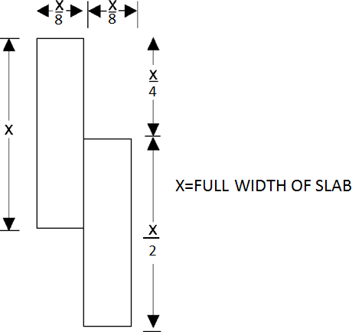
2

Figure 1: Seamed Specimens

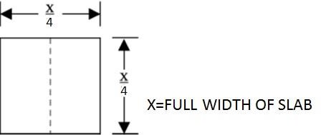

Figure 2: Square Specimen

  - Cleanability/Stain Resistance: ISFA QT 3.1-13

Scope

This test measures cleanability and stain resistance of quartz surface.

Test Apparatus and Materials

      - Concave glass covers having flat fire-polished rims, 25 mm (1 in.), in diameter

      - Denatured Alcohol

      - Acetone

      - Liquid household dish soap (Joy® or equivalent)

      - Clean absorbent lint-free material

      - Cellulose sponge 76 x 76 x 25 mm (3 x 3 x 1 in.) with 2 kg (5.0 lb.) weight

      - Overhead white fluorescent lights with bulbs positioned parallel to the line of sight and providing an intensity of 800-1100 lux (75-100 foot candles) at table height

      - Water

k) Micrometer with a resolution of 0.01 mm (0.0005 in.) minimum, with an accuracy of 0.03 mm (0.001 in.)

Test Specimen

The specimen shall be at least 380 x 380 mm (15 x 15 in.) in size, which will allow the placement of all 26 stains upon the surface in four rows.

Test Reagents

      - Naphtha
      - Ethyl Alcohol (90% v/v) aq.
      - Household Ammonia
      - Citric Acid (10% w/v) aq.
      - Povidone Iodine, 10%
      - Urea (6% w/v) aq.
      - Hydrogen Peroxide Solution, 3%
      - Household bleach (5 ± 0.5% aqueous solution of sodium hypochlorite)
      - Trisodium Phosphate (5% w/v) aq.
      - Vinegar
      - Distilled Water
      - #2 Pencil
      - Vegetable Oil
      - Lye Solution 1-2% (w/v) aq.
      - Pine Oil
      - Instant Coffee (one tsp. instant coffee per 170 ml [6 oz.] of boiling water)
      - Catsup

      - Prepared Yellow Mustard
      - Wet Pekoe Tea Bag (170 ml [6 oz.] of water brought to a boil and tea bag placed in water for two minutes)
      - Acetone
      - Permanent Marker (contrasting colors)
      - Ball Point Ink Pen (medium point/contrasting colors)
      - Black Paste Shoe Polish
      - Fingernail Polish Remover
      - Isopropyl Alcohol (90% v/v) aq.
      - Wax Crayon

Test Procedure

      - Test specimen shall be prepared according to Surface Preparation Procedure ISFA QT 1.1-13.

- Measure the sample thickness at the center of each edge using a micrometer to the nearest 0.01 mm (0.0005 in.).

- Specimen shall be placed on a flat, level table.

- Each stain shall be placed approximately 25 mm (2 in.) apart.

- Place a small spot of test reagent, approximately 6 mm (. in.) upon the surface of the test specimen. Place the concave glass cover, concave side down, over the test reagent. Rotate the glass cover gently so test reagent is both under the glass rim and outside the glass rim. Label each specimen with the reagent name.

- Allow the specimen to stand 16 to 24 hours. Remove glass covers and proceed with cleaning procedure.

- After each cleaning procedure, place the specimen without prior examination on a table and view at an eye to specimen distance of 760 to 910 mm (30 to 36 in.) and at an angle of 45-75° from the table surface (horizontal plane). View the specimen from all directions by rotating the specimen in the plane of the table. Avoid lighting that will accentuate or minimize the effect (sunlight or other angled light sources). Record and add scores for each reagent as shown in Table 3.

- Evaluation Procedure:

  - Wash with a liquid household dish soap and water using a cellulose sponge 76 x 76 x 25 mm (3 x 3 x 1 in.) weighted with 2 kg (5.0 lb.) for 25 cycles (a cycle shall be defined as one pass across the specimen followed by a return over the same path). All stains thus

completely removed will receive a rating of 0/0. (The first number denotes the effect of staining agent under the cover while the second number denotes the effect of the reagent outside the covered areas). Instances may occur where the area exposed or unexposed to air will be removed resulting in a rating of 0/1, etc.

  - Test specimens shall be cleaned with denatured alcohol using a cellulose sponge 76 x 76 x 25 mm (3 x 3 x 1 in.) weighted with 2 kg (5.0 lb.) for 25 cycles. If the stain is removed completely it will receive a score of 1 for each area (under concave glass cover or outside concave glass cover). Rinse the sample surface with tap water and wipe with a clean, absorbent, lint free material. If any stains remain, proceed to the next step.

  - Test specimens shall be cleaned with acetone using a cellulose sponge 76 x 76 x 25 mm (3 x 3 x 1 in.) weighted with 2 kg (5.0 lb.) for 25 cycles. All stains completely removed will receive a score of 2 for each area (under concave glass or outside concave glass). If any stains remain, they shall be graded as a 3 for each area (under concave glass or outside concave glass). Remeasure the test specimen to the nearest
0.01 mm (0.0005 in.) to insure 0.05 mm (0.0020 in.) or less in thickness has been removed. If more than 0.05 mm (0.0020 in.) has been removed then the score shall be 3.

Test Report

All numbers for each list shall be tabulated. Each reagent receives two scores – one for under concave glass cover and another for the outside of the concave glass cover. All scores shall be tabulated and recorded. A score less than or equal to 52 is considered passing. Report as Pass or Fail.
Disregard any changes in gloss due to cleaning and rate remaining stains as follows:

- No Effect – all reagents completely removed.

- Moderate Effect – difficult to perceive from all angles and direction.

- Severe Effect – easy to perceive from all angles and directions. Etching shall be considered a severe effect and listed as severe-etch.

An example follows:

Table 3 is an example only and does not necessarily represent actual test results.

Table 3: Scoring Reagent Effects (Example Only)
Reagent | Score | Visual Effect
Naphtha | 0/0 | No Effect
Ethyl Alcohol (90% v/v) aq. | 0/0 | No Effect
Household Ammonia | 0/0 | No Effect
Citric Acid (10% w/v) aq | 0/0 | No Effect
Povidone Iodine, 10% | 0/0 | No Effect
Urea (6% w/v) | 0/0 | No Effect
Hydrogen Peroxide Solution, 3% | 0/0 | No Effect
Household bleach (5 ± 0.5% aqueous solution of sodium hypochlorite) | 0/0 | No Effect
Trisodium Phosphate (5% w/v) aq. | 0/0 | No Effect
Vinegar | 0/0 | No Effect
Distilled Water | 0/0 | No Effect
#2 Pencil | 2/2 | No Effect
Vegetable Oil | 0/0 | No Effect
Lye Solution (1-2% w/v) aq. | 0/2 | No Effect
Pine Oil | 1/0 | No Effect
Instant Coffee (1 tsp. Instant coffee per 170 ml [6 oz.] of boiling water) | 0/0 | No Effect
Catsup | 0/0 | No Effect
Prepared Yellow Mustard | 2/2 | No Effect
Wet Pekoe Tea Bag 170 ml (6 oz.) of water) | 2/2 | No Effect
Acetone | 1/0 | No Effect
Permanent Marker (contrasting colors) | 3/3 | Moderate Effect
Ball Point Ink Pen (medium point/contrasting colors) | 2/2 | No Effect
Black Paste Shoe Polish | 2/2 | No Effect
Finger Nail Polish Remover | 0/0 | No Effect
Isopropyl Alcohol (90% v/v) aq. | 0/0 | No Effect
Wax Crayon | 1/1 | No Effect
TOTAL | 32

Flatness of Slabs: ISFA QT 4.1-13

Scope

This test measures the flatness of a slab of quartz material.

Test Apparatus

      - Table top approximately 760 mm (30 in.) high 915 x 1220 mm (36 x 48 in.) flat within 0.25 mm (0.010 in.) across the surface in all directions, sturdy enough not to deflect when the test specimen is placed upon it

      - Aluminum straight edge, accurate to within 0.25 mm (0.010 in.) across the edge, 1220 mm (48 in.) long

      - Taper gage or feeler gage

Test Specimen

The specimen shall be cut from a full slab; it shall be 0.83 m²(9 ft ²) with no dimension greater than 122.0 cm (48 in.). Specimen shall be conditioned at room temperature 23 ± 2 °C (73.4 ± 3.6 °F) for 40 hours before measuring.

Test Procedure

      - Table is checked in all directions for flatness.

      - The test specimen shall be placed on table, finish side up.

      - The aluminum straight edge is placed edgewise on the surface in the length and width direction.

      - If the surface is warped concave to the face, the amount shall be measured with a taper or feeler gage.

      - If the slab is convex to the face, then it shall be turned over and remeasured again with the straight edge and taper gage.

Test Report

Report warp to the nearest 0.05 mm (0.001 in.). The amount shall be measured with a taper or feeler gage. If the warp is concave to the finished face, report as positive warp; if the warp is concave to the back, report as negative warp.

Visual Defects: ISFA QT 5.1-13

Scope

This test sets a minimum acceptable standard for visual defects on quartz slabs.

Test Apparatus

      - A tabletop approximately 760 mm (30 in.) high

      - Overhead white fluorescent lights with bulbs positioned parallel to the line of sight and providing an intensity of 800 to 1100 lux (75 to 100 foot candles) at table height

      - Dial Indicator with a resolution of 0.025 mm (0.001 in.) equipped with Starrett contact point part number PT06632/8 or equivalent

c) TAPPI T 564-11 Transparent Chart for the Estimation of Defect Size

Test Specimen

Manufacturer’s standard full size slab

Test Procedure

      - Test Procedure for Finished Side:

        - The test specimen shall be placed on tabletop, finished side up.

        - The surface shall be prepared prior to testing using Surface Preparation Procedure ISFA QT 1.0-13.

        - The test specimen shall be viewed at an eye to specimen distance of 610-750 mm (24-30 in.) and at angles of 10°, 45°, and 90° relative to horizontal. Inspect the slab for the following defects:

          - Voids

            - Measure and record the maximum depth of void using a dial indicator.

            - Count and record the number of voids.

          - Foreign Particles

            - Measure and record the size of each foreign particle using the TAPPI Chart.

            - Count and record the number of foreign particles.

Test Report

Slab passes if occurrences do not exceed:

Table 4: Test Report

Voids | Finished Side
Depth/Dial Indicator | 1 ≥ 0.05 mm (0.002 in.) per slab or 5  ≥ 0.025 mm (0.001 in.) per slab
Foreign Particles | Finished Side
Size/TAPPI Chart | 1 ≥ 0.25 sq. mm. per slab
Quantity | 5 ≥ 0.10 sq. mm. per slab

  - Impact Resistance 226.8g (1/2 lb.) Ball: ISFA QT 6.1-13

Scope

This test measures the ability of quartz surface to resist chipping and cracking induced by impact from a large diameter ball.

Test Apparatus and Material
      - A free fall test stand of the type shown in Figure 3, or its equivalent, installed plumb and level, and fastened to a flat, level concrete floor using mortar to assure there are no voids between the floor and base plate.

      - Steel ball measuring 38.1 mm (1.5 in.) in diameter and weighing 226.8 ± 3 g (½ lb. ± 0.11 oz.). The steel ball shall have no flattened or damaged areas on its surface.

      - A device at least 381 x 381 mm (15 x 15 in.) long and at least 19 mm (¾ in.) thick, equipped with four clamps attached and capable of holding the sample flat. Said device shall have a 254 x 254 mm (10 x 10 in.) square cutout in the center of the device, or alternatively, a 63.5 mm (2.5 in.) solid support surrounding a 254 x 254 mm (10 x 10 in.) unsupported area. (See Figure 4.)

      - The device shall be clamped to the base of the test stand (see Figure 3) by four clamps attached to the test stand.

      - Overhead white fluorescent lights with bulbs positioned parallel to the line of sight and providing an intensity of 800 to 1100 lux (75 to 100 foot candles) at table height.

Test Specimen

The test specimen shall be 305 x 305 mm (12 x 12 in.) x. 12.7 mm (½ in) nominal thickness. The aforementioned sample shall have the “finish side” surface prepared by the Surface Preparation Procedure ISFA QT 1.1-00 and preconditioned at least 24 hours prior to testing at 23 ± 2 °C (73.4 ± 3.6 °F). The specimen shall be flat.

Test Procedure
      - Clamp the cutout device (5.6.2.c) onto the base of the test stand.

      - Measure the sample thickness and record to the nearest 0.01 mm (0.0005 in.).

      - Indicate the center of the sample by drawing a center line across both the width of the sample and the length of the sample using an indelible

marker on the finished side and clamp the sample finished side up into the cutout device. (See Figure 5.)

      - Adjust the heights of the scale (ruler attached to stand) so it touches the sample surface.

      - Raise the electromagnet to a height of 1525 mm (60 in.).

      - Place the steel ball on the electromagnet and drop the ball. On the first rebound, catch the ball so multiple impacts do not occur. Point of impact shall be no further than 13 mm (½ in.) from either centerline. One impact per sample. Examine the finished side for cracks or chips. All cracks and chips are considered failures.

      - On the table (5.6.2.e), examine the finished side for cracks or chips. All cracks and chips are considered failures.

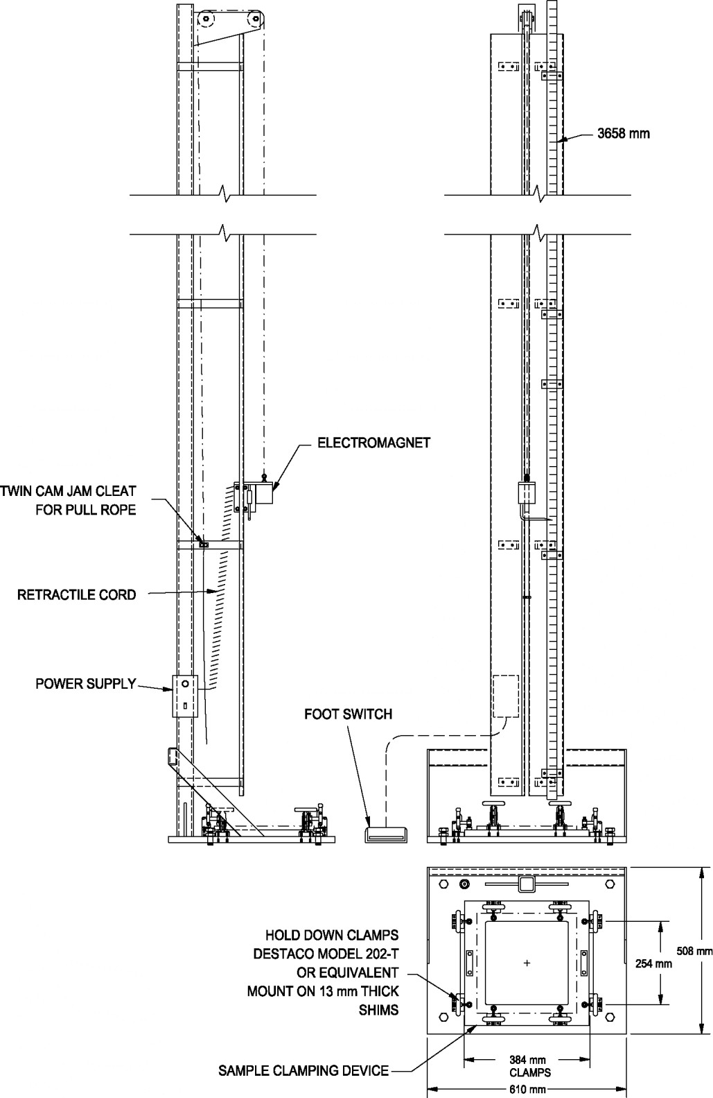

Figure 3: Free Fall Test Stand
Equipment shall be built within, and samples shall conform to, a tolerance of ± 1.6 mm (0.063 in.) of the dimensions specified in the drawing.

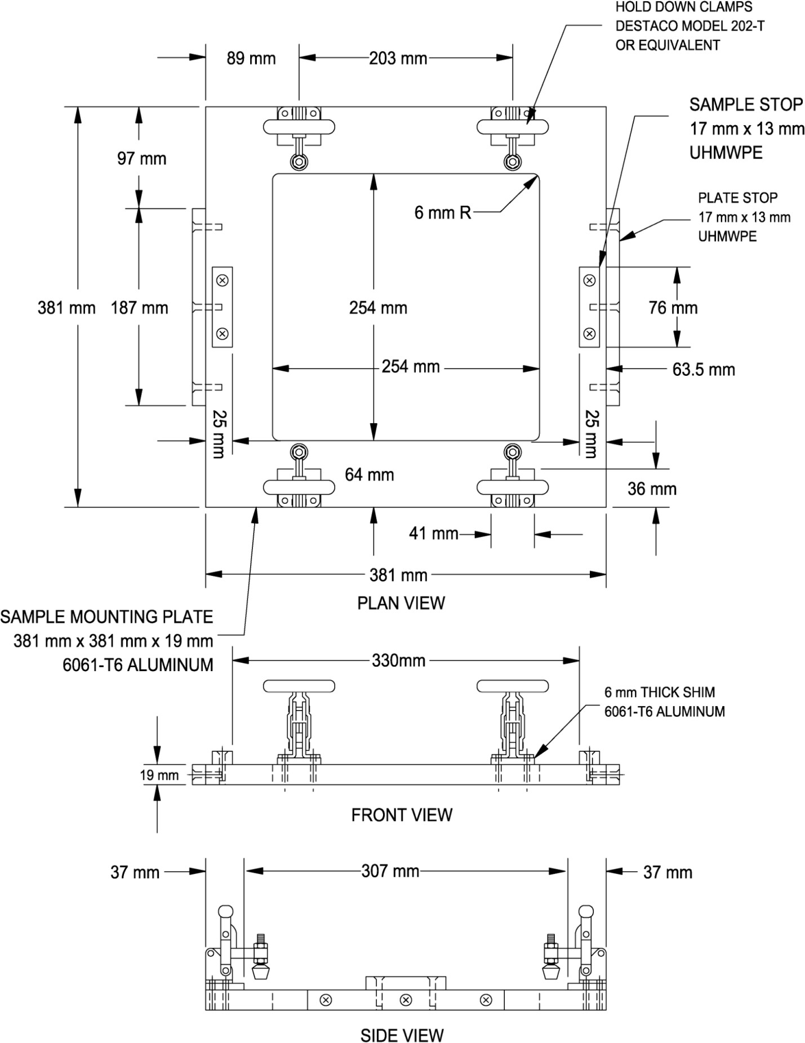

Figure 4: Sample Clamping Device
Equipment shall be built within, and samples shall conform to, a tolerance of ± 1.6 mm (0.063 in.) of the dimensions specified in the drawing.

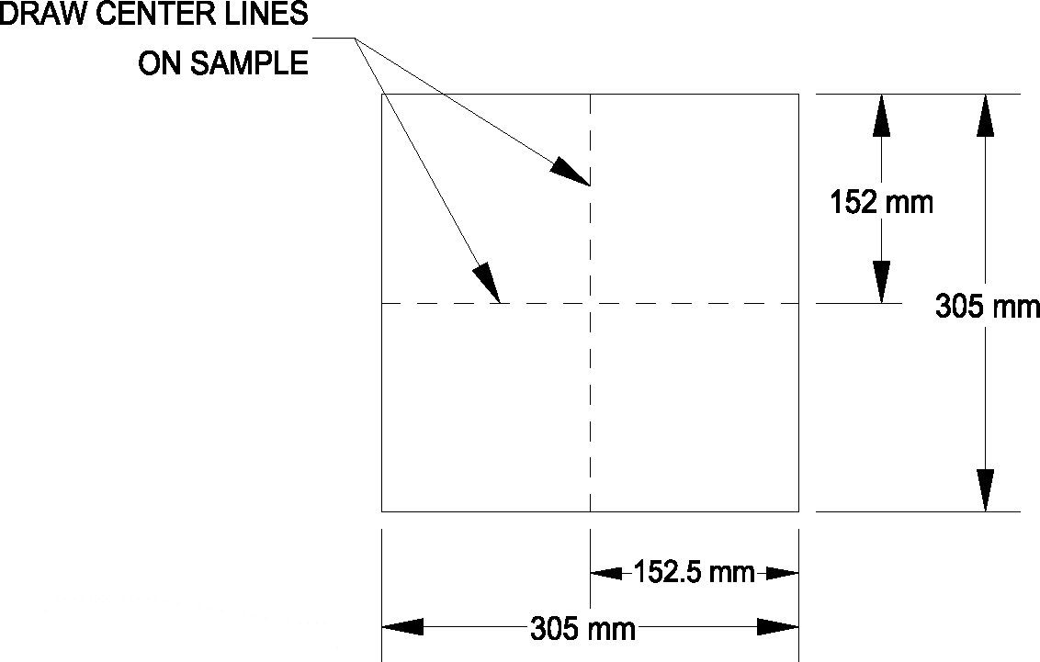

Figure 5: Sample Marking

Test Report

The test report shall include the following:

      - Pass or fail at 1525 mm (60 in.)

      - Sample thickness and description

Light Resistance: ISFA QT 7.1-13

    - Scope

This test measures the ability of quartz surface to retain its color when exposed to a light source having a frequency range approximating sunlight through window glass.

Modifications

Test conducted per NEMA LD 3-3.3 with the following exceptions:

      - Prepare sample according to Surface Preparation Procedure ISFA QT 1.1-00.

      - Eliminate the Petroleum Jelly Procedure.

Test Report

There shall be no effect.

Boiling Water Resistance: ISFA QT 8.1-13

Scope

This test measures the ability of quartz surface to maintain its color and surface finish when subjected to boiling water.

Modifications

Test conducted per NEMA LD 3-3.5 with the following exceptions:

      - Prepare sample according to Surface Preparation Procedure ISFA QT 1.1-13.

Test Report

There shall be no effect.

High Temperature Resistance: ISFA QT 9.1-13

Scope

This test measures the ability of quartz surface to maintain its color when subjected to high temperature.

Modifications

Test conducted per NEMA LD 3-3.6 with the following exceptions:

      - Prepare sample according to Surface Preparation Procedure ISFA QT 1.1-13.

Test Report

There shall be no effect.

