

Classification and Standards
For
Solid Surfacing Material ISFA 2-01 (2013)

Published by:

INTERNATIONAL SURFACE FABRICATORS ASSOCIATION
2400 Wildwood Road
Gibsonia, PA 15044 USA

Phone: 1-800-464-7732
Office: 1-412-487-3207
Fax: 1-412-487-3269

©2013 by International Surface Fabricators Association

Prologue

This Prologue is for informational purposes and is not part of the ISFA-2-01 (2013) Standard.

ISFA-2-01 (2013) is a revision of and supersedes ISSFA-2-01(2007).

Traditionally solid surface is considered a counter top material. Today the use of the product has grown from simple counter tops to include objects of art, wall cladding, furniture applications and much more. Available in colors ranging from subtle white on white patterns to a bright reds and yellows, solid surface has grown in popularity over the last decades due to its beauty, versatility, reparability and sanitary properties.

The reparability, cleanability and sanitary properties of solid surface have made it one of the most common products used in food preparation areas. As solid surface is indeed a hard, non-porous material, it ranks with stainless steel in resistance to fungal and bacterial growth. Hospitals use solid surface for everything from reception areas, to the wall cladding in operating rooms. In fact cladding for both interior and exterior uses continues to increase in popularity as designers and architects have become aware of the cleanability of the product. Simple procedures remove anything from indelible ink to spray-painted graffiti to cigarette burns. Inconspicuous seams allow a quality fabricator to easily repair damage in virtually any application.

In 1998, the International Solid Surface Fabricators Association (ISSFA) Specification Committee was formed and charged with the responsibility of creating a standard for solid surface. Its purpose was to clarify and simplify the choice and specification of solid surface materials by providing a common yardstick to measure performance and properties. It is the only solid surface standard written with widespread representation from fabrication organizations. The standard addresses the performance and properties of solid surface as a material with particular emphasis on characteristics that are meaningful for a high quality end product.

Ads were taken out in 1998 soliciting interested parties to participate. A committee was formed from any and all of those who responded. The committee that produced the document consisted of the following members:

Avonite®, Inc. 19445 Highway 304
Belen, NM 87002
505-864-3800

E.I. du Pont de Nemours and Company DuPont Surfaces Barley Mills Plaza
P.O. Box 80016 Wilmington, DE 19880-0016
800-426-7426

International Paper
Decorative Products Division 8339 Telegraph Road
Odenton, MD 21113-1397
410-551-5000

NBC Solid Surfaces P.O. Box 69 160 Clinton St.
Springfield, VT 05156
802-885-8677

Wilcor Solid Surface Inc. 55 Randall Street
Elk Grove Village, IL 60007 847-956-1001

Blume’s Solid Surface Products 904 Freeport
Road Freeport, PA 16229 724-294-3190

Formica® Corporation Solid Surface Division 8305 Telegraph Road
Odenton, MD 21113
443-734-2500
Polymon
2301 Velvet Ridge Drive Owings Mills, MD 21117 410-356-6562

Solid Surface Products P.O. Box 1461
18623 Northline Drive
Cornelius, NC 28031-1461
704-896-8677

Wilsonart® International P.O. Box 6110
2400 Wilson Place
Temple, TX 76503-6110
800-433-3222

ISSFA-1-98 was the first document drafted. The committee met periodically, as often as monthly, perfecting and crafting the document through numerous revisions until January of 2001 when ISSFA-2-01 was drafted at the specification committee meeting held in February during the 2001 Solid Surface Show at Caesars Palace in Las Vegas, Nevada.

The ISSFA Testing and Consulting Services Laboratory was instrumental in developing, perfecting and conducting testing of solid surface materials under this standard. From December 2000 until January 2001, fourteen solid surface materials consisting of acrylic, polyester, veneer, filled, unfilled, solid and particulated products were tested by the laboratory in order to evaluate the methods contained within the standard. Testing of replicate samples at four different laboratories was conducted to verify performance of the ISSFA laboratory under various test methods and the validity of those test methods to this standard.

Notices soliciting interested companies and individuals to participate in a canvass of ISSFA-2-01 were placed in the July 2001 issues of SolidSurface magazine, Kitchen &

Bath Design News and the ISSFA website, venues reaching a potential industry sampling in excess of 100,000 individuals. In response to those notices, companies and individuals requested and received over 130 canvass for comment forms and standards by mail. The recipients of the document throughout the world included architects, specifiers, trade associations, universities, government agencies, fabricators, consulting firms, scientists, trade periodicals, testing laboratories, solid surface manufacturers, distributors and raw material suppliers. Of the over 130 standards and accompanying comment forms mailed out, we received comments in reply from 39 individuals representing organizations on five different continents.

Comments were compiled and turned over to the committee, in their entirety. On November 29, 2001 a series of meetings and conferences of the ISSFA specification committee commenced that addressed every single comment received, in its entirety, without exception. No changes to the document were made without unanimous approval from all attending members. The document was approved by the specification committee and forwarded to the ISSFA board of directors. The board of directors voted to approve and issue ISSFA-2-01 (2002) based upon the recommendation of the specification committee. A list follows of the organizations and individuals who participated in the canvass by responding with comments in writing. The organizations contacted that failed to respond are not included in this list. Those listed may not concur with the recommendation of the specification committee.

A.C.S. International Inc Louis Giovannini
Alcoa World Chemicals LLC T. R. Clever
Akzo Nobel Ross Opsahl
Aristech Acrylics LLC Ettore Minghetti
Baer Supply Company Scott Belasco
E.I. du Pont de Nemours and Company Michael M. McDonnell
(DuPont Surfaces) Michael Saltzberg
L. H. Winkler Egyptian American Industrial Plastics Mohamed Mazen
Ferro Corporation Robert Thomson
Formica® Corporation Joseph Greenlee
Halstead International Ron Holmgren
Hodges Wood Products Laboratory Dr. C. A. LaPasha
Department of Wood and Paper Science (NC State University)
Nichimen American Inc Thomas Keily
NIST/NVLAP Larry Coffin

NSF International David LaMoreaux
Ohio Valley Supply Company Charles K. Sawyer
Polyceramics International Ltd Andrew Barry
Polymon Inc Israel S. Ungar
PolyStone (Zhuhai) Co. Ltd Ming Xiao
Rebus Inc James A. Steever
Reichhold Inc Paris W. Chen
Safas Corporation Bernard G. Brody
Schock and Co. GmbH Dr. Gunter Hieber
SolidSurface Magazine Russ Lee
Solid Surface Products Jon Lancto
Surfacing Design Consultants Jorge L. Alfonso
Donald L. Sawyers, Jr. TAPPI Charles T. Bohanan
TOR Minerals International, Inc./TP&T Division Dr. Olaf Karasch
United Granules/Laurentian Industries Gary Rodgers
UNLV Mechanical Engineering Dept Dr. Brendan O’Toole
Wilsonart® International Steven J. Lubowinski
Rajesh Ramamurthy
John Snow Steve Steele Bruce Trethewey
Woodwork Institute of California Stanley R. Gustafson
Individuals Kenneth J. Bunk, P.E.

Following the initial publication of the original ISSFA 2-01 document, there have been revisions in 2002 and 2007. This standard is reviewed periodically by ISFA and revised if necessary. As a result of this review process, ISFA has developed ISFA 2-01 (2013).
A list follows of the organizations and individuals who participated in the 2013 canvass by responding with comments in writing. The organizations contacted that failed to respond are not included in this list. Those listed may not concur with the final recommendation of the specification committee.

ASST Russ Berry
DuPont Building Innovations Michael A. Banks
Formica Corporation Dave Swenson
Fujiashi Products Ltd Leonard R. Elbon
Imbotec Group John Imbault
Individual Larry Cox
Wilsonart International John Snow

Comments for proposed improvement of this standard are solicited and welcomed. Proposed improvements to this standard should be forwarded to:
Director of Technical Services ISFA 2400 Wildwood Road
Wildwood, PA 15044 USA Email: standards@isfanow.org Phone 1-412-487-3207
Fax: 1-412-487-3269

International Surface Fabricators Association Classification and Standards for Solid Surfacing Material ISFA 2-01 (2013)

Table of Contents

Foreword 1
Section 1: General 2
  - Scope 2
  - Definition 2
  - Types and Descriptions 2
    - Standard Type 2
    - Special Purpose Type 2
    - Veneer Type 3
  - Fire and Smoke Rating 3
Section 2: Applications 4
  - Introduction 4
    - Horizontal 4
    - Vertical 4
    - Wet 4
    - Exterior 5
Section 3: Testing Methods 6
  - Referenced Standards 6
    - American Society for Testing and Materials 6
    - National Electrical Manufacturers Association 6
    - International Surface Fabricators Association 6
    - Technical Association for the Paper and Pulp Industry 7
Section 4: Performance Properties and Values 8
  - Performance Values 8
  - Standard Laboratory Conditions 9
Section 5: Test Methods 10
  - Surface Preparation Procedure: ISFA SST 1.1-00 10
    - Scope 10
    - Materials 10
    - Test Procedure 10
  - Consistency of Color: ISFA SST 2.1-00 10
    - Scope 10
    - Test Apparatus and Materials 11
    - Test Specimens 11
    - Test Procedure 11
    - Test Report 11
  - Cleanability/Stain Resistance: ISFA SST 3.1-00 12
    - Scope 12
    - Test Apparatus and Materials 12
    - Test Specimen 13
    - Test Reagents 13
    - Test Procedure 14
    - Test Report 16
  - Flatness of Sheets: ISFA SST 4.1-00 17
    - Scope 17
    - Test Apparatus 17
    - Test Specimen 17
    - Test Procedure 18
    - Test Report 18
  - Visual Defects: ISFA SST 5.1-00 18
    - Scope 18
    - Test Apparatus 18
    - Test Specimen 18
    - Test Procedure 19
    - Test Report 19
  - Impact Resistance 226.8g (1/2 lb.) Ball: ISFA SST 6.1-00 20
    - Scope 20
    - Test Apparatus and Material 20
    - Test Specimen 21
    - Test Procedure 21
    - Test Report 24
  - Light Resistance: ISFA SST 7.1-00 24
    - Scope 24
    - Modifications 24
    - Test Report 25
  - Boiling Water Resistance: ISFA SST 8.1-00 25
    - Scope 25
    - Modifications 25
    - Test Report 25
  - High Temperature Resistance: ISFA SST 9.1-00 25
    - Scope 25
    - Modifications 26
    - Test Report 26

List of Tables
Table 1: Performance Properties 9
Table 2: Engineering Properties 9
Table 3: Scoring Reagent Effects 18
Table 4: Test Report 21

List of Figures
Figure 1: Seamed Specimens 13
Figure 2: Square Specimen 13
Figure 3: Free Fall Test Stand 23
Figure 4: Sample Clamping Device 24
Figure 5: Sample Marking 25

Foreword

This Classification and Standards publication is intended for use by manufacturers, fabricators, installers and specifiers of solid surfacing materials.

The test methods and minimum performance values presented have been related as closely as possible to end-use applications. The fabrication method and technique employed may have a bearing on product performance and service. Consult ISFA, the manufacturer and your fabricator for application, fabrication and installation criteria.

The performance requirements include, but are not limited to, impact resistance, flexural strength, stain resistance, water resistance, chemical resistance, fungal resistance and thermal expansion properties.

Where values are given in both metric and U.S. customary units, the metric units are to be regarded as the standard.

International Surface Fabricators Association’s (ISFA’s) information is intended for guidance purposes only and individual fabricators or users must refer to the manufacturer’s or supplier’s stated warranty associated with sale and purchase of specific products. ISFA does not manufacture or sell products and cannot and does not warrant specific results or outcomes with respect to fabrication, installation or usage of products.

Scope
This standards publication covers the performance of solid surfacing sheets. The standard is intended to be a guide to manufacturers, fabricators, installers, and consumers about minimum requirements of solid surfacing materials.

Definition
Solid surface materials generally consist of reacted monomers and resins, mineral fillers and pigments manufactured in sheets of specific calipers. Solid surface materials are solid, non-porous, homogeneous, renewable, and, when applicable, may feature inconspicuous seams. Solid surface materials are free from conspicuous internal strengthening fibers.

Types and Descriptions
The following types and descriptions of solid surface sheets are covered in this standard. The different types were engineered to meet specific needs based on aesthetics, performance, economy, and use. Consult ISFA, the manufacturer and your fabricator for application, fabrication and installation criteria. Materials must meet or exceed performance standards within its category or type as set forth in this document.

Standard Type
Standard Type solid surface sheets are designed for horizontal, vertical, wet, and dry applications. Standard Type solid surface sheets do not require a full substrate to perform in horizontal applications. Standard Type solid surface sheets typically exhibit optimal performance and engineering characteristics.

Special Purpose Type
Special Purpose Type solid surface sheets are similar to Standard Type, however, the composition of the sheets may be altered to meet specific aesthetic requirements. This change in composition may affect the performance properties of the sheets. Special Purpose Type solid surface sheets may not be suitable for certain applications and are generally used for their aesthetic characteristics rather than performance criteria.

Veneer Type
Veneer Type solid surface sheets are similar to Standard or Special Purpose Type in composition. Due to their thickness, they generally must be laminated onto a substrate to perform in typical horizontal applications.
Since the type of substrate, type of adhesive and lamination process can affect ultimate performance, consult the manufacturer for recommendations and requirements. Veneer Type solid surface sheets may not be suitable for certain applications and may not be covered by manufacturers’ warranties when used on horizontal surfaces.

Fire and Smoke Rating
This standard does not characterize fire and smoke rating. Fire and smoke rating characteristics for these products should be reported in accordance with the procedures established by code specifying agencies. Consult the manufacturer for specific information.

Introduction
Solid surface products typically exhibit characteristics that set them apart from other surfacing products. The ability to seam solid surface products in an inconspicuous manner allows for: built-up edges in a variety of thicknesses; smooth, cleanable and difficult to detect seams; and the ability to join sheets and shaped goods in a myriad of combinations. The homogeneous nature of solid surface products allows the material to be cut and shaped while maintaining the same surface appearance. This same composition allows for a renewable surface. Due to their unique raw material composition and manufacturing processes, many solid surface products can be thermoformed with little or no significant change to their performance properties.

This section will provide typical applications for solid surface products. For all applications, consult ISFA, the manufacturer and the fabricator for fabrication and installation criteria.

Horizontal
Solid surface sheets can be fabricated into a wide variety of products including countertops, vanity tops, window sills, transaction tops, shelving and many other horizontal components for both commercial and residential applications. They are typically fabricated using 12.0 mm (1/2 in.) nominal thickness sheets supported by wood or steel members, or Veneer Type applied to a full substrate.

Vertical
Solid surface sheets can also be applied in a variety of vertical applications. Typically, all solid surface types can be used in vertical applications such as tub and shower walls, wainscoting and other decorative or functional vertical applications. Additionally in commercial settings, products include decorative wall cladding, operating and clean room walls, column surrounds, specialty cabinetry and artwork.

Wet
The non-porous nature of solid surface products allows them to be installed in wet applications. Typical wet area uses are tub and shower walls, tub surrounds, fountains, functional planters, and vanity and kitchen bowls. The performance properties and testing of shaped goods are not covered under this standard.

Exterior
Solid surface material has been used for some exterior applications. In all cases of exterior use, consult the manufacturer for suitability and appropriate techniques for fabrication, installation and maintenance.
Compliance with the ISFA SST 7.1-00, Light Resistance test method may not be suitable for exterior applications.

Referenced Standards
In this publication, reference is made to the standards listed below. Copies are available from the indicated sources.
    - American Society for Testing and Materials 100 Barr Harbor Drive
W. Conshohocken, PA 19428-2959
Phone: 610-832-9585

ASTM E 228-11 Standard Test Method for Linear Thermal
Expansion of Solid Materials with a Vitreous Silica Dilatometer
ASTM D 790-10 Standard Test Methods for Flexural Properties
of Unreinforced and Reinforced Plastics and Electrical Insulating Materials
ASTM D 2583-13a Standard Test Method for Indentation Hardness
of Rigid Plastics by Means of a Barcol Impressor
ASTM G 21-09 Standard Practice for Determining Resistance
of Synthetic Polymeric Materials to Fungi

National Electrical Manufacturers Association

1300 N. 17th Street Rosslyn, VA 22209
Phone: 800-854-7179

NEMA LD 3 (2005) High Pressure Decorative Laminates
    - International Surface Fabricators Association 2400 Wildwood Road
Gibsonia, PA 15044 USA
Phone: 1-412-487-3207

ISFA SST 1.1-00 Surface Preparation Procedure ISFA SST 2.1-00 Consistency of Color
ISFA SST 3.1-00 Cleanability/Stain Resistance

ISFA SST 4.1-00 Flatness of Sheets ISFA SST 5.1-00 Visual Defects
ISFA SST 6.1-00 Impact Resistance 226.8g (1/2 lb.) Ball ISFA SST 7.1-00 Light Resistance
ISFA SST 8.1-00 Boiling Water Resistance ISFA SST 9.1.00 High Temperature Resistance
(All ISFA SST Test Standards are adapted from the original ISSFA SST Test Standards)

Technical Association for the Paper and Pulp Industry

15 Technology Parkway South Norcross GA 30092. United States. (800) 332-8686 (770)-209-7256

TAPPI T 564-sp 11 (2011) Transparent Chart for the Estimation of Defect Size

Performance Values
All solid surfacing materials, regardless of their type must meet the minimum properties shown in Table 1. Standard type products must also meet the minimum property requirements shown in Table 2.

Table 1: Performance Properties

Performance Properties of Solid Surface | All Types | Test Method
Fungal Resistance* | No Growth | ASTM G 21-09
Consistency of Color* | Pass | ISFA SST 2.1-00
Cleanability/Stain Resistance* | ≤ 52 | ISFA SST 3.1-00
Visual Defects* | Pass | ISFA SST 5.1-00
Light Resistance * | No Effect | ISFA SST 7.1-00
Boiling Water Resistance** | No Effect | ISFA SST 8.1-00
High Temperature Resistance** | No Effect | ISFA SST 9.1-00
*To be tested without substrate
**Veneer grade to be tested with substrate

The following table lists engineering property requirements for Standard Type solid surface material.

Table 2: Engineering Properties

Engineering Properties | Standard Type | Test Method
Radiant Heat Resistance | 600+ Seconds | NEMA LD 3-3.10
Linear Thermal Expansion mm./mm./°C | ≤ 5.40 x 10⁻⁵ mm./mm. °C  (3.00 x 10⁻⁵ in./in.°F) | ASTM E 228-11  αm -30 to 60 °C  (-22 to 140 °F)
Flexural Strength | ≥27.58 Mpa (4000 psi) | ASTM D 790-10
Flexural Modulus | ≥ 6895 Mpa (1.00 Mpsi) | ASTM D 790-10
Hardness, Barcol | 50 – 70 | ASTM D 2583-13a
Flatness of Sheets | ≤1.6 mm (0.063 in.) | ISFA SST 4.1-00
Impact Resistance | Pass at 1525 mm. (60 in.) | ISFA SST 6.1-00

Since Special Purpose Type and Veneer Type are designed for specific applications and end uses, applicable engineering properties may not meet the performance values of this Standard. Consult the manufacturer for information. Specifications for Solid Surface materials should indicate the Type (Standard, Special Purpose or Veneer) and whether the product complies with ISFA 2-01 (2013) Performance Properties and Engineering Properties.

The engineering properties of Veneer Type materials are highly dependent on the way they are applied to substrate. Consult the manufacturer for directions as to the correct method of substrate application.

Standard Laboratory Conditions
Unless otherwise specified, all testing shall be conducted at standard laboratory conditions that shall be 23 ± 2 °C (73.4 ± 3.6 °F) and ambient relative humidity. Unless otherwise specified, all specimens shall be preconditioned for 40 hours at
standard laboratory conditions prior to testing.

Section 5: Test Methods

Surface Preparation Procedure: ISFA SST 1.1-00

Scope
This procedure is used to prepare samples prior to testing.

Materials
      - Cellulose sponge
      - Powder abrasive cleanser containing a bleaching agent (Comet® or equivalent)
      - Water

      - Clean, absorbent, lint-free material

Test Procedure
Surface shall be prepared prior to testing using a damp sponge and abrasive cleanser containing a bleaching agent. The surface area to be prepared shall be scrubbed with light hand pressure for up to a minute per 1.0 sq. meter (10.76 sq. ft.). The prepared surface shall be rinsed with water and dried with a clean, absorbent, lint-free material.

Consistency of Color: ISFA SST 2.1-00

Scope
      - To set an acceptable standard for color match from sheet to sheet within manufacturer’s specified lot.

      - To set an acceptable standard for sheet color and or particulate variation from center to edge of a sheet.

      - For this test, materials that have a distinctive design or pattern such as veining, etc., should not be considered a failure.

Test Apparatus and Materials
      - Tabletop approximately 760 mm (30 in.) high

      - Overhead white fluorescent lights with the bulbs positioned parallel to the line of sight and providing an intensity of 800-1100 lux (75-100 foot candles) at table height

      - Manufacturer’s recommended seam adhesive

      - Manufacturer’s recommended sand paper and random orbital sander

      - Test specimen

Test Specimens
Specimen shall consist of two pieces; with each piece being x/4 where x
= full width of the sheet. Two specimens shall be cut from the width of
the sheet, one from the beginning of the lot, and one from the end of the lot.

Test Procedure
      - Sample specimens shall be placed on the table face up.

      - They shall be seamed in the same direction as they were removed from the sheet and offset 50% to allow 50% of sheet to be seamed. (See Figure 1.)

      - The seam shall be fabricated and finished as per manufacturer’s recommendations.
      - Unseamed portion of the specimen shall be removed to produce a square sample. (See Figure 2.)

      - The specimen shall be placed on the table face up and viewed at an eye to specimen distance of 760 to 910 mm (30 to 36 in.). The specimen shall be viewed at angles of approximately 10°, 45°, and 90°.

Test Report
There shall be no noticeable color or particulate change in the length of the seam.

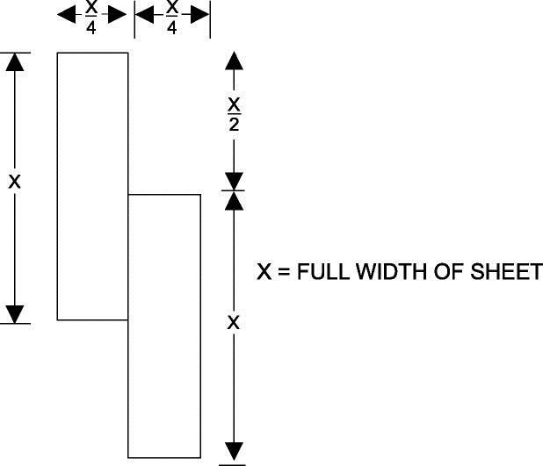

Figure 1: Seamed Specimens
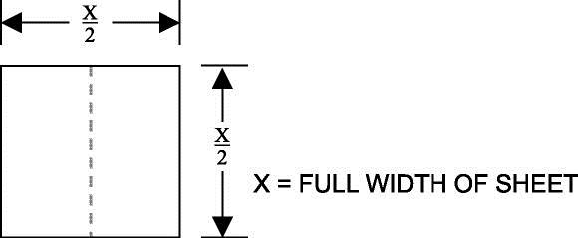

Figure 2: Square Specimen

Cleanability/Stain Resistance: ISFA SST 3.1-00

Scope
This test measures cleanability and stain resistance of solid surface sheets.

Test Apparatus and Materials
      - Concave glass covers having flat fire-polished rims, 25 mm (1 in.), in diameter

      - Powder abrasive cleanser containing a bleaching agent (Comet® or equivalent)
      - 76 x 76 mm (3 x 3 in.) Scotch-Brite® pad #7447 or equivalent
      - Liquid household dish soap (Joy® or equivalent)
      - Clean absorbent lint-free material

      - Cellulose sponge 76 x 76 x 25 mm (3 x 3 x 1 in.) with 2 kg (5.0 lb.) weight

      - Overhead white fluorescent lights with bulbs positioned parallel to the line of sight and providing an intensity of 800-1100 lux (75-100 foot candles) at table height

      - Water

      - Random orbital sander with dust extraction
      - 100 and 60 micron sanding discs

      - Micrometer with a resolution of 0.01 mm (0.0005 in.) minimum, with an accuracy of 0.03 mm (0.001 in.)

Test Specimen
The specimen shall be at least 380 x 380 mm (15 x 15 in.) in size, which will allow the placement of all 26 stains upon the surface in four rows.

Test Reagents
      - Naphtha

      - Ethyl Alcohol (90% v/v) aq.

      - Household Ammonia

      - Citric Acid (10% w/v) aq.

      - Povidone Iodine, 10%

      - Urea (6% w/v) aq.

      - Hydrogen Peroxide Solution, 3%

      - Household bleach (5 ± 0.5% aqueous solution of sodium hypochlorite)

      - Trisodium Phosphate (5% w/v) aq.

      - Vinegar

      - Distilled Water

      - #2 Pencil

      - Vegetable Oil

      - Lye Solution 1-2% (w/v) aq.

      - Pine Oil

      - Instant Coffee (one tsp. instant coffee per 170 ml [6 oz.] of boiling water)

      - Catsup

      - Prepared Yellow Mustard

      - Wet Pekoe Tea Bag (170 ml [6 oz.] of water brought to a boil and tea bag placed in water for two minutes)

      - Acetone

      - Permanent Marker (contrasting colors)

      - Ball Point Ink Pen (medium point/contrasting colors)

      - Black Paste Shoe Polish

      - Fingernail Polish Remover

      - Isopropyl Alcohol (90% v/v) aq.

      - Wax Crayon

Test Procedure
      - Test specimen shall be prepared prior to testing by sanding with a random orbital sander with a vacuum dust extraction system, using 100 micron, followed by 60 micron, and followed by Scotch-Brite® pad #7447 or equivalent. The surface area of the specimen shall be sanded at a rate of
3.05 lin. m (10 lin. ft.) per minute in a bi-directional fashion.

      - Repeat Surface Preparation Procedure SST 1.1-00.

      - Measure the sample thickness at the center of each edge using a

micrometer to the nearest 0.01 mm (0.0005 in.).

      - Specimen shall be placed on a flat, level table.

      - Each stain shall be placed approximately 25 mm (2 in.) apart.

      - Place a small spot of test reagent, approximately 6 mm (1/4 in.) upon the surface of the test specimen. Place the concave glass cover, concave side down, over the test reagent. Rotate the glass cover gently so test reagent is both under the glass rim and outside the glass rim. Label each specimen with the reagent name.

      - Allow the specimen to stand 16 to 24 hours. Remove glass covers and proceed with cleaning procedure.

      - After each cleaning procedure, place the specimen without prior examination on a table and view at an eye to specimen distance of 760 to 910 mm (30 to 36 in.) and at an angle of 45-75° from the table surface (horizontal plane). View the specimen from all directions by rotating the specimen in the plane of the table. Avoid lighting that will accentuate or minimize the effect (sunlight or other angled light sources). Record and add scores for each reagent as shown in Table 3.

      - Evaluation Procedure:

        - Wash with a liquid household dish soap and water using a cellulose sponge 76 x 76 x 25 mm (3 x 3 x 1 in.) weighted with 2 kg (5.0 lb.) for 25 cycles (a cycle shall be defined as one pass across the specimen followed by a return over the same path). All stains thus completely removed will receive a rating of 0/0. (The first number denotes the effect of staining agent under the cover while the second number denotes the effect of the reagent outside the covered areas). Instances may occur where the area exposed or unexposed to air will be removed resulting in a rating of 0/1, etc.

        - Test specimens shall be cleaned with water, an abrasive cleanser containing a bleaching agent using a cellulose sponge 76 x 76 x 25 mm (3 x 3 x 1 in.) weighted with 2 kg (5.0 lb.) for 25 cycles. If the stain is removed completely it will receive a score of 1 for each area (under concave glass cover or outside concave glass cover). Rinse the sample surface with tap water and wipe with a clean, absorbent, lint-free material. If any stains remain, proceed to the next step.

        - Test specimens shall be cleaned with water and an abrasive cleanser containing a bleaching agent using a new 76 x 76 mm (3 x 3 inch) Scotch-Brite® pad #7447 or equivalent weighted with a 76 x 76 mm (5.0 lb.) for 25 cycles. All stains completely removed will receive a score of 2 for each area (under concave glass or outside concave glass). If any stains remain, they shall be graded as a 3 for each area (under concave glass or outside concave glass). Re-measure the test specimen to the nearest
0.01 mm (0.0005 in.) to insure 0.05 mm (0.0020 in.) or less in thickness has been removed. If more than 0.05 mm (0.0020 in.) has been removed then the score shall be 3.

Test Report
All numbers for each list shall be tabulated. Each reagent receives two scores - one for under concave glass cover and another for the outside of the concave glass cover. All scores shall be tabulated and recorded. A score less than or equal to 52 is considered passing. Report as Pass or Fail. Disregard any changes in gloss due to cleaning and rate remaining stains as follows:

- No Effect - all reagents completely removed.

- Moderate Effect - difficult to perceive from all angles and direction.
- Severe Effect - easy to perceive from all angles and directions. Etching shall be considered a severe effect and listed as severe-etch.
An example follows:

Note: The TOTAL is the sum of the covered and uncovered results.

Table 3 is an example only and does not necessarily represent actual test results.

Table 3: Scoring Reagent Effects

Reagent | Score | Visual Effect
Naphtha | 0/0 | No Effect
Ethyl Alcohol (90% v/v) aq. | 0/0 | No Effect
Household Ammonia | 0/0 | No Effect
Citric Acid (10% w/v) aq. | 0/0 | No Effect
Povidone Iodine, 10% | 0/0 | No Effect
Urea (6% w/v) | 0/0 | No Effect
Hydrogen Peroxide Solution, 3% | 0/0 | No Effect
Household bleach (5 ± 0.5% aqueous solution of  sodium hypochlorite) | 0/0 | No Effect
Trisodium Phosphate (5% w/v) aq. | 0/0 | No Effect
Vinegar | 0/0 | No Effect
Distilled Water | 0/0 | No Effect
#2 Pencil | 2/2 | No Effect
Vegetable Oil | 0/0 | No Effect
Lye Solution (1-2% w/v) aq. | 0/2 | No Effect
Pine Oil | 1/0 | No Effect
Instant Coffee (1 tsp. Instant coffee per 170  ml [6 oz.] of boiling water) | 0/0 | No Effect
Catsup | 0/0 | No Effect
Prepared Yellow Mustard | 2/2 | No Effect
Wet Pekoe Tea Bag 170 ml (6 oz.) of water) | 2/2 | No Effect
Acetone | 3/0 | Severe-Etch
Permanent Marker (contrasting colors) | 3/3 | Moderate Effect
Ball Point Ink Pen (medium point/contrasting colors) | 2/2 | No Effect
Black Paste Shoe Polish | 2/2 | No Effect
Finger Nail Polish Remover | 0/0 | No Effect
Isopropyl Alcohol (90% v/v) aq. | 0/0 | No Effect
Wax Crayon | 0/0 | No Effect
Total | 32

Flatness of Sheets: ISFA SST 4.1-00

Scope
This test measures the flatness of a sheet of solid surface material

Test Apparatus
      - Table top approximately 760 mm (30 in.) high 915 x 1220 mm (36 x 48 in.) flat within 0.25 mm (0.010 in.) across the surface in all directions, sturdy enough not to deflect when the test specimen is placed upon it

      - Aluminum straight edge 1220 mm (48 in.) long

      - Taper gage or feeler gage

Test Specimen
The specimen shall be cut from the full width of the sheet; it shall be 0.83 m2 (9 ft ²) with no dimension greater than 122.0 cm (48 in.). Specimen shall be conditioned at room temperature 23 ± 2 °C (73.4 ± 3.6 °F) for 40

hours before measuring

Test Procedure
      - Table is checked in all directions for flatness.

      - The test specimen shall be placed on table, finish side up.
      - The aluminum straight edge is placed edgewise on the surface in the length and width direction.
      - If the surface is warped concave to the face, the amount shall be measured with a taper or feeler gage.
      - If the sheet is convex to the face, then it shall be turned over and re-measured again with the straight edge and taper gage.

Test Report
Report warp to the nearest 0.05 mm (0.001 in.). The amount shall be measured with a taper or feeler gage. If the warp is concave to the finished face, report as positive warp; if the warp is concave to the back, report as negative warp.

Visual Defects: ISFA SST 5.1-00

Scope
This test sets a minimum acceptable standard for visual defects on solid surface sheets.

Test Apparatus
      - A tabletop approximately 760 mm (30 in.) high
      - Overhead white fluorescent lights with bulbs positioned parallel to the line of sight and providing an intensity of 800 to 1100 lux (75 to 100 foot candles) at table height

      - Dial Indicator with a resolution of 0.025 mm (0.001 in.) equipped with Starrett contact point part number PT06632/8 or equivalent

      - TAPPI T 564 Transparent Chart for the Estimation of Defect Size

Test Specimen
Manufacturer’s standard full size sheet

Test Procedure

      - Test Procedure for Finished Side:

        - The test specimen shall be placed on tabletop, finished side up.

        - The surface shall be prepared prior to testing using Surface Preparation Procedure ISFA SST 1.0-00.

        - The test specimen shall be viewed at an eye to specimen distance of 610-750 mm (24-30 in.) and at angles of 10°, 45°, and 90° relative to horizontal. Inspect the sheet for the following defects:

          - Voids

            - Measure and record the maximum depth of void using a dial indicator.

            - Count and record the number of voids.

          - Foreign Particles

            - Measure and record the size of each foreign particle using the TAPPI Chart.

            - Count and record the number of foreign particles.

      - Test Procedure for Backside:

        - The test specimen shall be placed on tabletop, finished side down.

        - The test specimen shall be viewed at an eye to specimen distance of 610-750 mm (24-30 in.) and at angles of 10°, 45°, and 90° relative to horizontal.

- Inspect the sheet for an area with the greatest concentration of voids, measure off 30.48 x 30.48 cm (one square foot), count and record the number of voids in that area.

- Measure and record the maximum depth of each void using a dial indicator.

Test Report

Sheet passes if occurrences do not exceed:

Table 4: Test Report

Voids | Finished Side | Back Side
Depth/Dial Indicator | 1 ≥ 0.05 mm (0.002 in.)  per sheet or 5 ≥ 0.025 mm (0.001 in.) per sheet | 1 > 1.6 mm (0.063 in.) per  sheet or 20 > 0.8 mm (0.031 in.) per 0.093 m² (ft²)
Foreign Particles | Finished Side | Back Side
Size/TAPPI Chart | 1 ≥ 0.25 sq. mm per  sheet | N/A
Quantity | 5 ≥ 0.10 sq. mm per  sheet | N/A

  - Impact Resistance 226.8g (1/2 lb.) Ball: ISFA SST 6.1-
00 5.6.1 Scope
This test measures the ability of a solid surface sheet to resist chipping and cracking induced by impact from a large diameter ball.

Test Apparatus and Material
      - A free fall test stand of the type shown in Figure 3, or its equivalent, installed plumb and level, and fastened to a flat, level concrete floor using mortar to assure there are no voids between the floor and base plate.
      - Steel ball measuring 38.1 mm (1.5 in.) in diameter and weighing
226.8 ± 3 g (1/2 lb. ± 0.11 oz.). The steel ball shall have no flattened or damaged areas on its surface.

      - A device at least 381 x 381 mm (15 x 15 in.) long and at least 19 mm (¾ in.) thick, equipped with four clamps attached and capable of holding the sample flat. Said device shall have a 254 x 254 mm (10 x 10 in.) square cutout in the center of the device, or alternatively, a 63.5 mm (2.5 in.) solid support surrounding a 254 x 254 mm (10 x 10 in.) unsupported area. (See Figure 4.)

      - The device shall be clamped to the base of the test stand (see Figure 3) by four clamps attached to the test stand.

      - Tabletop approximately 760mm (30”) high

      - Overhead white fluorescent lights with bulbs positioned parallel to the line of sight and providing an intensity of 800 to 1100 lux (75 to 100 foot candles) at table height.

Test Specimen
The test specimen shall be 305 x 305 mm (12 x 12 in.) x. 12.7 mm (1/2 in) nominal thickness. The aforementioned sample shall have the “finish side” surface prepared by the ISFA Surface Preparation technique and preconditioned at least 24 hours prior to testing at 23 ± 2 °C (73.4 ± 3.6
°F). The specimen shall be flat.

Test Procedure
      - Clamp the cutout device (5.6.2.c) onto the base of the test stand.

      - Measure the sample thickness and record to the nearest 0.01 mm (0.0005 in.).

      - Indicate the center of the sample by drawing a center line across both the width of the sample and the length of the sample using an indelible marker on the finished side and clamp the sample finished side up into the cutout device. (See Figure 5.)

      - Adjust the heights of the scale (ruler attached to stand) so it touches the sample surface.

      - Raise the electromagnet to a height of 1525 mm (60 in.).

      - Place the steel ball on the electromagnet and drop the ball. On the first rebound, catch the ball so multiple impacts do not occur. Point of impact shall be no further than 13 mm (1/2 in.) from either centerline. One impact per sample.

      - On the table (5.6.2.e), examine the finished side for cracks or chips. All cracks and chips are considered failures.

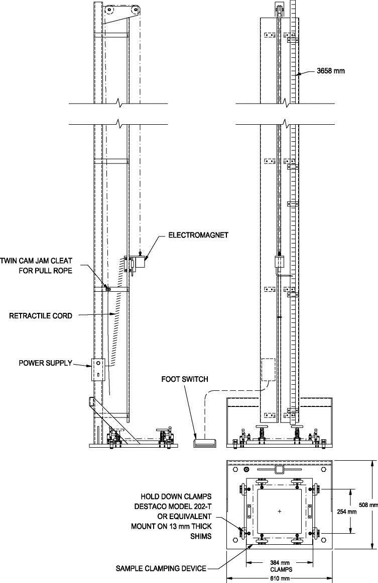

Figure 3: Free Fall Test Stand
Equipment shall be built within, and samples shall conform to, a tolerance of ± 1.6 mm (0.063 in.) of the dimensions specified in the drawing.

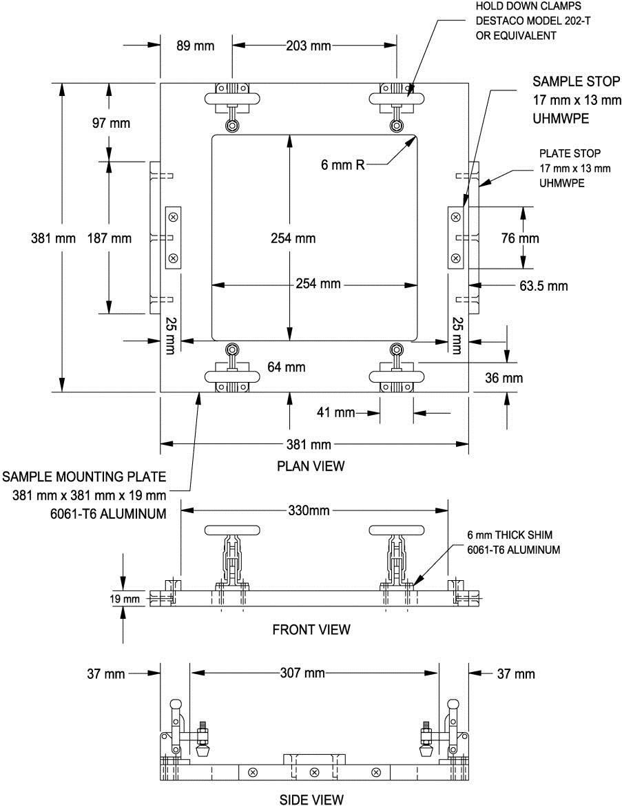

Figure 4: Sample Clamping Device
Equipment shall be built within, and samples shall conform to, a tolerance of ± 1.6 mm (0.063 in.) of the dimensions specified in the drawing.

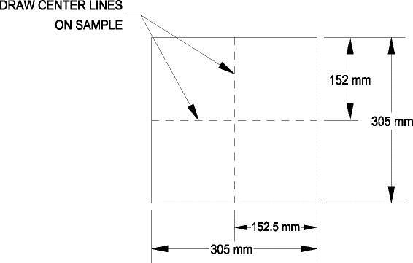

Figure 5: Sample Marking

Test Report
The test report shall include the following:

      - Pass or fail at 1525 mm (60 in.)

      - Sample thickness and description

Light Resistance: ISFA SST 7.1-00

Scope
This test measures the ability of solid surface to retain its color when exposed to a light source having a frequency range approximating sunlight through window glass.

Modifications
Test conducted per NEMA LD 3-3.3 with the following exceptions:

      - Additional test apparatus and materials

        - Random orbital sander with dust extraction

        - 100 and 60 micron sanding discs
        - Scotch-Brite® pad #7447 or equivalent

      - Prepare sample according to ISFA SST 1.1-00 Section 5.1 Surface Preparation Procedure.

      - Eliminate the Petroleum Jelly Procedure.

      - Examine the sample after exposure. The Specimen must be brought back to original finish by sanding with a random orbital sander with a vacuum dust extraction system, using 100 micron, followed by 60 micron, and followed by Scotch-Brite® pad #7447 or equivalent. The surface area of the specimen shall be sanded at a rate of 3.05 lin. m (10 lin. ft.) per minute in a bi-directional fashion.

Test Report
There shall be no effect.

Boiling Water Resistance: ISFA SST 8.1-00

Scope
This test measures the ability of solid surface to maintain its color and surface finish when subjected to boiling water.

Modifications
Test conducted per NEMA LD 3-3.5 with the following exceptions:
      - Additional apparatus and materials

        - Powder abrasive cleanser containing a bleaching agent (Comet® or equivalent)
        - 76 x 76 mm (3 x 3 in.) Scotch-Brite® pad #7447 or equivalent with 2kg (5.0 lb.) weight
      - Prepare sample according to ISFA SST 1.1-00 Section 5.1 Surface Preparation Procedure.
      - After test procedure, test specimen shall be cleaned with water and an abrasive cleanser containing a bleaching agent using a new 76 x 76 mm (3 x 3 in.) Scotch-Brite® pad #7447 or equivalent weighted with 2 kg
(5.0 lb.) for 25 cycles.

Test Report
There shall be no effect.

High Temperature Resistance: ISFA SST 9.1-00

Scope
This test measures the ability of solid surface to maintain its color when

subjected to high temperature

Modifications
Test conducted per NEMA LD 3-3.6 with the following exceptions: a) Additional apparatus and materials
- Powder abrasive cleanser containing a bleaching agent (Comet® or equivalent)
- 76 x 76 mm (3 x 3 in.) Scotch-Brite® pad #7447 or equivalent

- Prepare sample according to ISFA SST 1.1-00 Section 5.1 Surface Preparation Procedure.

- After test procedure test specimen shall be cleaned with water and an abrasive cleanser containing a bleaching agent using a new 76 x 76 mm (3 x 3 in.) Scotch-Brite® pad #7447 or equivalent weighted with 2 kg (5.0 lb.) for 25 cycles.

Test Report
There shall be no effect.

