_________________________________________________________________________

March 12, 2026

NOTICE is hereby given that the Council for the City of Chester has posted a Municipal Parking Management and Enforcement Request for Proposal (“RFP”) and is soliciting proposals from qualified parking management firms to provide: comprehensive municipal parking management (staff, management reports, etc.); enforcement (e-ticketing, booting); and technology services (mobile/web payment, etc.) for the City’s on-street, municipal lots, permit parking zones, event areas, and any other related parking facilities. Bids shall be submitted electronically via the PennBid portal by 2:00 PM, March 26, 2026. Interested bidders shall submit any questions regarding this opportunity via PennBid in the “Messages” menu tab, followed by the “Public Q&A” tab, no later than 5 pm March 19, 2026. The City of Chester reserves the right to reject any and all proposals submitted and to waive any informalities. A contract is expected to be awarded in the late April timeframe by the City Council. The City encourages participation from Diverse Business Enterprises. The City is an equal opportunity employer. No firm or person will be discriminated against because of race, color, religion, sex, handicap, familial status, or national origin.

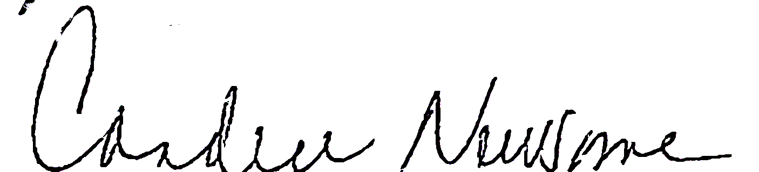

Candice Newsome
City Clerk

Are you new to the PennBid / Bonfire / Euna Procurement electronic bid platform? No Problem! Follow these steps:

 | WHAT | HOW
Step 1 | Register, for free (takes 3 minutes) | click here
Step 2 | Download the bid documents to your computer (must be logged into PennBid to do this) | Click the “Download All Files” button by scrolling down to the “Supporting Documentation” Sub-Header (click here)
Step 3 | On your computer hard drive, locate the .zip file entitled “City of Chester - Delaware County - pub - Municipal Parking Management and Enforcement” | Double click on the “.ZIP file” to view the 9 documents associated with this solicitation.  Please read “1. Bid Packet” in its entirety
Step 4 | After you have read the Bid Packet and are ready to submit your bid, please log back into PennBid with your username and password. | Click the “Prepare Your Submission” button, by scrolling down to the “Submissions” subheader at the very bottom of the page (click here). You can also click here for the vendor bid submission tutorial.
Step 5 | Need more help? No problem! | Email: info@pennbid.net or  Call: (610)-693-4769  - Tell them you are a vendor submitting a bid for the the City of Chester  - Agents are waiting to assist you. Don’t delay!
Please note, the estimated time to complete all 4 steps above is approximately 3 to 5 hours.

