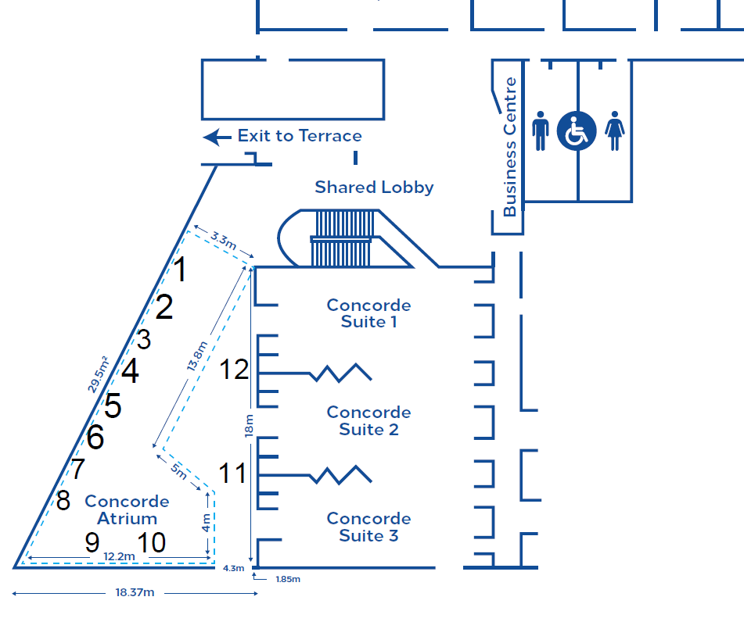

ILADS Meeting Room
Concorde Suite 1-3

