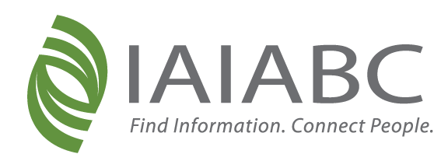

IAIABC Committee Leadership Transition Timeline 2025

May 12, 2025
- Open 2026-2027 leadership applications for all committees.

June 6, 2025
- Applications close.

Mid-July
- President confirms 2026-2027 leadership. Appointment communications are delivered.

July through September
- 2026-2027 leaders engage in Convention planning, Joint Committee Council meetings, and committee meetings.

October
- 2026-2027 leaders attend Board/Joint Committee Council meeting on site at Convention (October 5). Future leaders shadow current leaders as they host committee meetings.

November/December
- 2026-2027 leaders begin taking the lead on committee responsibilities for year-end meetings and The Forum 2026 planning. Current leaders take a more passive role but are still engaged.

January 2026
- 2026-2027 leaders officially start their term.

