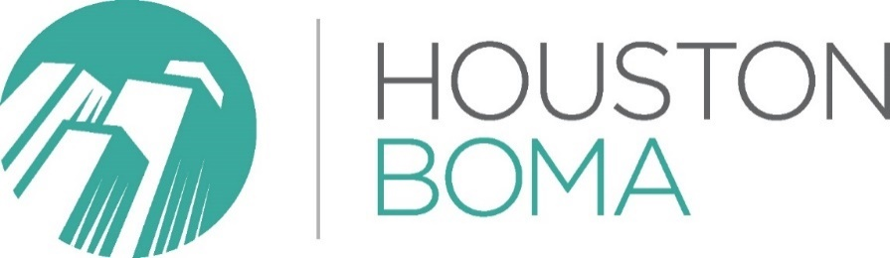

2025 DEI Calendar of Events

January
- January 15 – Martin Luther King, Jr. Day
- January 27 – International Holocaust Remembrance
February
- Black History Month
- Chinese New Year (Date varies yearly)

- February 4 — Rosa Parks Day
- February 12 – International Epilepsy Day
- February 17 – Random Acts of Kindness Day
March
- March 8 – International Women’s Day
- March 10 – Harriet Tubman Day
- March 21 – World Down Syndrome Day
- March 31 – César Chávez Day and Transgender Day of Visibility
April
- Arab-American Heritage Month
- Autism Awareness Month (Learn more about the Houston Zoo Annual Walk With Me Event)
- Houston Area Women’s Center (HAWC) Believe Luncheon (Learn more at hawc.org)

- April 2 – World Autism Awareness Day
- April 7 – World Health Day
- April 20 – Autism Awareness Walk (Learn more at Houston Zoo Website)
- April 22 – Earth Day
May
- Asian American Pacific Islander Heritage Month (Learn more at Visit Houston)
- ALS Awareness Month
- Haitian Heritage Month
- Indian Heritage Month
- Jewish-American Heritage Month
- Mental Health Awareness Month
- Celebrate Diversity Month
- Houston’s International Festival (Learn more at The International Fest)

- May 5 – Cinco de Mayo
- May 12 – Mother’s Day
- May 17 – International Day Against Homophobia, Transphobia and Biphobia
- May 21 – World Day for Cultural Diversity for Dialogue and Development
- May 27 – Memorial Day
June
- Pride Month
- Pride in Business Celebration Luncheon & Awards (Learn more at Houston LGBT Chamber)

- June 19 – Juneteenth (Learn more at Juneteenth Houston)
- June 16 – Father’s Day
July
- July 14 – International Non-Binary Persons Day
- July 18 – Nelson Mandela Day
- July 26 – National Disability Independence Day (commemorates the signing of the Americans With Disabilities Act)
August
- August 9 – International Day of the World’s Indigenous People
- August 19 – World Humanitarian Day
- August 26 – Women’s Equality Day
September
- Hispanic Heritage Month
- National Inclusion Week (Learn more at Diversity Inclusion Speakers)

- September 2 – Labor Day
- September 5 – International Day of Charity
- September 27 – National Native American Day
October
- Disability Employment Awareness Month
- Invisible Disabilities Week (Learn more at Houston Walk)

- October 11 – National Coming Out Day

November
- November 11 – Veteran’s Day
- November 19 – International Men’s Day
- November 20 – Transgender Day of Remembrance
- November 25 – International Day for the Elimination of Violence Against Women
December
- December 3 – International Day of Persons with Disabilities

