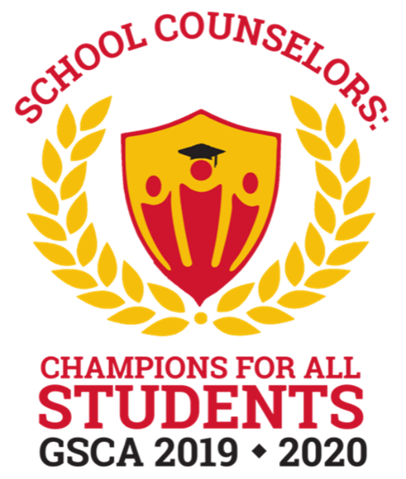

***Region 3 GSCA Virtual Mini-Conference***

***March 27, 2020***

***GSCA Region 3 Liaison…Barbara Truluck, Palmer Middle School***

***Session 1: Suicide Prevention… Dr. Melissa Marsh, Cobb County School Counseling Supervisor***

***Session 2: Girl Power…Laura Ross, Five Forks Middle School, 2020 National School Counselor of the Year***

***Session 3: On the Same Breath Program…Cheryl Crawford, Georgia Breathes Founder***

***Session 4: Teaching Growth Mindset in Schools…Lisa King, Blackwell Elementary School***