[HIGH SCHOOL NAME]

[RESTAURANT NAME]

Restaurant Concept

Type of establishment: [Ex: Quick service, fast casual, family dining, fine dining, café, food truck]

Purpose and impact:
Describe the story behind your restaurant, what experience you want guests to have, and how you will impact your community.
Meals served: ☐ Breakfast ☐ Brunch ☐ Lunch ☐ Dinner ☐ Late Night

Hours of operation:
• Monday–Thursday: __________________________
• Friday: ___________________________________
• Saturday: _________________________________
• Sunday: ___________________________________

Type of Cuisine: [Ex: Southern comfort, Latin fusion, Asian street food, classic American, plant-based, etc.]

Target market:
The geographic location of ProStartville, USA is at your discretion. ProStartville, USA is home to a diverse group of families, students, and young professionals. Residents of ProStartville enjoy a thriving arts scene, a large university with a strong sports program, an international airport, and unique neighborhoods.

Population
- 275,508
- Year-over-year population change - +2.6%
- Median age – 31.8
- Population breakdown by age

Age | % of Population
0-9 | 8%
10-19 | 12%
20-29 | 26%
30-39 | 16%
40-49 | 11%
50-59 | 10%
60-69 | 9%
70+ | 8%

- Families – represent 23% of the population.
- Gender
  - Men: 49%
  - Women: 51%
- Median income - $76,817

Economy
- In civilian labor force – 65%
Education
- High school graduate or higher (25+ years old) – 96%
- Bachelor’s degree or higher (25+ years old) – 59%

SWOT Analysis

Strengths:

Weaknesses:

Opportunities:

Threats:

Description of Interior and Décor

Describe the look and feel of your restaurant. Include colors, materials, lighting, seating, and any special features. Include pictures of all items.
- Wall décor:
- Seating style (booths, tables, bar, etc.):
- Lighting:
- Flooring/finishes:
- Special features (art display, stage, kids’ corner, etc.):

Floorplan

Type of location (strip mall, stand-alone building, food hall, etc.):
- Neighboring businesses: ______________________________________
- Pros of this location: ________________________________________
- Cons of this location & solutions:
- Challenge: ________________________________________________
- Solution: _________________________________________________

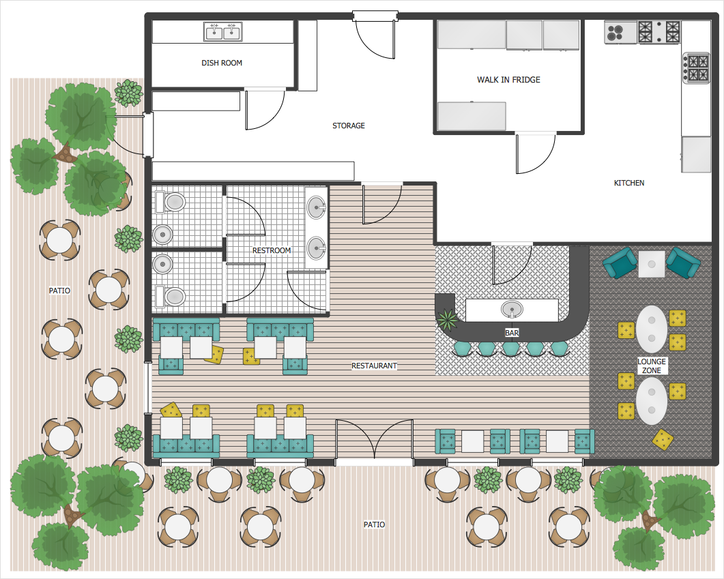

(Above is an example of a floor plan)

Organizational Chart
Describe and draw your staffing structure.
Roles may include (edit as needed):
- Owner / General Manager
- Assistant Manager
- Front-of-House Supervisor
- Back-of-House Supervisor / Kitchen Manager
- Servers
- Hosts / Cashiers
- Line Cooks / Prep Cooks
- Dishwashers
- Marketing / Social Media
(Attach an org chart image)

Sample Menu
Insert an image of the Sample Menu for your restaurant

Recipe

TEAM NUMBER

Menu Item
Number of Portions |  | Portion Size
Cooking Method(s)
Recipe Source

Ingredients
Item | Amount

Procedure
Protein:
- Prepare the protein by portioning it into individual servings and placing them into a bowl or pan. (Example: chicken breasts, pork chops, tofu, fish, etc.)
- Add marinade or seasoning (oil, acid, herbs, spices) and turn to coat evenly.
- Refrigerate or rest the protein for ___ minutes to marinate, if needed.
- Preheat the cooking surface (pan, grill, oven, etc.) to the correct temperature.
- Cook the protein using your chosen method (sear, bake, grill, sauté) for ___ minutes per side or until it reaches the proper doneness.
- Remove the protein from the heat and let it rest. Slice or portion as needed for plating.

Sauce / Purée / Spread:
- Prepare the main ingredient for your sauce or purée (example: avocado, roasted vegetables, herbs, etc.) by dicing, smashing, or blending.
- Add flavorings such as herbs, garlic, citrus juice, oil, salt, and pepper.
- Blend or whisk until smooth and adjust seasoning to taste.
- Refrigerate or hold the sauce/purée safely until ready to plate.

Salad / Vegetable Component:
- Prepare the fruits and/or vegetables (dice, julienne, slice, or rough chop as needed).
- Combine the ingredients in a bowl (example: main fruit/veg, onions, herbs, etc.).
- Add dressing ingredients (oil, acid, salt, pepper, spices) and toss gently to coat.
- Set aside until plating, keeping it cold if necessary.

Crunch / “Soil” / Texture Component:
- Place your dry base ingredient in a bowl (example: crumbs, nuts, crispy shallots, maltodextrin with flavored oil, etc.).
- Slowly add the liquid or fat component while mixing.
- Stir gently until the mixture reaches the desired “crumb” or “soil” texture.
- Hold in a dry container until plating.

Hot Sauce / Glaze (if using):
- In a small pot, combine your liquid base (stock, juice, soy/ponzu, etc.) with sugar, seasoning, or aromatics.
- Simmer over low heat for ___ minutes until slightly reduced or thickened.
- Taste and adjust seasoning as needed.
- Hold hot or reheat safely for service.

Plating:
- Place your sauce/purée on the plate first and spread or swipe it into the desired shape for presentation.
- Add the salad or vegetable component neatly (for example, in a ring mold or small pile).
- Arrange the sliced or whole protein attractively near the salad/vegetable component.
- Sprinkle the crunch/soil or texture component in a controlled area on the plate.
- Spoon or drizzle the hot sauce/glaze over or around the protein as appropriate.
- Add final garnishes (herbs, edible flowers, microgreens, citrus segments, etc.) to complete the presentation.

Menu Item
Number of Portions |  | Portion Size
Cooking Method(s)
Recipe Source

Ingredients
Item | Amount

Procedure

Menu Item
Number of Portions |  | Portion Size
Cooking Method(s)
Recipe Source

Ingredients
Item | Amount

Procedure

Menu Item
Number of Portions |  | Portion Size
Cooking Method(s)
Recipe Source

Ingredients
Item | Amount

Procedure

Menu Item
Number of Portions |  | Portion Size
Cooking Method(s)
Recipe Source

Ingredients
Item | Amount

Procedure

Menu Item
Number of Portions |  | Portion Size
Cooking Method(s)
Recipe Source

Ingredients
Item | Amount

Procedure

Food Cost

TEAM NUMBER

Menu Item
Number of Portions |  | Portion Size

Ingredient | Purchase Unit | Purchase cost | Unit cost | Amount Needed | Ingredient Cost

Subtotal
1 % for small amounts of spices (Q Factor)
Total Recipe Cost
Portion Cost

Menu Item
Number of Portions |  | Portion Size

Ingredient | Purchase Unit | Purchase cost | Unit cost | Amount Needed | Ingredient Cost

Subtotal
1 % for small amounts of spices (Q Factor)
Total Recipe Cost
Portion Cost

Menu Item
Number of Portions |  | Portion Size

Ingredient | Purchase Unit | Purchase cost | Unit cost | Amount Needed | Ingredient Cost

Subtotal
1 % for small amounts of spices (Q Factor)
Total Recipe Cost
Portion Cost

Menu Item
Number of Portions |  | Portion Size

Ingredient | Purchase Unit | Purchase cost | Unit cost | Amount Needed | Ingredient Cost

Subtotal
1 % for small amounts of spices (Q Factor)
Total Recipe Cost
Portion Cost

Menu Item
Number of Portions |  | Portion Size

Ingredient | Purchase Unit | Purchase cost | Unit cost | Amount Needed | Ingredient Cost

Subtotal
1 % for small amounts of spices (Q Factor)
Total Recipe Cost
Portion Cost

Menu Price

Menu Category | - Starter | - Entree | - Dessert

Recipe | Portion Cost

Total Plate Portion Cost
Menu Price at 33% Food Cost
Actual Price on Menu

Photo

Of a meal from above
Marketing #1
Tactic 1

Description
Describe the marketing idea (ex: loyalty program, kids’ night, email list, community partnership).
Goal
What do you hope to achieve (more repeat guests, higher check average, etc.)?
Budget
Estimated cost of the promotion (materials, discounts, ads, etc.).
$__________
Return on Investment (ROI)
- Estimated revenue generated: $__________
- ROI calculation (Revenue – Budget, then divide by Budget and convert to %):

Marketing #2

Tactic 2

Description
Describe the marketing idea (ex: loyalty program, kids’ night, email list, community partnership).
Goal
What do you hope to achieve (more repeat guests, higher check average, etc.)?
Budget
Estimated cost of the promotion (materials, discounts, ads, etc.).
$__________
Return on Investment (ROI)
- Estimated revenue generated: $__________
- ROI calculation (Revenue – Budget, then divide by Budget and convert to %):

