the existing structure, consult with your pest manage- ment professional to schedule necessary treatments, retreatments or alterations to your termite and other wood destroying organisms protection.

#### Building An Addition To The Existing Structure

When planning an addition or alteration that impacts existing foundation walls, the erection of new founda- tion walls, or changes to patios or slabs adjacent to the building, alert your pest management company before works begins. Alterations to the soil adjacent to ex-

isting foundations can impact the effectiveness of

treatments. Soil or wood that was treated during pre- construction, or bait treatments provide the greatest

level of protection with the least amount of disturb-

ance to the structure.

#### Altering Landscaping Or Grading Adjacent To The Structure

Adding or removing shrubs, installing hardscape ele- ments or adding mulch can interfere with the existing treatments and leave a structure unprotected. When- ever treated soil is moved or removed, the backfilled soil should be retreated to maintain protection. Even something as common as adding wood or pine straw mulch, especially if it covers treated soil, or is piled above exterior siding can be detrimental because it

provides an untreated “bridge” for termites and other wood destroying organisms to circumvent treated areas. If extensive landscape projects are undertaken, inform your pest management professional who can

#### Installing A French Drain System

Directing water away from underneath and around a build- ing generally helps to reduce the likelihood of pest infesta- tion. However, as with any alteration that requires excava- tion of treated soil adjacent to a building’s foundation, the area may need to be treated when installation is complete. To be sure, contact your pest management professional to determine the best course of action.

### The Bottom Line

The secretive behavior of termites and other wood destroy- ing organisms make them difficult to detect, even under the best of circumstances. Before undertaking any changes to your home that may cover up portions of the structure that were previously visible for inspection, alert your pest man- agement company to ensure that your warranty protection isn’t impacted. Additionally, whenever treated soil is exca- vated or the footprint of your home changes, contact a pro- fessional to devise a plan to protect the structure before work begins.

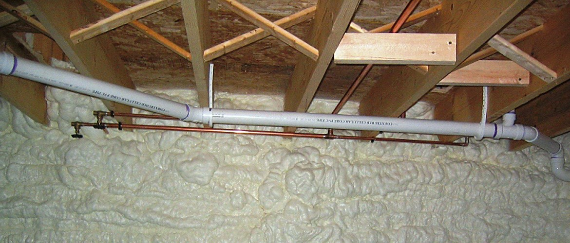

*Supplied in collaboration with the National Pest Management Association (NPMA).*

help determine if additional treatment is necessary.



# Consumer Alert:

Property Enhancements, Additions and Alterations that may Compromise Wood Destroying Organisms and Other Pest

Protection

Georgia Pest Control Association 2034 Beaver Ruin Rd

Norcross, GA 30071

770-417-1881

[www.GPCA.org](http://www.GPCA.org/)

## Consumer Alert: Property Enhancements,

**Additions and Alterations that may Compromise Wood Destroying Organisms and other Pest Protection**

A home represents the single largest investment that most people make in their lifetimes and investing in

termite and other wood destroying organism protec- tion is one of the most important decisions you can make for your property. Pest control firms work to

control infestations and protect your property from future infestations. They may employ several different

pest management treatments and monitoring systems, but cannot be successful in protecting your property without the ability to periodically inspect your home for potential infestations. Termites and other wood destroying organisms are some of the most difficult pests to control and prevent, so the partnership be-

tween you and your pest management professional is necessary for success. The following information is provided to educate homeowners on how changes to your home following a termite and other wood de-

stroying organism treatment can: impact the effective- ness of the wood destroying organism treatment, im- pair your pest management professional’s ability to detect a termite or wood destroying organism re-

infestation early, negatively impact your termite or wood destroying organism warranty coverage and

result in potentially costly damages and repair in the future.

Even well intentioned changes designed to improve the appearance, energy efficiency, or resale value of your home can impact your termite and other wood

destroying organisms protection and warranty. Before

making alterations to the exterior perimeter or substructure of your home, consult with your pest management profes- sional.

The vast majority of the structural timbers in most structures are concealed by walls, ceilings and floors. Basement and

crawlspace construction provide the last remaining glimpses into the locations in closest proximity to where termites and other wood destroying organisms originate. Pest manage- ment professionals carefully inspect the substructure of a building, including foundation walls, sill plates, band boards and joists for signs of termites and other wood destroying organisms and their damage. Covering these inspection lo- cations can seriously impede the inspectors’ ability to see

the areas most prone to attack by termites and other wood destroying organisms and in many cases could void your ter- mite and other wood destroying organism coverage due to

contractual language in your agreement with your pest man- agement professional.

### UPGRADES TO THE STRUCTURE

Upgrades and improvements to the structure are beneficial to you and your property but may have unforeseen impacts on your termite and other wood destroying organisms pro- tection. Before making upgrades to the existing structure, contact your Pest Management professional to schedule an appointment to discuss how alterations could affect your

current pest protection agreement(s).

#### Finishing A Basement

Adding livable space by installing drywall in a basement,

hides the most important areas of inspection from view. As a result, detecting termite and other wood destroying organ- ism evidence early is more difficult. In fact, termite and oth-

er wood destroying organisms infestation and damage may remain hidden for years, resulting in costly repair bills.

#### Enclosing Or Sealing A Crawlspace

Traditionally, crawlspace areas beneath structures have been protected from moisture and associated problems (fungus, mold, etc.) by the installation of

foundation vents and vapor barriers on top of the soil. In recent years, some building professionals have be- gun to recommend that crawlspace areas be com-

pletely sealed off from exterior air by sealing the space, installing drainage systems and conditioning the air with a dehumidifier or other means.

#### Applying Spray Foam Insulation

Installing spray foam insulation in crawlspaces, base- ments, and attics can help improve the energy efficien- cy of the home by eliminating drafts and insulating the building, but when spray foam is applied over structur- al timbers, inspectors are unable to detect termites and other wood destroying organisms. To make matters worse, termites and other wood destroying

organisms can easily tunnel through insulation which can provide a bridge over treated areas from the soil to the structure.

### ADDITIONS AND ALTERATIONS TO THE STRUCTURE

Additions and alterations to a property can interfere with the effectiveness of a treatment and protection from termite and other wood destroying organisms

infestation. Before making additions or alterations to