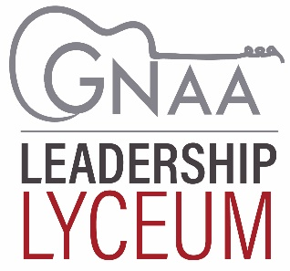

Nomination for Greater Nashville Apartment Association

Leadership Lyceum

This nomination is made by:
Name:
Company:

Lyceum CANDIDATE BEING NOMINATED:
Name:
Title:
Company:
Address:

Office Phone: ________________________________________ Mobile:
Email:
How long has nominee been a member of GNAA?
Local/State Affiliate Positions Held:

Why do you believe this person would be a good candidate for the LYCEUM?

Applications must be received by March 6, 2026
Please return application via email to: education@gnaa.org

Inspiring and Educating Association Volunteers

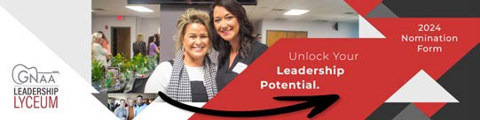
2026
Announcing Leadership Lyceum 2026: the premier program shaping leaders within GNAA! Join us as we cultivate the next wave of GNAA leaders from within. As one of just 12 handpicked candidates, comprising 10 management members and 2 supplier members, you’ll embark on a transformative journey of leadership development. Discover how to lead effectively within GNAA, navigating volunteer engagement, committee involvement, advocacy, legislation, and financial strategies crucial to GNAA’s success.

What are the requirements for 2026 Leadership Lyceum?
- The program cost is $350, which includes a professional development assessment as well as the opportunity to attend NAA’s Advocate conference.
- Attendance of the three Leadership Lyceum program modules: Leadership, Working with Association Volunteers and Staff, and Advocacy and Legislative.
- Upon graduation, candidates must select one committee to join and actively participate.
- Graduates will be responsible for nominating another peer member for the following years’ Lyceum program.

Candidates are required to attend the following within 18 months to complete the program:
- Each GNAA Committee (at least once)
- GNAA Board Meeting
- Legislative Committee Meeting
- TNAA Legislative Reception
- Two networking events. You can choose from: Gala, Apartment tour, Golf tournament, Trade Show, Maintenance Appreciation, Membership Mixer or Election Night
- Candidates must attend one of the following: General Membership Meeting, Managers Luncheon, Maintenance Luncheon, or Suppliers Luncheon

To make a nomination, please fill out the below form and return to education@gnaa.org by March 6, 2026

