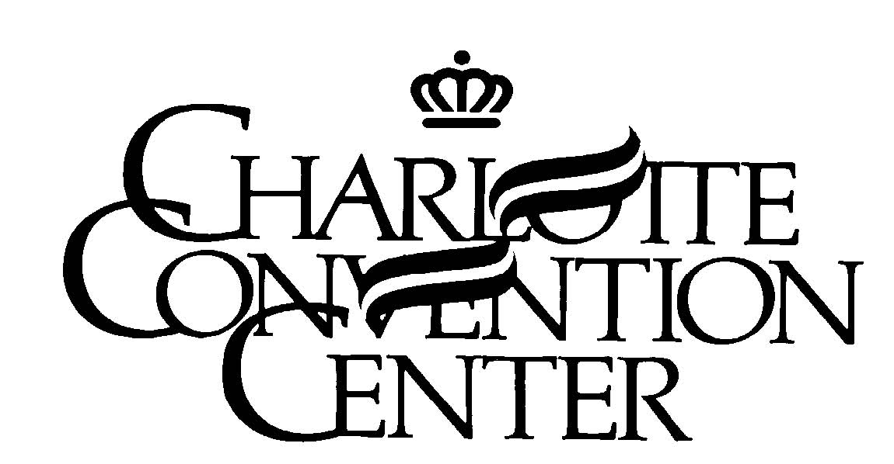

Food and Beverage Sample Distribution Request

The following constitutes a sample distribution request used for the sole purpose of distributing sample food and/or beverage to exhibit attendees.

The following information must be completed and submitted no later than two weeks prior to the event for approval.

Please submit to:

Charlotte Convention Center OR Email to: Elizabeth.Wehrheim@crva.com
Attn: Elizabeth Wehrheim
501 South College Street
Charlotte, NC 28202
(704) 339-6051 – fax

Company representative agrees that all items to be distributed as samples will be of individual bite-sized portions and that beverages will be in containers of four (4) ounces or less and that all items are company product only.

Company Name: | Event Name: |  | Event Date(s):
Company Address: |  | Contact Name (Please Print)
Phone Number: | Fax Number & Email:

Product Name/Type | Sample Size | Quantity | √  Approved | √  Denied
1.

2.

3.

4.

Signature (Company Representative): __________________________________________________

Signature (Charlotte Convention Center Representative):___________________________________

Comments:_______________________________________________________________________

________________________________________________________________________________

