2026 SOUTHERN AMUSEMENT

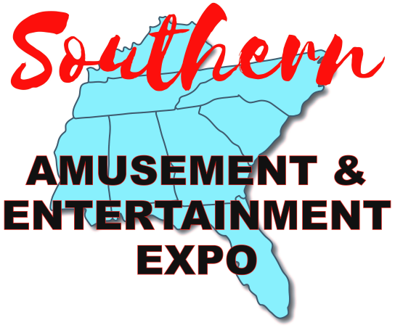
& ENTERTAINMENT EXPO
Skill Gaming Track
Agenda

Tuesday, August 18th
1:00 pm – 2:00 pm Session TBD TBD Speaker TBD
1:00 pm – 2:00 pm Session TBD TBD
Speaker TBD
2:15 pm – 3:15 pm Emerging Skill Markets Magnolia BC
Special Guest Speaker TBD
3:30 pm - 5:00 pm Gaming Legislative Update Magnolia BC
Featuring Paul T. Jenson
5:00 pm – 7:00 pm Sponsor/Exhibitor Appreciation Dave & Busters
Seminar Attendees Welcome
Shuttle buses will run from 5:00 pm – 8:00 pm
Wednesday, August 19th
10:00 am – 5:00 pm Expo Open GSD Hall A&B
5:00 pm – 6:00 pm Reception Westin Jasper Foyer
6:00 pm – 8:00 pm GAMOA Awards Banquet Westin Jasper Ballroom
Ticketed Event
8:00 pm – 9:00 pm Live Auction Westin Jasper Ballroom
Everyone Welcome
9:00 pm – 11:59 pm Ginger Foshee Casino Night Westin Jasper Ballroom
Everyone Welcome
Silent Auction ends
Thursday, August 20th
10:30 am – 2:00 pm Expo Open GSD Hall A&B
10:00 am – 12:00 pm Tech Training with Intralot
2:00 pm – 3:30 pm COAM Seminar GSD Magnolia A&B
GA Lottery COAM Division & Intralot
Proudly Hosted By:
