The Modified Ludzack-Ettinger process is designed to use nitrate produced by the aeration zone as an oxygen source for facultative bacteria in the breakdown of raw wastewater in the anoxic basin. The first process in the treatment train is a pre-anoxic basin where influent wastewater, return sludge from the clarifier, and nitrate-rich mixed liquor pumped from the effluent end of the aeration tanks are mixed together. The influent wastewater serves as the carbon source for bacteria, return activated sludge from the clarifier provides microorganisms, and the anoxic recycle pumps provide nitrate as an oxygen source. The anoxic basin is mixed, but not aerated. Mixers can be floating mechanical type or submersible motors fitted with propeller type mixers. The basic layout is shown in the figure below.
Influent wastewater
effluent
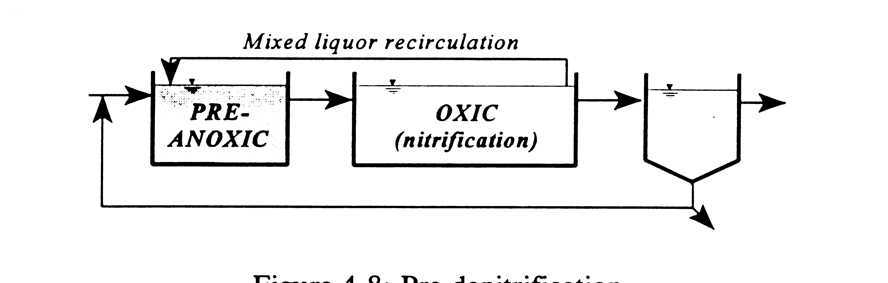
Waste sludge

Another variation that is used for denitrification of wastewater, is the Wurhman process.
The Wurhman Process places the anoxic basin after the nitrification zone. This process relies on nitrate produced in the preceding aeration tank as the oxygen source. Facultative bacteria that make up a majority of the MLSS perform the work of denitrification. In order to drive the denitrification process, organic matter is added to the anoxic basin. Since most of the organic matter present in raw wastewater has been consumed through the aeration tank by aerobic and facultative bacteria, a supplement must be added to the anoxic basin. Sources of organic matter can be raw wastewater, methanol, acetic acid or other carbon base material. The anoxic basin is mixed, but not aerated. Many facilities employ a reaeration zone after the anoxic basin to release nitrogen gas bound in the sludge, and freshen the mixed liquor before it enters the clarifier.

Denitrifying filters, are used for the purpose removing nitrogen as well as solids removal. Denitrifying filters are generally at the end of the secondary process and used in advanced treatment processes to meet TMDL requirements.
There two main process configurations for denitrificatio filters commercially available, down flow and up flow continuous backwash filters
Down flow denitrification filters operate in a conventional filtration mode and consist of media and support gravel over an underdrain. Manufactures of these include, Seven Trent Services, Fort Washington, Pa., TETRA Denite system; F.B. Leopold Co., and Siemens Water Technology Davco Products, Thomasville, Ga.
Wastewater enters a down flow filter over weirs along the length of the filter bed on both sides. Filter effluent leaves the filter from the bottom of the filter into a clear well. Backwashing is required at regular intervals. Backwashing involves air scouring, and water backwash. During the process, nitrate is metabolized to nitrogen gas, which becomes embedded in the filter media, and released as a gas.
Upflow differ in the fact that influent wastewater flows upward through the filter, and sand bed. Wastewater enters the filter through the influent pipe and then flows upward through the filter and the filtrate is discharged from the upper portion of the filter media.
Compressed air is used to scour the sand media.

The Bardenpho process, which stands for biological denitrification and phophorus removal, is an advanced design for further nutrient removal. As in the Wuhrman process, and Modified Ludzack-Ettinger, the Bardenpho process uses aerobic zones to nitrify the wastewater, and anoxic zones to denitrify, it if refined by going through a five stage process to ensure acceptable removal rates, that meet advanced wastewater treatment requirements. The process includes five stages which are 1. fermentation basin, 2. first anoxic basin, 3. aerobic basin, 4. second anoxic basin, and 5. reareation basin.

