Problems That Nitrogen Can Cause

Rising sludge
Rising sludge (‘pop-ups’) are particles or chunks of sludge floating to the surface of the clarifier. The sludge can be carried over the effluent weir, which results in elevated effluent TSS levels. The sludge is carried to the surface by bubbles of gas formed in the sludge blanket at the bottom of the clarifier or from sludge hung up on the walls of the clarifier. The gas may be either nitrogen or hydrogen sulfide gas (H₂S) formed from the biological decomposition of the sludge.

Some differences of the gas can be used to determine if the sludge is denitrifying or going septic at the bottom of the tank. Pop-ups caused by nitrogen are usually light brown to brown in color, and have no odor when broken up by a hose or cleaning brush. When pop-ups are caused by septic conditions, a classic “rotten egg” odor is noticeable when the sludge is hosed down or otherwise broken up, due to release of the hydrogen sulfide gas. The pop-ups are usually dark brown to black in color.

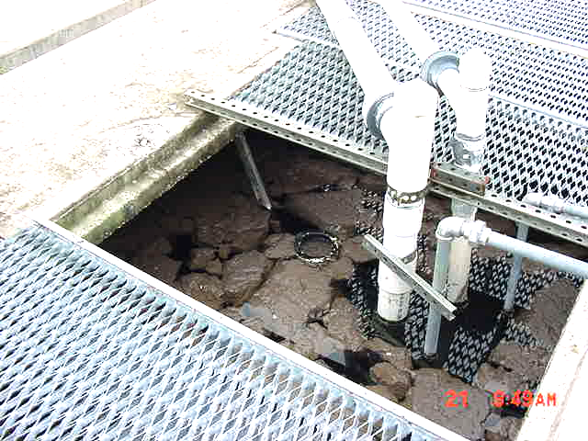
Figure 1 Pop-ups

Denitrification in the clarifier is the most probable cause of the rising sludge in the example shown in Figure 4. To remedy this situation, an increase in sludge wasting rates by no more than 10% per day, will help reduce or eliminate the degree of nitrification. Waste sludge rates should be maintained to keep the process within proper MCRT and F/M ratios. Maintaining a minimum DO at peak flow (1.0 mg/L) while ensuring that proper mixing is still being provided may also help. Adjust RAS rates to maintain a sludge blanket depth of 1 to 3 feet (or 25% of depth) in clarifier. Brushing or otherwise pushing settled solids in the clarifier to RAS hoppers on a regular basis will help reduce rising sludge due to denitrification or septicity occurring in clarifier. See troubleshooting guide #5 in appendix of this manual.
Ashing
Ashing on the surface of clarifiers is the result of very small particles of sludge bound to gas bubbles rising to the surface. These particles form small ‘islands’ of thin sludge that floats on the clarifier surface, and looks similar to ash (Figure 5). Ashing may also be accompanied by fine, dispersed floc extending throughout the clarifier (pin floc). Ashing is an indication that the aeration system is approaching an old sludge condition, or high MLSS levels. It also indicates that denitrification is beginning in the clarifier. See trouble-shooting guide #7 in appendix of this manual.

Figure 2 Ashing

When ashing and pin floc are noticed by the operator and determined to be from denitrification, an increase in sludge wasting is recommended to bring the process back into control. If the ashing can not be reduced by stirring or hosing the floating floc particles and the particles float back to the surface, then the cause may be traced to excessive amounts of grease in the mixed liquor. The grease may appear as small white particles floating on the clarifier surface.

Foam/Scum
Foam on the surface of clarifiers can be the result of several problems, including oil and grease entering the plant. A shiny, dark tan foam on aeration tank and clarifier surface means that the system is approaching an under-loaded condition (high MLSS) due to insufficient or lack of sludge wasting.

An excessive amount of grease and oil entering a wastewater treatment plant is a problem for many facilities. Improper or lack of grease trap pumping and deliberate dumping of waste grease down drains can be a food source for actinomycetes, a type of short, branched filamentous bacteria. Once these bacteria become predominant, a thick, dark-tan scum forms on the aeration tank and clarifier surface. The effluent quality deteriorates as the bacteria grow. Two types of bacteria can cause such problems, and once they proliferate, they are very difficult to get rid of. Nocardia and Microthrix Parvicella are two foam causing bacteria groups.

Foam or light scum from nitrification is an intermediate step between ashing and pop-ups (Figure 6). This type of scum occurs when a system has a high sludge age, and denitrification has begun in the clarifier. See troubleshooting guide #2 in appendix of this manual.
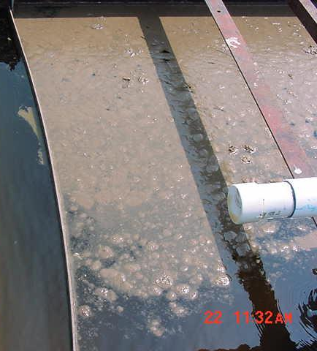
Figure 3 Light scum
For additional assistance in troubleshooting nitrification/denitrification problems, please refer to troubleshooting guide #8 located in the appendix of this manual.

