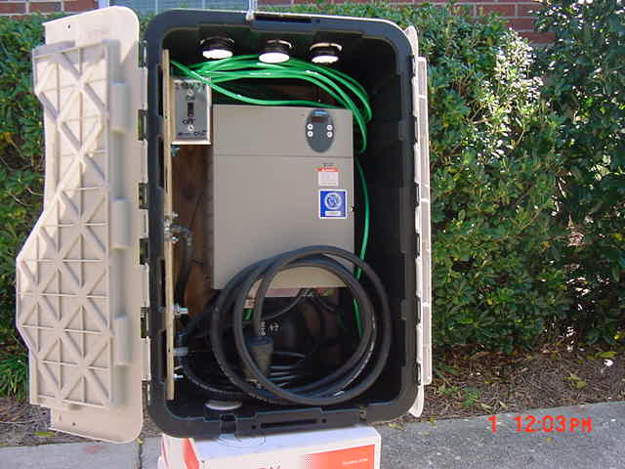
Air Venting Holes – 3 Top and Bottom
3/8” Plywood Box Reinforcement for Mounting
(side and bottom of box full length)
Standard Switch Box and Cover
17 Gallon PVC Storage Box
30’ - #10 grounding wire
VFD

4”

10/4 Power Cable with NEMA 30 AMP Receptacle outside (power out from VFD to motor)
10”0

10’ - 10/3 Power Cable with NEMA 30 AMP Plug
(power cord to connect to generator)
Cut Out
For Cable

Figure A VFD Mounted Inside Protective Box

No. Description Home Depot Part # Cost Function and/or Placement

- Air Louvers 050206191224 $6.99 6 total; 3 on ea. Side of Box
- 30’ - # 10 Grounding Wire 079407114375 $5.99 For External Ground to VFD Frame
- Grounding Lug 783786371853 $4.58 Connection to VFD Frame
- Standard Gang Electrical Box 034481074359 $1.29 Run Command to VFD
- Standard Electrical Plate 785007855579 $1.29 Run Command to VFD
- Universal 15A Switch 078477174500 $1.37 Run Command to VFD
- 3/8” Plywood 081999132057 $3.77 Box Reinforcement. Side & Bottom
- 17 Gallon Storage Box 785130405962 $9.97 Protective Box VFD
- 13’ - 10/4 Power Cable 369031 $25.61 Connect VFD to Motor Leads & Inside Box
- NEMA 30 Amp Plug 785007855173 $19.95 Connect Cable to VFD “Out”
- NEMA 30 Amp Receptacle 785007857696 $17.50 Connect VFD “Out” to Electric Box
- 10/3 Power Cable 751477 $10.90 Connect VFD to Generator
13. NEMA 30 Amp Plug 785007855173 $19.95 Connect Cable to Generator

Assembly Instructions for Constructing a VFD Control Box
for Field Applications

- All of the parts needed to construct a control box for protection of the VFD and to ensure the safety of personnel who will use the VFD in the field, can be obtained from Home Depot. Electrical parts and wires are also available at Lowes.
- A solid HPDE plastic storage box (part no. 785130405962) provides adequate space for mounting of the VFD and storage of cables used in making field connections. Make sure to provide a water tight cover for the box by cutting and mounting a piece of plywood over the top of the box (not shown) prior to field deployment. Cut the plywood cover large enough to provide 2” of extra space on each side over the top of the control box to prevent rainwater from seeping inside the box.
- Cut 2’ x 4’ - 3/8” plywood to fit bottom and side. Cut the side panel to ensure that the plastic top cover closes freely. Center VFD on plywood providing a minimum 10” clear distance from VFD to box at bottom. Ensure that there is proper clearance for installation of control box (see above.) The bottom area provides room for storage of cables used with the VFD. Securely attach VFD to plywood using 4 - ¼” hex screws (part no. 030699084227) to VFD back panel.
- Attach bottom plywood to box using 6 – ¼” hex screws. Make sure that holes through box are made in areas where the box and plywood are in direct contact. This ensures structural stability and water tightness. Tighten screws and use a washer to ensure proper compression is achieved to prevent the screws from loosing over time. Caulk around washers may be used.
- Install 6 air louvers (part no. 050206191224) as using hole saw. Cuts should be on flat part of box with flat side of vent on inside of box. Vents should be secured to the box with #10 screws to prevent them from dislodging in field.

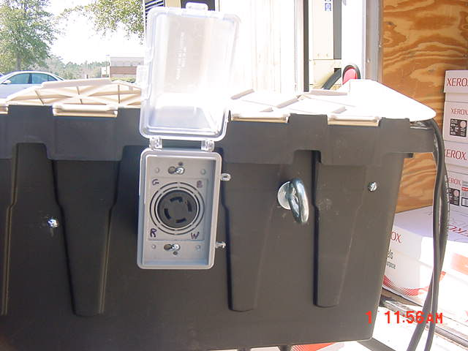
Bolt Plywood at flat box/wood interfaces
Ensure that top closes when side plywood is installed
I-Bolt for installation of security chain in field; scar threads inside box with chisel or drill hole for pin

Figure B Box Showing N1430 30 AMP Receptacle

- Cut opening through plywood for wire connection lug and install 10-4 cable (part no 079407114375) to VFD. Cable should be about 30” long to allow it to be secured inside box. Install electrical weather proof receptacle box (part no 03448108930.) and cover . The box should have a ½ hole at the bottom pointing down. This will allow for any water that could enter the box to drain away. Bolt electrical box to the plywood using 2 – 1/4 “ hex screws. Install 10/4 receptacle (7850078557696) with ground at the top of the box. Install weather protective cover (part no 785130405962.)
- Install standard on-off switch to be used for VFD start signal at side and top of box as shown in Figure A. For larger generator units, a 50 AMP receptacle should be provided.
- Cut at minimum 10’ feet of 10/4 cable (part no 079407114375) and install NEMA plug (part no 785007855173) at one end. On the other end strip wires back about ¾”. These will be connected to the motor breaker or directly to the motor.

No. Description Home Depot Part # Cost Function and/or Placement

14. ¼ “ Screws 030699280025 $3.97 Attachments to Box
15. ¼” Nuts 030699084227 $4.17 Attachments to Box
16. ¼” Washers 030699198221 $3.47 Attachments to Box
17. Weather Proof Cover 092326400367 $9.97 Weather Protection for Receptacle
18. Weather Proof Outlet Box 034481048930 $3.98 Weather Protection for Receptacle
19. Eye Bolt 030599091065 $1.78 VFD Security
20. Combo Pack Screws/Nuts 030699080342 $1.57 Miscl. Attachments to Box
21. Wire Securing Lugs 042269653252 $2.47 Secure Cable to Box

VFD Ordering Information

The Variable Frequency Drive (VFD) is an Altivar 31 manufactured by Alan Bradley in sizes 5 HP to 10 HP and by Telemencanique in the 20 HP size. The units can be ordered through Grainger. Ordering Information is as follows:

No. Description/Manf. Grainger Stock # Cost* Application Size Generator (Min)

1. 5 HP Square D 4RA49 ~$650 Maximum 5 HP 6.5 KW
2. 7.5 HP Square D 4RA50 ~$750 3 HP to 7.5 HP 9.0 KW
3. 10 HP Square D 4RA51 ~$850 3 HP to 10 HP 11.5 KW
4. 20 HP Telemencanique ATV31HD15MX3** ~$1440 4 HP to 20 HP 22.5 KW
* Call for quotation; Shipping not Included
** Special Order Item not in Std. Catalog
Wiring of VFD
LOCATION: LEFT BOTTOM OF VFD
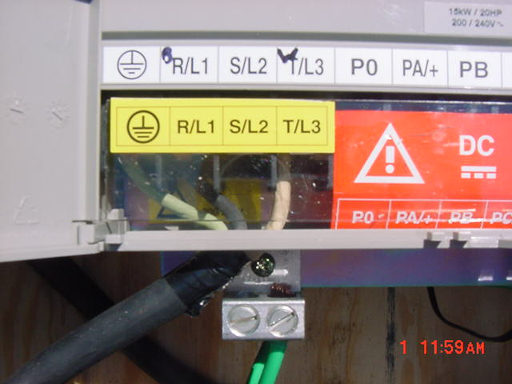
Cable #1 Green to VFD Ground
Cable #2 Black Power Cable to R/L 1
Cable #3 White Power Cable to T/L 3
Note: S/L2 is not Used
Cabinet Ground to External Ground Rod, Do NOT ground to generator

Figure C VFD Incoming 240V Single Phase and
External Grounding Connections

Important Wiring Instructions to Prevent Accidental Shock to Employees:

- All wire connections are made only inside the VFD unit and inside electrical boxes. This protects personnel from accidental electrical shock.
- The only voltage permissible in the protective box is 24 volt DC control voltage to energize to signal VFD start.
- All power cords use standard NEMA plugs and NEMA receptacles. Plugs are used to energize equipment and receptacles are used to access live power. A plug should never be in an energized condition unless it is attached to a receptacle. This convention protects employees from accidental shock.
- The green grounding wire is permanently attached to the metal frame of the VFD cabinet. It will be attached in the field to a ground rod typically found at the point of line power supply. This extra grounding protects against voltage potentials that may exist between metal covers on powered equipment.
- Wires that protrude from receptacles into the electrical box are attached with permanent wire connectors. This keeps cables from being accidentally pulled loose from internal wire connections inside the electrical box.
- Disconnecting a power source from a VFD does not de-energize it. Power is off when there is no display on screen.

Failure to Follow Wiring Instructions May Result in Serious Injury or Fatality
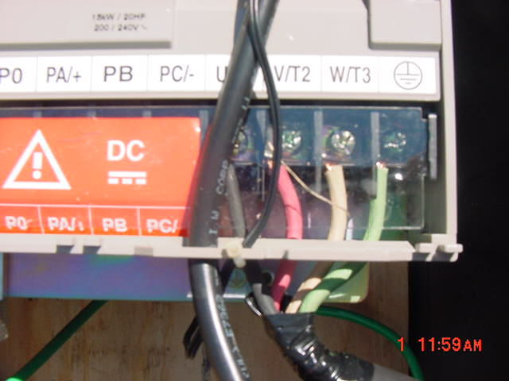
U/T1 Black Wire to Motor
W/T2 Red Wire to Motor
W/T3 White Wire to Motor
Green Wire - Ground to Motor

Figure D VFD Outgoing 240V Three Phase and
External Grounding Connection

- Ensure that wires are tightened securely to lugs.
- Use wiring convention BOYG, Black, Orange (Red), Yellow (White) and Green
- If different wiring convention is used in field motor will run backwards.
- Reverse leads at motor connections, not at VFD, to achieve proper motor rotation.
- Make sure that Single Phase Generator is properly sized to handle load. (See FRWA Guidelines for Generator Selection.) If Generator is undersized a fault will occur shutting down the VFD.

LOCATION: TOP RIGHT VFD

LOCATION: RIGHT BOTTOM OF VFD

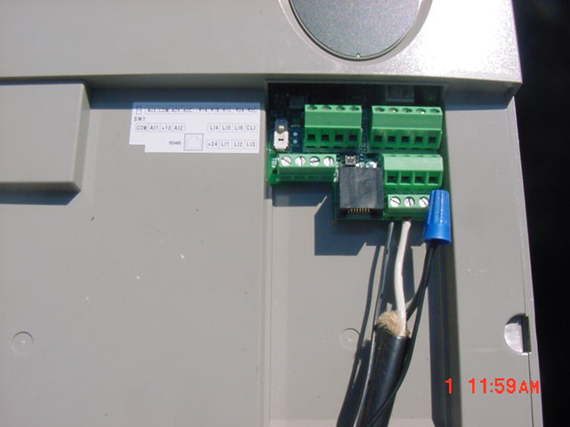
Note: Start command is initiated to VFD when 24 volts is supplied to Logical Inputs. In direct control (on-off) applications, 24 volts applied to
Logical Input 1 (L l1) initiates start command. (Right of 24V connection)
Black Wire- 24V Control Connection to “in” side of switch (see diagram)
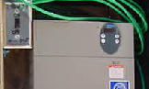
24V “On” Left
Terminal
VFD
White Connection – 24V Return from energized (on position) to L l1 from switch. (see diagram)
Black Wire

White Wire

Inset: Showing Control Switch VFD Control Wiring Connections

Figure E Control Connections Initiating “Run” Command to VFD

To initiate Run Command to the VFD, a switch mounted on the left side of the VFD cabinet is closed. A 24V signal travels from the VFD from the left terminal marked “24V” on the VFD, to a terminal marked L l1 on the VFD. The 24V signal initiates the “Run” command to the VFD.

VFD will not run unless connected to a load as shown in Figure 3 above.

