
FLORIDA RURAL WATER ASSOCIATION
2970 Wellington Circle • Tallahassee, FL 32309-6885
Telephone: 850-668-2746 ~ Fax: 850-893-4581

FRWA Whitepaper

Hydrogen Peroxide Oxidation for Disinfection By-Products
By Sterling L. Carroll, P.E., FRWA State Engineer

Hydrogen Peroxide (H₂O₂) is chemically water (H₂O) with an additional oxygen molecule. Unlike chlorine, hydrogen peroxide produces no harmful chlorination byproducts. During the reaction the oxygen molecule is liberated and chemically oxidizes (reduces) impurities in the raw water. These impurities include iron, sulfur, organics, tannins, color, odor, taste, etc. As a result hydrogen peroxide is a pre-oxidant for disinfection by-product precursors.

The typical hydrogen peroxide system consists of a chemical injection pump, solution tank, inline static mixer, and a backwashing filter to remove the oxidized iron, sulfur, tannins, etc. The filter is necessary to remove the precipitated elements after hydrogen peroxide treatment, as most of the oxidized particles are very fine. Activated carbon is a common the filter medium of choice.

Hydrogen Peroxide is uncommon in Florida. Use of hydrogen peroxide as an oxidant or pre-oxidant is fairly uncommon in Florida -- only three (3) Florida drinking water systems are using H₂O₂. It is used more commonly in wastewater collection systems to control hydrogen sulfide and odors.

- River Grove Mobile Home Village in Indian River County (PWS: 3054057)]
- Southwest Interconnect operated by Volusia County Utilities (PWS 3641336)
- Okeechobee Youth Development Center (PWS 4470472)

FRWA designed the Hydrogen Peroxide system for Okeechobee Youth Development Center, see results attached. The system included: liquid hydrogen peroxide (30% H₂O₂), multi-media filters, greatly lowered water age, lower chlorine feed rates, poly/orthophosphate, and chloramines. Please note the reduction in DBPs using a combination of best available technology and treatment changes. TTHMs dropped from 220 µg/L to 18 µg/L and HAA5s dropped from 70 µg/L to 10 µg/L.

We're thinking that we might stop the ammonia in six months if the DBPs remain as low as it is now. The system startup was Jan 12, 2013 -- so the jury is still out, but we are confident that this option is effective, inexpensive, and should have greater utility around Florida.

River Grove Mobile Home Village has been using H₂O₂ for about 3-years to reduce H2S, Fe & DBPs with mixed success. They have had dirty filters (lack of maintenance) and problems with maintaining a chlorine residual because of over feeding H₂O₂. I visited system April & August 2012. The system initially saw a reduction in chlorine demand to less that 20% of its original dose with a comparable disinfection by-product reduction of 80%.

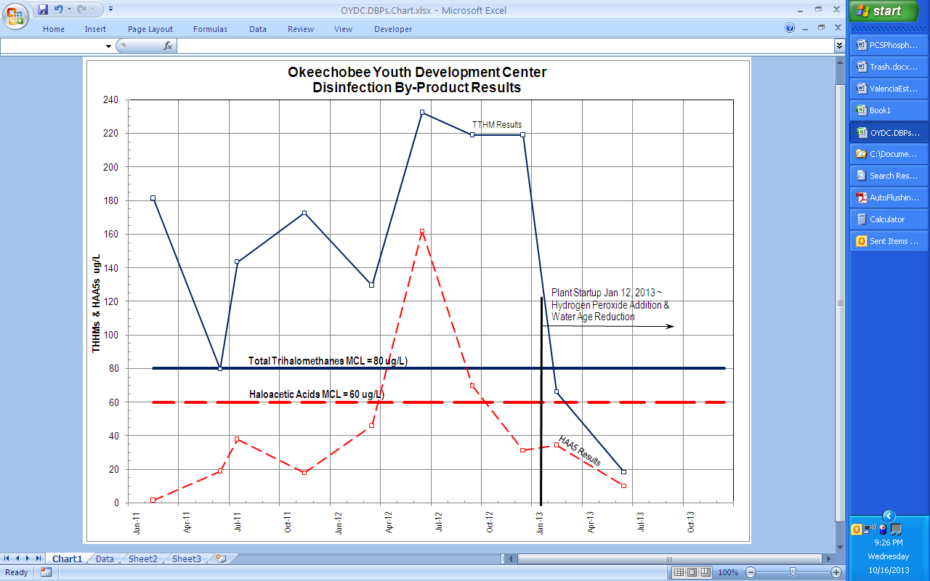

Figure 1 ~ Disinfection By-Product Reduction using Hydrogen Peroxide & Chloramination
Okeechobee Youth Development Center

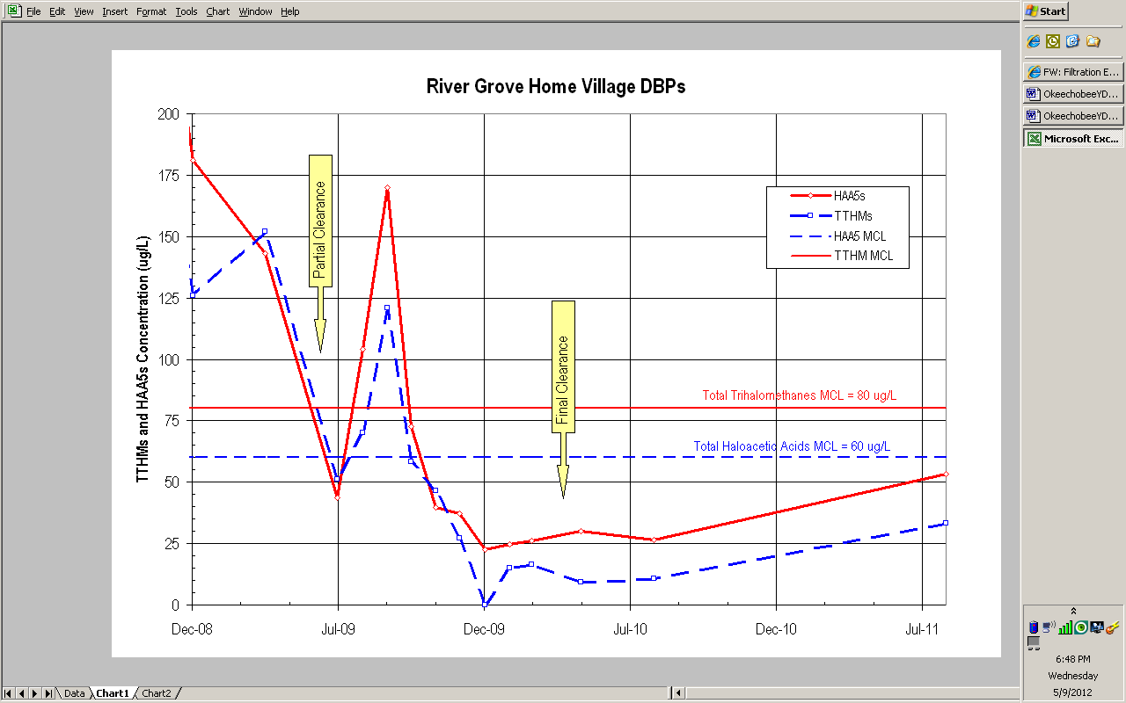

Figure 2 ~ Disinfection By-Product Reduction using Hydrogen Peroxide
River Grove Mobile Home Village
Partial Certification was granted June 2009, Final Certification April 2010
Hydrogen peroxide is a de-chlorinating agent so dosing of H₂O₂ must be carefully controlled or the system will have problems with maintaining a chlorine residual. The particulates formed by H₂O₂ are very small and tend to pass through most filters. If these are not completely removed the particles can collect in the distribution system, hot water heaters, and other quiescent zones -- in the presence of sulfur bacteria H₂S can be formed customers can experience black water or odor problems. Iron bacteria can cause grey or red water problems in the system.

In a July 2010 Florida Water Resources Journal article entitled “Innovative Hydrogen Sulfide Treatment Methods: Moving Beyond Packed Tower Aeration” several options were discussed -- including hydrogen peroxide.

“For conversion of hydrogen sulfide to sulfate using hydrogen peroxide oxidation, a stoichiometric ratio of 4.0 to 1.0 is required for water having a pH greater than 8.0 units, but the treatment method has not been demonstrated effectively for treatment of hydrogen sulfide in groundwater. Approximately 12.4 mg/L of potassium permanganate is required to oxidize 1.0 mg/L of hydrogen sulfide. Both peroxide and permanganate have been shown to provide complete removal of sulfide but yield both sulfate and colloidal sulfur as reaction products (Dohnalek 1983).” [emphasis added]

In the article the stoichiometric ratio hydrogen peroxide dose for the oxidation of sulfide is 0.25 mg H₂O₂ / mg H₂S for water having a pH greater than 8.0 units. According to MWH “Water Treatment Principles and Design” the required hydrogen peroxide dose for the oxidation of sulfide is 1.0 mg H₂O₂ / mg H₂S. The higher dose tends to match what we found in jar tests and we will use this value for our calculations, see section 6.

We assume that the intention of the comment “hydrogen peroxide oxidation… has not been demonstrated effectively for treatment of hydrogen sulfide in groundwater,” is to urge for more research and experimentation, not to rule out peroxide as a viable option. While it may be undemanding on the designer to choose a treatment scheme based on frequency of use or even relative popularity this is not a reason to exclude unusual methods from consideration.

It still remains important to demonstrate the peroxide treatment scheme’s effectiveness to each raw water application. Chemistries of raw waters vary from source to source. Water treatment chemistries and reactions are complex. As a consequence jar testing and chemical analysis of the raw water are essential to the decision making process. Selecting an appropriate treatment scheme must include all of these factors.

Potential problems with sulfate and colloidal sulfur byproducts from hydrogen peroxide treatment are somewhat overstated in the article. Firstly the amount of colloidal sulfur produced is minimal (only a fraction of a pound per day) that is easily removed by filtration. During the jar test the amount and size of particulates were such that most customers might not notice them (if they were not removed by filtration). Secondly the increased sulfate levels are so low as to be negligible. The secondary drinking water standard maximum contaminate levels for sulfate level is 250 mg/L -- a mere 2.83 mg/L increase over background levels cannot be significant.

The Florida Water Resources Journal article evaluates the advantage and disadvantages of hydrogen peroxide as well as other treatment schemes.

Treatment by Hydrogen Peroxide
Advantages | Disadvantages
- Controllable process  - Inexpensive capital installation  - Inexpensive chemical cost | - Optimum mixing and long reaction / contact times  - Incomplete oxidation  - Large dosages needed  - Turbidity – requires filtration

The four listed disadvantages are not a ringing endorsement for hydrogen peroxide use.

We agree with the first two listed disadvantages.

First, the reaction / contact time is in the range of 20 to 30 minutes.

Second, oxidation is dependent on pH, the higher the pH the better oxidation result. There is a strong relationship between pH and the three species of sulfur (hydrogen sulfide gas [H2S], bisulfide [HS1-], and elemental sulfur [S2]). The pH of the raw water is a vital factor in the treatment of raw water. At the neutral pH of 7.0 half of the dissolved sulfide species is hydrogen sulfide (gas) and the other half is bisulfide – typical for most of Florida’s ground waters. So removal by peroxide is dependent on pH, see Figure 3.

The third and forth listed disadvantages did not hold up to recent jar testing.
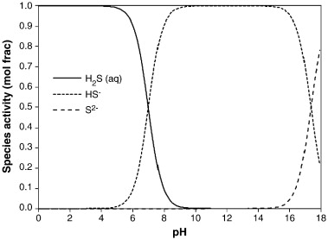
7
7.49
Figure 3 ~ Sulfide Species Distribution Diagram ²⁶
Third, peroxide dosage was low -- less than 5 mg/L.

Fourth, the resulting turbidity was lower; even considering the formation of micro-bubbles produced by the peroxide reaction.

Theory of Sulfide Removal using Hydrogen Peroxide.

According to MHW “Water Treatment Principles and Design” the required hydrogen peroxide dose for the oxidation of sulfide is 1.0 mg H₂O₂ / mg H₂S and the required hydrogen peroxide dose for the oxidation of iron is 0.30 mg H₂O₂ / mg Fe²⁺. The reaction between sulfides and hydrogen peroxide depends greatly on the pH and temperature of the raw water. The raw water is slightly alkaline, well buffered, pH is 7.6, and will tend to calcify.

The redox reactions are as follows:

H₂S + H₂O₂ ➔ S₀ + 2 H₂O

2 Fe²⁺ + H₂O₂ + 2H⁺ ➔ 2 Fe³⁺ + 2 H₂O

The H₂O₂ Dosage Rates are estimated as follows.

H₂O₂ Dose for H₂S = | 1.5 mg/L Sulfide x 1.0 mg H₂O₂ | = 1.5 mg/L H₂O₂
H₂O₂ Dose for H₂S = | mg H₂S | = 1.5 mg/L H₂O₂

H₂O₂ Dose for Fe²⁺ = | 0.62 mg/L Fe²⁺ x 0.3 mg H₂O₂ | = 0.186 mg/L H₂O₂
H₂O₂ Dose for Fe²⁺ = | mg Fe²⁺ | = 0.186 mg/L H₂O₂

So: H₂O₂ Dose for H₂S + Fe²⁺ = 1.69 mg/L H₂O₂

To account for the oxidation effects of other constituents in the raw water the hydrogen peroxide dose should be increased by 50% until field conditions, ORP meter jar tests, or operations shows a lower dose is appropriate.

For this application we started with a 30% H₂O₂ dose between 3 to 4 mg/L H₂O₂

Monitoring of Hydrogen Peroxide.

Standard Methods does not list procedures for measuring hydrogen peroxide. USEPA suggests several methods for hydrogen peroxide analysis including: titration methods; colorimetric methods; and horseradish peroxidase methods – each with limited working range, varying accuracy and precision, operator skill level required, and possible interferences.

The Brenntag representative recommended the use of an ORP meter to measure oxidation-reduction potential. This would directly notify us when the oxidation process is complete during jar tests. The ORP millivolt reading of plus 400 MV demonstrates a true oxidant reaction. The literature states that the estimated reaction time for hydrogen peroxide to convert sulfide to elemental sulfur is in the range of 20 to 30 minutes and we’ll try to provide for this reaction / contact time within the water treatment plant. Since the resulting solids are almost negligible and will be filtered prior to the point of entry filtering and reaction time is not a primary design concern (as will be demonstrated by the jar tests).

FRWA recommends the use of a Field Test Kit for measuring H2O2 residuals sold by LaMotte, Hach, or CHEMetrics.

Sample Hydrogen Peroxide Feed Rate Calculations.
Calculate monthly hydrogen peroxide usage and storage needs assuming the Hydrogen Peroxide feed rate is approximately 4.0 mg/L H2O2. The hydrogen peroxide feed is proportional to raw water flow.
Given:
- Average Daily Demand (ADD) 50 gpm = 71,830 gpd
- Maximum Daily Demand (MDD) 181 gpm = 260,850 gpd
- Well Pump Capacity @ 50 psi 250 gpm = 360,000 gpd
Feed Rate = ADD _{MGD} x Hydrogen Peroxide _{ppm} x Conversion Factor =
- Average Daily Demand (ADD) = 71,830 gpd = 0.0718 MGD
- 0.0718 MGD x 4.0 ppm x 8.34 lbs/gal = 2.40 lbs / day of H₂O₂
- Given: 30% H₂O₂ Solution (by weight) from Brenntag = 2.50 lb H₂O₂ / gallon
ADD H₂O₂ Usage = | 2.40 lbs / day of H₂O₂ | = 0.96 gpd H₂O₂ Solution
ADD H₂O₂ Usage = | 2.50 lb H₂O₂ / gallon | = 0.96 gpd H₂O₂ Solution
- However the actual dosage will have to be adjusted to account for oxidation of color, total organic carbon, and other oxidizable species in the raw water.
- 30 day storage of 30% Hydrogen Peroxide = 29 gallons per month.
- 55 gallon drums cost about $232.50/drum (or $4.23 / gal). Deliveries come at 2 to 4 drums at a time. The estimated cost for peroxide is approximately $121.82 per month.
- 55-gallon drum provides about 2 months storage.
Calculate Feed Rates for Well Pump Capacity:
- Assuming well pump runs all day to obtain feed pump setting
- Feed Rate = WellPump _{MGD} x Hydrogen Peroxide _{ppm} x Conversion Factor
- Feed Rate = 0.360 MGD x 4 mg/L x 8.34 lbs/gal = 12.0 lbs/day of H₂O₂
H₂O₂ Usage = | 12.0 lbs / day of H₂O₂ | = 4.80 gpd H₂O₂ Solution
H₂O₂ Usage = | 2.50 lb H₂O₂ / gallon | = 4.80 gpd H₂O₂ Solution
Initial Feed Pump Setting
- System will furnish and install a positive displacement, peristaltic-metering pump for chemical feed
- Stenner Chemical Feed Pumps Model:
45MHP2 = 3 gpd @ 100 psi
45MHP10 = 10 gpd @ 100 psi ⬅Use this pump
45MHP22 = 22 gpd @ 100 psi
Feed Pump Setting (%) = | 4.80 gpd of H₂O₂ Solution | = 48% Pump Setting
Feed Pump Setting (%) = | 10 gpd Stenner Pump | = 48% Pump Setting
Hydrogen Peroxide Installation includes (1) 45MHP10 = 10 gpd with 55-gal Drum of 30% Hydrogen Peroxide. Approximately $1,500 for initial installation.

EPA (1999), Alternative Disinfectants and Oxidants Guidance Manual, Doc No. 815-R-99-014]
During the third quarter of 2013 the operator ran out of hydrogen peroxide and ammonia the resulting DBPs were TTHMs 102 µg/L and HAA5s 52 µg/L.
Duranceau, S.J., Trupiano, V.M., Lowenstine, M. Whidden, S., and Hopp, J. (July 2010) “Innovative Hydrogen Sulfide Treatment Methods: Moving Beyond Packed Tower Aeration.” Florida Water Resources Journal, pp. 4-12
ibid. p.12
MWH, Crittenden, J., Trussell, R., Hand, D., Howe, K., and Tchobanoglous, G. (2005) Water Treatment: Principles and Design, 2nd Edition, John Wiley & Sons, New York. pp. 552-553.
Duranceau, et. al. p.10
Sawyer, et. al. Parkin, G.F. (2003) Chemistry for Environmental Engineering and Science, 5th Edition, McGraw-Hill, New York, pp. 476-481
MWH, Crittenden, J., Trussell, R., Hand, D., Howe, K., and Tchobanoglous, G. (2005) Water Treatment: Principles and Design, 2nd Edition, John Wiley & Sons, New York. pp. 552-553.
APHA, AWWA, WEF. (1995). "Standard Methods for the Examination of Water and Wastewater" (Standard Methods), 19th edition, Washington, DC. Franson, et. Al. (editors). APHA (American Public Health Association), AWWA, and Water Environment Federation
USEPA. (1999). Alternative Disinfectants and Oxidants Guidance Manual. p. 7-10.

