### **FLORIDA RURAL WATER ASSOCIATION**

2970 Wellington Circle • Tallahassee, FL 32309-6885

Telephone: 850-668-2746 ~ Fax: 850-893-4581



**Recommended Treatment Techniques**

**for Controlling Disinfection By-Products**

We recommend these treatment techniques to small & medium sizedwater systems for controlling / reducing the formation of disinfection by-products (DBPs). The best actions and treatment techniques are have been included and systematized into a stepwise approach -- starting with the most effective steps and lowest cost alternatives. It is hoped that systems might avoid common pitfalls, expensive engineering studies, and benefit from FRWA experience.

First, it is vital to understand how disinfection by-products are formed so the operator understands why these recommendations are effective. The formation of total trihalomethanes (TTHMs) and haloacetic acids (HAA5s) is a function of many factors. All organic DBPs are formed by the reaction between organic substances, inorganic compounds such as bromide, and oxidizing agents that are added to water during treatment (e.g., chlorine). The table below is a brief summary of those factors that affect the formation of disinfection by-products in water treatment processes and distribution systems.

**Factors Affecting DBP Formation & Possible Options**[1]

|  |  |  |  |
| --- | --- | --- | --- |
| **Factors** | **Affects** | **Controllable?** | **Possible Actions** |
| **Time** | * Higher water age 🡪 higher DBPs | **Yes** | * Lower residence time in tanks[2] * Install automatic flushing devices |
| **Temperature** | * Higher temps 🡪 higher DBPs | No | N/A |
| **pH** | * Higher pH 🡪 higher TTHMs * Lower pH 🡪 higher HAA5s | Marginally Yes | * Lower pH only if TTHMs are high and HAA5s are low |
| **Water Quality** | * Poor water quality 🡪 higher chlorine demand 🡪higher DBPs * Higher Organics 🡪 higher DBPs | **Yes** | * Remove impurities / TOC with treatment * Oxidize TOCs, Fe & H2S |
| **Disinfectants** | * More free chlorine available for reactions 🡪 higher DBPs | **Yes** | * Lower chlorine feed * Use alternative preoxidant in WTP and move chlorine injection near point of entry * Recommend AGAINST using chloramines |

**Begin with these proven actions to control and reduce DBPs:**

* Clean and flush tanks / distribution system,

**Where to start**

* Lower water age in the tanks / distribution system,
* Lower chlorine feed and minimize chlorine contact time, and
* Treat to improve water quality (remove or oxidize impurities).

**Aggressive Cleaning, Flushing & Chlorine Reduction Program**

Many systems could make higher quality water if they were operated with cleaner tanks and water mains. Positive results have been repeatedly demonstrated with this aggressive cleaning, flushing and chlorine reduction program. When systems actually implement the program there is an expected 30% reduction in TTHMs & HAA5s – often enough to bring the system back into compliance. Several systems reduced disinfection by-products by as much as two-thirds.

| **Steps** | **Recommended Action** | **Description of Recommended Actions** |
| --- | --- | --- |
| **1** | **Aggressive Tank Cleaning Program**[3] | It is essential to remove any and ALL accumulated sludge, biogrowth, sediment, and biological matter from tanks in order to improve water quality and lower chlorine demand and feed rates. |
| **2** | **Systematic Water System Flushing & Cleaning[4]** | Start a systematic and regular water main flushing program to remove biofilm and deposits in the distribution system. Begin at the water plant / source and move out to system extremities. Consider unidirectional flushing in problem areas. It is better and different than conventional flushing. It employs targeted and high-velocity water flow (2 - 6 feet per second) to scour the mains. |
| **3** | **Reduce Water Age**[5] **& Install Automatic Flushing Devices** | Increase tank turnover rate to every 72-hrs – turnover at least one-third of the tank volume daily. Liberally install automatic flushing devices at water system extremities. The operational goal is to lower residence age. The valves can be set to run 3 or more times a week at night for 15-30 minutes. Although it is not always practical, try to keep water age to 2 to 3-days in the water system. Systems may purchase commercially available devices for $2,500 or construct their own for under $500, design is attached. |
| **4** | **Minimize Chlorine Contact Time in the WTP** | Move the chlorine feed point in the water plant closer toward the point of entry. Substitute chlorine feed in other points in the water plant with an alternative pre-oxidant to lower total chlorine dosage.[6] |
| **5** | **Reduce Total Disinfection Dosage** | Reduce total chlorine dosage, but maintain minimum free residual. We recommend chlorine booster station for systems with large services areas. This allows chlorine dose reduction at the water plant, in the overall system, and fewer DBPs formed. |
| **The first five steps must be completed before results should be expected. In other words, if chlorine feed isn’t (or can’t be) lowered don’t expect positive results!** | | |
| **6** | **Install Treatment to Improve Water Quality** | If the first five steps don’t work for your system then treatment may be needed to improve water quality and remove disinfection by-product precursors. Recommended treatment technologies are expanded herein. |

The five-step aggressive cleaning, flushing and chlorine reduction program is a mitigation technique to reduce the amount of disinfection by-products formed in the water system. It also manages the remaining DBP formation potential and total organic carbon interaction with chlorine. Warmer temperatures contribute to biofilm regrowth in drinking water distribution systems and water storage facilities. Chlorine residuals are kept higher to manage regrowth, but increase DBP formation. It’s common for chlorine levels to be kept artificially high due to operator convenience, to avoid low residuals / bacteriological hits, and for a margin of safety.

**Step 6 ~ Install Treatment to Improve Water Quality**

Recommended Treatment Techniques

for Oxidizing or Removing Disinfection By-Product Precursors

**Follow the money.** Solutions used for larger systems do not always work for smaller systems -- scaled down technologies are not as cost effective nor workable. Smaller water systems may be of little interest to the engineering design consultant as there may be few financial rewards for working with these systems; nevertheless unique approaches are needed. These less known innovative solutions for medium /small systems are being played out that are of interest for all drinking water professionals.

If you hire an engineer it is likely that they will start with Step 6. Don’t let your consultant jump to treatment. Whatever you do, don’t skip the first five steps and miss out very effective operational changes, improved water quality, and lower DBP formation.

Engineering firms don’t get a lot of fees for helping you with operational fine-tuning. Firstly they may not understand those issues and secondly the profit motive is low. So it is easy to understand why consultants tend to focus on larger construction projects.

**There is NO Silver Bullet.** Medium and small water systems are hard pressed to conduct their own research and hire experienced design professionals to wade through the myriad of choices. FRWA has performed the research and fieldwork to isolate the best treatment techniques (TTs) for oxidizing or removing disinfection by-product precursors. FRWA has eliminated options that don’t make sense for most medium and small systems.

Treatment techniques are ranked according to installation cost, ease of operation, and effectiveness. Installed cost and operator skill metrics are provided as a general guidance in your decision-making process for selecting a treatment technique best for your system. Some treatment techniques have been intentionally excluded from the recommendations for a variety of reasons, some which tend to be much too expensive to install or complex to operate.

There is still work to do. Water professionals must choose the best treatment options for their own system. Each system and raw water is unique – solutions for each system will be unique and tailored for its distinctive circumstances.

**Installed Costs & Operator Attention Scale**

|  |  |  |
| --- | --- | --- |
| **Scale** | **Installed Costs** | **Operator Attention** |
| **1** | Low cost / easy to install - often under $5,000 for a small system | Low attention & ease of operation |
| **2** | Affordable cost / easy to install | Periodic attention & operator expertise needed |
| **3** | Moderate cost | Regular / close monitoring & fine-tuning |
| **4** | High cost | Involved monitoring & treatment adjustments |
| **5** | Expensive – often $15 to $20 per gal capital cost | Complex chemistries, controls & attention |

Installed costs are rated 1 through 5 – a rating of 1 equates to low costs (under $5,000 for a small system), while reverse osmosis which has a complex arrangement of chemical feed and controls is rated 5 for high costs.

Most treatment schemes have a degree of automatic control to limit the amount of operator attention. Operator attention for each technologies is rated based from 1 through 5 on the complexity of the method -- a simple system with few mechanical elements, is rated 1 for low attention, while reverse osmosis which has a complex arrangement of chemical feed and controls, is rated 5 for high attention.

**Summary of FRWA Recommended Treatment Techniques**

| **RANK** | **Recommended Treatment Technique for DBPs** | **Installed Costs** | **Operator Attention** | **General Comments** |
| --- | --- | --- | --- | --- |
| **1** | **Aeration** | - - - | - - - | Includes cascade trays, forced draft towers, bubble diffusers, spray, or air induction. Little operator skill is needed. |
| **1A** | **Cascade Tray Aerators** | **2** | **1** | Requires a storage tank and high service pumps. Trays must be cleaned regularly. |
| **1B** | **Air Stripping Towers** (Packed Tower Aeration) | **3 to 4** | **2** | More effective and much more expensive than tray aerators. Regular / annual cleaning of the plastic packing material with a citric acid is required to remove deposits. |
| **1C** | **Venturi Induction with air filter** | **1** | **1** | Air entrainment system for systems without aerators - less effective / expensive. Requires a storage tank and high service pumps. |
| **2** | **Chemical Oxidation** | - - - | - - - | Includes ozone, chlorine dioxide, permanganate, or hydrogen peroxide |
| **2A** | **Hydrogen Peroxide**  (H2O2) | **1** | **1 to 2** | H2O2is inexpensive and easy to install – feed pump and drum. Jar testing is a MUST to determine effectiveness. Requires adequate contact time before chlorination. H2O2 is an alternative oxidant that can be substituted for chlorine at the aerator or pre-oxidation. H2O2 must be used up before chlorination as H2O2 is a dechlorinating agent. Watch for the Tyndall effect. |
| **2B** | **Sodium Permanganate with Greensand Filtration** (NaMnO4solution) | **3** | **2** | NaMnO4is moderately expensive to install and much easier to use than KMnO4. NaMnO4is suspended in a brine solution and is fed neat. NaMnO4chemical costsforare more expensive. Can be overfed turning water pink or purple.  Both permanganates must be followed by 15 to 20 minute reaction / mixing / contact zones then greensand filters. The greensand media pulls any remaining soluble Fe and Mn from solution by ion exchange properties. Periodic backwashing to remove the Fe and Mn is required. |
| **2C** | **Potassium Permanganate** **with Greensand Filtration**  (KMnO4 solid granules) | **3 to 4** | **3** | KMnO4is moderately expensive and is followed by rapid rate pressure filters. KMnO4is a strong oxidizer and should be carefully handled when preparing the feed solution. Granules must be dissolved. Can be overfed turning water pink or purple. See NaMnO4for greensand filter discussion. |
| **2D** | **Ozone** (O3) | **4** | **4** | Ozone capital costs are high and O&M relatively complex – power A bench scale pilot study is important. Ozone MUST be followed with GAC to remove organic molecules that pose a problem for regrowth in the distribution system. |
| **2E** | **Peroxone** (O3+ H2O2) | **4** | **4 to 5** | Peroxone is applied at points similar to ozone for oxidation. This advanced oxidation process generates highly reactive hydroxyl free radicals to oxidize various compounds in the water. MUST be followed with GAC. Peroxone is used for oxidation of taste and odor compounds, and oxidation of synthetic organic compounds (herbicides, pesticides, and VOCs). |

| **RANK** | **Recommended Treatment Technique for DBPs** | **Installed Costs** | **Operator Attention** | **General Comments** |
| --- | --- | --- | --- | --- |
| **3** | **Adsorption and Filtration** | |  |  |
| **3A** | **Granular Activated Carbon (GAC) Filters** | **3** | **4** | GAC absorption is an EPA recommended technology for DBP precursors. Design of filters includes using a min. empty bed contact time of 10 minutes (GAC10). Pilot studies are recommended to predict specific media life for each site and raw water characteristics. Prudent design dictates that the expected GAC life to last at least six months. The GAC regular replacement on is often costly. Monitoring TOC before and after filters can indicate when GAC is spent. Refilling GAC in filters requires specialized expertise to avoid media channeling. This TT also includes powdered activated carbon. |
| **3B** | **Biologically Active GAC Filters (BAC)** | **3** | **4** | Any GAC Filter following chemical oxidants (e.g. ozone, hydrogen peroxide) will become biologically active. GAC offers an excellent surface for biological activity. The rough surface provides numerous good places for attachment. Amount of organic carbon removed is far beyond that which can be removed by adsorption alone. |
| **3C** | **Biologically Active Slow Sand Filtration (BAF)** | **3** | **2** | Advantages of slow sand filtration include its low maintenance requirements (since it does not require backwashing and requires less frequent cleaning) and the fact that its efficiency does not depend on actions of the operator. However, slow sand filters do require time for the schmutzdecke to develop after each cleaning: during this “ripening period,” however, filter performance steadily improves. |
| **4** | **Anion Exchange** |  |  |  |
| **4A** | **Anion Exchange** | **3** | **2** | Strong base anion exchange resin is specially designed to remove tannins and naturally occurring organic matter. Pre-filtration is recommended if source water turbidity is >0.3 NTU. Contaminant breakthrough can be avoided by careful monitoring and by running several columns in series, keeping the most recently regenerated column last. Can include mixed beds with ion & anion resins in same vessel – also TT for arsenic, radon, & uranium removal. |
| **4B** | **MIEX Treatment** (Suspended Magnetic Anion Exchange) | **3 to 4** | **3 to 4** | MIEX® can specifically remove dissolved organic carbon (DOC) from natural water. MIEX has been successfully installed in a dozen Florida systems. The magnetic ion exchange resin has traditional anion exchange resin properties – is smaller and has a magnetic core. The resin is suspended in a stirred tank reactor with the raw water fed upwards. Resin is removed from the treatment stream to be recharged in a brine bath – producing only 20% brine as compared to ion exchange. Pre-filtration is recommended if source water turbidity is >0.3 NTU. |

| **RANK** | **Recommended Treatment Technique for DBPs** | **Installed Costs** | **Operator Attention** | **General Comments** |
| --- | --- | --- | --- | --- |
| **5** | **Corrosion Control & Sequestration** with Poly / Orthophosphates– 70% / 30% Blend | **1** | **1** | Phosphates are inexpensive and easy to install – feed pump and drum. Small water plants may choose to either sequestrate with polyphosphates or remove iron and manganese. Sequestration only works for Fe and Mn. If the water contains less than 1.0 mg/L iron and less than 0.3 mg/L manganese, using polyphosphates followed by chlorination can be an effective and inexpensive method for mitigating iron and manganese problems. Below these concentrations, the polyphosphates combine with the iron and manganese preventing them from being oxidized. Orthophosphates inhibit control corrosion in water distribution systems. Blended phosphates rely on hydrolysis to maintain orthophosphate residual in system – actual phosphate concentration will increase with time in system and build up a protective coating on pipe walls which tends to lower chlorine demand. **Expect a 10% reduction in DBPs.** Phosphates are added to groundwater at the well head or at the pump intake before the water has a chance to come in contact with air or chlorine. This ensures that the iron and manganese stays in a soluble form. No sludge is generated in this method. |
| **6** | **Enhanced Coagulation**  Conventional Water Treatment Involves coagulation, flocculation, and clarification followed by filtration | **4** | **3** | Enhanced coagulation is an applicable treatment technique ONLY if the source water is surface water or ground water under the direct influence (Subpart H system); and the utility uses conventional treatment (i.e., flocculation, coagulation or precipitative softening, sedimentation, and filtration). The coagulants effective for removing TOC include: Regular Grade Alum (Aluminum Sulfate) Al2[SO4]3*14H2O, reagent grade alum Al2[SO4]3*18H2O, Polyaluminum Chloride (PACl), cationic polymers, Ferric Chloride FeCl3*6H2O, Ferric Chloride FeCl3, Ferric Sulfate Fe2(SO4)3*9H2O, and Ferrous Sulfate FeSO4*7H2O. For TOC removal high coagulant doses requires significant coagulant doses. Required Treatment Technique for some systems once LT2SWTR Rule is in effect. |
| **7** | **Membrane Filtration**  includes Nanofiltration (NF) & Reverse Osmosis (RO) | **5** | **4** | Membrane processes are the most expensive to construct and operate. Requires chemical addition, pre-treatment acidification / conditioning, and post-treatment re-stabilization. Reject water has high TDS and must be carefully disposed using expensive measures such as deep well injection. |
| **8** | **Last Choice Option**  **Chloramines**  (monochloramine NH2Cl) | **1** | **2** | Chloramination is NOT RECOMMENDED. Although chloramines are inexpensive and easy to install (feed pump and drum) their by-products may be ultimately more health adverse and subject to future regulation. Chloramines have been shown to pose simultaneous compliance problems such as nitrification, biofilm regrowth and degraded water quality. Chloramine is a mixture of ammonia and chlorine, and is more persistent but less potent in distribution systems. Chloramine is generated onsite using Ammonium Hydroxide NH3 or Ammonium Sulfate (NH4)2SO4 (is preferred). Min allowed residual is 0.6 mg/L |

**Details of FRWA Recommended Treatment Techniques**

**Recommendation 1 ~ Aeration.**

**Includes Cascade Trays, Forced Draft Towers, Bubble Diffusers, Spray, or Air Induction.** Oxidation via aeration is frequently used for surface waters, sometimes groundwaters high in odors, iron and manganese. Contaminants are oxidized, such as iron and manganese, causing them to form solids, which can then be removed by filters. Aeration is relatively inexpensive and easy use. Aerators require frequent cleaning.

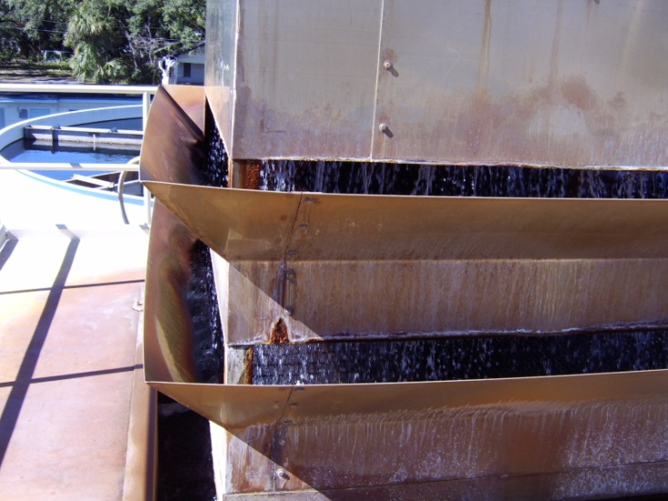**Recommendation 1A ~ Cascade Tray Aerators.**

Cascade aeration is accomplished by natural draft units that mix cascading water with air that is naturally inducted into the water flow. Raw water is pumped to the top of the aerator, and cascades over a series of trays. Air is naturally inducted into the water flow to accomplish iron oxidation and some reduction in dissolved gasses. Design of cascade tray aeration is dependent on aeration contact time, aeration transfer efficiency, and the nature of raw water.

Tray aerators can significantly reduce CO2, H2S, iron, manganese, color and odor in raw waters. Tray aerators are not as effective with oxidizing tannins.

Cascade aerators have no moving parts and are constructed of non-corroding materials – fiberglass, redwood, aluminum, or stainless steel.

**Installed Costs: 2.** Tray aerators cost as little as $15,000 and as much as $50,000. Installation requires a storage tank and high service pumps. Aerators are typically mounted on top of the storage tank.

**Operation and Maintenance Issues and Costs: 1.** Verylittle operator skill is needed. Regular removal of bioslime buildup on trays is required. The storage tank is in essence a reaction vessel where the oxidation process is completed and oxidized metals and organics can stabilize and settle. The storage tank must be cleaned regularly to reduce sludge / bioslime buildup and chlorine demands.

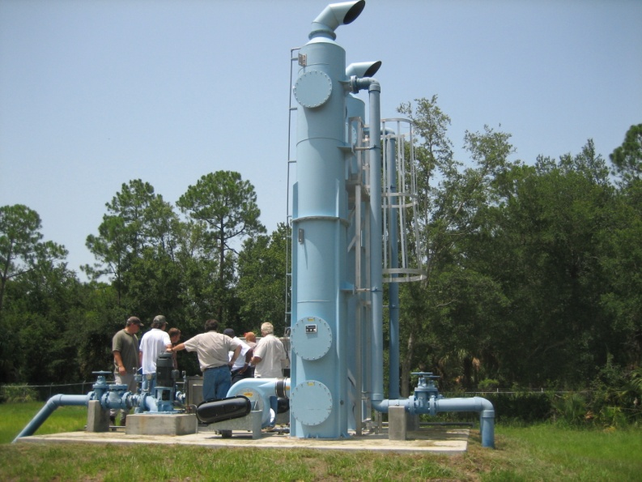**References:** MWH. (2005). pp. 1176-1182; USACE. (1999). p. 6-10

**Recommendation 1B ~ Air Stripping Towers** (Packed Tower Aeration - PTA).

Air strippers provide contact between air and water that encourage volatile material to move from the water to the air. A packed column air stripper consists of a cylindrical column that contains a water distribution system above engineered (structured or dumped) packing with an air distributor below.

Raw water is distributed at the top of the column and flows generally downward through the packing material. At the same time, air, introduced at the bottom of the column, flows upward through the packing (countercurrent flow). The packing provides an extended surface area and impedes the flow of both fluids, extending the contact and to increase the gas-liquid interface. As water and air contact, VOCs and H2S, move from the water to the air. Iron, manganese, color, CO2, and organics are also reduced by oxidation in the packed tower.

The VOCs transferred to the air exit the top of the column in the air stream. Off- gas (air) is released to the atmosphere or treated if necessary to meet emission limits. pH adjustment / acidification is often used to enhance H2S stripping.

**Installed Costs: 3.** Packed towers start at about $150,000

**Operation and Maintenance Issues and Costs: 2.** Packed towers are much more effective than tray aerators. Annual (or more frequent) cleaning of the plastic packing material with a potable acid solution is required to remove deposits.

**References:** MWH. (2005). pp. 1176-1182; USACE. (1999). p. 6-10, USACE. (2001).

**Recommendation 1C ~ Venturi Induction with Air Filter**

The simplest aeration system is air entrainment accomplished by induction venturi. This is a passive system that requires no outside power. It pulls air into the water line by means of an induction device called a Venturi. The Venturi (sometimes called a “Micronizer” or an educer) is installed in the water line to enhance a cascade tray, spray aerator, or alone. As water is forced through the venturi while the pump operates, air is sucked into the water line.

The improved the air-water ratios facilitate oxidation of impurities and DBP precursors. The main advantages of the Venturi system are its low cost, its economy of operation, and its simplicity. The main disadvantage is that the Venturi itself restricts water flow.

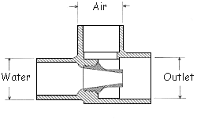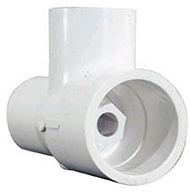

**Installed Costs: 1.** Construction is under $500 with a fabricated air filter.

**Operation and Maintenance Issues and Costs: 1.** Air filter needs periodic cleaning / replacement.

**References:** N/A

**Recommendation 2 ~ Chemical Oxidation.**

**Includes Ozone, Chlorine Dioxide, Permanganate, Hydrogen Peroxide, or UV Radiation.** Chemical oxidation improves the aesthetic characterizes and quality of most raw waters. Oxygen, chlorine and permanganate are the most frequently used oxidizing agents. Oxidation is used for many purposes to reduce taste, odor, color, iron, manganese, and natural organic materials, all are DBPs precursors. Chemical oxidation is relatively inexpensive and easy to perform. Chlorine is the most frequently used chemical oxidant in water treatment – but increases DBPs. For this reason alternative chemical oxidants are recommended.

**Recommendation 2A ~ Hydrogen Peroxide.**

Hydrogen peroxide (H2O2) is an alternative oxidant that can be substituted for chlorine for pre-oxidation or at the aerator. During the reaction the oxygen molecule is liberated and chemically oxidizes (reduces) impurities in the raw water, including iron, sulfur, organics, tannins, and TOC – all contribute to color, odor, and taste.

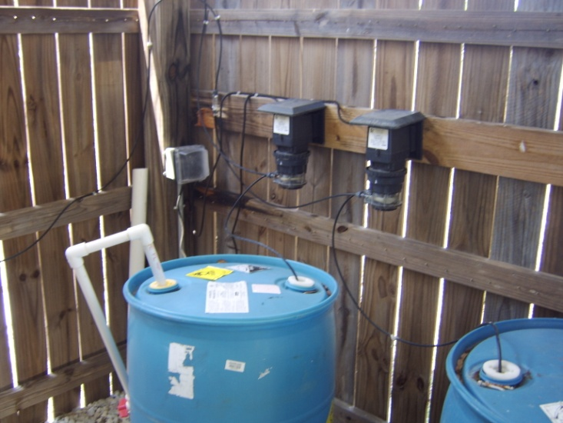Partial oxidation with H2O2 gives rise to lower molecular weight organics that are more easily biodegradable – food for the bioslime in water distribution systems. High TOC waters may require biological filtration, a systematic flushing program, and continual chlorine residual above 0.5 mg/L.

**Installed Costs: 1.** Peroxide is fed as a 30% to 35% solution with a chemical feed pump (peristaltic pumps required because of H2O2 off gassing. Cost starts under $1,000.

**Operation and Maintenance Issues and Costs: 1 to 2.** H2O2 is inexpensive and easy to install – chemical feed pump and drum. Dosing is determined by jar testing and pilot study. H2O2 costs marginally more than sodium hypochlorite to use. Do NOT overfeed as peroxide is a dechlorinating agent and reacts with other oxidants, such as chlorine, chlorine dioxide, and monochloramines.

**References:** USACE. (1999)., p. 6-13; USEPA. (1999a).

**Recommendation 2B~ Sodium Permanganate with Greensand Filtration (NaMnO4) solution**

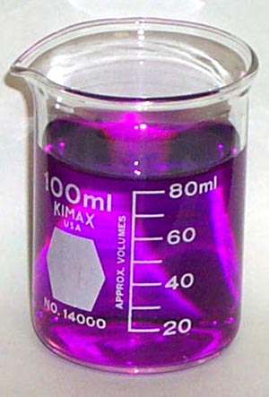NaMnO4 is 2 to 3 times more effective / reactive than KMnO4 -- can be used to oxidize organic precursors, iron, and manganese at the head of the treatment plant, thus minimizing the formation of DBPs at the downstream disinfection stage of the plant. No mixing required.

Very effective as a primary disinfectant to control DBP precursors, TOC, iron, manganese, color, odor, and taste. Not efficient for raw waters high in sulfides. Greensand is a naturally occurring mineral that consists largely of dark greenish grains of glauconite (green clay), and a natural ion exchange mineral capable of softening water and removing iron and manganese. Greensand filters follow KMnO4 / NaMnO4. The media pulls any remaining soluble Fe and Mn from solution by the ion exchange properties.

**Installed Costs: 3.** Capital cost for a permanganate and greensand filtersystem is high. Permanganate requires 20-minutes of contact and MUST be followed with filters.

**Operation and Maintenance Issues and Costs: 2 to 3.** O&M is somewhat complex. NaMnO4 is fed as a solution with a chemical feed pump. A bench scale pilot study on the raw water is important. Periodic backwashing of the media to remove the Fe and Mn is required. Sludge disposal is required. Can be overfed turning water pink or purple.

**References:** USEPA. (1999a). pp. 6-10; Carus Corp, www.caruscorporation.com

**Recommendation 2C ~ Potassium Permanganate with Greensand Filtration (KMnO4)**

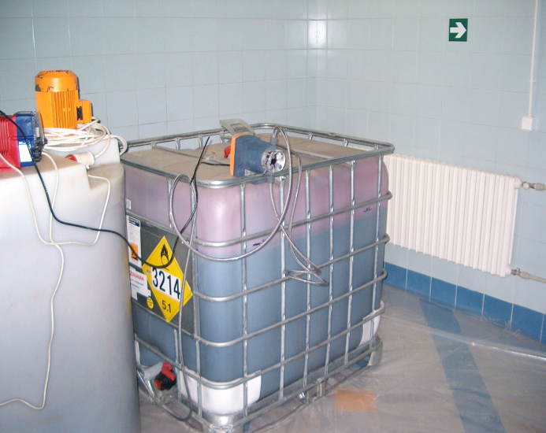NaMnO4 is 2 to 3 times more effective / reactive than KMnO4 -- can be used to oxidize organic precursors, iron, and manganese at the head of the treatment plant, thus minimizing the formation of DBPs at the downstream disinfection stage of the plant. See NaMnO4for greensand filter discussion.

**Installed Costs: 3.** Capital costs for a permanganate and greensand filtersystem is high. Permanganate requires 20-minutes of contact and MUST be followed with filters.

**Operation and Maintenance Issues and Costs: 3.** KMnO4 mixing is required, messy and problematic.O&M is somewhat complex. A bench scale pilot study on the raw water is important. Periodic backwashing of the media to remove the Fe and Mn is required. Sludge disposal is required. KMnO4 is more easily overfed turning water pink or purple.

**References:** USEPA. (1999a). pp. 5-1 – 5-12

**Recommendation 2D ~ Ozone (O3).**

Ozone is a most powerful oxidizing and disinfecting agent formed by passing dry air through a system of high voltage electrodes. Requiring shorter contact time and a smaller dosage than chlorine, ozone is widely used as a primary disinfectant. Ozone is often combined with peroxide to more completely oxidize organics.

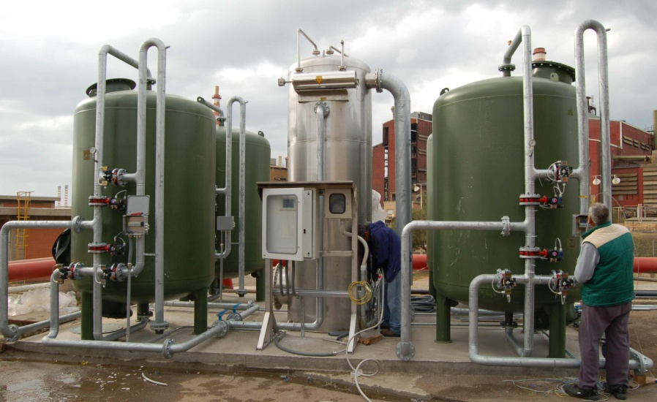Ozone eeduces DBP precursors, TOC, color, odor, and taste. Ozone does not directly produce halogenated organic materials unless a bromide ion is present. Partially oxidizes organics into biodegradable compounds that may need to be removed by biological filtration – food for the bioslime in water distribution systems.

**Installed Costs: 4.** Capital costs of ozonation systems are relatively high. Ozone requires a contact chamber and MUST be followed with GAC filters to remove organic molecules that pose a problem for regrowth in the distribution system.

**Operation and Maintenance Issues and Costs: 4.** O&M is relatively complex – with high power and GAC media replacement costs. A bench scale pilot study on the raw water is important.

**References:** USEPA. (1999A). pp. 3-1 – 3-43

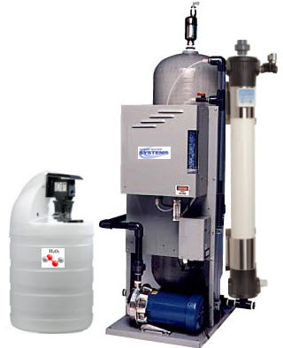**Recommendation 2E ~ Peroxone (Ozone/Hydrogen Peroxide).**

Advanced oxidation processes generate highly reactive hydroxyl free radicals to oxidize various compounds in the water. Peroxone is used for oxidation of taste and odor compounds, and oxidation of synthetic organic compounds (herbicides, pesticides, and VOCs). Several methods have been used to increase ozone decomposition and produce high concentrations of hydroxyl radicals. One of the most common of these processes involves adding hydrogen peroxide to ozonated water, a process commonly referred to as peroxone.

The two oxidation reactions compete for substrate (i.e., compounds to oxidize). The ratio of direct oxidation with molecular ozone is relatively slow compared to hydroxyl radical oxidation, but the concentration of ozone is relatively high. On the other hand, the hydroxyl radical reactions are very fast, but the concentration of hydroxyl radicals under normal ozonation conditions is relatively small. A key difference between the ozone and peroxone processes is that the ozone process relies heavily on the direct oxidation of aqueous ozone while peroxone relies primarily on oxidation with hydroxyl radical. In the peroxone process, the ozone residual is short lived because the added peroxide greatly accelerates the ozone decomposition.

However, the increased oxidation achieved by the hydroxyl radical greatly outweighs the reduction in direct ozone oxidation because the hydroxyl radical is much more reactive. The net result is that oxidation is more reactive and much faster in the peroxone process compared to the ozone molecular process. However, because an ozone residual is required for determining disinfection CT credit, peroxone may not be appropriate as a pre-disinfectant. The peroxone process utilizes oxidation by hydroxyl radicals. The oxidation potential of the hydroxyl radical and ozone are as follows:

**Installed Costs: 4.** Capital costs are similar to ozone.

**Operation and Maintenance Issues and Costs: 4 to 5.** Peroxone is applied at points similar to ozone for oxidation. Addition of ozone first and hydrogen peroxide second is the better way to operate -- MUST be followed with GAC.

**References:** USEPA. (1999a). pp. 7-1 – 7-16

**Recommendation 3 ~ Adsorption and Filtration.**

Filtration methods include **Slow and Rapid Sand Filtration, Diatomaceous Earth Filtration, Direct Filtration, Membrane Filtration, and Cartridge Filtration**. Federal and state laws require all surface water systems and systems under the influence of surface water to filter their water. Filtration alone does not reduce DBP precursors – **GAC Absorption, Biologically Active GAC, and Biologically Active Slow Sand Filtration** are the only devices that can effectively lower disinfection by-products.

**Recommendation 3A ~ Granular Activated Carbon (GAC) Filters**.

GAC absorption is an EPA recommended technology for DBP precursors. Design of filters includes using a min. empty bed contact time of 10 minutes (GAC10). Pilot studies are recommended to predict specific media life for each site and raw water characteristics. Prudent design dictates that the expected GAC life to last at least six months. The GAC regular replacement on is often costly. Monitoring TOC before and after filters can indicate when GAC is spent. Refilling GAC in filters requires specialized expertise to avoid media channeling. This TT also includes powdered activated carbon.

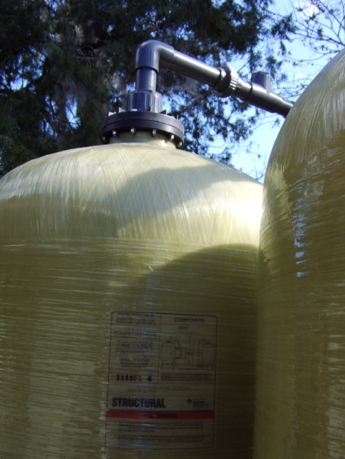GAC installations are expected to increase since they provide a passive, broad-spectrum barrier against many emerging contaminants, such as endocrine disrupting compounds. The list of organic contaminants targeted for removal continues to expand due to increasing sensitivity of analytical method at trace levels, advancing knowledge of adverse effects, and growing threats of deliberate contamination.

**Installed Costs: 3.** Capital costs for GAC Filters are high.

**Operation and Maintenance Issues and Costs: 4.** The GAC regular replacement on is often costly. Monitoring TOC before and after filters can indicate when GAC is spent. Refilling GAC in filters requires specialized expertise to avoid media channeling.

**References:** MWH. (2005). pp. 1309-1347; AWWA. (1999). pp. 13.16 - 13.62

**Recommendation 3B ~ Biologically Active GAC Filters (BAC)**

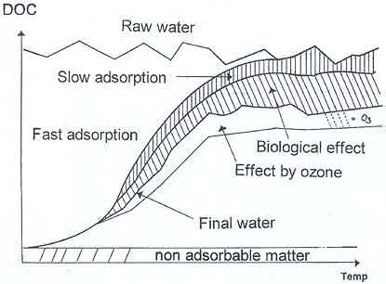Any GAC Filter following chemical oxidants (e.g. ozone, hydrogen peroxide) will become biologically active in 4 to 6 weeks – there is no need to “seed” the filters. GAC offers an excellent surface for biological activity. The rough surface provides numerous good places for attachment. Amount of organic carbon removed is far beyond that which can be removed by adsorption alone.

Biological activity is commonly expected to extend the lifetime of GAC filters now termed BAC filters. When contaminants are removed by BAC, two main parallel mechanisms are involved: adsorption due to the presence of adsorption sites on the activated carbon, and biodegradation due to microbial activity developing in the crevices of the media.

Biologically Active Filters are used downstream of ozone, perozone, or peroxide. Filter media may be GAC, anthracite, or sand, or some combination. TOC removals in the 20-70 percent range possible, dependent on the nature of the organics present, ozone: TOC dose, and filter contact time.

TOC removals in the 20-70 percent range possible, dependent on the nature of the organics present, ozone: TOC dose, and filter contact time. Also reduces NO3, Fe, Mn.

**Installed Costs: 3.** Same high capital costs as GAC Filters.

**Operation and Maintenance Issues and Costs: 2.** In addition to O&M for GAC, monitoring TOC before and after filters, replacing GAC, and biological monitoring.

A biological baseline must be established so that if changes in operations cause detrimental impacts to the filter, the impact can be assessed. Changes in biological parameters may not directly correlate to changes in removal of specific compounds of interest, but they have more subtle impacts/correlations such as relationships with resiliency during upset conditions or colder temperatures. The baseline should be developed over the period of at least one year to assess seasonal impacts on water quality and treatment efficacy.

This baseline should include one or more biological parameters (e.g., ATP or hydrolase activity on media and online LDO consumption across the filter), organic carbon parameters (e.g., TOC, DOC, AOC, and carboxylic acids), water quality parameters (e.g., turbidity, temperature, pH, nutrients and DBP formation potential), operational parameters (head loss accumulation rate and oxidant residual on top of the filter), and control parameters (e.g., pre-oxidant type(s) and dose(s), nutrients, and contact time).

**References:** USEPA. (1999a). pp. 3-19 – 3-20; 9-5 – 9-6

**Recommendation 3C ~ Biologically Active Slow Sand Filters**

Slow sand filters are simple, are easily used by small systems, and have been adapted to package plant construction. The schmutzdecke, the top-most, biologically active layer of filter, removes suspended organic materials and microorganisms by biodegradation and other processes, rather than relying solely on simple filter straining or physico-chemical sorption.

Slow sand filtration has demonstrated removal efficiencies in the 90 to 99.9999% range for viruses and greater than 99.99% for Giardia lamblia. Standard slow sand filtration expected to remove 5-25% of TOC.

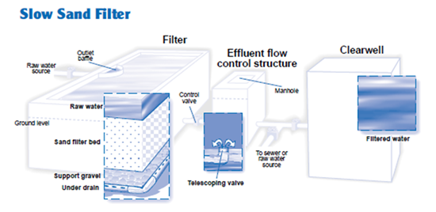

Biological filters remove contaminants by three main mechanisms: biodegradation, adsorption of micropollutants, and filtration of suspended solids. The microbial growth attached to the filter media (biofilm) consumes the organic matter that would otherwise flow through the treatment plant and ultimately into the distribution system. The end products are carbon dioxide, water, biomass, and simpler organic molecules. Particle filtration takes place on the bare filter media as well as the biofilm. In biofilters used for biological denitrification, nitrate is converted to nitrogen. In this case, microorganisms are fed a form of carbon, and they use nitrate as an electron acceptor in place of oxygen. Granular activated carbon (GAC) is often used to provide the necessary surface to promote the development of the biofilm.

**Installed Costs: 3.** Open bed filters are fairly expensive to install.

**Operation and Maintenance Issues and Costs: 2.** Advantages of slow sand filtration include its low maintenance requirements (since it does not require backwashing and requires less frequent cleaning) and the fact that its efficiency does not depend on actions of the operator. However, slow sand filters do require time for the schmutzdecke to develop after each cleaning: during this “ripening period,” however, filter performance steadily improves.

**References:** USEPA. (1999a). pp. 3-21; AwwaRF. (1993).

**Recommendation 4 ~ Anion Exchange**

A physical-chemical process in which ions are swapped between a solution phase and a solid resin phase. The solid resin adsorbs anions and releases chloride into the water. pH 6.5 to 9.0 is optimal.

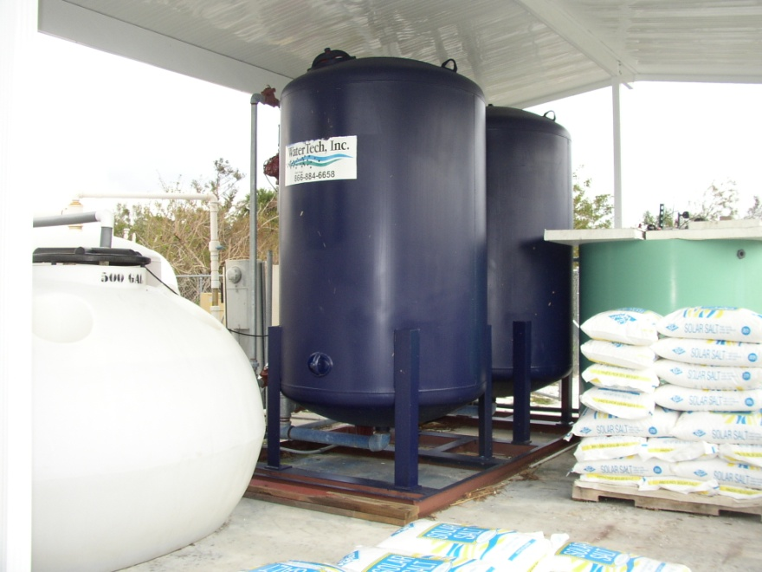**Recommendation 4A ~ Anion Exchange.**

Strong base anion exchange resin is specially designed to remove tannins and naturally occurring organic matter. Breakthrough can be avoided by careful monitoring and by running several columns in series, keeping the most recently regenerated column last. Can include mixed beds with ion & anion resins in same vessel.

Most of the color in raw water is weakly acidic and thus can be exchanged with basic functionality of the resin. The non-ionic constituents get adsorbed on the resin beads due to Van-Der-Waal’s attraction and because of the large surface area and macroporosity of the resin. The resin performs dual functions of chemical and physical adsorption of naturally occurring organic matter. The matter is stripped off by passing brine or alkaline brine solution through the resin.

**Installed Costs: 3.** Very effective to remove DBP precurors, TOC, iron, manganese, arsenic, nitrates, uranium, color, odor, and taste. Sulfates, nitrates, and other ions compete for adsorption sites.

**Operation and Maintenance Issues and Costs: 2.** Pre-filtration is recommended if source water turbidity is >0.3 NTU. Contaminant breakthrough can be avoided by careful monitoring and by running several columns in series, keeping the most recently regenerated column last. Brine disposal is a major concern.

**References:** AWWA. (1999). pp. 9.68 - 9.88

**Recommendation 4B ~ MIEX Treatment** (Suspended Magnetic Anion Exchange).

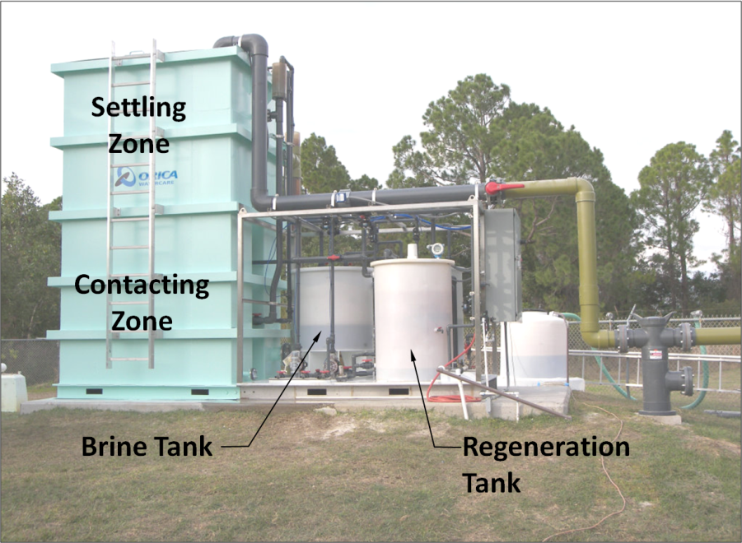MIEX® can specifically remove dissolved organic carbon (DOC) from natural water. This product has been installed in several Florida systems. The magnetic ion exchange resin has traditional ion exchange resin properties – is smaller and has a magnetic core. However, the resin is suspended in a stirred tank reactor and the raw water is fed upwards. Pre-filtration is recommended if source water turbidity is >0.3 NTU. Only 20% brine is produced as compared to ion exchange.

**Installed Costs: 3 to 4.** This is an excellent treatment scheme using anion resin coated over magnetic particles suspended in the water. Just introduced to Florida with high success rate from Australia mining industry.

**Operation and Maintenance Issues and Costs: 3 to 4.** Unique treatment scheme can be difficult to start up and adjust settings. Very effective to remove DBP precursors, TOC, iron, manganese, arsenic, nitrates, uranium, color, odor, and taste. Sulfates, nitrates, and other ions compete for adsorption sites.

**References:** USEPA. (2007a).; miexresin.com

**Recommendation 5 ~ Corrosion Control & Sequestration**

with Poly / Orthophosphates – 70% / 30% Blend

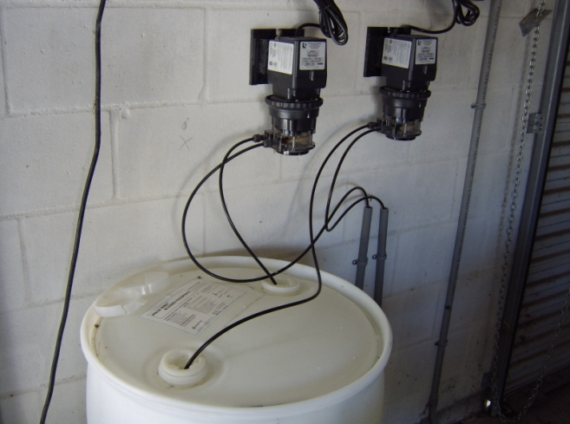Poly / Orthophosphates have been found to improve disinfection efficiency of free chlorine for biofilm bacteria in iron pipes. Polyphosphate is used as a sequestering agent that formed soluble complexes with metallic ions. Orthophosphate is used to control corrosion for the Lead and Copper Rule as a ‘best available technology’ (BAT) to minimize the leaching of lead from water lines and brass fixtures into the drinking water.

Phosphates are inexpensive and easy to install – feed pump and drum. Small water plants may choose to either sequestrate with polyphosphates or remove iron and manganese. Sequestration only works for Fe and Mn. If the water contains less than 1.0 mg/L iron and less than 0.3 mg/L manganese, using polyphosphates followed by chlorination can be an effective and inexpensive method for mitigating iron and manganese problems. Below these concentrations, the polyphosphates combine with the iron and manganese preventing them from being oxidized. Orthophosphates inhibit control corrosion in water distribution systems. Blended phosphates rely on hydrolysis to maintain orthophosphate residual in system – actual phosphate concentration will increase with time in system and build up a protective coating on pipe walls which tends to lower chlorine demand. Expect a 10% reduction in DBPs.

Phosphates are added to groundwater at the well head or at the pump intake before the water has a chance to come in contact with air or chlorine. This ensures that the iron and manganese stays in a soluble form. No sludge is generated in this method.

**Installed Costs: 1.** Simple installation uses a chemical feed pump and drum storage. Corrosion in a system can be reduced by adjusting pH and alkalinity, softening the water, and changing the level of dissolved oxygen. Expected DBP 10% reduction.

**Operation and Maintenance Issues and Costs: 1.** Any corrosion adjustment program should include monitoring as water characteristics change over time

**References:** USACE. (1999). p. 6-13 – 6-14

**Recommendation 6 ~ Enhanced Coagulation**

Conventional Water Treatment involves coagulation, flocculation, and clarification followed by filtration

Enhanced coagulation is an applicable treatment technique ONLY if the source water is surface water or ground water under the direct influence (Subpart H system); and the utility uses conventional treatment (i.e., flocculation, coagulation or precipitative softening, sedimentation, and filtration). Enhanced coagulation is the term used to define the process of obtaining improved removal of DBP precursors by conventional treatment. Enhanced softening refers to the process of obtaining improved removal of DBP precursors by precipitative softening.

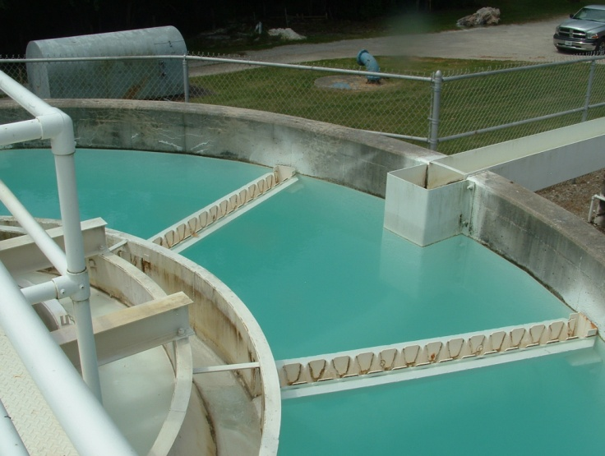Chemical coagulation and flocculation consists of adding a chemical coagulant combined with mechanical flocculation (rapid mix) to allow fine suspended and some dissolved solids to clump together (floc). Clarification allows the flocs to settle and then the water is filtered. The conventional chemical and physical treatment process removes suspended solids removal in surface waters – this includes turbidity, silt, odor, color and other particulates including bacteria. Routine check of chemical feed equipment is necessary several times during each work period to prevent clogging and equipment wear, and to ensure adequate chemical supply. Routine checks of contaminant buildup in the filter is required, as well as filter backwash. Recharging or clean installation of media is periodically required.

The coagulants effective for removing TOC include:

* Regular Grade Alum (Aluminum Sulfate) Al2[SO4]3*14H2O,
* Reagent Grade Alum Al2[SO4]3*18H2O,
* Polyaluminum Chloride (PACl), cationic polymers,
* Ferric Chloride FeCl3*6H2O,
* Ferric Chloride FeCl3,
* Ferric Sulfate Fe2(SO4)3*9H2O, and
* Ferrous Sulfate FeSO4*7H2O.

For TOC removal high coagulant doses requires significant coagulant doses. Required Treatment Technique for some systems once LT2SWTR Rule is in effect.

Alum (aluminum sulfate) is one of the most widely used coagulants in water treatment. Alum is commercially available in dry powder, granule, or lump form, and as a liquid. For small water plants, liquid alum is usually most practical. When alum is added to water, insoluble precipitates such as aluminum hydroxide AI(HO)3 are formed. Alum is used suspended solids removal in surface waters – this includes turbidity, silt, odor, color and other particulates including bacteria.

**Installed Costs: 4.** Suitable primarily for conventional surface water plants. Nature of source water organic material, treatment conditions (coagulation pH) and background alkalinity control effectiveness.

**Operation and Maintenance Issues and Costs: 3.** Requires significant coagulant doses. Required Treatment Technique for some systems once LT2SWTR Rule is in effect.

**References:** USEPA (1999b)., MWH. (2005). pp. 247-258; AWWA. (1999). 6.2 - 6.62

**Recommendation 7 ~ Membrane Filtration**

including Nanofiltration (NF) and Reverse Osmosis (RO)

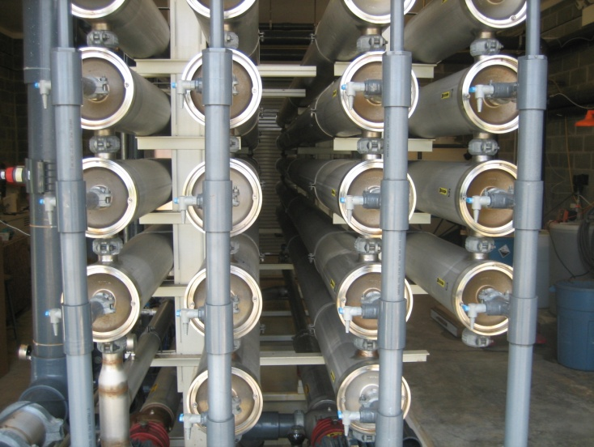Membrane Filtration is the process for separating larger size solutes from aqueous solutions by means of a semi-permeable membrane.

Membranes remove a high variety of contaminants depending on the membrane type – arsenic, fluoride, iron, calcium, manganese, nitrates, odor, color, DBP precursors, etc. More stringent water quality regulations and inadequate water resources are making membrane technology increasingly popular as an alternative treatment technology for drinking water. Membranes are some of the more expensive processes to install and operate. Post treatment corrosion control may be required, high operational cost, concentrate disposal issues must be evaluated.

NF employs a spiral membrane configuration with larger pore size than RO, down to 0.001 micron. NF employs pressures between 100 to 200 psi for operation. Softening. 60-80% of all ions are rejected, 90-95% of divalent ions (sodium chloride) are removed, and organic compounds in the 300 to 1000 molecular weight range are eliminated, the technology is also very effective for removing color and DBP precursors.

**Installed Costs: 5.** Membrane processes are the most expensive to construct and operate. This alternative may make sense for larger systems but the cost puts them out of reach for smaller systems – typically $15 to $20 per gallon. Requires chemical addition, pre-treatment acidification / conditioning, and post-treatment re-stabilization.

A large cost component of membrane systems is the disposal of reject / brine with high TDS that require expensive deep wells or rapid infiltration basins. In Florida deep injection wells start at $3.5M.

**Operation and Maintenance Issues and Costs: 4.** NF is an expensive membrane processes to construct and operate. Requires chemical addition and post treatment stabilization. Reject water has high TDS and must be carefully disposed using expensive measures such as deep well injection.

**References:** MWH. (2005). pp. 1429-1506

**Recommendation 8 ~ Last Choice ~ CHLORAMINES**

(monochloramine NH2Cl)

Chloramination is NOT RECOMMENDED by FRWA. Although chloramines are inexpensive and easy to install (feed pump and drum) their by-products may be ultimately more health adverse and subject to future regulation. Chloramines have been shown to pose simultaneous compliance problems such as nitrification, biofilm regrowth and degraded water quality. Chloramine is a mixture of ammonia and chlorine, and is more persistent but less potent in distribution systems. Chloramine is generated onsite using Ammonium Hydroxide NH3 or Ammonium Sulfate (NH4)2SO4 (is preferred). Minimum allowed residual is 0.6 mg/L

The very stable monodichloramine is produced by combining by weight, approximately 4.5 parts of chlorine to 1 part of ammonia. FRWA recommends against adding ammonia (a by-product of waste) to drinking water. Chloramine is an effective bactericide that produces fewer disinfection by-products.

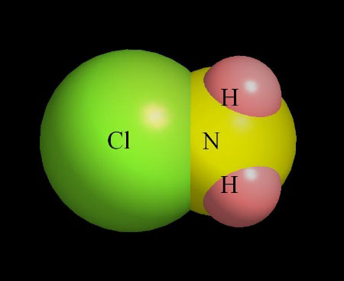**Installed Costs: 1.** Chloramine is inexpensive and relatively easy to generate onsite using Ammonium Hydroxide NH3 or Ammonium Sulfate (NH4)2SO4 (is preferred). Installation includes a chemical feed pump and drum.

**Operation and Maintenance Issues and Costs: 2.** Minimum allowed residual is 0.6 mg/L. Chloramine residual can drop without warning – recommend the use of ORP meters[7] to monitor for nitrification. Chloramines may pose simultaneous compliance problems such as nitrification, biofilm regrowth and degraded water quality.

**References:** USEPA. (1999). pp. 6-1 – 6-29

**Treatment Techniques not included in DBP Recommendations.**

The following treatment techniques have not been included with recommended alternatives mostly because of their ineffectiveness with DBP reduction and/or problematic operation. Potassium and Sodium Permanganate were close to be placing on this list due to problematic operation alone.

|  |  |
| --- | --- |
| * Activated Alumina Adsorption * Bag / Cartridge Filtration * Bubble Diffusers * Chlorine Dioxide * Diatomaceous Earth Filtration * Direct Filtration * Electrodialysis (ED ) * Ion Exchange | * Lime Softening * Microfiltration (MF) * pH Adjustment * Silicates * Spray Aeration * Ultrafiltration (UF) * UV Radiation |

**References:**

AWWA. (1999). *Water Quality & Treatment – A Handbook of Community Water Supplies*. Fifth edition. McGraw-Hill, Inc.

AwwaRF. (1993). Eighmy, T.T., et al, *Biologically Enhanced Slow Sand Filtration for Removal of Natural Organic Matter*, Denver Colo.: AwwaRF

AwwaRF. (1996). Anselme, C & Jacobs, E.P, *Water Treatment Membrane Processes*, Chapter 10 , American Water Works Research Foundation, McGraw Hill,

AwwaRF. (1999). Maintaining and Operating Finished Water Storage Facilities to Prevent Water Quality Deterioration.

AwwaRF (2000a). Guidance Manual for Maintaining Distribution System Water Quality.

AwwaRF (2000b). Water Quality Modeling of Distribution System Storage Facilities. Grayman et al.

Carroll, S. et al. (2012, Spring). Water Age and Water Quality Deterioration. The Floridan. Florida Department of Environmental Protection. 4:10, pp. 7, 12-13.

MWH. (2005). *Water Treatment Principles and Design.* Second Edition. John Wiley & Sons.

NRWA. (1992). *Training Guide: Filters and Filtration*. National Rural Water Association. TGR-24-92

Reiss, R. et al (2010, March). *Unidirectional Flushing: Enhance Water Quality and Improve Customer Relations*. Opflow, AWWA. 36:3, pp. 10-14

USACE. (1999). *Design of Small Water Systems*, Engineer Manual 1110-2-503,

USACE. (2001). *Engineering and Design, Air Stripping.* Design Guide. 1110-1-3.

USEPA. (1998). *Small System Compliance Technology List for the Surface Water Treatment Rule and Total Coliform Rule*. EPA #815-R-98-001.

USEPA. (1999a). *Alternative Disinfectants and Oxidants Guidance Manual.* EPA #815-R-99-014. Available online at: http://www.epa.gov/safewater/mdbp/implement.html

USEPA. (1999b). *Enhanced Coagulation and Enhanced Precipitative Softening Guidance Manual.* EPA #815-R-99-012. Available online at: http://www.epa.gov/safewater/mdbp/implement.html

USEPA. (2001). *Controlling Disinfection By-Products and Microbial Contaminants in Drinking Water.* EPA #600-R-01-110. Available online at : http://www.epa.gov/nrmrl/pubs0199.html

USEPA (2002). *Effects of Water Age on Distribution System Water Quality.* Prepared by AWWA with assistance from Economic and Engineering Services, Inc.Available online at: http://www.epa.gov/safewater/disinfection/tcr/regulation_revisions.html

USEPA. (2006). *Ultraviolet Disinfection Guidance Manual for the Final Long Term 2 Enhanced Surface Water Treatment Rule.* EPA #815-R-06-007. Available online at: http://www.epa.gov/safewater/disinfection/lt2/compliance.html.

USEPA. (2007a). *Simultaneous Compliance Guidance Manual for the Long Term 2 and Stage 2 DBP Rules.* EPA #815-R-07-017. Available online at: http://www.epa.gov/safewater/disinfection/stage2/compliance.html

USEPA. (2007b). *Removing Multiple Contaminants from Drinking Water: Issues to Consider****[8]***. EPA #816-H-07-004, Available online at: http://www.epa.gov/OGWDW/treatment/pdfs/poster_treatment_technologies.pdf

USEPA. (2008). *Stage 2 Disinfectants and Disinfection Byproducts Rule – Operational Evaluation Guidance Manual.* EPA # 815-R-08-018, Available online at: http://www.epa.gov/ogwdw/disinfection/stage2/pdfs/draft_guide_stage2_operationalevaluation.pdf

**Abbreviations / Acronyms:**

AOC Assimilable organic carbon

ASDWA Association of State Drinking Water Administrators

AWWA American Water Works Association

AWWARF AWWA Research Foundation

BAC Biologically active carbon

BAF Biologically active filtration

BAT Best Available Technology

BDOC Biological dissolved organic carbon

BMP Best management practice

BOM Biodegradable organic matter (BOM = BDOC + AOC)

Cl2 Chlorine

ClO2 Chlorine Dioxide

CT Concentration-Time

CT Disinfectant residual × contact time

DBPs Disinfection By-Products

DOC Dissolved Organic Carbon

EBCT Empty bed contact time

EPA Environmental Protection Agency

ESWTR Enhanced Surface Water Treatment Rule

FBR Filter Backwash Rule

Fe Iron

GAC Granular Activated Carbon Adsorption / Filtration (can include powdered activated carbon)

GWR Ground Water Rule

H2O2 Hydrogen Peroxide

H2S Hydrogen Sulfide

HAA5s Haloacetic Acids

MCL Maximum Contaminant Level

MCLG Maximum Contaminant Level Goal

mg/L milligrams per liter

MGD Million Gallons per Day

MRDL Maximum Residual Disinfectant Level (as mg/l)

MRL Minimum Reporting Level

NOM Natural Organic Matter

O2 Oxygen

O3 Ozone

POE Point-of-Entry Technologies

POU Point-of-Use Technologies

ppm parts per million

PTA Packed Tower Aeration

SDWA Safe Drinking Water Act, or the “Act,” as amended in 1996

Stage 2 DBPR Stage 2 Disinfectants and Disinfection Byproducts Rule

SWTR Surface Water Treatment Rule

TOCs Total Organic Carbon

TT EPA has established specific treatment techniques (standards and removal processes) for certain contaminants under the SDWA.

TTHMs Total Trihalomethanes

UV Ultraviolet

VOC Volatile Organic Chemical

1. USEPA. (2008). *Stage 2 Disinfectants and Disinfection Byproducts Rule – Operational Evaluation Guidance Manual.*
2. USEPA (2002). *Effects of Water Age on Distribution System Water Quality.*
3. AwwaRF (2000b). Water Quality Modeling of Distribution System Storage Facilities. Grayman et al.
4. Reiss, R. et al (2010, March). Unidirectional Flushing: Enhance Water Quality and Improve Customer Relations. Opflow, AWWA. 36:3, pp. 10-14
5. Carroll, S. et al. (2012, Spring). Water Age and Water Quality Deterioration. The Floridan. Florida Department of Environmental Protection. 4:10, pp. 7, 12-13. & USEPA (2002). *Effects of Water Age on Distribution System Water Quality.*
6. USEPA. (1999a). *Alternative Disinfectants and Oxidants Guidance Manual.* EPA #815-R-99-014.
7. Oxidation Reduction Potential meters are the most accurate way of tracking nitrification and nitrifying bacteria growth in the distribution system. See http://www.hach.com/hqdguide?gclid=CIey6OS3v5wCFUdM5QodMi29nQ
8. USEPA. (2007). *Removing Multiple Contaminants from Drinking Water: Issues to Consider*. EPA 816-H-07-004, http://www.epa.gov/OGWDW/treatment/pdfs/poster_treatment_technologies.pdf