[POTW] Best Management Practices

for Mercury Waste Management in Dental Offices

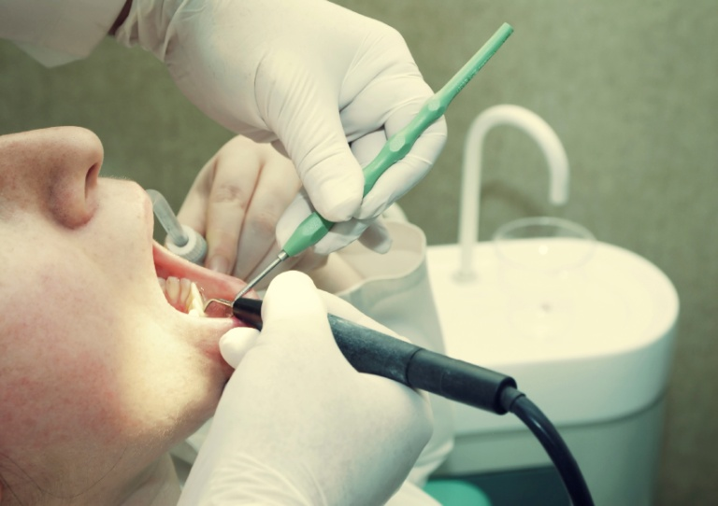

Prepared by [POTW] for the control of mercury discharged to the sanitary collection system by dental offices.

[Month, Year]

**Table of Contents**

Introduction 3

Best Management Practices (BMP) 4

#1 Disposal 4

Elemental Mercury 4

Amalgam 4

Amalgam Capsules 4

#2 Amalgam Retention and Equipment

Maintenance 5

Chair-side Traps 6

Secondary Vacuum Pump

Filters 6

Amalgam Separators 6

#3 Storage 7

#4 Environmental Release 8

Plumbing Replacement

and Repairs 8

Disinfectants, Cleaners and

Other Chemicals 9

Spills 9

#5 Records Requirements 10

#6 Training 10

Appendices

Amalgam & Mercury Recycling 12

[POTW] Discharge Prohibitions 13

[POTW] Local limits 14

Acknowledgements 15

**Introduction**

The [POTW] Amalgam Best Management Practices (BMPs) for Dental Facilities are designed to comply with environmental regulations, prevent pollution, and assist dental offices in the proper management of mercury and amalgam waste in their day-to-day activities. This best management practices booklet contains a set of **required**and**recommended** **operating procedures and guidelines** designed to reduce the amount of mercury discharged to the [POTW] sanitary sewer system, a publicly owned treatment works (POTW). Proper implementation of these procedures is intended to protect Florida’s natural environment from the discharge of hazardous mercury-containing compounds.



Because of the hazardous nature of mercury, [POTW] may require dental facilities to obtain an Industrial User Discharge Permit. By implementing these [POTW] Best Management Practices, dental facilities may be exempt from obtaining such a permit.

As part of the Clean Water Act, the National Pretreatment Regulation (40CFR 403) was established to protect publicly owned treatment works and the waterways into which they discharge. The Environmental Protection Agency (EPA) delegates this responsibility to the State of Florida Department of Environmental Protection (FDEP). In [insert City], the FDEP has delegated local authority to [POTW] (the electric, water, and sewer utility). It is the responsibility of [POTW]’s Industrial Pretreatment program to regulate non-residential discharges to the publicly owned treatment works.

This manual identifies certain practices that dental offices are required to follow. These requirements are summarized at the end of each topic as **BMP Summary Requirements**. In addition, guidance is given on optional practices that offer environmentally preferable practices for dental offices and may help save money through waste minimization. These will be summarized in each section under the heading, **“To take compliance to the next level, consider the following.”**

**BMP #1 - Disposal**

**Elemental Mercury**

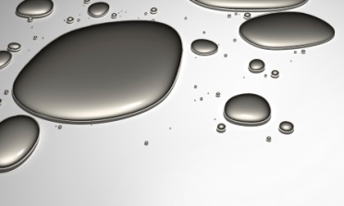Although most dentists have adopted the use of pre-capsulated amalgam, some offices may still have supplies of elemental mercury tucked away in a storeroom. This supply, especially if it is forgotten or poorly managed, exists as a potential risk to employees and can be very expensive to clean up.

Recycle all unused free mercury. Many hazardous waste haulers and dental amalgam recyclers will accept elemental mercury for recycling.

**Amalgam**

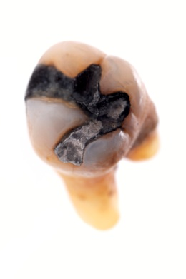Common dental amalgam is composed of approximately 49 percent mercury, 35 percent silver and the remainder is tin, copper and zinc. These heavy metals have the potential to adversely impact water quality. There are regulated limits for most of these metals in wastewater discharged to [POTW]’s sanitary sewer system (see Appendix C).

**Contact Amalgam** is any amalgam that is left over from a procedure, collected in chair-side traps and filters or any unused amalgam from a procedure. It should be collected and stored in an airtight container labeled as “Contact amalgam – to be recycled.”

**Non-Contact Amalgam** is any amalgam capsule that is defective or expired and has not been used in a procedure. It should be collected and stored in a separate container labeled, “Non-contact amalgam – to be recycled.” Some recycling companies may pay for non-contact amalgam. If this is not the case, all recycled amalgam may be placed in the same container labeled “contact amalgam.” Be sure to follow the requirements of a licensed amalgam handler or recycler for the storage, disinfection, labeling, packaging and shipping of scrap amalgam.

**Amalgam Capsules**

Convert to pre-capsulated amalgam capsules and use the correct size needed for each procedure. A variety of amalgam capsule sizes should be stocked to minimize the amount of waste generated from each restoration. After mixing the amalgam, the empty capsules should be placed in an airtight container labeled “Non-contact amalgam – to be recycled.” Unused amalgam and capsules with amalgam residue should also be placed in the non-contact amalgam container. Use standard personal protection equipment precautions.

For further information on amalgam recycling, see Appendix A.

**BMP #1 Summary Disposal Requirements**

* **Never discard elemental mercury or amalgam in any sink or drain, sharps container, biohazard waste bag (red bag) or trash.**
* **Always recycle or dispose all mercury-containing materials through a licensed mercury waste recycler or handler.**

**To take compliance to the next level, consider the following:**

* **Discontinue using elemental mercury.**
* **Discontinue mixing your own amalgam.**
* **Use pre-capsulated alloy to reduce the risk of an elemental mercury spill.**
* **Stock a variety of capsule sizes to reduce waste.**
* **Use amalgam substitutes when clinically and ethically appropriate.**
* **Designate all sinks as “Sanitary Use Only – No Chemical or Amalgam Disposal” to eliminate cleaning of amalgam-contaminated instruments in the sink.**

**BMP #2 - Amalgam Retention Equipment and Maintenance**

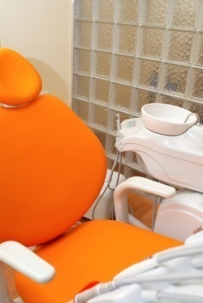

Multiple levels of amalgam retention devices, when properly installed and maintained, can prevent up to 81 percent of amalgam waste from entering the sewer system. The combination of properly functioning chair-side traps and secondary vacuum filters provides the minimum required levels of amalgam retention necessary to comply with these BMPs. Additional retention (up to 99 percent) can be attained by installing an optional amalgam separator system.

The control of waste dental amalgam includes proper management of the traps and filters used in the dental office vacuum system. Because of the difficulty in effectively cleaning amalgam particles from the trap or filter without spilling debris into the drain or trash, disposable chair-side traps and secondary vacuum filters are required for compliance with this BMP. Finer screens are recommended due to increased effectiveness at trapping amalgam particles so consider using a smaller mesh size trap. Replacing a 40-mesh screen with a 100-mesh screen (if the vacuum system can function adequately) can greatly reduce the amount of amalgam particles that pass through the system and subsequently into the wastewater. Most dental amalgam recyclers will allow the combination of amalgam particles with used trap and filters in the contact amalgam waste container. Be sure to check the requirements prior to disposal.

**Chair-side Traps**

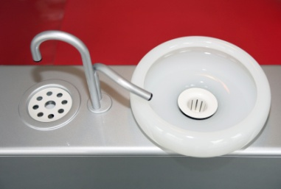Regularly maintained chair-side traps will best retain amalgam particles while maximizing system flow efficiency. When conducting any maintenance procedure, make sure to use appropriate personal protective equipment.

1. Replace chair-side amalgam traps as recommended by the equipment manufacturer or at least once per quarter*.*
2. Remove the trap from the chair-side equipment and place the entire trap into the airtight container labeled “Contact amalgam for recycling.” Install a new trap. Do not rinse the trap as this could introduce amalgam into the drain.

Please note that the chair-side trap from a dental chair dedicated to hygiene only can be disposed of as typical medical waste and is not regulated under this BMP.

**Secondary Vacuum Pump Filters (in the central vacuum)**

1. Replace vacuum pump filter as recommended by the equipment manufacturer or at least once per quarter.
2. Remove the filter apparatus. Do not pour the liquid content into any sink or drain. While holding the filter container over a tray or other container that can catch spills, put the lid on the filter and place it (with liquid contents) into the contact amalgam container. When the container is full, it should be sent for recycling. Be sure to check with the amalgam recycler to ensure these filters are acceptable.

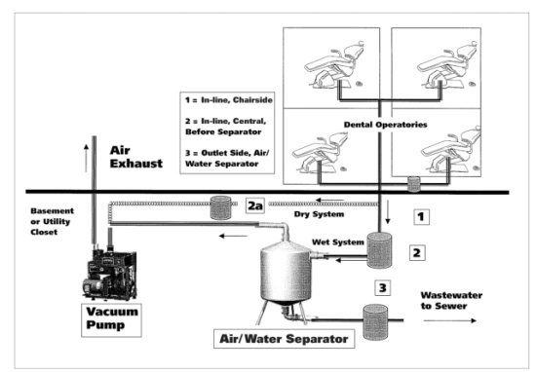

**Amalgam Separators (Optional)**

Due to the superior amalgam removal capability of amalgam separators over chair-side traps and vacuum filters, the installation of a separator should be considered. These systems are designed to capture very fine amalgam particles. When a separator is used in conjunction with appropriately functioning chair-side traps and secondary vacuum filters, amalgam removal rates can increase to the 95 percent to 99 percent range.

## At this time, [POTW] does not require amalgam separator technologies to be employed in dental offices but they are recommended. Any decision to purchase an amalgam separator should be made based upon the specific technology that works best for the existing equipment.

**BMP #2 Summary Equipment and Maintenance Requirements**

* **Never rinse traps, filters or screens over the sink or drain.**
* **Install disposable-only chair-side traps and secondary vacuum system filters.**
* **Regularly maintain the filter system according to manufacturer** **recommendations or at least once per quarter.**
* **Dispose of trap, filter and separator waste through a licensed mercury waste recycler or handler.**

**To take compliance to the next level, consider the following:**

* **Use the finest mesh disposable traps and secondary filters that the vacuum system can efficiently handle.**
* **Install an amalgam separator that is ISO 11143 compliant.**

*The American Dental Association recommends that any dentist considering the purchase and installation of an amalgam separator read “Purchasing, Installing and Operating Dental Amalgam Separators: Practical Issues,” K.R. McManus, P.L. Fan; J. American Dental Association 2003 (134:1054-1065), online at**http://jada.ada.org.*

**BMP #3 - Storage**

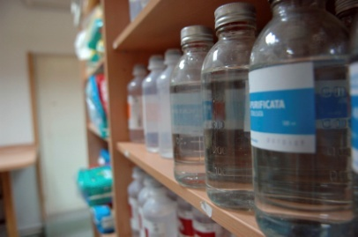For small quantity generator offices, it may take a long time to generate enough amalgam waste to trigger a disposal event. Sometimes, dental offices will store waste amalgam under radiographic fixer or other solutions prior to disposal. These solutions may dissolve the mercury in the amalgam and thus are classified as mercury contaminated hazardous waste. These liquids are prohibitedfrom being discharged to the [POTW] sanitary sewer.

For example, the silver in X-ray fixer can be reclaimed reducing cost and disposal liability. However, if it is used to store scrap amalgam, then the only option for disposal is as hazardous waste. Not only is the creation of this additional waste unnecessary, it is also costly for disposal and creates an additional source for potential spills. If this type of waste is present, contact a licensed dental amalgam recycler or hazardous waste hauler for more information on how to discard this material properly and begin to store the scrap amalgam in a dry, properly labeled, air-tight container.

Contact a mercury recycler/hauler to determine if any disinfection is required prior to shipment. If amalgam must be disinfected before shipment to the recycler, do so just prior to shipment. Do not use any bleach- containing chemicals that dissolve mercury, an autoclave, or any other method that uses heat for disinfection. The heat from an autoclave may cause the mercury to volatilize and be released to the air.

**BMP #3 Summary Storage Requirements**

* **Never store amalgam waste under any liquid.**
* **Store all amalgam waste dry in a properly labeled, air-tight container.**
* **Dispose of any liquids used to disinfect contact amalgam as hazardous. These cannot be discharged to the sewer system.**

**To take compliance to the next level, consider the following:**

* **If the mercury recycler/handler requires it, add a liquid disinfectant just prior to shipment. This liquid must be disposed of as hazardous waste.**

**BMP #4 - Environmental Release**

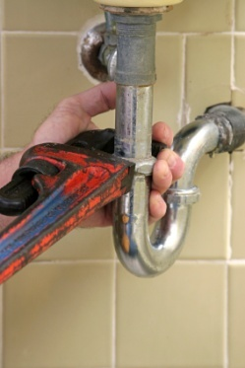**Plumbing Replacement and Repairs**

After an office adopts its new amalgam management practices, it may be appropriate to clean or replace sink traps. Mercury from past activity often settles at low points such as sink traps and sumps. The slow dissolution of the mercury in a sink trap or sump can release mercury into the [POTW] sanitary sewer for years after past disposal practices have been corrected.

When plumbing parts are removed or cleaned, caution should be taken to avoid spilling the contents in case amalgam or mercury is present. Pour and brush out the sludge and handle it as if it were contact amalgam, or have it discarded as hazardous waste. Contact an amalgam or mercury recycler or a licensed hazardous waste handler (Appendix A) for further clarification. The plumbing parts can then be put back in place or recycled.

**Disinfectants, Cleaners and Other Chemicals**

* Follow the label directions on the product container for guidance on the proper use, handling and disposal of used disinfectants and cleaners, along with the residue remaining in the product containers.
* Use only the amount of cleaning solution needed for the job.
* Flammable materials that release ignitable vapors must not be discharged to the [POTW] sanitary sewer. These materials are considered hazardous waste.
* Unused products should be discarded through a hazardous waste hauler or, if acceptable, send unused products back to the manufacturer or supplier.

*The American Dental Association offers more information on the effect of disinfectants and line cleaners on the release of mercury from amalgam:*

http://www.ada.org/prof/resources/positions/statements/amalgam_plumbing_guidelines.pdf.

**Spills**

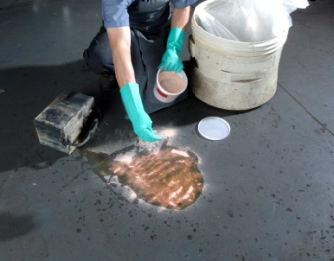Do not handle mercury or mix amalgam in carpeted areas because it is very difficult to collect all of the contaminants if there is a spill. In the event of a mercury spill, put on nitrile gloves (do not use latex gloves as mercury can penetrate latex) along with other appropriate proper protective equipment and clean it up immediately. Never clean up a mercury spill using a vacuum cleaner as this has the potential to spread mercury dust and/or vapor throughout the area in the vacuum exhaust. Mercury spill kits are available from companies that specialize in Occupational Safety and Health Administration compliance supplies, amalgam recyclers and dental product suppliers. Before purchasing a kit, make sure it includes complete instructions on how to perform a spill clean- up. Train staff members in proper spill cleaning procedures.

**BMP #4 – Summary Environmental Release Requirements**

* **Never us an autoclave or heat to disinfect amalgam.**
* **Never use disinfectants or line cleaners containing chlorine (bleach) to flush dental unit wastewater lines.**

**To take compliance to the next level, consider the following:**

* **Review “The effect of disinfectants and line cleaners on the release of mercury from amalgam” in the Journal of the American Dental Association (2006, Vol. 137, No. 10, 1419-1425), available online at http://jada.ada.org.**

**BMP #5 - Records Requirements**

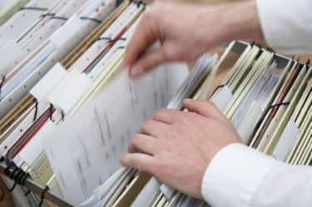Retention of records is required to demonstrate compliance with required BMPs. Dental offices are required to maintain a written or electronic log of all maintenance performed on traps and vacuum system or plumbing. In addition, retain receipts, shipping manifests and other certified documentation from the recycler or hazardous waste hauler of all amalgam waste recycling and disposal shipments. These documents must be kept on file for at least three years, and must be made available to authorized [POTW] inspectors upon request.

**BMP #5 Summary Records Requirements**

* **Retain the following records for three years:**

**All waste amalgam recycle/disposal receipts and shipping manifests.**

**All trap, filter and separator maintenance records**

**BMP training documentation for all employees.**

* **Submit semi-annual certification of the dental amalgam waste handler certificates to [POTW]. Certifications are due on the 28th day of January and July each year.**

**BMP #6 - Training**

Proper knowledge and handling of amalgam is vital to preventing accidental exposure and release of hazardous materials into the environment. A proper training program must include all six of the [POTW] Best Management Practices included in this manual. Anyone who handles or has the potential to come into contact with mercury-containing materials must be trained in these BMPs for proper mercury/amalgam waste handling requirements.

**BMP #6 Summary Training Requirements**

* **Use these [POTW] Best Management Practices to teach proper handling techniques to all staff who may come into contact with mercury-containing materials.**

**To take compliance to the next level, consider the following:**

* **Require all personnel who may come into contact with mercury-containing materials to review the Occupational Safety and Health Administration’s proper mercury safe handling and disposal procedures at the OSHA Web site: http://www.osha.gov/SLTC/mercury/standards.html**.

**For additional copies of this guide or more information, please visit our web site:**

[insert web address here]

**Or contact:**

**[POTW] Industrial Pretreatment**

**[Street Address]**

**[City], FL [Zip Code]**

**[Phone Number]**

**Appendix A**

**Amalgam & Mercury Recycling**

**Supplemental Guidance for Recyclers and Wastes**

Many waste handlers are licensed to receive, transport, and manage amalgam and mercury materials, along with other hazardous materials. However, only a limited number of facilities across the country are licensed to treat and/or recycle amalgam and mercury-containing materials. Be sure to obtain documentation that the hauler or recycler is appropriately licensed to handle mercury-containing materials and that they are disposing the materials appropriately. If the materials are improperly disposed in a landfill or elsewhere, the generating dental office may be responsible for any penalties and costs associated with remediation.

There are various companies that will provide recycling of amalgam and other mercury-containing materials. Contact any of these companies to negotiate this service and shipping arrangements. In addition, other environmental service companies can provide pickup of these materials. These companies are typically “go-betweens” that will eventually ship to one of the disposal companies. A licensed waste handler should take care of all administrative issues related to shipping and handling of potentially hazardous materials.

A list of dental amalgam recycling facilities reviewed by the Florida Department of Environmental Protection can be found at the following Web site -

http://www.dep.state.fl.us/waste/quick_topics/publications/shw/mercury/AmalgamRecyclerList042507.pdf.

The American Dental Association has also assembled a directory of dental waste transporters at the following Web site -

http://www.ada.org/prof/resources/topics/topics_amalrecyclers.pdf.

**Appendix B**

**Industrial Pretreatment**

**PROHIBITED DISCHARGES AND LOCAL LIMITS**

[insert prohibited discharges here]

**Appendix C**

# Local Limits

[insert POTW local limits here]

**Appendix D**

**Acknowledgements**

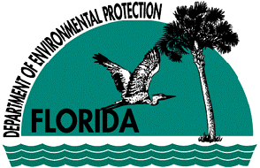

**Florida Department of Environmental Protection (FDEP)**

FDEP Amalgam BMP

<http://www.dep.state.fl.us/waste/quick_topics/publications/shw/mercury/AmalgamBMPsBrochure.pdf>



**Florida Dental Association (FDA)**

<http://www.floridadental.org/index.html>

**NorthEast District Dental Association (NEDDA)** <http://www.nedda.org>

**ADA logoAmerican Dental Association (ADA)**

<http://www.ada.org/prof/resources/topics/amalgam_bmp.asp>

The ADA provides a document entitled, ADA Best Management Practices for Amalgam Waste, as well as a 10-minute video on handling waste amalgam. The document and video are available on the ADA Web site http://www.ada.org/prof/resources/topics/amalgam_bmp.asp



**Virginia Dental Association (VDA)**

<http://www.deq.state.va.us/p2/mercury/documents/manual.pdf>



**Virginia Department of Environmental Quality (VDEQ)**

<http://www.deq.state.va.us/>