Sanitary Sewer Overflow

Response Plan
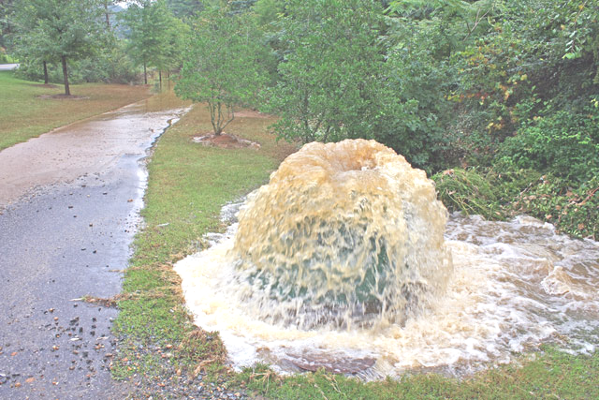
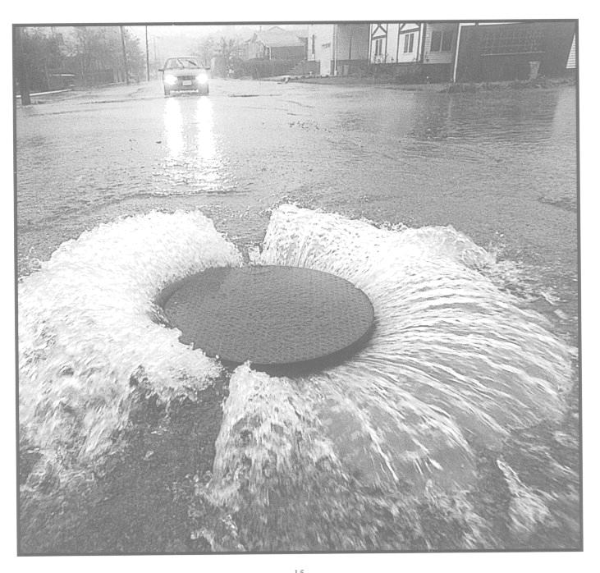

System Name:

GMS ID:

Address:

City/State/Zip:

Phone Number:

Fax:

Email:

CONTENTS

SECTION

I. Purpose

II. Objectives

III. Procedures
A. Receipt of Information Regarding a Sanitary Sewer Overflow
B. Dispatch of Sewer Maintenance Personnel to Site of Sewer Overflow
C. Overflow Correction, Containment, and Clean Up
D. Overflow Report
E. Customer Satisfaction

IV. SSO Response Plan Maintenance

V. Appendices
Appendix A – Contacts
Appendix B – Spill/SSO Reporting Form

I. Purpose

This Sanitary Sewer Overflow Response Plan has been prepared in accordance with FDEP regulation 62-604.550. The purpose of this SSO Response Plan is to ensure proper SSO reporting and minimize the adverse effects that may be caused by a Sanitary Sewer Overflow.

This plan is effective beginning on
Date: mm / dd / yy

This plan will be reviewed and/or updated annually to incorporate any changes in contact information; system components; and/or personnel.

II. Objectives

The objectives of this plan are listed below:

- To protect the public health and the environment

- To meet regulatory and permit requirements

- To develop and implement procedures to mitigate the effects of an SSO

- To protect collection system and wastewater treatment personnel

- To ensure the longevity of the collection system and wastewater treatment plant equipment

- To protect both public and private property

- To minimize regulatory enforcement and/or penalties, resulting from a spill/SSO

- To provide appropriate customer service
III. Procedures

A. Receipt of Information Regarding a Sanitary Sewer Overflow

Sanitary Sewer Overflow’s may be recognized and reported by system personnel or by others. The System is responsible to act, in a timely manner, to all reports of a possible SSO. Reports may be received via telephone, email, or by other means.
1. Typically reports received from the public will be received at the utility offices. Personnel collecting information regarding a possible SSO, please obtain the following:
a. Time and date call was received
b. Specific location
c. Description of problem
d. Time possible overflow was noticed
e. Reporter’s name and phone number
f. Observations of the reporter
g. Relevant information that will enable system personnel to quickly locate, assess and stop the overflow
- Appropriate system personnel will be notified when a possible spill is reported. System personnel must confirm the spill before it will be considered and SSO. Only after confirmation by system personnel will a spill be considered an SSO.
- Within 24 hours of the confirmation of a Sanitary Sewer Overflow, FDEP will be notified according to FDEP Rule 62-604.550. The rule is provided below:

62-604.550 Abnormal Events.
(1) The provisions of Rule 62-604.550 are applicable to both new and existing domestic wastewater collection/transmission systems.
(2) The owner/operator of the collection/transmission system shall report to the Department all unauthorized releases or spills of wastewater to surface or ground waters from its collection/transmission system or any other abnormal events as described below:
- Unauthorized releases or spills in excess of 1,000 gallons per incident, or other abnormal events where information indicates that public health or the environment will be endangered, shall be reported orally to the STATE WARNING POINT TOLL FREE NUMBER (800) 320-0519 as soon as practical, but no later than 24 hours from the time that the owner/operator becomes aware of the circumstances. The owner/operator, to the extent known, shall provide the following information to the State Warning Point:
1. Name, address, and telephone number of person reporting;
2. Name, address, and telephone number of owner/operator of the collection/transmission system or responsible person for the discharge;
3. Date and time of the discharge and status of discharge (ongoing or ceased);
4. Characteristics of the wastewater spilled or released (untreated or treated, industrial or domestic wastewater);
5. Estimated amount of the discharge;
6. Location or address of the discharge;
7. Source and cause o the discharge;
8. Whether the discharge was contained on-site, and cleanup actions taken to date;
9. Description of area affected by the discharge, including name of water body affected, if any; and
10. Other persons or agencies contacted.
(b) Unauthorized releases or spills of 1000 gallons per incident or less shall be reported orally to the Department within 24 hours from the time that the owner/operator of the collection/transmission system becomes aware of the circumstances.
(c) The oral notification shall be followed by a written submission, which shall be provided within five days of the time that the owner/operator becomes aware of the circumstances. The written submission shall contain: a description of the spill, release or abnormal event and its cause; the duration including exact dates and time, and if it has not been corrected the anticipated time it is expected to continue; and steps taken or planned to reduce, eliminate, and prevent recurrence. The Department shall waive the written report if the oral report has been received within 24 hours from the time that the owner/operator of the collection/transmission system becomes aware of the circumstances, and the release, spill or abnormal event has been corrected and did not endanger health or the environment.

Rule Highlights

- Spills / Sanitary Sewer Overflows greater than 1,000 gallons must be reported to the STATE WATCH OFFICE formerly known as STATE WARNING POINT (800-320-0519) within 24 hours of learning of the spill/SSO.
- Spills / Sanitary Sewer Overflows that endanger public health or the environment must be reported to the STATE WATCH OFFICE formerly known as STATE WARNING POINT (800-320-0519) within 24 hours of learning of the spill/SSO.
- Spills / Sanitary Sewer Overflows less than 1,000 gallons must be verbally reported to the FDEP within 24 hours of learning of the spill/SSO.
  - Written report describing the spill/SSO must be provided to the FDEP within five days.
  - The Department shall waive the written report if the oral report has been received within 24 hours from the time that the owner/operator of the collection/transmission system becomes aware of the circumstances, and the release, spill or abnormal event has been corrected and did not endanger health or the environment.

B. Dispatch of Sewer Maintenance Personnel to Site of Sewer Overflow

Confirmation of a Spills / Sanitary Sewer Overflows will activate an immediate response to isolate and correct the problem. Personnel and equipment shall be available to respond to any and all SSO locations.

1. Dispatching Personnel Instructions

- When a spill/SSO is received by the system, the necessary response personnel and equipment shall be dispatched to isolate and correct the problem in a timely manner
- Maintenance personnel will be dispatched by telephone or radio
- Dispatching personnel must verify that all notified maintenance personnel have received the message

2. Maintenance Personnel Instructions

- All dispatched maintenance personnel should proceed immediately to the site of the spill/SSO. Any delays and/or conflicts should be promptly reported to the supervisor
- Upon arrival at the site of the spill/SSO, maintenance personnel will immediately report any and all findings to the Utility supervisor. These findings should include, damage to both public and private property

3. Utility Supervisor Instructions

- The Utility Supervisor should contact response personnel to assess the spill/SSO, if findings have not been reported within one hour
- The Utility Supervisor will dispatch additional personnel, supplies, and equipment as needed or requested by dispatched maintenance personnel

4. Initial Damage Assessment

- All dispatched personnel must use discretionary action when responding to a spill/SSO. Dispatched personnel must be aware that the System may be responsible and/or liable for further damage to private property
- Dispatched personnel should not enter private property without authorization from the Utility Supervisor
- In order to thoroughly document the affected area, the dispatched personnel will take appropriate photos and/or video. Any photos and/or video will be retained and filed with the spill/SSO report

5. Field Supervision and Inspection

- The Utility Supervisor will ensure that the guidelines outlined in this SSO Response Plan are properly implemented
- The Utility Supervisor is responsible for properly notifying FDEP, according to FDEP Rule 62-604.550, within the amount of time specified within the rule

6. Hazardous Material Response

- Upon arrival at a spill/SSO, should dispatched personnel confront a suspicious substance (oil sheen, foam, etc.) or odor (gasoline, etc.), the dispatched personnel should contact the Utility Supervisor prior to taking further action
- The Utility Supervisor will contact a HAZMAT team, should it be deemed necessary. Dispatch personnel will await the arrival of the HAZMAT team
- The Utility Supervisor will remain in contact with the HAZMAT team. Once the HAZMAT team determines it is safe, the system will continue appropriate response, in accordance with the SSO response plan

C. Spill/SSO Correction, Containment, and Clean-up

The objectives of the actions taken by system personnel are:
- To protect public health, the environment, and property from a spill/SSO
- To restore the surrounding area/property back to normal as quickly as possible
- To establish an appropriate perimeter to contain the spill/SSO, using equipment (traffic cones, barricades), existing infrastructure (fencing, etc.), and/or natural boundaries (berm, ditch, stream, etc.)
- To notify the appropriate regulatory agencies within permitted timeframe
- To protect surface water from contamination
- To minimize regulatory enforcement and/or penalties, resulting from a spill/SSO

- Upon arrival at a spill/SSO, the dispatched system personnel will perform the following:

- Determine the cause of the spill/SSO (collection line blockage, lift station malfunction, line break, etc.).
- Report findings to Utility Supervisor and identify or request additional personnel and equipment to minimize the affects of the spill/SSO.
- Should it be determined the cause of the spill/SSO is not the responsibility of the system, dispatched personnel will;
  - Take appropriate action to protect public health, property (public and private), and surface water bodies from immediate danger.

- Containment of a spill/SSO will be of utmost priority and will include, but are not limited to, the following measures:

- Determine the immediate destination of the spill/SSO (storm drain, water body, ditch, etc.)
- Identify and request the necessary personnel and equipment to contain and minimize the affects of the spill/SSO
- Take the appropriate, immediate action to contain the spill/SSO

- Additional measures may be necessary to contain a prolonged spill/SSO. These measures will be determined and implemented by the Utility Supervisor.

- Clean up of a spill/SSO will be prompt and thorough. The necessary measures will be taken to eliminate any identifiable evidence of the spill/SSO.

  - If possible, photos will be taken before and after clean up. Photos will be filed with the spill/SSO report
  - The affected area will be cleaned of any sewage and debris. All materials collected will be properly disposed of
  - The area will be secured to prevent public contact, until the affected area has been thoroughly cleaned
  - The spill/SSO site should be disinfected and deodorized, if appropriate
  - If spill/SSO has affected a surface water body, the FDEP will be contacted for specific instructions

D. Overflow Reporting

The Utility Supervisor will complete the required reports and submit them to the FDEP. All spills/SSO will be reported to FDEP, according to FDEP Rule 62-604.550. This information should include, but is not limited to, the following:
The italicized list below is taken from the FDEP website.
- Name, address, and phone number of person reporting the spill
- Name, address, and phone number of the responsible party
- Date and time of the discharge; Status of the discharge (ongoing or stopped)
- Characteristics of the discharge (untreated, treated, industrial, or domestic wastewater)
- Estimated amount of the discharge
- Location or address of the discharge
- Source and cause of the discharge
- Whether the discharge was contained on-site, and any cleanup actions taken to date.
- Description of area affected by the discharge, including name of water body affected, if any.
- Other persons or agencies contacted
- Additional information

For accurate reporting purposes, system personnel should gather the following information:

- Determine if the spill/SSO has affected any surface water bodies

- Estimate the start time of the of the spill/SSO:
  - Date/time reported and confirmed by system personnel
  - Visual observations

- Estimate the stop time of the spill/SSO:
  - Date/time the blockage or equipment malfunction has been corrected
  - Date/time system personnel arrived onsite, if spill/SSO stopped before system personnel arrived

- Visual Observations
  - Estimate the flow rate of the spill/SSO
  - Estimate the volume of the spill/SSO
  - Take photos for documentation
  - Assess damage to public and private property (System personnel will not enter private property to assess damage, unless authorized by the Utility Supervisor)

E. Customer Satisfaction

To ensure good public relations and customer satisfaction, the appropriate system personnel will follow up with the reporting party. This follow up will include either a personal visit or telephone call. The Utility Supervisor will determine the information to be disclosed to the reporting party.

IV. SORP Maintenance

This Sanitary Sewer Overflow Response Plan will reviewed annually. Amendments may include:
- Changes in procedure
- Changes in contact personnel
- Changes due to regulatory requirements

V. Appendices
Appendix A

CONTACTS

State Warning Point – 800-320-0519

“Spills which are of 1,000 gallons or greater, or which may threaten the environment or public heath are required to be immediately reported by a utility to the Florida Department of Environmental Protection (FDEP) through a toll-free, 24-hour hotline known as the State Warning Point.”

Contact / Affiliation | Phone | Email
Florida Rural Water Association | (850) 668-2746 | FRWA@frwa.net

FDEP Inspector(s)

System Owner/Operator

Utilities Supervisor

HAZMAT

Appendix B

SANITARY SEWER OVERFLOW REPORT FORM

1. General Information

Facility ID:
Authorized representative filing this form:
Name:
Title:
E-mail Address:
Type of filing report: (check one)
Initial
Final
Date of filing report: (check one)
Initial / /
Final / /

2. Reporting of Spill/SSO

-Less than 1,000 gallons-
Verbal report to FDEP
Date:
Contact:

-Greater than 1,000 gallons-
Contacted STATE WARNING POINT
Date:
Contact:

-Endangered public health-
Contacted STATE WARNING POINT
Date:
Contact:
Oral Report Provided to FDEP within 24 hours

FDEP Contact:
Phone Number:
E-mail Address:
FDEP Office:
Date of phone notification: ____/____/____

Spill/SSO Location and Description
Location:

City/Town/Village:

Address or Landmark:

Discharge Location: (check one)
Directly to receiving ground water
Ground
Receiving water via storm drain
Building
Other

SEWER OVERFLOW RESPONSE PLAN (SORP)

Type of overflow (check one)
Gravity sewer manhole
Pump station
Bypass at treatment plant
Other

Time of Spill/SSO Incident
- When did the incident begin? Date: ____/____/____
- Was the overflow/bypass event ongoing at the time of report: (check one)
Yes No
If yes, how long is the incident expected to continue?

If no, when did event end? Date: ____/____/____
Time:

General Information about Overflow at this Location
Estimated volume of overflow released at time of report:

Method of estimating volume:

Estimated total volume of overflow released at end of incident:

Were photos taken: (check one) Yes No

Corrective measures taken: (check one)
No action
Removed blockage
Repair pump station
Other

Cause of overflow/bypass (check ALL that apply):
Rain
High ground water
Other excessive flow
Sewer system blockage or collapse
Pump /lift station failure
Other

Additional comments:

FIVE DAY WRITTEN INCIDENT REPORT
Complete this notification form and use the space below to include any additional information regarding the overflow. Include any steps taken or planned to prevent a recurrence. Submit this form to the FDEP office within five days of becoming aware of the incident.

http://www.dep.state.fl.us/legal/Rules/wastewater/62-604.pdf
FDEP. 12/21/2010<http://www.dep.state.fl.us/water/wastewater/wce/spills.htm>.

