Methods of Controlling Nitrogen

There are several ways to monitor the treatment process to determine the degree of nitrification and denitrification.

Sludge settleability
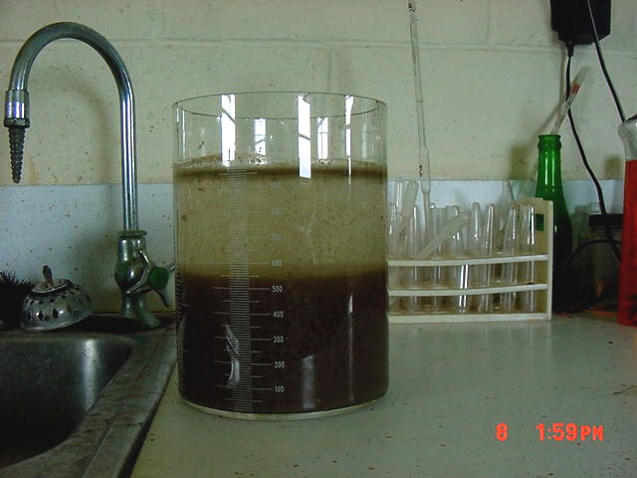
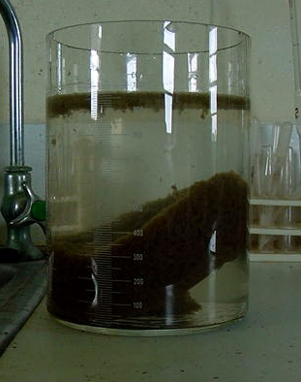
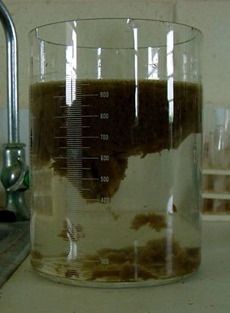
One of the least costly and easiest ways to check the process is a settleability test. A sample grab of well-mixed aeration tank mixed liquor is taken at the last point accessible where the aeration mixed liquor leaves the basin before entering the clarifier. This sample is allowed to settle. If a portion or all of the sludge rises to the surface within four hours of pulling the sample, denitrification is the probable cause.

Figure 1 Settleometer (showing rising sludge)

Settleability tests can be run using inexpensive mason jars, plastic containers or more elaborate Settleometers (Figure 7). These can be purchased through laboratories and utility supply companies. Whatever type container is used, it should have a wide mouth and hold at least one liter. Graduated cylinders are not generally acceptable for settling tests.

Nitrogen series testing
A colorimeter is a helpful tool in determining the degree of nitrogen removal and process stability. Testing the effluent for ammonia, nitrite and nitrate can help the operator determine how well the system is working. There are several brands of colorimetric instruments on the market, which vary in price (Figure 8).

It is important to note that monitoring for only one nitrogen parameter does not give a true indication of the removal of nitrogen. Since nitrate is the end result of nitrification, a low nitrate result could mean that the facility was successfully nitrified and then denitrified, or it may indicate that the process did not complete nitrification. It is important to monitor the complete nitrogen series for proper process control. This would include testing for ammonia, nitrite and nitrate.
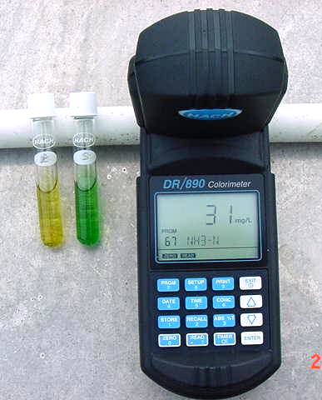
Figure 2 colorimeter (showing ammonia–N results and test tubes)

Dissolved oxygen
Monitoring dissolved oxygen (DO) is a vital part of controlling the conversion of nitrogen from ammonia to nitrate. As mentioned previously, it takes approximately 4.6 pounds of oxygen to convert one pound of ammonia to nitrate. About one- and one-half pounds of oxygen are required for the oxidation of carbonaceous biochemical oxygen demand (CBOD).

Keeping oxygen levels at optimum concentrations is necessary to maintain aerobic conditions. DO levels between 1.0 to 3.0 mg/L are acceptable, however DO concentrations over 3.0 mg/L provide no additional benefit. Keeping constant DO levels below 0.5 mg/L can contribute to the growth of filamentous organisms, which can cause slow settling in clarifiers (sludge bulking).

A DO meter hooked to a probe that is submerged into the mixed liquor is the best method for accurate dissolved oxygen measurement (Figure 9). If a test kit is used for DO measuring, it is crucial that the sample is not aerated additionally after the sample is pulled. Several companies manufacture DO meters that range in price from $250 to $1000.

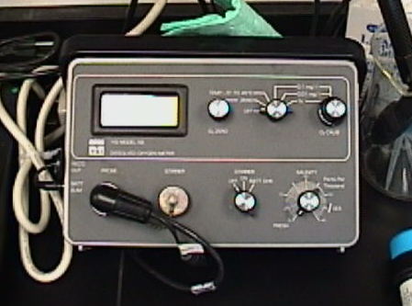
Figure 3 Dissolved Oxygen meter
Oxidation Reduction Potential (ORP)
Oxidation Reduction Potential is an effective way of measuring the oxygen source that is available to microorganisms. While a DO meter is a good way of measuring residual dissolved oxygen, it doesn’t give an accurate representation of the oxygen source is available when DO gets to 0.2 mg/L and lower.

For purposes of this manual, we will look at the ORP ranges required for nitrification and denitrification. An ORP reading of +50 to about +225 mV indicate the presence of dissolved oxygen (O₂). An ORP reading of +225 to +400 mV indicates the presence of oxygen and nitrate (NO₃). ORP readings in the range of +50 to –50 mV indicate that no free available dissolved oxygen is present, and nitrate is present as an electron acceptor (oxygen source). This is the range needed for anoxic tanks and timed anoxic cycles. There should be no free DO present in this zone, and a DO meter would read zero mg/L. ORP readings less than –50 mV indicate there is no free oxygen or nitrate present, and the microorganisms would be utilizing sulfate (SO₄) as an electron acceptor for their energy requirements. ORP meters vary in price, but for about $100 you can get a decent ORP meter and submersible probe with a ten-foot cable.

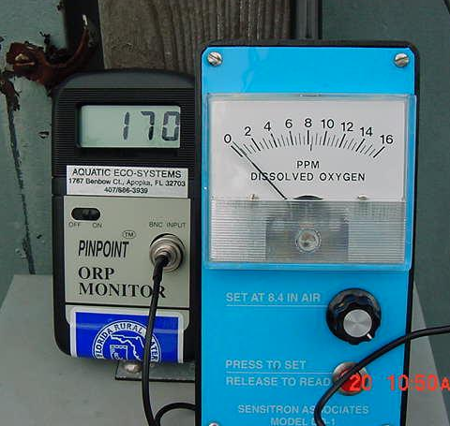
Figure 4 ORPmeter (at left) and DO meter

Figure 10 shows an ORP meter and a DO meter taking measurements from an aeration tank. The DO meter shows a residual DO of about 0.5 mg/L while the ORP meter shows 170 mV. These readings indicate that while dissolved oxygen levels are declining, there is still oxygen present since the ORP meter is registering a +170 mV. This particular aeration tank is not yet into an anoxic cycle. Figure 11 shows how ORP can be used to evaluate the treatment system or parts of a system for operating efficiency. The arrows that correspond to #3 and #4 show ranges for nitrification and denitrification, respectively.

ORP & Metabolic Processes
(Gronsky, etal, 1992)
Figure 5

In the example given in Figure 12, the dissolved oxygen meter reads zero mg/L and the ORP meter reads +11. These readings indicate the basin is operating in an anoxic condition. This is the optimal condition for denitrification in an anoxic tank or in an aeration tank while the blower is in an off cycle.

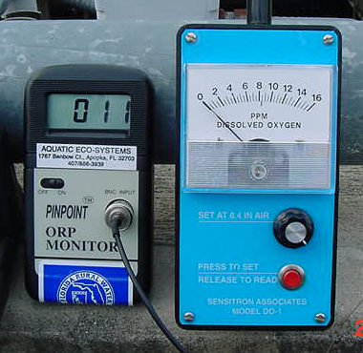

Figure 6 ORP meter (left) and DO meter

Some Suggestions for Overall Plant Operation

When operating a wastewater treatment facility that has an aerobic digester for waste sludge stabilization and plant hydraulic capacity is not limited, it can be beneficial to return digester supernatant during high daily flow periods. Since aerobic digester supernatants can be high in nitrate, this supernatant can be used as a source of oxygen in anoxic basins or during anoxic periods. This same supernatant can also be the cause of high nitrate results during regular effluent sampling required by the operating permit.

When operating a treatment facility with anaerobic digesters, it is beneficial to return digester supernatant during times of low flows. The strength of this type of supernatant can be high in BOD and ammonia, and returning this liquid during low flows provides food for bacteria during times when the food source is not readily available. Feeding this strong waste stream into the plant during peak flow can deplete dissolved oxygen levels in aeration tanks and adversely effect treatment efficiency.

