

FLORIDA RURAL WATER ASSOCIATION
2970 Wellington Circle West • Suite 101 • Tallahassee, FL 32309-6885
Telephone: 850-668-2746 ~ Fax: 850-893-4581

Setting Capacity Charges for Water & Wastewater Systems
By Sterling L. Carroll, P.E., FRWA Engineer

Growth should pay for Growth. New development causes the need for expansion and should therefore pay its fair share for the costs incurred. These costs are plant expansions and water / sewetr line extensions -- requiring significant cost. Existing ratepayers have supported and maintained the existing facilities, and so new customers should support any new, additional or expanded facilities plus pipelines.
Some officials and developers argued incorrectly that the utility should allow new customers on the system without charge or at original plant costs (not adjusted for inflation). It’s not fair to existing ratepayers and it’s not prudent utility practice. Nor would it be good business practice.
Public officials may be tempted at times to trim budgets; lower utility rates below operational costs; and keep capacity charges below actual capital investment needs -- but this seriously reduces utilities’ ability to perform its central mission, shortchanges ratepayers by delaying costs, sets up unrealistic expectations, and undermines the future vitality of the community.
Capacity Charges are one-time charges assessed to the new development or connections to reimburse utility systems for costs to supply water, collect, treat, and dispose of wastewater. Capacity charges are proportional to the capacity set aside for the new development or connection. In some systems these charges are called Impact Fees while others may be called Benefit Assessments, User Fees, Contributions In Aid of Construction (CIAC) or Connection Charges.
Dealing with Growth & Infrastructure Decay. Florida law requires communities to maintain adequate levels of service for public facilities and to anticipate and prepare for growth. In addition to keeping pace with growth, water and wastewater utilities must maintain the infrastructure in good operating condition. This requires adequate funding and continual repair and replacement (R&R) just to keep up with normal usage and aging. Proper management, training and hiring practices are also essential for efficient utility operation.
As new customers come online more and more of the treatment capacity is used up until the plant is at capacity and must be expanded. Further, the Florida Department of Environmental Protection requires that when a water plant reaches 75% of capacity that planning for expansion must start (Rule 62-555.348 FAC) and when 85% capacity is used that engineering design and construction plans must commence. Similar requirements apply for wastewater facilities during each 5-year operational permit renewal process.
Utilities are Capital Intensive. The water supply and wastewater treatment industry are very capital intensive because almost every component of these systems requires fixed capital investments in long-term infrastructure. Water facilities include water supply, treatment, storage, distribution, and disposal of treatment residuals. Wastewater facilities include sewage collection, pumping (lift stations), transmission, treatment, disposal of treated effluent, and disposal of sludge.
Funding Utilities. Utilities typically operate for many years without fully recovering the initial construction costs. Loans and grants supported by rates are used to finance capital facilities. In addition to paying the debt obligation for existing facilities, rates support operation, maintenance, salaries, chemicals, power, vehicles, equipment, repair and replacement. Rates frequently cannot be structured to accommodate new or expanded facilities for new customers. So capacity charges are used to assess new customers for capital construction costs and allow new customers to “buy-in” to the system. Capacity charges bridge the funding gap the needed to build the new facilities to provide service to new residents and businesses. Capacity charges cannot be used for operation, maintenance, repair, replacement, or normal utility administrative costs.
Costs of New Water Treatment Capacity. Establishing the cost for new treatment capacity is not easily determined. Most new construction projects or plant expansions include a variety of unique items. Apples-to-apples comparisons are not easy to make. FRWA is committed to providing clarity and we have provided some rules-of-thumb to help you estimate Capacity Charges.
Type of Treatment. The type of treatment used throughout Florida can be as simple as disinfection or advanced such as reverse osmosis / demineralization. As treatment becomes more complex total costs increase. Treatment could include lime softening, filtration, polyphosphate sequenterant, chloramination, etc.
Economies of Scale. Size of system is a major cost factor. Larger systems have economies of scale and reduced per gallon costs. Smaller systems should not be tempted to compare rates, costs and fees to larger systems.
Cost Per Gallon / ERU Calculations. The cost per gallon for treatment involves:
Cost per gallon = | Total Project Costs to Construct Treatment Capacity ^{A} ($)
Cost per gallon = | Total Treatment Capacity (gallons per day)
A -- Total Project Costs to Construct Treatment Capacity MUST include wells, land acquisition, storage, buildings / structures, instrumentation and controls, residuals disposal, planning, financing, engineering, permitting, administrative, and construction activities.
For an Equal Residential Unit (ERU), which uses an estimated 250 gallons per day, the equation would look like this: involves:
ERU Costs = | Total Project Costs ($) x 250 gallons per day per ERU
ERU Costs = | Total Treatment Capacity (gallons per day)

The example chart below provides estimated treatment plant Construction Costs versus Plant Size and shows three different treatment processes. Costs below include financing, engineering, permitting, administrative, and construction -- but DO NOT INCLUDE raw water wells, raw water piping, land acquisition, operation / administration offices, additional distribution piping, automatic instrumentation & controls, emergency power generation, or deep wells for reverse osmosis brine disposal. For instance the initial costs for one reverse osmosis brine disposal well starts at $7 Million.
FRWA Capacity Charges Rules-of-Thumb. Ten years ago conventional lime softening plants would cost about $4 to $6 per gallon to construct, today you would expect to spend approximately $8 to $9 per gallon to construct. Actual costs vary greatly by community, by region, and between design consultants. Plus any estimate must include unique site-specific needs like new raw water wells, piping, land, instrumentation & controls, emergency power generation, or deep wells.
Caution: Utility professionals should use actual construction costs to establish capacity charges that would be able to withstand legal challenges.
Example Capacity Charge Calculations. The capacity charge equation for the treatment component would start like this:
- Given Water Treatment Plant Costs = $5 per gallon
- Capacity Charge = $5 per gallon x 250 gallons per day per ERU = $1,250 per ERU
- So for every equal residential unit the capacity charge is about $1,250 per ERU.
- If a business decides to connect and their estimated flows are 1,500 gpd.
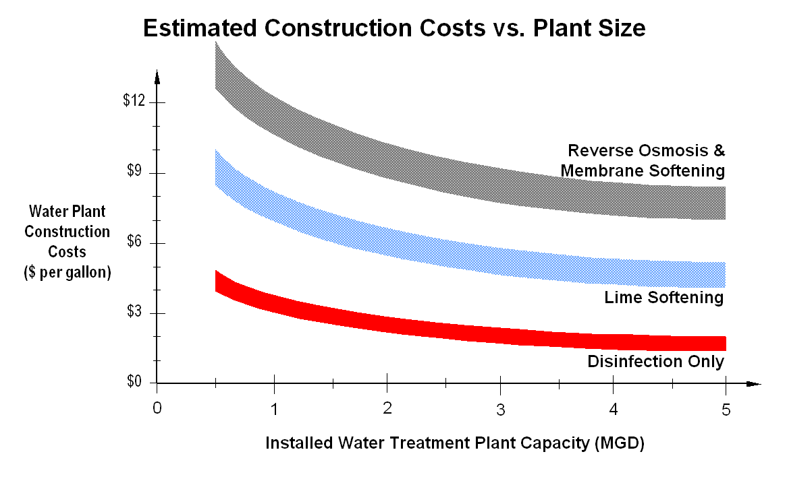
- Capacity Charge = (1,500 gpd x $1,250 per ERU) / 250 gpd / ERU = $7,500
Costs of New Wastewater Treatment Capacity. Establishing the cost for new wastewater treatment capacity just as difficult for wastewater treatment plants. Rules-of-thumb to help you estimate Capacity Charges for wastewater plants are provided, but do not include collection systems, lift stations, force mains, land acquisition, offices, SCADA, controls, emergency power generation, sprayfields, percolations ponds, or deep wells for disposal.
Ten years ago conventional extended aeration secondary treatment plant would cost about $3 to $5 per gallon to construct, today you would expect to spend approximately $6 to $12 per gallon to construct. Actual costs vary greatly by community, by region, and between design consultants.
Setting Capacity Charges. Communities wishing to establish capacity charges should take the following steps:
- Establish Equivalent Residential Unit Flows. From Monthly Operating Reports flow history establish maximum daily flows per connection. This should give you an ERU value of about 200 to 250 gallons per day.
- Remaining Capacity Available and Population Growth. Have your chief operator or design engineer determine remaining capacity in your treatment plant – this should be reported in gallons per day and ERUs. Evaluating remaining capacity in the plant along with population growth should give you a good idea of the needed capacity for the next 5 to 10 year planning horizon.
- Estimate Costs to Expand Treatment Capacity. Have your utilities director or design engineer estimate costs to expand treatment capacity to meet the needs over the next 5 to 10 years. Comparing actual costs in a neighboring community for a similar expansion you can make an estimate for your system.
- Calculate Per Gallon Costs for Expanded Treatment Capacity. Divide estimated costs by gallons of expanded capacity – now you have Capacity Charges.
- Develop a Capacity Charge Table. A Capacity Charge Table can be based on flows (gpd) or equal residential units. We recommend flows should be used instead of meter size, since it is more accurate and easier to manage.
- Adopt Capacity Charge Ordinance. Have your utilities director and attorney draft an ordinance to formally adopt the capacity charges. We strongly recommend that capacity charges be automatically adjusted to the cost of living index. Your circuit rider can provide several good examples or you can find many by Googling the web.
Capacity Charges necessary for proper utility financial health and operation! Growth should pay for growth and system impacts -- to maintain adequate levels of service for public facilities. Utilities are capital intensive and connections should account for all costs. Rates are not be structured to accommodate new or expanded facilities for new customers. So capacity charges are used to assess new customers for capital construction costs and allow new customers to “buy-in” to the system and bridge the funding gap.
Florida Rural Water Association would be pleased to provide assistance in establishing adequate Capacity Charges for your community as a free membership benefit.

This is the fifth in a series of five articles on utility operations (1) Enterprise Fund Transfers are Not Recommended; (2) The Impending Infrastructure Expenditure Gap (3) What is an Enterprise Fund & How does it Operate? (4) Ratemaking Decisions in Florida’s Public Water and Wastewater Utilities; and (5) Setting Capacity Charges for Water & Wastewater Systems

Water Rates and Related Charges, AWWA Manual M26, Fourth Edition, 1999, American Water Works Association, p. 19-37
FDEP Rule 62-555-348, FAC requires an initial Capacity Analysis Report (CAR) to be submitted within 6 months after the total maximum-day of finished water produced by all the PWS’s treatment plant(s) exceeds 75 percent of the total permitted maximum-day operating capacity of the plant(s). Additionally FDEP Rule 62-555-350, FAC requires that the suppliers of water operate and maintain their public water systems so as to comply with applicable standards, in good condition, and under the plant’s permitted operating capacity. Similar requirements apply for wastewater systems.

