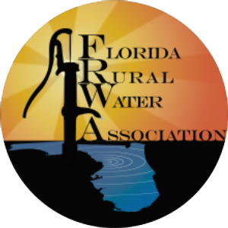

FLORIDA RURAL WATER ASSOCIATION
2970 Wellington Circle West • Suite 101 • Tallahassee, FL 32309-6885
Telephone: 850-668-2746 ~ Fax: 850-893-4581

Ratemaking Decisions

in Florida’s Public Water and Wastewater Utilities
By Sterling L. Carroll, P.E., FRWA Engineer

Introduction. Ratemaking in Florida varies by utility depending on its size and ownership. Privately held systems are regulated by Florida Public Service Commission (FPSC) or by their County Commission, which probably follows FPSC guidelines. Public systems, which fall under the category of municipalities, counties, authorities, non-profit associations, or special districts, are self-regulating under the guise of home rule and operate under the Government-in-the-Sunshine and Public Records Laws.
The current ratemaking practice in Florida typically involves the hiring of an outside professional to prepare a formal rate study, unless an experienced staff member can perform the analysis. The FPSC is available to work with the privately held systems that need help. The Florida Rural Water Association provides formal rate studies to systems serving fewer than 10,000 people as a free membership benefit.
Water and wastewater service is economical and taken for granted until rates need to be adjusted. The largest segment of the Florida water and wastewater utility field, systems that serve less than 10,000 persons are the most challenged maintaining financial sustainability and regulatory compliance. These systems are probably most in need of modifying rates, so revenues exceed expenses and that all expenses are included in the ratemaking equation.
Conservation rates are the most commonly used rates and are typically block rates or base rate plus uniform rates. There is moderate water demand elasticity (as the price increases the consumer buys less) for water rates under $5 per thousand. Public water systems can consider alternative rate bases for low income and disabled citizens through a Lifeline Rate Structure or Low-Income Discount as a matter of public policy.
Reserves are necessary for proper financial operation in anticipation of contingencies and the actual costs of running a utility. Reserve monies should be placed in separate accounts and monies should only be used when approved by the governing board. Revenue requirements for the water and sewer systems typically include Debt-Service Reserves; Repairs and Replacements (R&R) required for routine utility operation; Line Extensions (and other minor capital projects); Depreciation (Infrastructure Investment and unexpected Major Repairs and Replacements) and Emergencies, like hurricanes, fire or drought.
Water and wastewater today. Today in Florida an average of 165 gallons of water is treated per person per day and the ordinary household uses between 250 to 350 gallons per day. Eighty-eight percent (88%) of Florida’s homes receive water at home through public water underground distribution systems. The remaining twelve percent (12%) of residences have their own drinking water wells. Central wastewater systems connect about three-quarters of Florida’s residents, the balance about twenty-seven percent (27%), use on-site treatment and disposal (septic tanks and drainfields).
Did you know that most community water and wastewater systems in Florida serve less than 10,000 people? Florida has about 1,823 Community Water Systems and the overwhelming majority of water systems, eight seven percent (87%), serve populations under 10,000 persons, while 238 medium to large systems serve most of Florida’s population (12.8 million), thirteen percent (13%) of the total CWS’s, see Figure 1.
These smaller systems face problems of economies of scale and more frequently find themselves struggling with system reliability, cost-effectiveness, manpower shortages, financial sustainability and regulatory compliance. This defines the dilemma – financial sustainability is difficult for most small Community Water Systems.
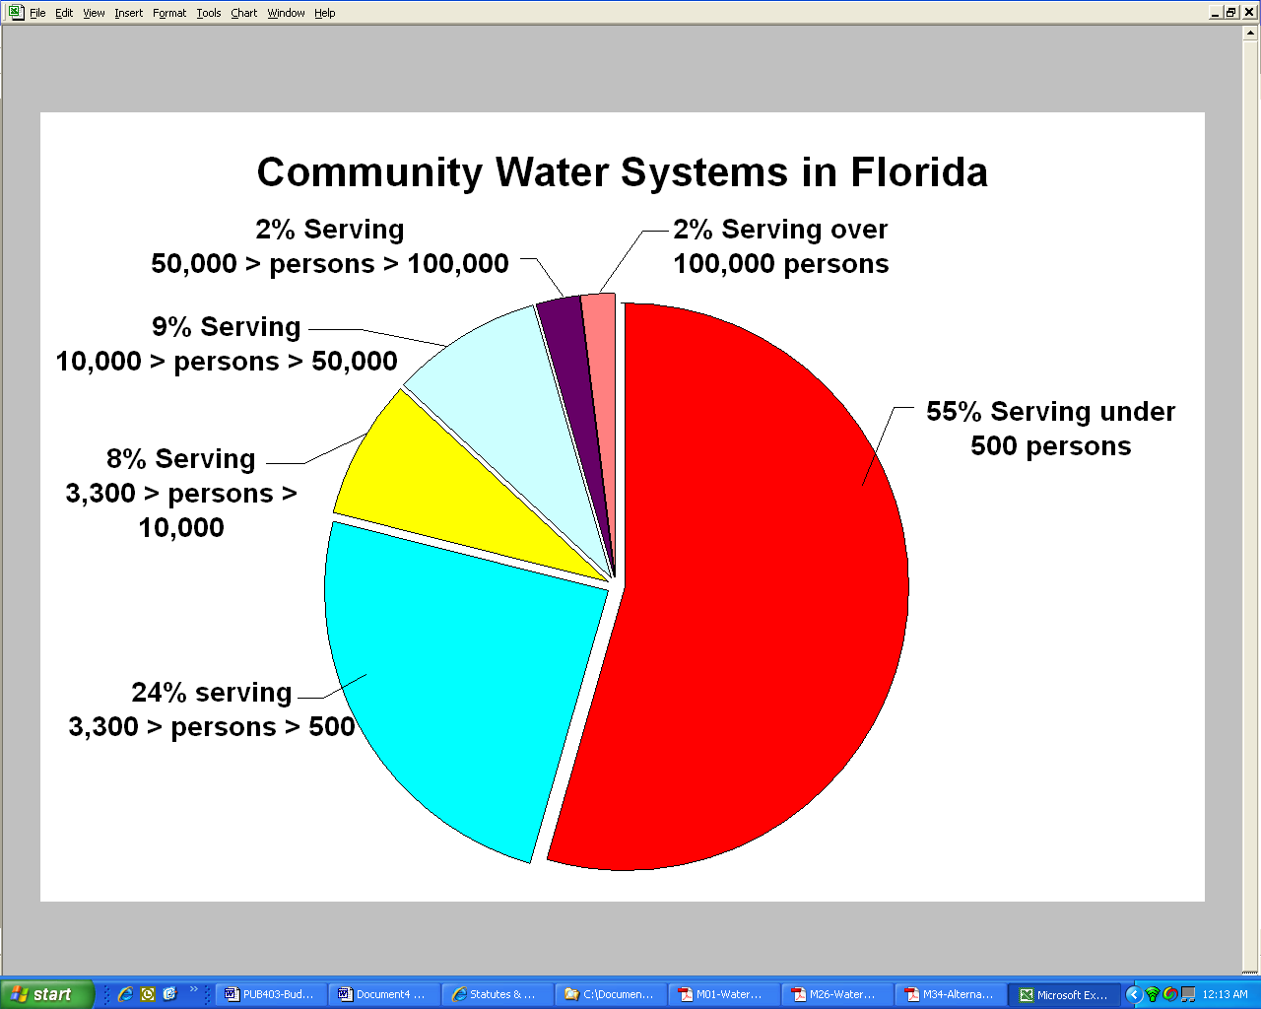
Regulated Systems -- Florida Public Service Commission, County Regulation and Self-Regulation. “Regulation of water in Florida is fragmented”, according to the Office of Program Policy Analysis and Government Accountability (OPPAGA). “In Florida, several entities are responsible for regulating the quality, supply, and cost of water. The specific regulatory entities vary depending on whether the utility is privately or government owned.” The Florida Public Service Commission (FPSC) only regulates private industry (investor-owned water and wastewater companies) in 34 counties out of 67, see map below, Figure 2. The FPSC exercises regulatory authority over utilities (water, wastewater, electric, telephone & natural gas) in three key areas: (1) rate base/economic regulation; (2) competitive market oversight; and (3) monitoring of safety, reliability, and service.
Figure 2 – FPSC Jurisdiction throughout Florida
Figure 1 - Florida’s Community Water Systems
County governments through the home-rule principle have the authority and responsibility to regulate the remaining investor-owned water and wastewater companies as granted by the state legislature under Chapter 367, Florida Statutes. Apparently 33 counties have asserted home rule powers, passed resolutions assuming jurisdiction, and opted out of the Florida Public Service Commission jurisdiction. Presently, Gadsden County is performing a study of water and wastewater needs which includes considering utility regulations, cooperation through agreements, regionalization, and other methods to address the impacts of growth and needs in the county. The rationale for considering regulatory authority over the private-held systems are that “the benefit of this action is that the County could obtain additional powers to decide which areas of the County are to be served by investor-owned utilities and under what conditions. This power would create additional County authority overgrowth within the County and present an alternative means by which the County could directly protect its residents, i.e., regulating the rates which residents must pay for utility service and ensuring that the public health and safety and well-being of the environment are protected.” The proposed change would net the county 4.5% of all private-held water and sewer systems gross revenues to handle the regulatory responsibilities.
Municipally owned and county-owned water and wastewater utilities are self-regulating and do not fall under FPSC or county jurisdiction. These public entities are authorized to adopt rates, budgets and policies under Florida Law and do not have outside review or approval of rates and fees. Oversight comes during the required public hearings through citizen input and comment. Citizens have further influence during board member elections (county, city and authority) in adoption of rates and tariffs. Table 1 below summarizes the distribution of rate setting oversight in Florida by water system numbers and by population, see also Figures 2 and 3.

Table 1 – Regulation of Rates for Community Water Systems in Florida
Agency Regulating Rates & Fees | Community Water Systems (CWS) | Percentage  (%) CWS | Population Served | Percentage  (%) Population
FPSC | 842 | 46% | 1,795,751 | 10.0%
Counties | 434 | 24% | 600,639 | 3.3%
Self Regulating | 547 | 30% | 15,650,841 | 86.7%
Totals | 1823 | 100% | 18,047,231 | 100%
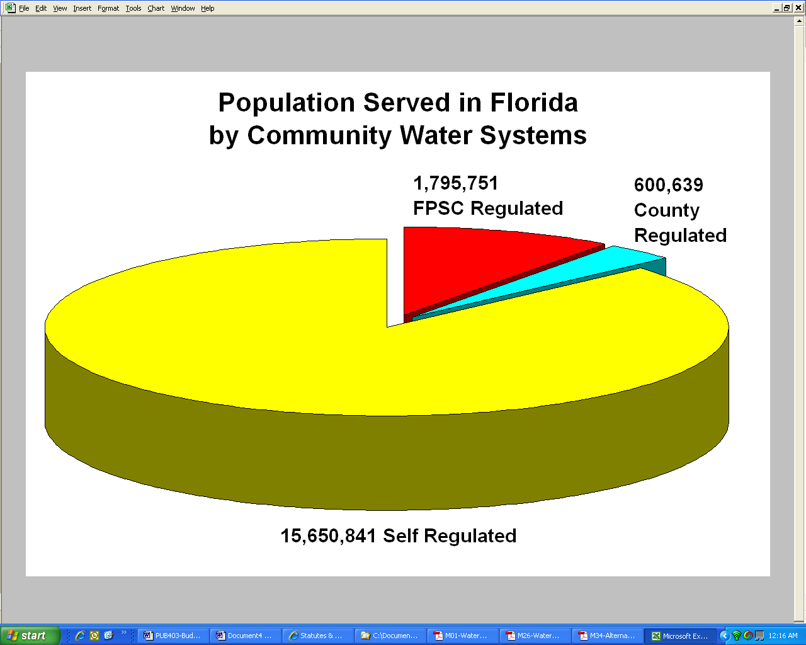
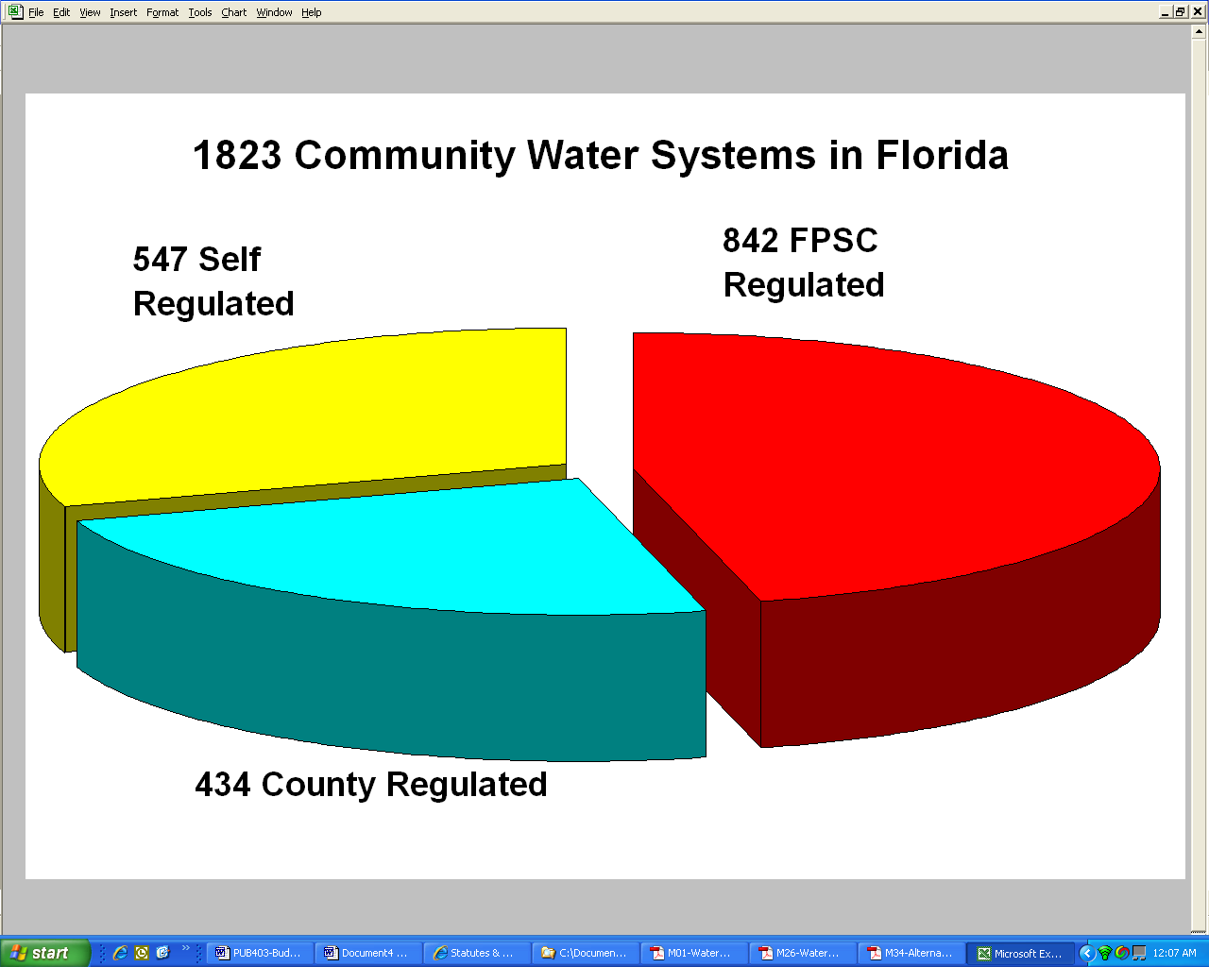
Figure 3 – Distribution of Rate Setting Regulations in Florida by Systems
Figure 4 – Distribution of Rate Setting Regulations in Florida by Population

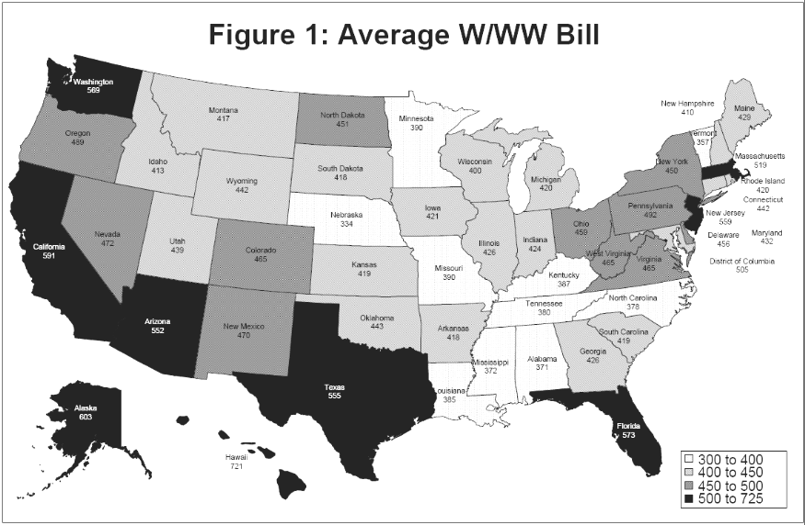
Figure 5 – Average Annual Water & Wastewater Bill ¹³

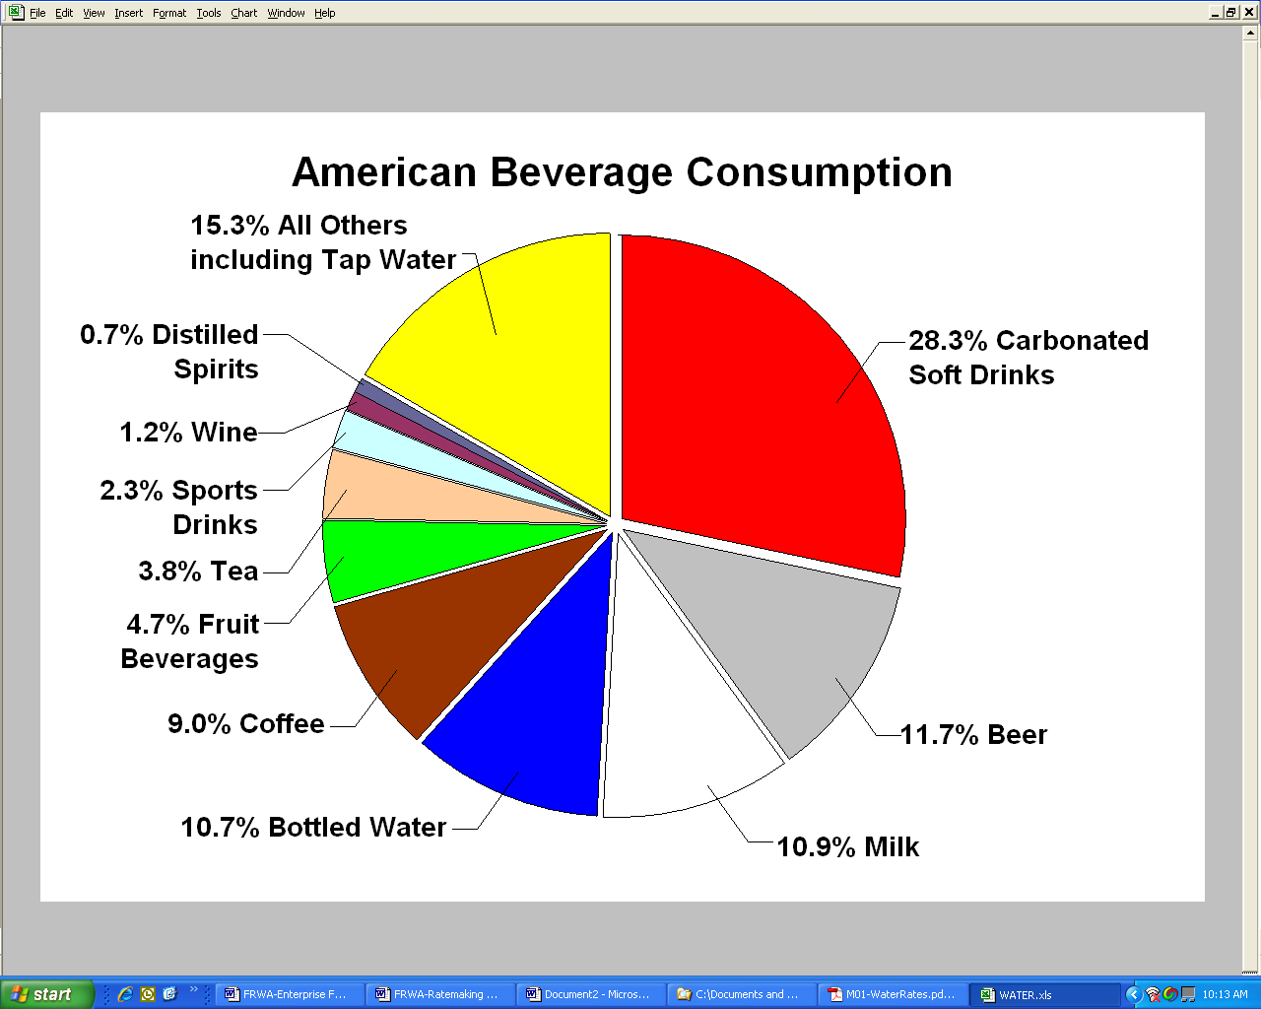
Figure 6 – American Beverage Consumption

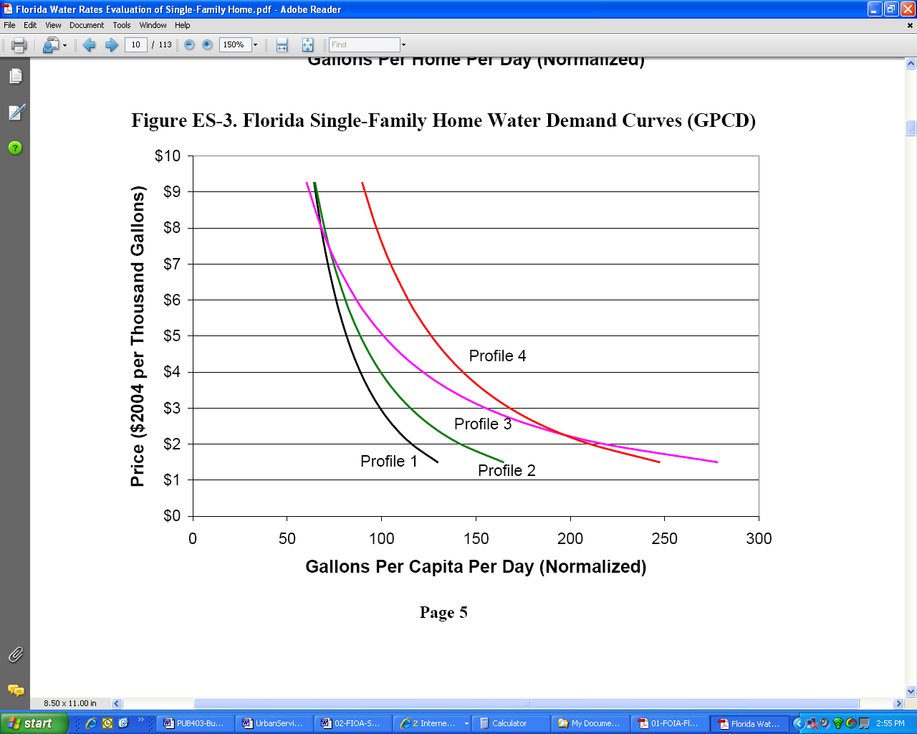
Figure 7 – Florida Single-Family Home Water Demand Curves (GPCD) ²⁰
Elastic Pricing Range
Inelastic Pricing Range
Price-Usage Walls

Almost half of the Community Water Systems in Florida are regulated by the FPSC, however these are smaller systems. The total population under FPSC jurisdiction accounts for only 10% of the state’s population or 1.8 million people. Counties regulate an additional 3.3% of the state’s population or 0.6 million people. This leaves 15.7 million people or 86.7% of Florida’s population in self-regulating systems.
Rate setting (user fees) decisions constitute a largely self-regulated activity for most of Florida’s population. Water and wastewater utilities are natural monopolies -- most citizens receive services through these publicly owned monopolies. However, cities, counties and authorities are required to operate under the Government-in-the-Sunshine Laws Chapter 286 of the Florida Statutes, the Federal Freedom of Information Act (FOIA), and the Public Records Law, Chapter 119 of the Florida Statutes.
Snapshot of Water and Wastewater Rates in Florida. In 2000, there were approximately 6.2 million households in Florida, of these 62.25% paid directly for water and wastewater utilities via a bill separate of a rental or maintenance fee. Among the households that paid a water and wastewater bill, the average bill was $573 per year (or $47.75 per month), which equates to a low 1.91% burden of their average household income. The national average utility bill was $476 per year, almost $100 lower than Florida’s average, see Figure 5. Water typically represents about 55% to 60% of the total utility bill while the wastewater portion is 40% to 45%. A Florida Rural Water Association study conducted in October 2005 of 34 small water systems averaging 3,000 persons showed the average water bill was $18.79 per month and wastewater bill $20.13. The total average bill for water and wastewater service was $38.92 monthly or $467.06 annually. The cost for drinking water is measured in the thousands of gallons – typically $1.50 to $4.00 per thousand gallons (or $0.0015 to $0.004 per gallon).
In stark comparison, the average American household spends $707 per year on carbonated soft drinks and other bottled drinks. According to beverage trade sources, American tastes are diverse in beverage consumption (see Figure 6) – the distributed choices are:
- 28.3% carbonated soft drinks
- 11.7% beer
- 10.9% milk
- 10.7% bottled water
- 9.0% coffee
- 4.7% fruit beverages
- 3.8% tea
- 2.3% sports drinks
- 1.2% wine
- 0.7% distilled spirits
- 15.3% all others.
- Unfortunately, tap water is less than 5% of the total U.S. beverage consumption.
Drink More Tap Water – it’s a Bargain! “Compared with other developed countries, the United States has the lowest burden for water/wastewater bills when measured as a percentage of household income.” Tap water is a bargain; the cost for bottled water at the local quickie mart is well over $10 per gallon (more than gasoline).
Average Water Usage and Conservation Rates in Florida. The typical residential customer uses 6,500 gallons per month with a usage range of 3,000 to 9,000 gallons per month. A recent study financed by four of the five Water Management Districts in Florida showed that there is considerable price elasticity for the ‘typical’ water rate range (in the $1.50 to $5.00 per thousand gallons), see Figure 7.
The profiles represent four distinct home types based on median property value (in 2004) and house size characteristics: About 3,500 homes were sampled for the study using 16 utilities spread around Florida. The four home profiles target characteristic types and were normalized for the study.
Table 2 - Profile Definitions
Profile | Property Value Percentile | Assessed Property Value | House Size (sq ft)
1 | 25% | $57,890 | 1,350
2 | 50% | $84,330 | 1,727
3 | 75% | $126,932 | 2,197
4 | 90% | $197,400 | 2,841

Price Elasticity of Water Demand. Price elasticity is a term from the study of economics meaning that as the price changes the consumer buys less or more. In this example as the water rates increase the water usage decreases – conservation rates work well for rates under $5 per thousand.
For example, let’s use Profile 3 (the purple line) which represents a 2,197 square foot home with an assessed value of $126,932. When the price of water is set at $1.5 per 1000 gallons the useage is about 275 gallons per capita per day (gpcd). When the price goes to $2 / 1000 gal the useage drops to about 215 gpcd. At $3 / 1000 gal useage is 155 gpcd, but when it goes to $6 / 1000 gal the useage is under 90 gpcd.
Once the price for water reaches about $6 per thousand gallons, usage becomes inelastic, or hits the wall so to speak -- a price-usage wall. John B. Whitcomb, PhD states in the report, “As price exceeds $6, additional water savings become progressively harder to achieve as customers have cut back to core water uses (e.g., indoor water for toilets, showers, clothes washers, and cooking) or have accessed source substitutes. Customers’ marginal utility or value from remaining utility water use is high, and hence they are less willing to make further water cuts in response to price increases.”
Ratemaking Process. Rates are designed to provide revenues for the operation and maintenance requirements of the utility and include salaries, wages, employee fringe benefits, power, chemicals, minor equipment, contract services (engineering, laboratory tests, auditors, etc.), office space, fittings, materials, supplies, and other general overhead expenses.
Utilities typically hire outside professionals to prepare a formal rate study, unless an experienced staff member can perform the analysis. Florida Rural Water Association provides formal rate studies to systems serving fewer than 10,000 people as a free membership service. The study can be completed in about three months’ time if accurate financial records are provided. Membership for a water and wastewater system servicing 10,000 people is under $500 per year. The typical rate study by a consultant is $25,000 to $45,000.
The basic concept for ratemaking is that revenues must equal or exceed expenses. This is an important concept. One that we have to repeat more often than we think we should.
Ratemaking Equation:
Revenues > Expenses
Rate analysis or audits may uncover the inconvenient truth that current water and wastewater rates may not fully cover all the operating costs and/or fail to capture the actual future (or past) capital costs (that there is not adequate investment accruing into the infrastructure). This situation is all too common for the smaller systems around Florida. They have the expectation of future grants from federal or state sources to “bail them out” for infrastructure replacement. This entitlement mentality constitutes an unrealistic expectation, which allows them to neglect maintenance and upkeep; the real cost of utility operation; and their stewardship of public assets.
Although the myth of 100% grants still exists in the minds of public officials, still engineering consultants have been all too careful to avoid dissuading them of the myth. “The time of 75% grants is over”, says Michael A. Langston, USDA Rural Development Florida Community Programs Director, “those days are past, except for a small group of disadvantaged systems.”
The process of establishing rates is based on a rational method, is defensible against challenge, and uses four basic four steps: “(1) determination of revenue requirements; (2) allocation of costs to the functional components of the cost of service; (3) distribution of the function costs of service to customer classes; and (4) development and design of a schedule of rates and charges to recover the revenue requirements”. We will explore the mechanics of ratemaking more completely in another article, however this is an important process that impacts utility operation in the short and long-term.
Setting Rates Comparable to Neighbors. Additionally, it is prudent to take a sampling of surrounding communities’ rates to confirm that rates are comparative and allows for public officials to justify making the hard decisions in the public arena. Utility professionals have sometimes set rates based only on polling surrounding communities. Although it may be a quick and easy process providing public officials with that warm and fuzzy feeling, rates set by market comparison do not have a rational basis and so are not defensible should they be challenged.
Types of Rate Pricing Structures Common to Florida. The two most common rate structures in use in Florida are Increasing Block Rates and Base Rate plus Uniform Rates. The Increasing Block Rate is used most often – as it encourages customer conservation, which is favored by the all five of Florida’s Water Management Districts. These types of rates send a strong cost signal to the customer in their monthly bill based on usage. As demonstrated by the Whitcomb study (above) these conservation rates are very effective at reducing usage.
Increasing block rates, also called tiered pricing, establishes a basic rate for nominal usage but increases incrementally as the usage increases. This makes the “pain” higher for higher use. The result is more thoughtful conservation by the end user. Implementation of this rate requires computer programs and a minimum of sophistication by the utility’s financial staff.
Base Rate plus Uniform Rate establishes a base rate for minimal usage, a fixed customer charge to cover fixed costs, and adds the same price per unit for water usage beyond the minimum. Classes for residential, commercial, industrial or institutional users are varied for base rate and usage rate.
Other rate structures currently used but not as frequently are:
Flat Fees – the same fee is charged to each customer regardless of usage or class. This category of rates are used by mobile home parks and developer-built subdivisions with no individual water meters.
Seasonal – fees rise and fall usually during in the dry months or “snowbird” season.
Time of day pricing – for commercial, industrial or institutional users with heavy demands which require more storage / pumping infrastructure to accommodate them.
Lifeline Rates is an alternative designed to provide a minimal or essential volume of water service at a reduced cost to those residential customers who, due to their income level, find it difficult to afford water service and as a matter of public policy.. A lifeline rate structure provides an initial, below-cost rate for a specified volume of water. The volume of water billed at the lifeline rate is set at a level that represents the perceived minimal sanitary requirements for the residential customers it is intended to benefit. Eligibility is only offered to customers who meet pre-established income or disability eligibility requirements and who apply to the program.
Low-Income Discount is an alternative similar to the lifeline rate structure but simply provides for a percentage discount from the normal rates. The discount can be applied to some (or all) of the water bill and can be set to ensure that the average water bill does not exceed a specified percentage of poverty-level income.
Required Reserve Funds. Reserve funds are normal operating accounts that are funded in anticipation of contingencies and the actual costs of running a utility. Reserve monies should be placed in separate accounts and funds should only be used when approved by the governing board. Revenue requirements for the water and sewer systems typically include Debt-Service Reserves and other required to provide for normal utility operation routine Repairs and Replacements (R&R); Line Extensions (and other minor capital projects); Depreciation (Infrastructure Investment and unexpected Major Repairs and Replacements) and Emergencies, like hurricanes, fire or famine.
Debt Service Reserve. Debt Reserves are typically established by the bonding company or entity and is often ten percent (10%) of annual debt service. Reserves are collected until it equals one year of debt service. Reserves can be placed in the same Debt Service Account. The utility can earn interest on those funds, but the funds should only be used after the debt is retired.
Repairs and Replacements (R&R) Reserves. Renewal & Replacement Reserves need to be at least three to five-percent (3% to 5%) of revenues for general repairs and maintenance. R&R includes Short-Term Reserves, these are items that require replacement or repair every one to five years (parts, water meters, valves, electrical components, vacuum sewer, small submersible sumps, spray nozzles, vehicles, chemical components, etc). Long-Term Reserves are items that require replacement after ten or more years pumps, motors, standby power generation, blowers, fences, etc.
Line Extensions (and other minor capital projects). Line extensions (and other minor capital projects) can be estimated on system need year-to-year but a good rule of thumb is three to ten percent (3% to 10%) of normal operation for minor capital projects - mains, valves, pumps, etc.
Depreciation Reserve (Infrastructure Investment and unexpected Major Repairs and Replacements). The depreciation reserve funds for capital projects and replacement and protects the long-range sustainability of utility services. Ratepayers have made a significant investment in the capital infrastructure and it is good stewardship to set aside funds for major component replacement (pipelines, lift stations, tanks, buildings, wells, plants, etc.) Depreciation of capital assets is the one-line item that most systems do not typically fund. The Governmental Accounting Standards Board Statement No. 34 – Basic Financial Statements and Management's Discussion and Analysis for State and Local Governments, or more commonly known as GASB 34 establishes the accounting methods for calculating annual depreciation and funding reserves for capital replacement. Reliance on growth for plant expansion and upgrade is not a sustainable policy.
Emergency Reserves. Emergency Reserves need to be at least five to ten-percent (5% to 10%) of revenues for emergency operations during natural or manmade disasters -- hurricanes, storm surges, fires, floods, vandalism, sabotage, drought, hazardous material release, or other catastrophes. This is vital for any utility in Florida!
Water and Wastewater Capacity Charges (Impact Fees). Any discussion of rates and ratemaking should include consideration of water and wastewater capacity charges. A full treatment of capacity charges is found in the FRWA whitepaper on the subject. Capacity charges are one-time charges assessed to the new development or connections to reimburse utility systems for capital (sunk) costs to supply water, collect, treat, and dispose of wastewater. Capacity charges are proportional to the capacity set aside for the new development or connection. In some systems these charges are called impact fees while others may be called benefit assessments, user fees, contributions in aid of construction or connection charges.
Florida law requires communities to maintain adequate levels of service for public facilities and to anticipate and prepare for growth. In addition to keeping pace with growth, water and wastewater utilities must maintain the infrastructure in good operating condition. This requires adequate funding and continual repair and replacement just to keep up with normal usage and aging. Proper management, training and hiring practices are also essential for efficient utility operation.
The case can be made that new development causes the need for expansion and should therefore pay its fair share for the additional costs incurred – growth paying for growth. Ratepayers have supported and maintained the existing facilities, and so new customers should support any new, additional or expanded facilities plus pipelines each requires significant investment. Some public officials have argued that the utility should allow new customers on the system without charge or at original plant costs (not adjusted for inflation). It’s not fair to current ratepayers and it’s not prudent utility practice -- nor is it good business practice.
Summary – Good Public Policy, Accountability and Stewardship. Public officials may be tempted to trim budget, lower utility rates below operational costs, and keep rates and capacity charges below actual capital investment needs – but this seriously reduces the utilities’ ability to perform its central mission, shortchanges ratepayers by delaying costs, sets up unrealistic expectations, and undermines the future vitality of the community.

This is the fourth in a series of five articles on utility operations (1) Enterprise Fund Transfers are Not Recommended; (2) The Impending Infrastructure Expenditure Gap (3) What is an Enterprise Fund & How does it Operate? (4) Ratemaking Decisions in Florida’s Public Water and Wastewater Utilities; and (5) Setting Capacity Charges for Water & Wastewater Systems

ENDNOTES ? Revenue Requirements, AWWA Manual M351, Fourth Edition, 1999, American Water Works Association, p. 4
U.S. Geological Survey, Estimated Use of Water in the United States in 2000, USGS Circular 1268. Denver, Colorado p. 13-16
ibid p. 13-16
Your Home Septic Tank, Fact Sheet SL-59, Soil and Water Science Department, Florida Cooperative Extension Service, Institute of Food and Agricultural Sciences, University of Florida, 2003, http://edis.ifas.ufl.edu/SS115
A Community Water System (CWS) is a public water system that supplies water through pipes or other constructed conveyances to at least 15 service connections or serves an average of at least 25 of the same people year-round. EPA Public Drinking Water Systems: Facts and Figures, http://www.epa.gov/safewater/pws/factoids.html
Water System statistics from the Florida Department of Environmental Protection, October 2007, summarized by the author, http://www.dep.state.fl.us/water/drinkingwater/pws_sys.htm
OPPAGA Report No. 02-67, Intergovernmental Authorities Provide Public Benefits, But They Lack Accountability, Dec 2002. p. 3-4
FPSC Jurisdictional and Non-Jurisdictional Counties, http://www.psc.state.fl.us/utilities/waterwastewater/
Interview with Florida Public Services Commission representative February 21, 2008. The FPSC carries on its work through two primary functional units: The Office of the Executive Director and the Office of the General Counsel. The Offices of the Executive Director and the General Counsel are charged with implementing Chapters 350, 364, 366, 367, 368 and 427, Florida Statutes, and Sections 403.064, 403.501-403.539, and 403.9401-403.9425, Florida Statutes. FPSC Mission Statement: To facilitate the efficient provision of safe and reliable utility services at fair prices.
Chapter 367, Florida Statutes, authorizes counties through their to reinstate their own regulatory authority by home rule powers principle and exclude themselves from FPSC jurisdiction over investor-owned water and wastewater utilities within their counties after at least ten (10) continuous years of Florida Public Service Commissioner jurisdiction. Chapter 367 also prescribes a resolution rescinding FPSC jurisdiction and requires minimum conditions for a county’s exercise of regulatory jurisdiction. Section 125.01(t), Florida Statutes, authorizes a county to adopt ordinances and resolutions as needed to exercise its power and authority.
Gadsden County Utility Report 2007, Eutaw Utilities, Inc., p. 136-141, Appendices 6.4A & 6.4B
Public notices and hearing are required by Florida Statute 180.136 Water or Sewer Utilities; Notice – “Before a local government water or sewer utility increases any rate, charge, or fee for water or sewer utility service, the utility shall provide notice of the proposed increase to each customer of the utility through the utility's billing process. The notice shall state the date, time, and place of the meeting of the governing board of the local government at which such increase will be considered. The notice required in this section is in addition to any notice and public meeting requirements for ordinance adoption as provided by general law.”
Excerpted from the University of Florida Brechner Center for Freedom of Information http://brechner.org/resources.asp “Thirty years ago, Florida enacted the Sunshine Law, Chapter 286 of the Florida Statutes. It established a basic right of access to most meetings of boards, commissions and other governing bodies of state and local governmental agencies. The Sunshine Law, Chapter 286 of the Florida Statutes, requires that government decision-making take place in public. The Sunshine Law prohibits elected officials from meeting behind closed doors to decide matters that affect the citizens they represent in the absence of a specific exemption approved by the Legislature. The basic requirements of the law are that meetings of any public decision-making body must be open to the public, reasonable notice of such meetings must be given and minutes of the meeting must be taken… The Public Records Law, Chapter 119 of the Florida Statutes first passed in 1909, provides that citizens shall have virtually unlimited access to records made or received by any public agency in the course of its official business, unless specifically exempted by the Legislature. Chapter 119 mandates that custodians of these records shall permit them to be inspected and examined by any person desiring to do so, at any reasonable time.”
Rubin, p. 5, Table 8
Community Water Supply Assessment Report prepared for the Suwannee River Water Management District by FRWA. The report was used to implement the provisions of Senate Bill 444, passed during the 2005 legislative session, to development of alternative water supply projects and a regional water supply plan.
Total sales for bottled beverages in 2001 were obtained from the Beverage Digest Fact Book 2002, Beverage Digest Company, Bedford Hills, NY. Total retail sales in 2001 for carbonated, non-carbonated, and bottled water was $82 billion. Dividing $82 billion by 116 million households in the U.S. (obtained from U.S. Census information) yields spending of $707 per household per year. These calculations were made by Holly Stallworth, Ph.D., EPA Office of Water economist. http://www.epa.gov/waterinfrastructure/pricing/index.htm.
American Beverage Association, www.ameribev.org and the Beverage Marketing Corporation, www.beveragemarketing.com
EPA Water & Wastewater Pricing, http://www.epa.gov/waterinfrastructure/pricing/index.htm
Field research -- Aquafina (16 fl. oz) at $1.29 – $1.29 / 16 oz x 128 oz / gallon = $10.32 / gallon
April 20, 2004 JEA News Release http://www.jea.com/about/news/stories/waterconservationrate.asp, The average household uses about 6,600 gallons of water a month.
ibid pp. 17-18
John B. Whitcomb, PhD, “Florida Water Rates Evaluation of Single-Family Homes,” Southwest Florida Water Management District, St. Johns River Water Management District, South Florida Water Management, District Northwest Florida Water Management District, July 13, 2005, p. 70, http://www.swfwmd.state.fl.us/documents/reports/water_rate_report.pdf
Water Rates, AWWA Manual M1, Fourth Edition, 1999, American Water Works Association, p. 2
Florida Rural Water Association provides formal rate studies to systems serving fewer than 10,000 persons as a free membership service. The study can be completed in about three months time if provided accurate financial records. Membership for a water and wastewater system servicing 10,000 persons is under $500 per year. The typical rate study by a consultant is $30,000 to $45,000.
Sterling L. Carroll, P.E., How do I Choose the Right Engineering Firm for my Project? Water Writes, Spring 2007, official publication of Florida Rural Water Association, p. 5
Michael A. Langston, Community Programs Director, USDA Rural Development, Gainesville, FL, e-mail: michael.langston@fl.usda.gov
Water Rates, AWWA Manual M1, Fourth Edition, 1999, American Water Works Association, pp. 76-77
About Water & Wastewater Pricing, http://epa.gov/waterinfrastructure/pricing/About.htm
Alternative Water Rates, AWWA Manual M34, Fourth Edition, 1992, American Water Works Association, pp. 10-15
Alternative Water Rates, AWWA Manual M34, Fourth Edition, 1992, American Water Works Association, pp. 10-15
Revenue Requirements, AWWA Manual M351, Fourth Edition, 1999, American Water Works Association, p. 4
GASB White Paper: Why Governmental Accounting and Financial Reporting Is -- And Should Be – Different, www.gasb.org/white_paper_mar_2006.html, p. 26-27
FDEP Rule 62-555-348, FAC requires an initial Capacity Analysis Report (CAR) to be submitted within 6 months after the total maximum-day of finished water produced by all the PWS’s treatment plant(s) exceeds 75 percent of the total permitted maximum-day operating capacity of the plant(s). Additionally FDEP Rule 62-555-350, FAC requires that the suppliers of water operate and maintain their public water systems so as to comply with applicable standards, in good condition, and under the plant’s permitted operating capacity. Similar requirements apply for wastewater systems.
Excerpted from Capacity Charges Whitepaper by Florida Rural Water Association

