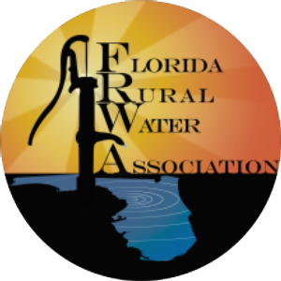

FLORIDA RURAL WATER ASSOCIATION
2970 Wellington Circle West • Suite 101 • Tallahassee, FL 32309-6885
Telephone: 850-668-2746 ~ Fax: 850-893-4581

The Impending Infrastructure Expenditure Gap
By Sterling L. Carroll, P.E., FRWA Engineer

Aging Infrastructure. Leading industry experts and authorities warn about the coming challenges facing utilities small and large. This mounting problem of old pipe and plants will be faced by all utilities in Florida during the coming decades.
The estimated price to ramp up for infrastructure reinvestment, rehabilitation and replacement may be as much as 2% to 4% above the rate of inflation – quite a cost commitment!
A number of factors contributing to the impending infrastructure spending gap are:
- Combined aging of water and wastewater piping – reaching the end of useful life.
- Reduced function of treatment facilities and increased need for replacement.
- Substantial decline in federal and state grants in meeting mandates.
- Population growth.
- New consumptive use restrictions implemented by state Water Management Districts.
- New, more costly, and more complex federal rules and regulations – unfunded mandates; and,
- Potential impacts from global climate changes.
Florida’s water and wastewater infrastructure represents more than a century of investment, substantially funded by local ratepayers. A significant of Florida’s infrastructure dates from the period just following World War II. Florida’s population boom followed the advances in affordable of air conditioning and improved mosquito control making Florida a desired location. All of this means the newest of Florida’s systems are now over 50 years old and a considerable number of city systems have pipes approaching 100 years old – nearing the end of their useful life.

These systems were built and expanded to accommodate the baby boom generation – and now aging with them into retirement.

AWWA Infrastructure Replacement Study. AWWA’s study, “Reinvesting in Drinking Water Infrastructure, Dawn of the Replacement Era” focused on twenty medium to large utilities scattered throughout the United States projecting infrastructure needs. The historic pattern (1870 to 2000) of water main installation was analyzed by AWWA graphically presented in Figure 1.
The historic pattern of main installation reflects the total cost in current dollars of replacing the pipes laid down between 1870 and 1998 from the AWWA study. Figure 1 is graphical representation is a reflection of the development of the overall pattern of population growth in large cities across the country.
Note there are periods of boom and slower growth -- an 1890s boom, a World War I boom, a roaring ’20s boom, and the massive post-World War II baby boom.
Why is it important? These system expansion waves are echoed in near future with the aging infrastructure and needed rehabilitation or replacement.
Replacement Costs for Water Infrastructure. The AWWA does not have good news for ratepayers or utility professionals. “The cumulative replacement cost value of water main assets (that is, the cost of replacing water mains in constant year 2000 dollars) has increased steadily over the last century in our sample of 20 utilities. In aggregate across our sample of utilities, the replacement value of water mains in today’s dollars is about $6,300 per household. If water treatment plants, pumps, etc., are included, this figure rises to just under $10,000 per household. This is more than three times what it was in 1930 in constant dollar terms. The difference is not due to inflation; rather, there is simply more than three times as much of this infrastructure today as there was in 1930, in order to support improved service standards and the changing nature of urban development.”
The AWWA study predicts that by 2030 an average utility will be spending 3.5 times more for pipe replacement due to end of useful life, leaks and breakage issues. The news is worse for small systems since these costs will be higher on a per capita basis.
Figure 1 - Original Water and Wastewater Infrastructure Asset Investment Profile ³
Predictions of Aging Pipelines. EPA predicts the shift in the likely condition associated with the aging pipe networks (see Figure 2). As systems age and deteriorate the need to replace pipe will generally echo the original installation wave as shown in Figure 1. Although there will be differences based on pipe material and condition, systems are going to be faced with replacement and renewal projects.
Based on the deterioration projections, the amount of pipe classified as either "poor," "very poor," or "life elapsed" will increase from 10 percent of the total network to 44 percent of the total network.
AWWA has forecasted needed infrastructure replacement over the next 30 years, see the Nessie curve Figure 3, Asset Replacement Projections for Combined Water & Wastewater Utility. The report takes 20 utilities spread over the continental United States and presents demographic trends.
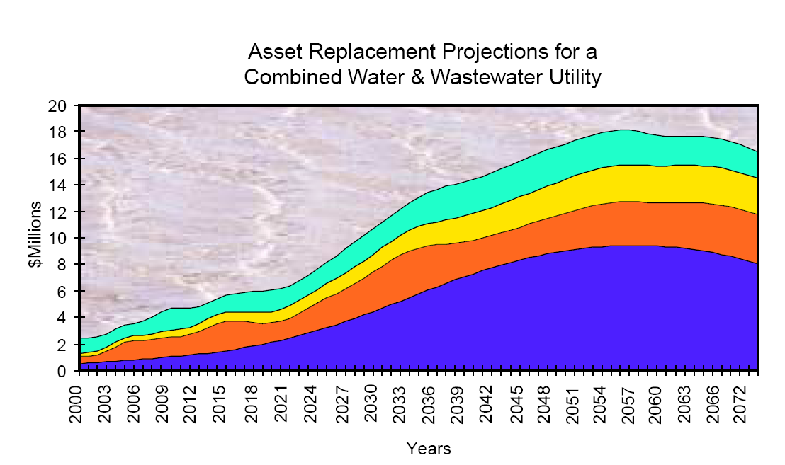
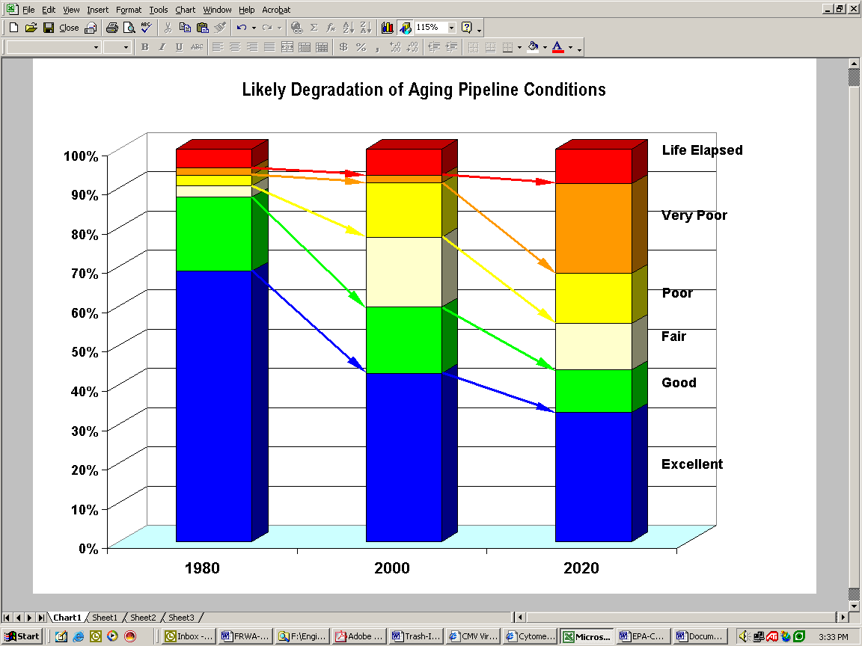
Figure 3 - Asset Replacement Projections for Combined Water & Wastewater Utility ⁷
Figure 2 - Likely Degradation of Aging Pipeline Conditions ⁶
The up-ramp impact for small system replacement of piping, treatment plants and other equipment should be even more concentrated since demographics are more concentrated than national trends.
Another issue that will dominate water and wastewater system expenditures will be population growth and investments to meet new mandates. These demands tend to “push aside the more subtle need for investments in pipe replacement. This is exacerbated by the fact that the costs of water and wastewater service appear on the same bill in most communities. Thus, the need to replace wastewater treatment plants and to replace wastewater lines compete with drinking water needs for the same consumer dollar. Sewer pipes generally impose higher unit replacement costs than water pipes, owing to their inherent characteristics (size, depth, etc.). “
Water utility infrastructure replacement will include, among other things, treatment plants, pumping stations, storage facilities, distribution mains, valves, and service lines. Utilities of all sizes are tasked with evaluating, prioritizing, funding, and implementing infrastructure maintenance and replacement activities. The need to replace water utility infrastructure is increasing, because the facilities installed to meet the unprecedented growth following World War II are nearing the end of their useful lives.
Other problems that will likely lead to revenue shortfall for small water systems are new unfounded requirements under the federal Safe Drinking Water Act (SDWA), difficulty convincing management of pressing long-term utility infrastructure needs, inability to fund programs with the rising costs of chemicals and electricity, and difficulty in achieving economies of scale needed to average costs. Small Florida water systems have also felt the impacts of larger homes and the effects of landscape irrigation that stress peak water production capacity.
While Replacement Cost are Increasing Federal Funds are Decreasing. The Association of Metropolitan Sewerage Agencies has reported that more than 95% of capital investment and operating funds come from local sources for the past seven years. Meanwhile, the federal and state funding investment into wastewater has been almost flat from 1991 to 2001 at $2 to $2.5 billion per year per General Accounting Office estimates, see Figure 3, Local vs. Federal Wastewater Expenditures.
Local expenses are continuing to escalate, while the percentage of costs covered by federal assistance has dropped to well under 5% percent for the AMSA utilities surveyed. Federal government spending on wastewater peaked in the late 1970s and rapidly diminished during the early 1980s. While federal spending has remained flat during the past 10 years, local costs have escalated well beyond the rate of inflation, in 2000 dollars.
Another factor contributing to the current funding gap is that simultaneous with the aging of local water and wastewater infrastructure, has come a significant increase in population.
Solution for the Aging Infrastructure Challenge. The solution for utility professionals and governing board will be to keep ahead of the problem. In addition to rates account for the full cost of utility operation and keep up to the consumer price index it will need to ramp up for infrastructure reinvestment over the next three decades.
AWWA predicts, “To avoid an infrastructure gap, utilities are going to have to increase expenditures to keep up with both compliance requirements and infrastructure replacement.”
The estimated price to ramp up for infrastructure reinvestment, rehabilitation and replacement may be as much as 2% to 4% above the rate of inflation – quite a cost commitment!
Infrastructure problems come in every shape and size. The following is an actual customer service call to a utility in Florida about the unpredictable nature of service disruptions due to line breaks.
The customer calls the utility engineer after a water main break complaining about the loss of water and the precautionary boil water notice. The engineer patently listens for several minutes and is finally able to calm the customer down.
Customer: “Why didn’t you let us know it was going to break?”
Engineer, “Ma’am the main just broke, no one disturbed the line, and there were no contractors in the area. No one can predict when these type of things will happen.”
The customer repeats her request before hanging up, “This was very inconvenient. Please let us know next time before it happens again!”

This is the second in a series of five articles on utility operations (1) Enterprise Fund Transfers are Not Recommended; (2) The Impending Infrastructure Expenditure Gap (3) What is an Enterprise Fund & How does it Operate? (4) Ratemaking Decisions in Florida’s Public Water and Wastewater Utilities; and (5) Setting Capacity Charges for Water & Wastewater Systems

ENDNOTES ? U.S. Senate Testimony by Bruce Tobey, Statement of the Honorable Bruce Tobey, Mayor of Gloucester, Massachusetts on Behalf of the National League of Cities and the Water Infrastructure Network before the Environment and Public Works Committee Subcommittee on Fisheries, Wildlife, and Water United States Senate Water and Wastewater Infrastructure Needs, March 27, 2001, http://epw.senate.gov/107th/tob_0327.htm
Theorizing Land-Cover and Land-Use Change: The Case of the Florida Everglades and Its Degradation, Robert Walker and William Solecki, Annals of the Association of American Geographers, 94(2), 2004, pp. 311–328
Reinvesting in Drinking Water Infrastructure, Dawn of the Replacement Era, Analysis of Twenty Utilities’ Needs for Repair and Replacement of Drinking Water Infrastructure, American Water Works Association, May 2001. The American Water Works Association undertook a study of 20 large and medium utilities to better understand the problem of aging infrastructure. These utilities were: Austin Texas, Boston Massachusetts, Bridgeport Connecticut, Charleston West Virginia, Cincinnati Ohio, Columbus Georgia, Denver Colorado, Des Moines Iowa, Oakland California, Gloucester Massachusetts, Honolulu Hawaii, Louisville Kentucky, New Rochelle New York, Philadelphia Pennsylvania, Portland Oregon, St. Paul Minnesota, Seattle Washington, Tacoma Washington, Tucson Arizona, Wausau Wisconsin.
Reinvesting in Drinking Water Infrastructure, p.10, Figure 2
Reinvesting in Drinking Water Infrastructure, p. 11
The Clean Water and Drinking Water Infrastructure Gap Analysis, Office of Water (4606M), EPA-816-R-02-020, September 2002, p. 14-15, www.epa.gov/safewater
Reinvesting in Drinking Water Infrastructure, p. 20
Reinvesting in Drinking Water Infrastructure, p.19
Why Not Water – Investing in the Nation’s Clean Water Future, Association of Metropolitan Sewerage Agencies, 1990-2002 AMSA Financial Survey, www.amsa-cleanwater.org
Reinvesting in Drinking Water Infrastructure, p. 20
The Clean Water and Drinking Water Infrastructure Gap Analysis, Office of Water (4606M), EPA-816-R-02-020, September 2002, p. 7, www.epa.gov/safewater “The analysis found that a significant funding gap could develop if the nation’s clean water and drinking water systems maintain current spending and operations practices. However, this gap largely disappears if municipalities increase clean water and drinking water spending at a real rate of growth of three percent per year. This real rate of growth represents a three percent per year increase over and above the rate of inflation and is consistent with the long-term growth estimates of the economy.”

