Instructions For Constructing a 3 to 7.5 HP VFD Control Box For Field Applications

Standard Switch Box w/Cover
10 H.P. Variable Frequency Drive Controller (See Parts List Page 5)
12 Gallon PVC Container
10/4 Power Cable w/NEMA 30 Amp Receptacle (power out from VFD to motor)
10/3 Power Cable w/NEMA 30 Amp Plug
(power in from generator)
Air Vent Holes 3 Each Top And Bottom

20 Ft. # 10 Ground Cable

Figure A: VFD Mounted Inside Protective Box

Important Wiring Instructions to Prevent Accidental Shock:

Note: All wire connections are made only inside the VFD unit and inside electrical boxes. This protects personnel from accidental electrical shock. The only voltage permissible in the protective box is 24 volt DC control voltage to energize to signal VFD start. All power cords use standard NEMA plugs and NEMA receptacles. Plugs are used to energize equipment, and receptacles are used to access live power. A plug should never be in an energized condition unless it is attached to a receptacle. This convention protects employees from accidental shock.
The green grounding wire is permanently attached to the metal frame of the VFD cabinet. It will be attached in the field to a ground rod typically found at the point of line power supply. This extra grounding protects against voltage potentials that may exist between metal covers on powered equipment.
Wires that protrude from receptacles into the electrical box are attached with permanent wire connectors. This keeps cables from being accidentally pulled loose from internal wire connections inside the electrical box.

Assembly Instructions for Constructing a VFD Control Box for Field Applications

- All of the parts needed to construct a control box for protection of the VFD and to ensure the safety of personnel who will use the VFD in the field can be obtained from Home Depot., Lowes and other home improvement (hardware) stores.
- A solid HPDE plastic storage box (part no. 045989011357) provides adequate space for mounting the 10 HP VFD and storage of cables used in making field connections. Make sure to provide a watertight cover for the box by cutting and mounting a piece of plywood over the top of the box (not shown) prior to field deployment. Cut the plywood cover large enough to provide 2” of extra space on each side over the top of the control box to preventing rainwater from seeping inside the box.
- Cut 2’ x 4’ - 3/8” plywood to fit bottom and side. Cut the side panel to ensure that the plastic top cover closes freely. Center VFD on plywood; providing a minimum 7” clear distance from VFD to box at bottom. Ensure that there is proper clearance for installation of control box (see above.) The bottom area provides room for storage of cables used with the VFD. Securely attach VFD to plywood using 4 - ¼” hex screws (part no. 03069920025) to VFD back panel.
- Attach bottom plywood to box using 6 – ¼” hex screws. Make sure that holes through box are made in areas where the box and plywood are in direct contact. This ensures structural stability and water tightness. Tighten screws and use a washer to ensure proper compression is achieved to prevent the screws from loosing over time.
- Install 6 air louvers (part no. 050206191224) using hole saw. Cuts should be on flat part of box with flat side of vent on inside of box. Vents should be secured to the box with #10 screws, (this of course, is to aid in cooling of VFD).
Ensure top closes when side plywood is installed
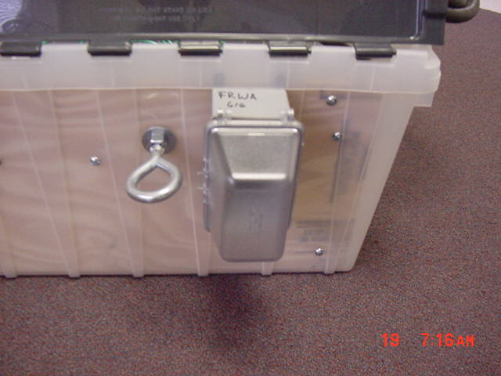
Bolt plywood at box to wood surfaces, tighten securely.
Secure I-Bolt inside box with nuts and drill hole thru bolt for pin. Provided to chain unit in place as theft deterrent system.

Figure B: Box Showing NEMA L 14-30 Receptacle mounted in water proof cover.
- Cut opening through plywood for wire connection lug and install 10-4 cable to VFD. Cable should be about 25” long to allow it to be secured inside box. Install electrical (weatherproof) receptacle box (part no 03448108930) and cover (part no. 092326400367). The box should have a ½ hole at the bottom pointing down. This will allow for any water that could enter the box to drain away. Bolt electrical box to the plywood using 2 – 1/4 “hex screws. Install 10/4 receptacle: (785007857696) with ground at the top of the box. Install weather protective cover (part no 092326400367)
- Install standard on-off switch to be used for VFD start signal at side and top of box as shown in Figure A. For larger generator units, a 50 AMP receptacle should be provided.
Cut at minimum 10’ feet of 10/4 cable and install NEMA plug (part no 785007855173) at one end. (On the other end strip wires back about ¾”, protect bare wires ends by installing a wire nut and/or electricians’ tape). These will be connected to the motor breaker or directly to the motor.
Wiring of VFD

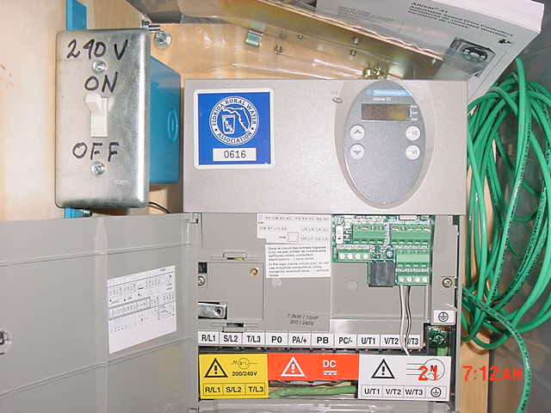
Black Wire
White Wire
Standard 2 conductor thermostat wire, (18 or 20 guage) be sure to use multi strand wire (not single strand)

Figure C: Showing Control Box and VFD Control 24 V Wiring Connections

# 10 Grounding Wire Shown Coiled Inside Protective Box
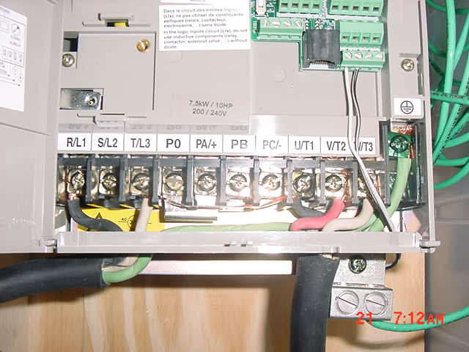
Incoming Single Phase 240 Volt Supply, Note Connections To: R/L 1 T/L 3 And Ground

Three Phase Power From VFD To 3 Phase Motor Via NEMA 30 AMP Receptacle

Figure D: Showing All Incoming and Outgoing Power Connections

Three-phase power out shown in Figure D connects to motor leads as follows:

- U / T 1 Connects To Black Motor Lead
- V / T 2 Connects To Red Motor Lead
- W / T 3 Connects To White Motor Lead
- Green Grounds To Motor
- Ensure all wires are securely tightened to lugs.
- Use wiring convention BOYG, Black, Orange (Red), Yellow (White), and Green.
- Reverse motor leads at motor, NOT at controller, to achieve proper motor rotation.
- Make sure single phase generator is properly sized to handle load. (See FRWA Guidelines for Generator Selection on the FRWA web-site, look under generators).
- FRWA recommends a minimum size generator of 11.5 KW for up to a 10 HP motor.

Parts and Materials List To Construct A 10 HP VFD With Box Enclosure

Description Function

Air Louvers | 6 Total Required (3 per end of box)
30 Feet # 10 Ground Wire | External Ground To VFD Frame
Ground Lug | Ground Connection To VFD Frame
Standard Gang Electrical Box | Run Command To VFD
Standard Electrical Plate | Run Command To VFD
Universal 15 Amp Switch | Run Command To VFD
3/8” Plywood | Box Reinforcement, Side and Bottom
12 Gallon Storage Box | Protective Box For VFD
15 Foot – 10/4 Power Cable | Connect VFD To Electric Motor
NEMA 30 AMP Plug L14-30P | Connect Cable To VFD “Out”
NEMA 30 AMP Receptacle L14-30R | Connect VFD “Out” to Motor Leads
12 Foot – 10/3 Power Cable | Connect Generator To VFD “In”
½” Hex Nuts, Flats, Eyebolt | Secure VFD Protective Box
¼” Bolts, Nuts, Flats | Secure Components To Protective Box
Weatherproof Cover | Weather Protection For Receptacle
Weatherproof Outlet Box | Weather Protection For Receptacle
Halex Clamp Connectors ¾ “ | Secure 10/4 Cable To Receptacle Box
Carlon Conduit Clamps ½ “ | Secure 10/4 and 10/3 Cable Inside Box
10 HP Square D Controller (Grainger Part # 4RA51, Cost $983.00) | 3 To 10 Horsepower Variable Frequency Drive
Thermostat Wire 18 0r 20 Guage | Connect On/Off Switch to VFD

The approximate cost to build one 10 horsepower variable drive enclosure including all wiring, materials and controller is approximately $1160.00.

3 To 7.5 HP VFD Additional Information

Note: It will be necessary to remove the standard 30 Amp breaker on portable generators and install a suitable 50 Amp breaker in its place. Five (5) Horsepower motors will require more starting amperage than the smaller 30 Amp breaker will allow. Make sure the installation of the larger breaker on the portable generator follows safety protocol and installation procedures.

A suitable sized PTO generator powered by a tractor could also power the Variable Frequency Drive (VFD) unit. The portability of a tractor mounted unit may be an enhancement to operations during weather disaster responses.

This information may be found on Florida Rural Water Association web site (www.frwa.net), follow the link to generators, or you may call FRWA at 850-668-2746.

