**Florida Rural Water Association**

2970 Wellington Circle ~ Tallahassee FL 32309

Telephone: 850-668-2746 ~ e-mail: [FRWA@frwa.net](mailto:FRWA@frwa.net)

Certificate of Authorization No.: 29291



### **Collection System**

### **Operation & Maintenance**

### **and Performance Report**

### for

|  |
| --- |
| **Name of Wastewater System** |
| Wastewater System Name |
| **FLA123456** |
| Wastewater Facility Identification No. |
| **County Name** |
| County |
| **Today’s Date** |
| Date |

**Table of Contents**

| **Section** | **Collection System Operation & Maintenance and Performance Report** |
| --- | --- |
|  | **Acknowledgement by the Owner and the facility’s Lead Operator** |
| **1** | **General Information and System Description** |
| 1.1  1.2  1.3 | Wastewater Collection System Description  Wastewater Treatment Plant Description  Wastewater Flows |
| **2** | **Wastewater Collection System Operation & Maintenance Plan** |
| 2.1  2.2  2.3  2.4  2.5 | O&M Plan Description  Infiltration & Inflow Smoke Test and Push Camera Findings  Manhole Findings  Lift Station Findings  Grinder Findings |
| **3** | **Collection System O&M Manual** |
| 3.1  3.2  3.3  3.3.1  3.4  3.4.1  3.4.2  3.4.3  3.4.4  3.5  3.5.1  3.5.2  3.6  3.6.1  3.6.2  3.6.3  3.6.4  3.6.5  3.6.6  3.6.7  3.6.8  3.6.9  3.6.10  3.6.11  3.6.12  3.6.13 | O&M Manual  Organization Chart  Owner’s Responsibilities  Financial Responsibilities  Operator’s Responsibilities  Operational Procedures  Operational Management and Responsibility  Maintenance Staff  Maintenance Staff Capabilities and Limitations  Collection System Management  Reporting of Sanitary Sewer Overflows (SSOs)  Emergency Response  Lift Station Operations  General  Preventive Maintenance  Corrective Maintenance  Contract Maintenance  List of Basic Features  Maintenance Guidelines (Preventative and Corrective)  Schedule Chart  Work Order System  Contract Maintenance Work  Lift Station Operation: Record Keeping  Lift Station Emergency Operation:  Maintenance Schedule for Emergency Bypass Pump and Connection at Lift Station  Air Release Valve SOP |

**Abbreviations**

3MMADF Three Max. Month Average Daily Flow

AADF Annual Average Daily Flow

ACP Asbestos-Cement Pipe

ADF Average Daily Flow

Alum Aluminum Sulfate or Al2(SO4)3•14 H2O

AMP Asset Management Plan

ARV…………….Air Release Valve

BEBR Florida Bureau of Economic and Business Research

BOD-5 Biological Oxygen Demand (5 day)

CBOD-5 Chemical Biological Oxygen Demand (5 day)

CDBG Community Development Block Grant

CEB Chemically Enhanced Backwashing

CIP Capital Improvement Program,

CIP Cast Iron Pipe

Cl Chloride

CW Clean Water

CWSRF Clean Water State Revolving Fund Program

DIP Ductile Iron Pipe

DMRs Discharge Monitoring Reports

DW Drinking Water

ERC Equivalent Residential Connection

ERP Emergency Response Plan

ES Equalization Storage

F.S. Florida Statute

FAC Florida Administrative Code

FDEP Florida Department of Environmental Protection

FRWA Florida Rural Water Association

FY Fiscal Year

gpcd Per Capita Usage per Day

gpd gallons per day

gph gallons per hour

gpm gallons per minute

H2O2 Hydrogen Peroxide

H2S Hydrogen Sulfide

HP Horsepower

ID Identification

kW kilo Watt

kWh kilo Watt hours

LF Linear Feet

LS Lift Station

MCLs Maximum Contaminant Levels

MDF Maximum Daily Flow

MG million gallons

mg/L milligrams per liter

MGD million gallons per day

MH Manhole

NaOCl Sodium Chloride, liquid chlorine, bleach

NaOH Sodium Hydroxide

NPDES National Pollutant Discharge Elimination System

O&M Operations and Maintenance

PDR Preliminary Design Report

PHF Peak Hour Flow

PLC Programmable Logic Controller

PM Preventative Maintenance

ppb Part per billion (µg/L)

ppd pounds per day

PPE Personal Protection Equipment

ppm Part per million (mg/L)

PVC Polyvinyl Chloride Pipe

R&R Rehabilitation & Replacement

R/W Right of Way

RFI Request for Inclusion (for the SRF)

SCADA Supervisory Control and Data Acquisition (Telemetry)

SCFM Standard Cubic Feet per Minute

SOP Standard Operating Procedures

SRF State Revolving Fund

SSOs Sanitary Sewer Overflows

TPC Total Permitted Capacity

TSS Total Suspended Solids

US EPA US Environmental Protection Agency

µg/L micro-grams / Liter

VCP Vitrified Clay Pipe

VFDs Variable Frequency Drives

WTP Water Treatment Plant

WWTP Wastewater Treatment Plant

**Section 1 ~ General Information and System Description**

**1.1 ~ Wastewater Collection System Description**

|  |  |  |  |
| --- | --- | --- | --- |
| The Wastewater System is located in | City Name | , | County Name |
|  | City Name |  | County |
| The systems serves: | # |  | residential customers and |
|  | No. of Residential Customers |  |  |
|  | # |  | commercial customers. |
|  | No. of Commercial Customers |  |  |

See the System Location and System Service Area Maps below.

The wastewater collection system consists of the following components:

|  |  |  |  |  |
| --- | --- | --- | --- | --- |
| **Component** | **Size** | **Material of Construction** | **Quantity** | **Units** |
| Manholes | **4-ft dia.** | **Concrete** |  | Number |
| Gravity Sewer | **4-in** | **PVC** |  | Feet |
| Gravity Sewer | **6-in** | **VCP** |  | Feet |
| Gravity Sewer | **8-in** | **VCP** |  | Feet |
| Gravity Sewer | **12-in** | **PVC** |  | Feet |
| Lift Stations | **6-ft dia.** | **Concrete** |  | Number |
| Force Main | **2-in** | **DIP** |  | Feet |

Complete the Table above with an inventory of Collection System components

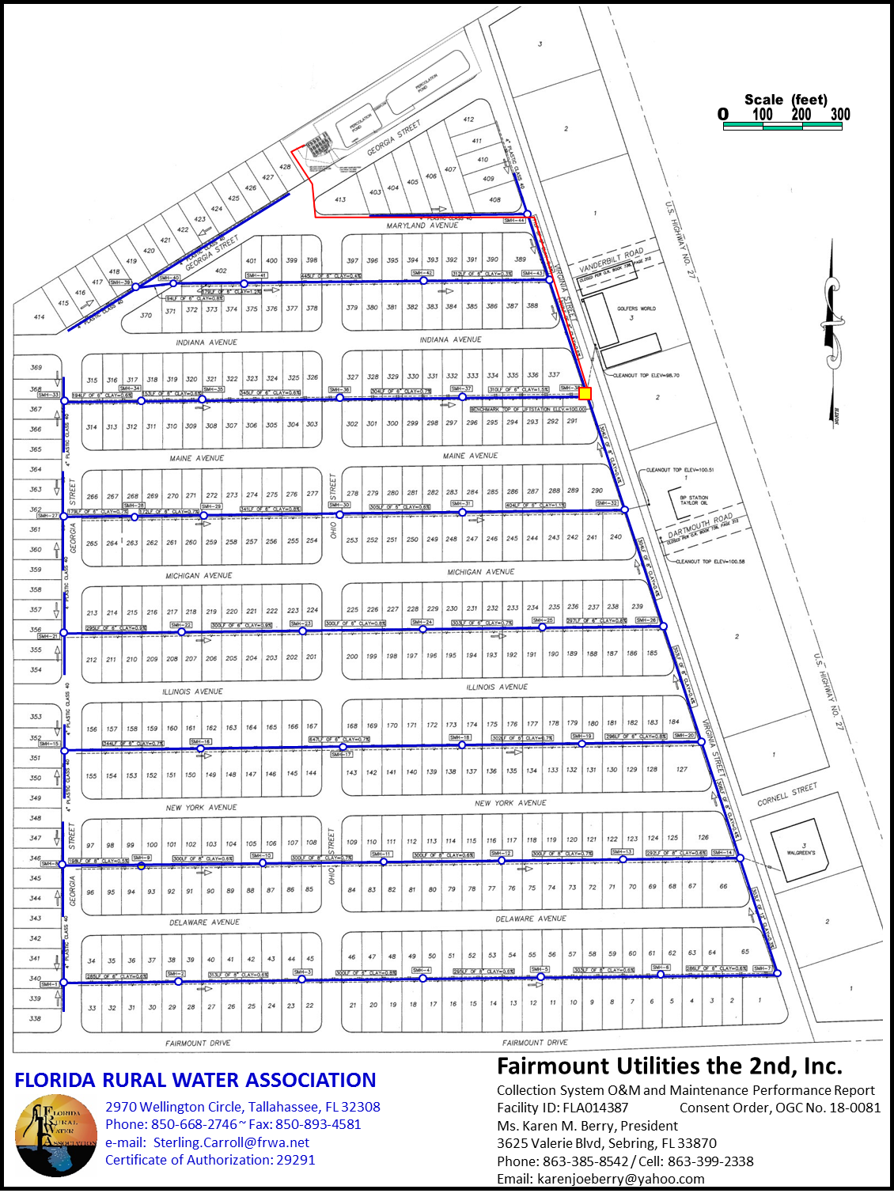

Inert System Service Area or Collection Map Here

**Wastewater Collection System Map**

**Section 2 ~ Wastewater Collection System O&M Plan**

**2.1 ~ O&M Plan Description**

This Wastewater Collection System Operation & Maintenance (O&M) and Performance Plan will be used as a guide for the sanitary sewer system. The purpose of the manual is to instruct the operating and maintenance personnel in the proper understanding, techniques, references, and necessary procedures for operating and maintaining the utility lift station and sewage collection system.

By following the guidelines recommended in this manual, the utility will be assured an efficient, effective, continuous operation in accordance with the rules and FAC of the Florida Department of Environmental Protection.

The ultimate goal of this wastewater system is to efficiently convey the incoming waste in the most efficient manner possible. This manual will outline the recommendations and methods permissible by the sewage system; to enable the lift station operating and maintenance personnel to evaluate the quantity of incoming waste and convey waste at a maximum efficiency in an attempt to achieve this goal.

**2.2 ~ Infiltration & Inflow Smoke Test and Push Camera Findings**

FRWA performed Smoke Tests and Push Camera Inspection of the wastewater collection system and found the following locations in need of repairs.

| **I&I Address** | **Issue** |
| --- | --- |
|  |  |
|  |  |
|  |  |
|  |  |
|  |  |
|  |  |
|  |  |
|  |  |
|  |  |
|  |  |
|  |  |
|  |  |
|  |  |
|  |  |
|  |  |
|  |  |
|  |  |
|  |  |
|  |  |
|  |  |
|  |  |
|  |  |
|  |  |
|  |  |
|  |  |
|  |  |
|  |  |
|  |  |
|  |  |
|  |  |
|  |  |
|  |  |
|  |  |
|  |  |
|  |  |
|  |  |
|  |  |
|  |  |
|  |  |
|  |  |
|  |  |
|  |  |
|  |  |
|  |  |
|  |  |
|  |  |

**2.3 ~ Manhole Findings**

FRWA performed an inspection of the wastewater collection system and found the following manholes in need of repairs.

| **Manhole Address** | **Issue** |
| --- | --- |
|  |  |
|  |  |
|  |  |
|  |  |
|  |  |
|  |  |
|  |  |
|  |  |
|  |  |
|  |  |
|  |  |
|  |  |
|  |  |
|  |  |
|  |  |
|  |  |
|  |  |
|  |  |
|  |  |
|  |  |
|  |  |
|  |  |
|  |  |
|  |  |
|  |  |
|  |  |
|  |  |
|  |  |

**2.4 ~ Lift Station Findings**

FRWA performed an inspection of the wastewater collection system and found the following lift stations in need of repairs.

| **Lift Station Address** | **Issue** |
| --- | --- |
|  |  |
|  |  |
|  |  |
|  |  |
|  |  |
|  |  |
|  |  |
|  |  |

**2.5 ~ Grinder Station Findings**

FRWA performed an inspection of the wastewater collection system and found the following Grinders in need of repairs.

| **Grinder Address** | **Issue** |
| --- | --- |
|  |  |
|  |  |
|  |  |
|  |  |
|  |  |
|  |  |
|  |  |
|  |  |

**Section 3 ~ Collection System O&M Manual**

**3.1 ~ O&M Manual**

This operation manual has been prepared to facilitate easy and quick reference. Lift Station operators should study the manual’s Table of Contents to become familiar with the information presented in it. The chapters are arranged in a logical order beginning with a general introduction, collection systems management, collection systems operations, maintenance and equipment, collection system capacity assurance program and appendices.

It is recommended that all operating personnel read the entire manual so that they become familiar of the details contained in each chapter.

**3.2 ~ Organization Chart**

**Technical Support**

FRWA Wastewater Circuit Rider

**Operator**

**Maintenance**

**Testing Lab**

Equipment, Chemical Suppliers, etc.

Insert Circuit Rider’s Name

Insert Wastewater System Name

Insert Owner’s / Manager’s Name

Owner’s / Manager’s Title

Insert Maintenance Person’s Name

Phone Nos.

Insert Operator’s Name

Phone Nos.

Insert Lab Name

Phone Nos.

**3.3 ~ Owner’s Responsibilities**

The Owner of the wastewater system understands that it is ultimately responsible for the operation of the system in compliance with FDEP rules and regulations. This responsibility cannot be delegated to the Contract Operator per Florida Statute. The Owner may hire a Contract Operator to perform the specific duties for the operation of the wastewater system in compliance with FDEP requirements. The owner is responsible for communicating all required regulatory information to the operator.

The Owner is responsible to obtain relevant utility management training including, but not limited to wastewater system management, operations, financial, and regulations. The Owner should not ask, require, or put the Contract Operator in a position to falsify, submit inaccurate reports, records, and so forth, that would impact operations, permit compliance, or the Contract Operator’s license.

The Owner may delegate certain responsibilities such as,

* Maintaining Equipment – lift stations, pumps, blowers, valves, chemical feed equipment, meters, controls, etc. so that these units provide continuous and acceptable operational status.
* Maintaining Infrastructure – inspecting manholes, cleanouts, Laterals, gravity sewer, lift station structures, force mains, etc.
* Preventative Maintenance (Equipment) – lubrication of equipment, checking motor amperages, calibrating meters, cleaning of treatment units, repairing chemical feed equipment, etc.
* Preventative Maintenance (Infrastructure) – repairing manholes, cleanouts, Laterals, gravity sewer, lift station structures, force mains, etc.
* WWTP housekeeping and maintaining site mowing and landscaping
* Major maintenance such as, removing a pump or blowers for repairs or replacements.

The Owner is responsible for FDEP fines and fees, but what if fines come from monitoring violations or operator issues the agreement should clearly delineate who is responsible and pays these fines.

**3.3.1 ~ Financial Responsibilities**

The Utility will prepare an annual operating budget and a five (5) year capital projects budget. The following items are to be included in the budget:

1. **Separation of Maintenance Costs**

This portion of the operation and maintenance manual is provided to guide Lift Station personnel in the keeping of adequate records to enable costs of maintenance to be extracted and maintenance budgets to be compiled. Lift Station information on maintenance costs are very important for their incorporation and maintenance budget. It is important to divide the maintenance operations into service categories and keep costs separate for each category. The service categories recommended are:

* Preventive maintenance
* Corrective maintenance
* Major repairs or alterations

It is recommended that the facility’s personnel work in conjunction with the municipal bookkeeping department to maintain the information on cost and man-hours.

1. **Preventive Maintenance**

Most of the cost attributable to preventive maintenance will be in man-hours since a major part of this maintenance is performed with a minimum of consumed parts and materials. Costs should be further divided into the following:

* Site Work
* Building housekeeping Equipment and tank cleaning Painting
* Lubrication Administration Miscellaneous Corrective Maintenance

The costs falling into this category will include labor and materials for replacing parts in machinery and making repairs to leaking pipes, fittings, valves, etc.

1. **Corrective maintenance**

Corrective maintenance costs shall be made up of labor and materials. In this category the difference between labor costs and material costs shall not be as great as in the preventive cost category. Costs should be further divided into the following:

* Machinery repairs
* Piping repairs
* Site work repairs
* Tank repairs
* Building repairs
* Electrical repairs
* Small equipment replacement

1. **Major Repairs or Alterations**

Major repairs or alteration costs do not occur frequently or on a regular routine basis. Whenever these type costs are incurred they should be kept separate and tallied as such:

* Construction additions
* Contract maintenance items
* Major equipment replacement
* Process modification

1. **Cost Accounting System**

The Lift Station operator is to set up a cost accounting filing system to retain information on costs of preventive maintenance, corrective maintenance and major repairs or alterations. The acquired information shall be kept in file folders along with purchase orders, receipts, man-hour reports and other important papers. Man-hours for each employee are to be broken down into the half hour of the work shift with charge numbers established to separate operations and maintenance work. Individual charge numbers are to be assigned to each category or maintenance work; e.g., preventive, corrective and major repairs or alterations. Since the cost accounting system is to be incorporated into the municipalities bookkeeping system, charge numbers should be acquired from this agency and maintained throughout the Lift Stations filing network. The cost accounting files prove an invaluable asset to local and public officials and to those involved in financing the operation and maintenance of the sewage system.

1. **Budgeting**

Appropriating adequate operational funds to facilitate proper levels of operation and maintenance is prerequisite to implementation of a successful preventive maintenance program. Lack of funding is a primary cause of neglect and resultant deterioration. Annual line item budget development by the Administrative Staff, Engineer and Operations Superintendent is recommended.

**3.4 ~ Operator’s Responsibilities**

The person in charge who is responsible for the operations and maintenance of the sewerage system is the operator. They have the most difficult and demanding position in the employer’s organizational chart.

The operator needs to have an intricate knowledge of the sanitary sewer system. Maintenance personnel are expected to have similar knowledge for operation and maintenance of the Lift Stations and sewerage system.

The operator should provide a list of routine operations checks. The owner or responsible person will notify the contract operator of any scheduled or unplanned system problems, repairs, or modifications that arise in the contract operator’s absence.

**3.4.1 ~ Operational Procedures**

The operator in charge should be thoroughly familiar with his own sanitary sewer system. He should know the function of each unit in the system; how each unit accomplishes its function; how to evaluate the operation of each Lift Station in the system; how to evaluate each station, and how each unit fits into the overall sanitary sewer system. The sewer foreman should also be thoroughly familiar with the theory and practice of operations of his own facilities and those of other types of systems.

**Accurate Records.** The operator and maintenance staff shall keep complete and accurate records of all phases of Lift Station operations and maintenance.

**Keeping the Utility Owner Informed.** The operator shall continue to provide a monthly report to the Utility Owner in charge of sanitary sewers in relation to design standards, physical condition, and the costs of operations and repairs. The Utility Owner shall be provided with the monthly report as well so they may be aware of any potential repairs or necessary expansion of facilities.

**Keeping Informed of Current O&M Practices.** The operator in charge should be familiar with and continuously informed of the best maintenance procedures. Proper maintenance leads to an efficient system.

**Courses and Operator Schools Available.** The operators should participate in continuing educational classes as well as attend seminars related to the proper operations and maintenance of the sanitary sewer system.

**Professional Journals and Periodicals Related to Wastewater Systems.**

The operators should subscribe to magazines, journals and periodicals related to wastewater systems.

**3.4.2 ~ Operational Management and Responsibility**

The operator is responsible to operate the wastewater system in compliance with FDEP rules and regulations. The operator must be Florida licensed and responsibilities include, but are not limited to the following:

* The maintenance of efficient system operation and maintenance
* Maintaining sewerage system operational and management records
* Develop a listing of staff requirements, develop job descriptions, develop an organizational chart and assign personnel.
* Provide adequate working conditions, safety equipment, and provide proper tools for operations personnel
* Establish and implement and operator training program
* Provide salaries commensurate with the skill level, experience and responsibilities of a sewer foreman and operators/laborers
* Providing operations personnel with sufficient funds to properly operate and maintain the Utility’s wastewater system
* Project the need for increased future expenditures. The operator should advise the Utility owner of the expected future needs to permit early budgeting if possible.
* Being thoroughly familiar with the system, the operator should know the function of each unit in the system; how each unit accomplishes its function; how to evaluate the operation of each unit; and how each unit fits into the overall system and collection process. The operator should be thoroughly familiar with the theory and practice of the operations of his own system and to some extent those of other types of systems.

**3.4.3 ~ Maintenance Staff**

A system as small as Fairmont Utilities operates with a limited number of personnel and therefore is expected to be short of qualified individuals needed to perform many of the technical maintenance services required. Only properly trained personnel can be expected to perform satisfactory inspections, repairs and corrective and preventive maintenance tasks. The maintenance staff for this system generally consists of the operator, assistant operator and maintenance personnel. The operator and assistant operator are expected to assist in performing preventive maintenance items as well as corrective maintenance and supervising contract maintenance work.

**3.4.4 ~ Maintenance Staff Capabilities and Limitations**

Properly trained personnel must possess a thorough knowledge of the functions and operation of the equipment and the procedures for servicing. Lift Station operations and maintenance personnel are generally limited in their knowledge of equipment specifics which places many maintenance tasks under contract maintenance work.

Lift station personnel at these facilities must be familiar enough with the equipment to perform routine maintenance tasks such as monitoring for unusual noises, smells and visual defects, lubricating, cleansing, etc. Whenever contract maintenance or maintenance beyond the capabilities of the full time and/or part time staff is performed, the plant workmen should observe the work and ask as many questions as possible to acquire additional knowledge of the maintenance. Any information gained in this manner can be put to good use later in cutting maintenance costs and reducing equipment down time.

Another area of information for Lift Station personnel is the manufacturer’s service manuals. These manuals must be thoroughly reviewed before maintenance is performed unless the workmen are familiar with the maintenance requirements. Generally work on pump equipment requires knowledge of mechanical equipment and some mechanical aptitude. Electrical maintenance, other than changing light bulbs and fuses, requires detailed electrical abilities and should be done by a certified electrician; therefore, most electrical maintenance shall be contract maintenance.

**3.5 ~ Collection System Management**

The operator shall routinely consult with the Utility owner to review the overall status of the sewerage system. Upcoming sewer maintenance repair and televising shall be determined and planned as necessary. Mapping updates shall be completed on an as needed basis.

Future budgeting for upcoming sewer projects shall be reviewed with the operator and Utility owner.

The operator is responsible for the overall operations and maintenance of the Utilities sanitary sewer system. This includes all Lift Stations, force main and gravity sewers. He is a licensed professional. His primary duties include the daily inspections of the Lift Stations, making any necessary repairs to the Lift Stations, sanitary sewer lines, reporting any violations, implementing the Sanitary Sewer Overflow (SSO) Response Plan and making sure spare parts are available for Lift Stations.

**Laborers.** The laborers report to the operator. Their primary responsibility is to assist the operator in maintaining and operating the sanitary sewer system.

**3.5.1 ~ Reporting of Sanitary Sewer Overflows (SSOs)**

The chain of communication for reporting SSO’s can be seen below and Appendix A the SSO Response Plan.

**Maintenance**

**Wastewater Operator**

**Call Public Information Officer,**

**Collection System Manager**

**Over**

**1,000-gal?**

**Notify the**

**State Watch Office (SWO)**

**800-320-0519 or**

**850-413-9900**

**FDEP Pollution Notification,**

**Abnormal Event report**

**Conduct Cleanup, if necessary**

**No**

**Yes**

**60 minutes**

**24 hours**

Insert Operator’s Name

Phone Nos.

Insert Owner’s / Manager’s Name

Owner’s / Manager’s Title

Insert Maintenance Person’s Name

Phone Nos.

Phone Nos.

FDEP or DOH District Office

Phone Nos.

**Reporting of Sanitary Sewer Overflows (SSOs)**

**3.5.2 ~ Emergency Response**

During Emergency Response the operator will be on call twenty-four (24) hours a day seven (7) days a week to address such emergencies. The procedure outlined in the SSO Response Plan should be followed including proper Owner, DEP, and resident notifications.

**3.6 ~ Lift Station Operations**

Wastewater Lift Station have complex operations and controls. The objective for managing and operating lift station at the lowest unit cost with the highest efficiency. A key to fulfilling this responsibility is a sound maintenance management program.

**3.6.1 ~ General**

All moving parts of any type of machinery must be kept clean, well lubricated and properly adjusted. If equipment is not maintained properly, wear will increase, efficiency will decrease and eventually the equipment will fail. A well planned and implemented preventive maintenance program will be effective in assuring maximum efficiency and long life for each item of equipment installed in the Lift Stations.

The equipment selected for use in these Lift Stations was considered on the basis on the basis of initial cost and for its ability to provide long life and service under the working conditions to which it would be subjected. Most equipment is of heavy duty type and with proper care should provide many years of service without requiring any corrective maintenance.

The life care of any piece of equipment is dependent upon the care the machine receives. Properly maintained, the major equipment items of this wastewater pumping facility should provide approximately twenty (20) years of service.

**3.6.2 ~ Preventive Maintenance**

As previously mentioned, the preventive maintenance, program is perhaps the most important of all maintenance procedures. Manufacturer’s catalogues and literature furnished with eth equipment generally furnish the preventive maintenance requirements of the equipment. This type of maintenance generally consists of lubrication, cleaning, adjusting, replacing worn parts, winterizing, housekeeping and work directed by this manual, equipment service requirements, and sensual (including visual, audio, feel and smell) observations which can be accomplished with the tools provided as the Lift Stations and by workmen having an average understanding of the workings of the machinery and total Lift Station operation.

Preventive maintenance will not require skilled or factory trained workmen nor sophisticated tools and machinery. Each workman responsible for this type maintenance will be required to become familiar with the purpose, scope, advantages, safety precautions, economics, and necessity of the performance of the work.

**3.6.3 ~ Corrective Maintenance**

Some items of equipment located in the Lift Stations may have corrective maintenance performed by the operator or unskilled workmen at the Lift Station site. Some items of equipment may require corrective maintenance performed by a highly skilled or factory trained personnel at the Lift Stations. Additionally there are some items which cannot be repaired at the stations and will require corrective maintenance performed at the manufacturing plant or a plant required for this type of repair work.

Whenever an item of equipment requires repair the operator should, except for minor items, always acquire additional assistance from persons such as:

* + Laborers
  + Engineer
  + Manufacturer
  + Skilled repairman

This assistant is to determine the cause and result of the failure or malfunction. The operator then must evaluate the knowledge of his workmen, the instruction provided with the equipment, the tools at hand, and the availability of repair in order to ascertain whether the corrective maintenance should be undertaken by the employees of the Lift Station’s owner or whether the repair should be made by contract maintenance.

**3.6.4 ~ Contract Maintenance**

Contract maintenance is that portion of corrective maintenance which cannot be done by municipal employees (regular, part time or temporary). This type of maintenance is that which is conducted in its entirety by hiring of workmen skilled and regularly engaged in the type of work involved whether it is a factory which builds equipment, a service agency of the factory, or whether it be a privately owned independent firm skilled in the nature of the work required.

**3.6.5 ~ List of Basic Features**

The following is a list of basic features of the maintenance management system recommended for adoption and use at these Lift Stations.

* Equipment record system
* Planning and scheduling
* Storeroom and inventory system
* Maintenance and personnel. Cost and budgets for maintenance operations
* Lift Station Operation: Inspection. Each Lift Station should be inspected daily. The operator or his assigned laborer will be responsible for checking each station, taking readings, monitoring pump cycles, and the general maintenance of each Lift Station.
* Lift Station Operation: Emergencies. The Lift Station is equipped with an audible and visual system in case of emergencies such as high water alarms, power failures, etc. The operator is on call twenty-four (24) hours a day seven (7) days a week to address such emergencies.
* Lift Station Operation: Monitoring
* The operator or his assigned laborer will be responsible for checking each station, taking readings, monitoring pump cycles, and the general maintenance of each Lift Station.

**3.6.6 ~ Maintenance Guidelines (Preventative and Corrective)**

The Lift Stations and facilities do not observe holidays, vacations or weekend shutdowns. The Lift Stations do experience variations in flows and maintenance work loads. Under these conditions, it is imperative that maintenance is planned and scheduled so that there is no idle time or peak work load period. Preventative maintenance must be performed on a periodic basis. For Lift Station equipment, the manufacturer’s maintenance manuals must be consulted and a schedule of maintenance required listed. For Lift Station facilities other than equipment, inspections of items and/or Lift Station history will provide information for putting together a schedule.

Corrective maintenance must be scheduled immediately upon occurrence. A history of corrective maintenance problems will greatly contribute to scheduling future work of a similar nature. Indoor and outdoor maintenance should be scheduled to take advantage of good or inclement weather.

All maintenance work should be scheduled just as the operating routine has to be scheduled. Preventative maintenance should not be a haphazard procedure to be done if time permits.

Some types of maintenance must be scheduled on a yearly basis. There are seasonal items to be scheduled such as:

* Lawn and landscaping work
* Pressure washing
* Exterior painting

There are items which may occur annually or others with as much as four or five year intervals. These items include:

* Painting
* Roofing
* Paving and road repairs
* Fencing
* Insulating
* Electrical system upgrading
* Plumbing revisions

The manufacturer’s maintenance manual is generally the best guide for preventive maintenance instructions for any item of equipment. Most equipment is mass produced on a competitive basis and the cost of its maintenance should be consistent with its value, life expectancy and replacement costs. Equipment should be rated as to its critical position in the sewage system and its maintenance priority. Unnecessary or too frequent preventive maintenance can be as wasteful as improper maintenance procedures.

**3.6.7 ~ Schedule Chart**

A schedule chart with priorities of subjects, personnel and time is a convenient aid to reduce impulse searches for work, for idle personnel. The schedule chart may be divided into daily, weekly, monthly, quarterly, semi-annually, and yearly sections so that the entire range of maintenance functions can be observed. Color tabs and labels can be coded to account for all personnel and their duties at a specific point in time. The removal of the tag from the schedule chart indicates the work is underway or has been completed. The chart provides a graphic indication of tasks that are running behind. Charts are available from most office supply companies. The size, method of use, and detail of the schedule chart depends upon facility management.

**3.6.8 ~ Work Order System**

A work order system should be established to initiate all corrective maintenance tasks. The work order will aid in identifying work to be accomplished, procedure priority, and information on any special aspects of the job. A log of the work orders will provide a record of when the work order was initiated and completed. The work order forms should be numbered to provide a means of maintaining accountability.

* Work Order Form. The operator is requested to complete a work order format which is convenient, explicit and cost effective.
* Work Order Log. Each form is to be numbered consecutively and dated at the time the work order is initiated. A brief description of the work to be performed must also be tallied.

Whenever the work is done a listing of personnel, title and hours are to be recorded. The date the work is done should be noted. The person making out the work order form should sign whenever the form is initiated. The date of completion is to be entered and any unusual or exceptional conditions noted under comments.

**3.6.9 ~ Contract Maintenance Work**

The plant owner should make arrangements with contractors and repair services to aid the Lift Station maintenance personnel in performing various maintenance tasks and emergency repairs. These tasks may include structural, electrical and mechanical problems or malfunctions in the sewers themselves. Other general maintenance tasks such as snow removal, ground work, painting, or other minor functions can be contracted out.

**3.6.10 ~ Lift Station Operation: Record Keeping**

Proper record keeping will be essential to the successful implementation of this O & M Manual. Records for flows, call-outs, routine and preventive maintenance and major capital improvements will be kept by the Township. The following items should be included in the Lift Station record keeping:

1. **Preventive Maintenance Items.** A list of preventive maintenance items to be performed is to be recorded. These are acquired form the manufacturer’s maintenance catalog or made up by persons familiar with the equipment operation and operating conditions. Adjacent to the maintenance item is to be noted the frequency of the maintenance. Space must be provided to note when the maintenance was performed, buy whom and comments as to any irregular observations detected. Specific data on the number of man-hours, cost and material or supplies consumed should be noted whenever any unusual preventive maintenance is performed. Routine maintenance may be documented simply by date and initial of the person doing the work.
2. **Corrective Maintenance.** All the information mentioned under the paragraph above must be kept for preventive maintenance items. This information may be kept on the record or an additional file may be made and stapled or attached to the preventive maintenance record when documenting the corrective maintenance should be recorded with a contrasting color or underlined in another color so that this information clearly stands out and is easily distinguished from the preventive maintenance items. Unusual preventive maintenance should also be logged with a contrasting color.
3. **Budget Development System.** All information relative to costs of maintenance (e.g., man-hours, wages, cost of spare parts, contract costs, etc.) are also to be noted and filed chronologically for each fiscal year. The work done, the date and all costs relating to the particular work accomplished should be noted. This information will be used annually in compiling a budget for the following year.
4. **Equipment Record Keeping.** An equipment record system is recommended for Lift Stations. This data should be filed on a weekly basis. The following information shall be recorded:
   * Name and number given to the item
   * Name of manufacturer or supplier
   * Name of telephone number of representative
   * Cost and installation date
   * Model number, serial number, size, type, etc.
   * Equipment data
   * Maintenance item on hand
   * Spare parts on hand
5. **Purchase Orders.** In order to effectively implement a procedure for the acquisition of supplies and inventory items a purchase order system should be established and followed, if one does not exist. The system will provide a record of the date an item was ordered and when received, quantity, unit cost, total cost, supplier and item destination (stock, preventive maintenance, corrective maintenance, service). Standing purchase orders can be used effectively for spreading out delivery of large quantities of supplies.

Each purchase order must be assigned a number and an understood designation to keep from coming in conflict with other purchase orders made out by the owner of the sewage system. Filing must be done in numerical order. Once an order is filled, the file copy is to be transferred from “Purchase Orders Outstanding” file to “Purchase Orders Filled” file.

**3.6.11 ~ Lift Station Emergency Operation:**

In the event of a natural disaster such as flooding of Hurricane Protocol will be Safety first, assess whether it is safe to be outside. When safe inspect lift station control panel check that both pumps are operational. Check circuit breakers and thermal resets. Manually turn on ach pump to determine that it pumps. If lift station is without grid power retrieve gas emergency pump and hoses from storage bin at facility and transport to lift station and connect emergency bypass pump discharge hose to camlock on lift station bypass, and insert suction hose of pump into lift station wet well. If needed prime pump then open emergency bypass gate valve and start pump. Pump down station and monitor and run gas pump as needed to keep lift station pumped down. Till facility can have grid power restored monitor and run as needed keeping personal safety in mind. Once emergency is over and station operation returned to normal Flush hoses and pump and prep for storage. Ensure that Stabil is used in fuel to ensure pump starts when needed. Maintain per manufacture’s recommendations.

**3.6.12 ~Maintenance Schedule for Emergency Bypass Pump and Connection at Lift Station**

Once a month the Bypass valve at lift station will be exercised to ensure functionality when needed. In addition emergency bypass pump will be started and run with water from the Chlorine Contact Chamber to ensure that it pumps when needed. Water will then be drained and pump put back in storage. Pump will have fuel with Stabil added to ensure gas remains viable and that pump will start when needed. Once a week pull rope will be pulled to ensure that pump does not freeze up.

**3.6.13 ~Air Release Valve SOP**

The need for an air release program can be very beneficial to any wastewater collection system. Air that is allowed to build up within a collection system can cause lift station pumps to run longer to try and pump the liquid into the force main and in some cases the pumps become ineffective and increasing operating costs. Also, air that does build up within the collection system contains Hydrogen Sulfide when mixed with sewage drive the pH within the system and can lead to crown corrosion on the force main as well as manholes and influent structures. Odor complaints from customers can also be the result of this. Many collection systems have been severely damaged by the buildup and have led to system failures. Having a good program does not cost money, it actually saves capital improvement dollars spent on the collection system.

* **Installation** according to the manufacture’s specifications. Located at high spots within the force main designed to release the trapped air.
* **Exercise** weekly for first three months. This will allow you to release an air entrapped in the force main that may not already have been released. This also allows you to become familiar with the locations and which air release valves are releasing air and which ones are not. This will allow you to develop a trend as to where your problem areas are or are not.
* **Maintenance** the air release valves once every six months. This will allow you to clean the debris around the ball and know your release valves. This will also help you in the prevention of sewage spills.
* **Replacement** of the air release valves will be as needed. When the air release valve is no longer serviceable, replace immediately.
* **Log** every air release valve and serial number. Keep additional air release valves on hand for replacement. It is recommended to keep one spare on hand and replace that device when the spare is placed into service.
* **Landscaping and protection** is a must. Public perception is at an all-time high. Cover with shrubbery or decorative boxes for aesthetics. It is recommended that bollards be placed around the air release valves for protection. On break in the middle of the night could cost you thousands of gallons of spillage before it goes notice as these devices are often place in concealed places or off the normal view and person or persons. There are (Activated Carbon) as well as bio-filters that run the air through a compost material to allow air scrubbing devices that can be installed to greatly reduce the odors from releasing the H2S. These devices will greatly reduce the H2S levels usually well below the odor threshold.
* **PH adjustment** If needed there are products available such as Magnesium Hydroxide (Thioguard) which keeps the H2S from being released as long as the pH stays high. Products such as Bi-oxide provide an oxygen source to keep enough oxygen to prevent the sewage from becoming septic. Ozone can also be utilized to reduce the septic conditions as well.
* **Operational Problems**  low influent pH and low dissolved oxygen can lead to problems at the wastewater treatment facility with not having enough aeration to treat and settling in the clarifier

**APPENDICES**

**A. Inspection Forms (Lift Station, Manhole, Air Release Valve, Grinder Station, Vacuum Pit)**

**B. Sanitary Sewer Overflow (SSO) Response Plan**

**C. Wastewater Collection System Plan**

**D. Lift Station Bypass Pump & Connection Assembly Instructions**

**APPENDIX A**

**Inspection Forms**

(Lift Station, Manhole, Air Release Valve,

Grinder Station, Vacuum Pit)

**Lift Station Inspection Form**

|  |  |  |  |  |  |
| --- | --- | --- | --- | --- | --- |
| System: |  | | | Date: |  |
| LS No. |  | | | Time: | **A.M. / P.M.** |
| LS Address: |  | | | Inspector: |  |
| GPS Coords | **O** | **’** | **” N** |
| **O** | **’** | **” W** |

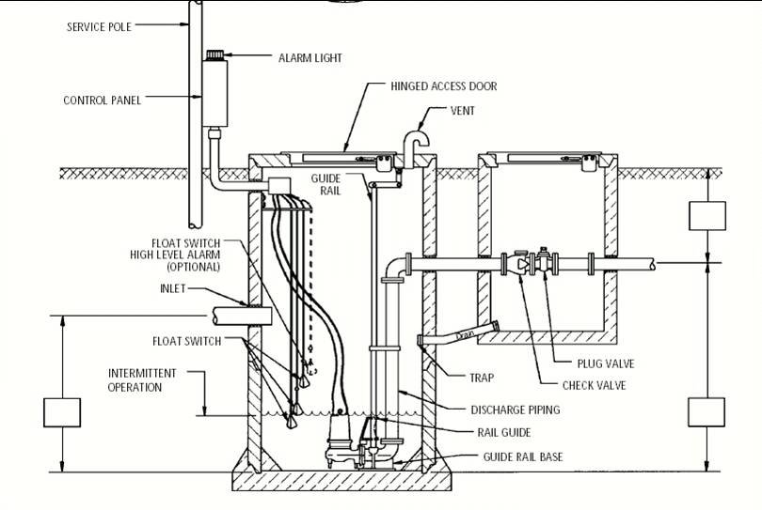**Overall LS Condition:** (check all that apply)

Good / Satisfactory

Debris / Solids Buildup in LS

Needs Maintenance (describe in comments)

Needs Repair (describe in comments)

Cracked / broken sides / foundation

Misaligned joints

Roots at joints

Visible infiltration

|  |  |
| --- | --- |
| Condition: | 5 4 3 2 1 0  New Failing |
| Comments:[1] |  |
|  | |
|  | | Material:  Brick / Mortar  Pre-cast Concrete  Lined |
|  | | other |

|  |  |  |  |  |  |  |  |  |  |
| --- | --- | --- | --- | --- | --- | --- | --- | --- | --- |
| Run each pump for a short time. Did all pumps operate properly during inspection? | | | | | | | Yes | No | |
| Were any pumps clogged or suctions obstructed at the time of inspection? | | | | | | | Yes | No | |
| Record current draw of each pump | | Pump 1 ______ amps | | | Pump 2 _____ amps | | Pump 3 ______ amps | | |
| Record run time for each pump at the station. Analyze the runtime minutes onsite to locate any trouble. Do the pump runtime indicate any operational problem? | | | | | | | Yes | No | |
| Does wet well to need cleaning? Is there a buildup of grease & debris? | | | | | | | Yes | No | |
| Check pump on/off floats for proper operation. Did all floats operate properly? | | | | | | | Yes | No | |
| Check high water float operation for alarm notification. Did the alarm telemetry /auto-dialer work? Did the alarm sound? Did the light flash? | | | | | | | Yes | No | |
| Exercise all lift station valves. Did all valves properly function? | | | | | | | Yes | No | |
| Exercise generator (if applicable) at lift station. Did the generator properly function? | | | | | | | Yes | No | |
| Do you exercise ALL standby generators at least monthly for 15 to 30 minutes? | | | | | | | Yes | No | |
| Surcharge / flooding indications? | grease / debris on sides | | | | | grease / debris under / around / on cover | | |
| Vermin or insects present? | Yes | | No | Description: | | | | |
| Comments: |  | | | | | | | |
|  | | | | | | | | |

**Lift Station Inspection Photograph**

**Lift Station Inspection Photograph**

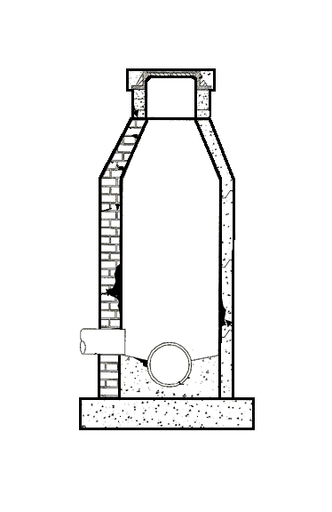**Manhole Inspection Form**

|  |  |  |  |
| --- | --- | --- | --- |
| System: |  | Date: |  |
| MH No. |  | Time: | **A.M. / P.M.** |
| MH Address: |  | Inspector: |  |



**Overall Condition:** (check all that apply)

Good / Satisfactory

Debris / Solids Buildup in MH / channel

Needs Maintenance (describe in comments)

Needs Repair (describe in comments)

Cracked / broken shelf or foundation

Cracked / broken sides or walls

Misaligned joints / loose bricks

Roots at joints

Visible infiltration

|  |  |
| --- | --- |
| Condition: | 5 4 3 2 1 0  New Failing |
| **Action Plan to address deficiencies found:**[2] | |
|  | |
|  | |
|  | |
|  | |
|  | | Material:  Brick / Mortar  Pre-cast Concrete  Lined  Show north arrow, label inlets & outlets, sizes and flow direction |
|  | | other |
| Summarize all inspections and Action Items into a report and submit with the Bacteria Rule Demonstration Checklist. | | |
| Cover / Ring Condition:  serviceable  loose  damaged  missing  raise  lower | | |
| Riser Condition:  serviceable  loose  damaged  missing  raise  lower | | |
| Walls & Bottom:  serviceable  loose  damaged  cracked  holes  roots | | |

|  |  |  |  |  |  |  |  |  |  |  |
| --- | --- | --- | --- | --- | --- | --- | --- | --- | --- | --- |
| Overflow or diversion lines present? | | | | | | | Yes | | No | |
| Other utility lines present? Including force main outfall? | | | | | | | Yes | | No | |
| Drop line present/ visible? Internal / External | | | | | | | Yes | | No | |
| Surcharge / flooding indications? | | grease / debris on sides | | | | grease / debris on shelf | | | |
| Clarity of Flow? | | turbid sewage appearance | | | | clear sewage appearance | | | |
| Flow Conditions? | | steady | | | pulsing | | | turbulent | |
| Flow Conditions? | | low | | | normal | | | high | |
| Vermin or insects present? | Yes | | No | Description: | | | | | |

Summarize all inspections and Action Items into a report and submit with the Bacteria Rule Demonstration Checklist.

**Manhole Inspection Photograph**

**Manhole Inspection Photograph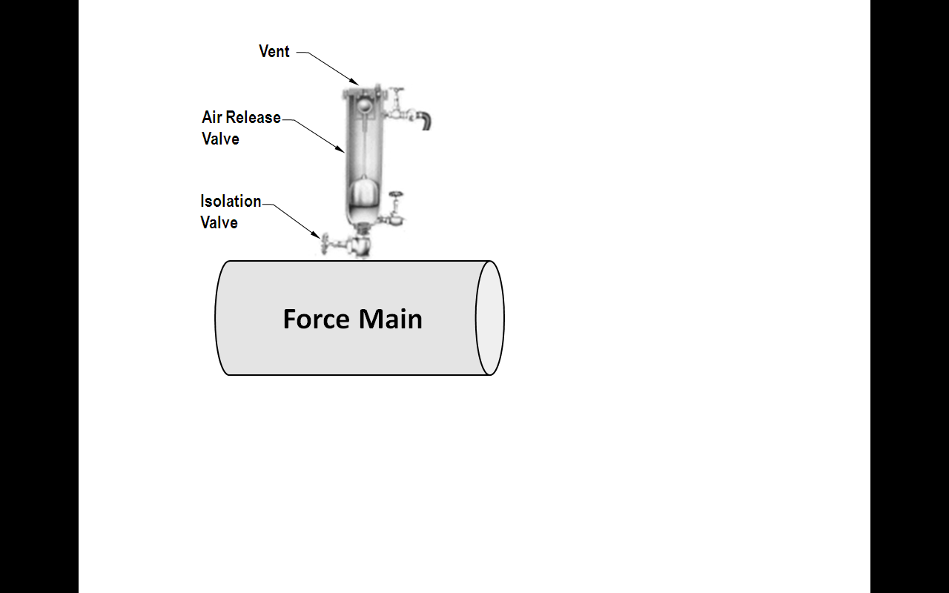Air Release Valve Inspection Form**

|  |  |  |  |
| --- | --- | --- | --- |
| System: |  | Date: |  |
| ARV No. |  | Time: | **A.M. / P.M.** |
| ARV Address: |  | Inspector: |  |

**Overall ARV Condition:** (check all that apply)

Good / Satisfactory

Debris / Solids Buildup in ARV

Needs Maintenance (describe in comments)

Needs Repair (describe in comments)

Visible / dry sewage around valve

|  |  |
| --- | --- |
| Condition: | 5 4 3 2 1 0  New Failing |
| Comments: |  |
|  | |
|  | |
|  | |

|  |  |  |  |  |  |  |
| --- | --- | --- | --- | --- | --- | --- |
| Have you taken photos of the Air Release Valve and attached them to second page? | | | | Yes | No | |
| Was there indication of visible / dry sewage around valve? | | | | Yes | No | |
| If yes, does the leakage look intermittent around valve? | | | | Yes | No | |
| Is the leakage contained immediately around valve? | | | | Yes | No | |
| If no, is it possible that the leakage could be washed by rainfall into stormwater systems, gutters, catch basins, pipes, swales, ditches, canals, surface waters or any other wet areas? | | | | Yes | No | |
| Check the isolation valve. Was it open and functional? | | | | Yes | No | |
| Check the vent. Was it free of encrustation, debris and able to vent? | | | | Yes | No | |
| Vermin or insects present? | Yes | No | Description: | | |
| **Action Plan to address deficiencies found:** | | | | | |
|  | | | | | |
|  | | | | | |
|  | | | | | |
|  | | | | | |
|  | | | | | |

Summarize all inspections and Action Items into a report and submit with the Bacteria Rule Demonstration Checklist.

**Air Release Valve Photograph**

**Air Release Valve Photograph**

**Grinder Station Inspection Form**

|  |  |  |  |
| --- | --- | --- | --- |
| System: |  | Date: |  |
| GS No. |  | Time: | **A.M. / P.M.** |
| GS Address: |  | Inspector: |  |

**Overall Grinder Station Condition:** (check all that apply)

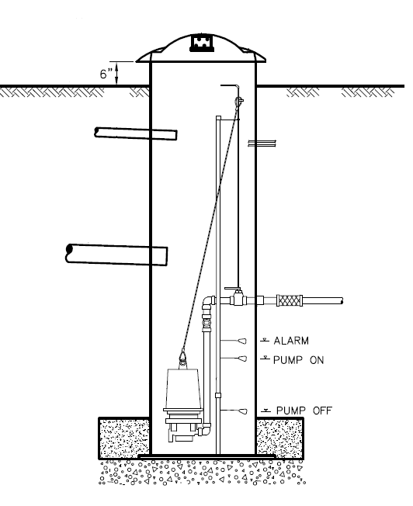 Good / Satisfactory

Debris / Solids Buildup in GS

Needs Maintenance (describe in comments)

Needs Repair (describe in comments)

Cracked / broken sides / foundation

Misaligned joints

Roots at joints

Visible infiltration

|  |  |
| --- | --- |
| Condition: | 5 4 3 2 1 0  New Failing |
| Material: | Fiberglass  HDPE  Metal  other________ |
| Comments:[3] | |
|  | |
|  | |
|  | |
|  | |
|  | |
|  | |

|  |
| --- |
| Cover / ring condition:  serviceable  loose  damaged  missing  raise  lower |
| Air vent condition:  serviceable  loose  plugged  missing  raise  lower |

|  |  |  |
| --- | --- | --- |
| Are there surcharge / flooding indications (grease / debris) around the cover / vent? | Yes | No |

|  |
| --- |
| **Action Plan to address deficiencies found:** |
|  |
|  |
|  |

Summarize all inspections and Action Items into a report and submit with the Bacteria Rule Demonstration Checklist.

**Grinder Station Inspection Photograph**

**Grinder Station Inspection Photograph**

**Vacuum Pit / Air Admittance Points Inspection Form**

|  |  |  |  |
| --- | --- | --- | --- |
| System: |  | Date: |  |
| VP No. |  | Time: | **A.M. / P.M.** |
| Address: |  | Inspector: |  |

**Overall Vacuum Condition:** (check all that apply)

Good / Satisfactory

Debris / Solids Buildup in GS

Needs Maintenance (describe in comments)

Needs Repair (describe in comments)

Cracked / broken sides / foundation

Misaligned joints

Roots at joints

Visible infiltration

|  |  |
| --- | --- |
| Condition: | 5 4 3 2 1 0  New Failing |
| Material: | Fiberglass  HDPE AirVACvalvePit.03.png  Metal  other________ |
| Comments:[4] |  |
|  | |
|  | |
|  | |
|  | |
|  | |
|  | |

|  |
| --- |
| Cover / ring condition:  serviceable  loose  damaged  missing  raise  lower |
| Air vent condition:  serviceable  loose  plugged  missing  raise  lower |

|  |  |  |
| --- | --- | --- |
| Are there surcharge / flooding indications (grease / debris) around the cover / vent? | Yes | No |

|  |
| --- |
| **Action Plan to address deficiencies found:** |
|  |
|  |
|  |

Summarize all inspections and Action Items into a report and submit with the Bacteria Rule Demonstration Checklist.

**Vacuum Inspection Photograph**

**Vacuum Inspection Photograph**

**APPENDIX B**

**Sanitary Sewer Overflow**

**(SSO) Response Plan**

This can be downloaded from FRWA at:

<https://www.frwa.net/wastewater-publication>

**APPENDIX C**

**Wastewater Collection**

**System Plan**

**APPENDIX D**

**Lift Station Bypass Pump & Connection Assembly Instructions**

This can be downloaded from FRWA at:

https://assets.noviams.com/novi-file-uploads/frwa/pdfs-and-documents/liftstation_bypassconnection_assemblyinstructions.pdf

1. Sample Comments: Poor Structural Condition, Serviceable, Broken, Unsafe, Damaged, Corroded, Missing Grout, Needs Raising, Needs Lowering, Misaligned, Leaking, Ill-Fitting, Dirty, Bad Joint, Roots, Grease, Infiltration, Cracks
2. Sample Comments: Poor Structural Condition, Serviceable, Broken, Unsafe, Damaged, Corroded, Missing Grout, Needs Raising, Needs Lowering, Misaligned, Leaking, Ill-Fitting, Dirty, Bad Joint, Roots, Grease, Infiltration, Cracks
3. Sample Comments: Poor Structural Condition, Serviceable, Broken, Unsafe, Damaged, Corroded, Missing Grout, Needs Raising, Needs Lowering, Misaligned, Leaking, Ill-Fitting, Dirty, Bad Joint, Roots, Grease, Infiltration, Cracks
4. Sample Comments: Poor Structural Condition, Serviceable, Broken, Unsafe, Damaged, Corroded, Missing Grout, Needs Raising, Needs Lowering, Misaligned, Leaking, Ill-Fitting, Dirty, Bad Joint, Roots, Grease, Infiltration, Cracks