# Lead and Copper Rule Revisions Requirements

The Lead and Copper Rule Revisions (LCRR) were finalized in 2021. Requirements for water systems regarding the notification of known or potential service lines containing lead are outlined in 40 CFR § 141.85(e) provided for reference at the end of this document. The following pages include templates that water systems may choose to use to develop these notifications. The templates below contain mandatory text from the regulation as well as example language that you may use and/or modify for required content. Required text is provided in italics throughout the document. Bold underlined text in brackets highlight areas for water systems to fill in information specific to their individual system and other considerations.

# **Notice of unknown service line material**

### **<Insert PWS Name>** is focused on protecting the health of every household in our community. This notice contains important information about your drinking water. Please share this information with anyone who drinks and/or cooks using water at this property. In addition to people directly served at this property, this can include people in apartments, nursing homes, schools, businesses, as well as parents served by childcare at this property.

### **<Insert PWS name>** is working to identify service line materials throughout the water system. This is a continuing effort and a field visit still needs to be made to your address; therefore, your service line is currently designated as “Unknown”. “Unknown” means that your water service line could be plastic, copper, galvanized steel, or lead. Investigation of service lines throughout the State of Florida have found a very low percentage of lead service lines. Nevertheless, because your service line material is unknown, it will still need to be checked to confirm the material so you can be notified if it is lead or a galvalnized pipe previously connected to lead.

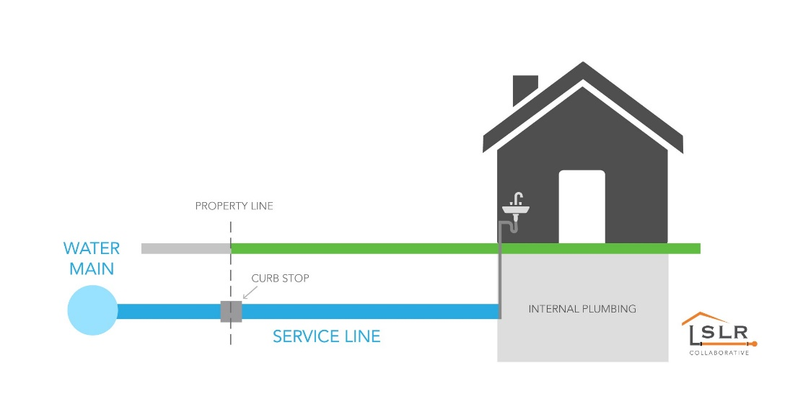

## Identifying service line material

To help determine the material of your service line, please **<contact PWS via phone, email and/or visit website>.** EPA has developed an online step-by-step guide to help people identify lead pipes in their homes called Protect Your Tap: A Quick Check for Lead. It is available at: https://www.epa.gov/ground-water-and-drinking-water/protect-your-tap-quick-check-lead-0

## Health effects of lead

*Exposure to lead in drinking water can cause serious health effects in all age groups. Infants and children can have decreases in IQ and attention span. Lead exposure can lead to new learning and behavior problems or worsen existing learning and behavior problems. The children of women who are exposed to*

*lead before or during pregnancy can have increased risk of these negative health effects. Adults can have increased risks of heart disease, high blood pressure, and kidney, or nervous system problems.[1]*

## Steps you can take to reduce lead in drinking water.

Below are recommended actions that you may take, separately or in combination, if you are concerned about lead in your drinking water. The list also includes where you may find more information and is not intended to be a complete list or to imply that all actions equally reduce lead in drinking water.

**Use filters properly**. Using a filter can reduce lead in drinking water. If you use a filter, it should be certified to remove lead. Read any directions provided with the filter to learn how to properly install, maintain, and use your cartridge and when to replace it. Using the cartridge after it has expired can make it less effective at removing lead. Do not run hot water through the filter. For more information on facts and advice on home water filtration systems, see EPA’s <https://www.epa.gov/water-research/consumer-tool-identifying-point-use-and-pitcher-filters-certified-reduce-lead>.

**Clean your aerator.** Regularly clean your faucet’s screen (also known as an aerator). Sediment, debris, and lead particles can collect in your aerator. If lead particles are caught in the aerator, lead can get into your water.

**Use cold water**. Do not use hot water from the tap for drinking, cooking, or making baby formula as lead dissolves more easily into hot water. Boiling water does not remove lead from water.

**Have your water tested.** You may contact a certified laboratory to have your water tested for lead. A list of certified laboratories is available at **<provide location of list or explain your water system’s testing program and any costs to customer if one exists>.** For information on sources of lead that include service lines and interior plumbing, please visit <https://www.epa.gov/ground-water-and-drinking-water/basic-information-about-lead-drinking-water#getinto>.

For more information, on the lead service line inventory, visit the Florida Department of Environmental Protection’s lead service line inventory website at <https://floridadep.gov/water/source-drinking-water/content/lead-service-line-inventory-links>.

Our top priority is to provide safe and healthy water to every household in our community. We will continue to work on identifying all the service line materials in the community, including the line at your address, and we will continue to ensure that the drinking water we provide meets state and federal standards. For more information, call us at [Insert Number], or (if applicable) visit our website at [Insert Website Address].

1. Text in italics is required and cannot be changed.