Harbour Ridge Y&C Club Water and Wastewater treatment plant Operator
$30.-$35. per hour based on experience
Full time with benefits, Monday- Friday
Operator- Must have a current Class C water and Class C wastewater license.
Must have a valid driver’s license.
Please send your resume to d.jenkins@hrycc.org
Thank you,
Duane Jenkins

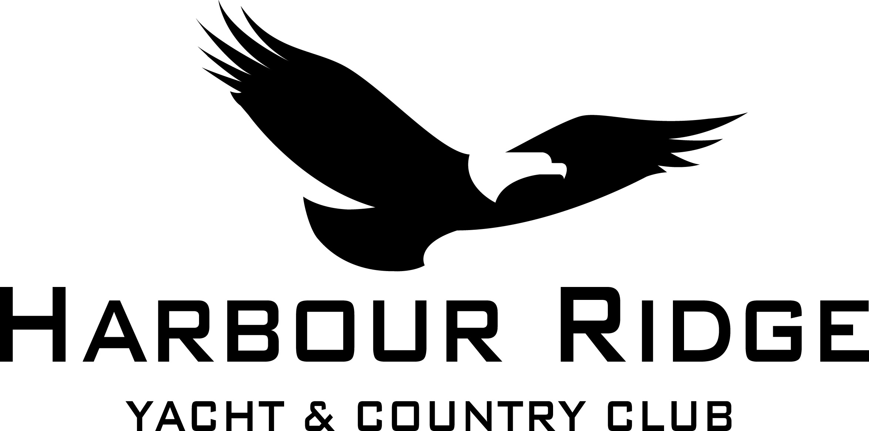

Job Description

Job Title: Water and Wastewater Operator

Reports To: Utilities Director

Department: Water and Sewer

Revised Date: October 2026

FLSA Status: Non-exempt

Job Summary: Provide safe, palatable drinking water for the club and POA and dispose of treated domestic wastewater safely and legally.
Essential Duties and Responsibilities include the following, but are not limited to:
- Daily operations and adjustments as needed by the water and wastewater plants.
- Lift station checks and routine maintenance duties.
- Maintain chlorine residuals, PH, hardness and alkalinity levels.
4. Add chemicals to prescribed standards, this requires the ability to lift and or move 50 pounds.
5. Perform daily inhouse laboratory analysis.
6. Collect samples to be sent out for laboratory analysis.
7. Change chlorine gas cylinders and liquid ammonia containers.
8. Backwash filters at both sites as needed.
9.Valve locations and exercising as well as hydrant flushing.
10.Field repairs as needed.
11. Monthly reporting of compliance sheets. (DMR) (MOR) etc.

Job Requirements include the following, but are not limited to:
- Conduct the day-to-day operations of the department in a business-like, ethical and professional manner.
- Strive to exceed customer service expectations of members, guests and associates.
- Maintain good working relationship with club members, employees and all customers.
- Utilize a clear speaking voice in the English language.
- Dress appropriately for position; professional manner and well groomed.
- Demonstrate record of good work attendance and reliability.

- Demonstrate flexibility in work habits and work schedule.

- Use time effectively: complete work in a timely manner.

- Comply with company policies and procedures as established in the Employee
Handbook or as demonstrated as common practice.
- Seek to improve self in knowledge and skills.

Supervisory Responsibilities: This job has no supervisory responsibilities.
Qualifications: To perform this job successfully, an individual must be able to perform each essential duty satisfactorily. The requirements listed above are representative of the knowledge, skill, and/or ability required. Reasonable accommodations may be made to enable qualified individuals with disabilities to perform the essential functions.

Certificates/Licenses:

Class C Wastewater License (Florida)

Class C Water License (Florida)

Please note, if you hold an out of state license, applying for reciprocity is necessary.

Valid Florida driver’s license

Work Environment: The work environment characteristics described here are representative of those an employee encounters while performing the essential functions of this job. Reasonable accommodations may be made to enable qualified individuals with disabilities to perform the essential functions. The noise level in the work environment is usually loud.
Physical Demands: The physical demands described here are representative of those that must be met by an employee to successfully perform the essential functions of this job. Reasonable accommodations may be made to enable individuals with disabilities to perform the essential functions.
While performing the duties of this job, the employee is regularly required to stand and walk; to reach with hands and arms, to use hands to finger, handle or feel and to climb or balance. The employee is occasionally required to sit and to stoop, kneel, crouch or crawl. The employee must regularly lift and/or move up to 100 pounds or more. There is no specific vision abilities required by this job minus the ability to see shades of pink. Sensory requirements include the senses of sound, smell, sight, and speech.

