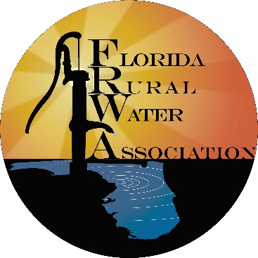

**Media Release Consent**

I, the undersigned, give Florida Rural Water Association permission to use photos, videos, sound clips, and any other media created in relation the Florida Rural Water Association Apprenticeship Program for promotional, reporting, and other purposes as seen fit by Florida Rural Water Association free of charge. I, the undersigned, give Florida Rural Water Association permission to share photos, videos, sound clips, and any other media created in relation to the Florida Rural Water Association Apprenticeship program with Florida Rural Water Association’s national and state partners, to include but not limited to National Rural Water Association free of charge.

I affirm my understanding of this agreement by signing below on the ______ day of ______________________ in the year 20___.

_________________________________________________  
Printed Name

_________________________________________________  
Signature