Cascades Parking Garage 850 Gadsden Street

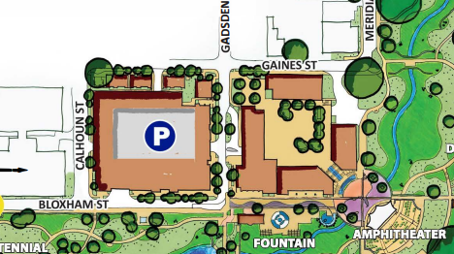
Ballroom Room
414 E. Bloxham St.
BR
Take Elevator to the 3rd floor
Walking path to the meeting

- Please park in the Cascades Parking Garage.
-Address: 850 Gadsden Street

- Your parking ticket will be validated when you exit the garage.

- We will have signs to direct you to the ballroom which is located on the third floor of the building.

- Parking Ambassadors will be available to assist.

