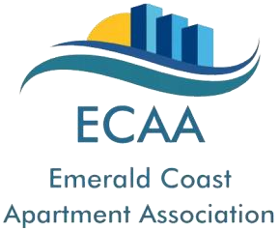

**Manager ~ Assistant Manager ~ Leasing Agent ~ Maintenance Person ~ Supplier OF THE YEAR 2021**

The Emerald Coast Apartment Association is looking for nominees for the 2021 Manager, Assistant Manager, Leasing Agent, Maintenance Person and Supplier/Vendor of the Year Awards. There are so many outstanding people in our local industry that deserve recognition. We would like to thank them for their efforts.

To submit a candidate for consideration please complete this form and provide us with a narrative stating why your candidate should be chosen in **150 words or less**.

**Nominations must be received no later than NOVEMBER 30th**.

All Nominees will be recognized and Winners will be presented at our Holiday Party & Awards Banquet on **December 9th**.

Nominators will have their name entered in a prize drawing for each nomination submitted.

(Winners must be present)

Name of Nominee: Position/Title: __________________

Community:

I believe the above should be selected because:

Submitted by: Position/Title: __________________

Community:

**Please return to: lindsay@ecaaofnwf.com**