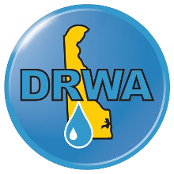

To: Wastewater and Water Professionals
From: Heather Warren, Executive Director, Delaware Rural Water Association Date: October 8, 2025
Re: 2026 Wastewater and Water Team of the Year Nominations

Good Day from DRWA!
Each year, each week, and each day, our industry relies on groups of hard-working and underrecognized folks to keep the toilets flushing and faucets running. To honor those working in the cold on main breaks, resolving FOG problems, and ensuring our industrial waste is properly treated, we’re opening nominations for Team of the Year. Winners will be announced at our Awards Dinner on Tuesday, February 24, 2026.
Please return completed nomination forms to Heatherw@drwa.org by December 10th, 2025, so our committee has ample review time to review before the Conference.

To learn more about the Annual Conference, visit www.drwa.org.

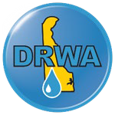

Nominee Information
Nominee Names and Positions

Check One | Wastewater Water Both
Wastewater or Water System
Name
Nominee’s Phone Number
(List primary contact)
Nominee’s Email

(List primary contact)
Combined Years in Industry
Why should this Team win Team of the Year?

Describe any challenges or hardships that are of particular interest that have made this Team exemplary.

Nominator Information
Nominated by
Email
Phone Number
Wastewater or Water
System Name

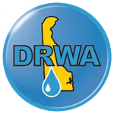

Feel free to use more space as needed.


Please return completed nomination forms to Heatherw@drwa.org
by November 30, 2025.

