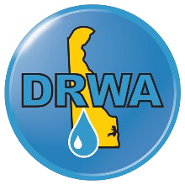

To: Wastewater and Water Professionals
From: Heather Warren, Executive Director, Delaware Rural Water Association Date: October 8, 2025
Re: 2026 Wastewater and Water Operator of the Year Nominations

Good Day from DRWA!
A long-standing tradition in the wastewater and water industries has been the Operator of the Year Awards Ceremony. Over the years, the ceremony has been held to honor those who have overcome, persevered, and upheld a commitment to excellence. Each year, individuals proudly receive their awards and applaud fellow awardees. The Ceremony encourages fellowship, community, and pride in the work that Operators perform each day. The Delaware Rural Water Association is pleased to continue the Operator of the Year Awards tradition. Winners will be announced at our Awards Dinner on the evening of Tuesday, February 24, 2026.
Please return completed nomination forms to Heatherw@drwa.org by December 10th, 2025, so our committee has ample review time to review before the Conference.
Multiple nominations can be submitted per wastewater or water system. To learn more about the Annual Conference, visit www.drwa.org.

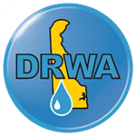

Nominee Information
Nominee Name
Check One | Wastewater |  | Water |  | Both
Wastewater or Water System
Name
Nominee’s Phone Number
Nominee’s Email
Nominee’s License Number | Wastewater:  Water:  *Nominees do not need both licenses to be nominated. They only need one.
Years in Industry
Current Position
Outstanding Professional Qualities
Displays of Leadership

Knowledge of Industry
Additional Comments
Nominator Information
Nominated by
Email
Phone Number
Wastewater or Water System Name

Feel free to use more space as needed.


Please return completed nomination forms to Heatherw@drwa.org
by November 30, 2024.

