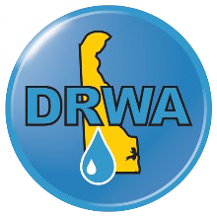

To: Wastewater and Water Professionals
From: Heather Warren, Executive Director, Delaware Rural Water Association Date: October 8, 2025
Re: 2026 Wastewater and Water Team of the Year Nominations

Good Day from DRWA!
As more of our workforce reaches retirement age, an opportunity arises to recognize those who have set examples, answered those 2 am calls, and put the needs of their communities or industry above their own. These same folks have shared information, blazed trails, and have been unafraid to tackle ever-changing challenges.
The Delaware Rural Water Association is pleased to accept nominations for the 2026 Lifetime Achievement Award. Nominees should be in the industry for over 40 years and still working, OR have submitted their official retirement documents, OR have retired in 2025. Winners will be announced at our Awards Dinner on Tuesday, February 24, 2026.
Please return completed nomination forms to Heatherw@drwa.org by November 30, 2025, so our committee has ample review time to review before the Conference.

To learn more about the Annual Conference, visit www.drwa.org.

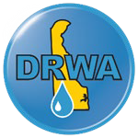

Nominee Information
Nominee Name and Position

More than one nominee per system is acceptable.
Check One | Wastewater Water Both
Wastewater or Water System
Name
Nominee’s Phone Number

Nominee’s Email

Years in Industry  OR  Official retirement documents submitted?  OR  Retirement occurred in 2025 | _____ # years  _____ yes  _____ yes

Insert a brief bio of the nominee.

List career milestones.

Be sure to highlight skill sets, talents, or accomplishments that warrant this award.

Nominator Information
Nominated by
Email
Phone Number
Wastewater or Water
System Name
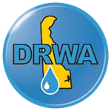
Feel free to use more space as needed.


Please return completed nomination forms to Heatherw@drwa.org
by November 30, 2025.

