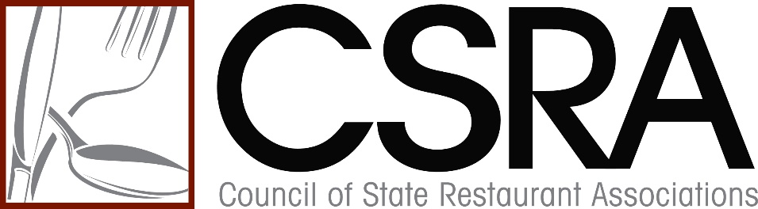

**CSRA 2025 Scholarship Application Form**

* **Summer** Conference, July 15-17, 2025, Alyeska Resort. The Scholarship Application **deadline** is **April 15, 2025**.
* **Fall** Conference, November, Dallas, Texas. The Scholarship Application **deadline** is **September 5, 2025**.

|  |  |
| --- | --- |
| Scholarship Recipient Name & Title |  |
| State Restaurant Association |  |
| Email |  |
| Phone |  |
| Application Date |  |
| Amount Requested | $ |

|  |
| --- |
| Please briefly explain how scholarship funds will be applied: |
|  |
|  |
|  |
|  |
|  |

Completed application should be submitted to:

Suzanne Bohle

Council of State Restaurant Associations

Email: [sbohle@staterestaurantassociations.org](mailto:sbohle@staterestaurantassociations.org)

**CSRA Conference Scholarship Procedure**

The CSRA Scholarship Program is to set up to assist SRAs to offset costs of attending the CSRA | National Restaurant Association Conferences. The scholarship amount for 2025 is a total of $10,000 per conference with each scholarship worth up to $1,400. Scholarship applications are reviewed then awarded by the CSRA Executive Committee and the process is confidential.

Each SRA may receive a scholarship once every two years.

Criteria:

* The applicant’s sponsoring organization must lack the resources to pay for staff participation, including registration fees or transportation costs.
* The applicant must be a current CSRA state executive or staff and have been a current CSRA member for at least one year, as of the date of the application.

**2025 Deadlines:**

The deadlines for applying for 2025 funds are:

* May 9, 2025, for the summer conference
* September 5, 2025, for the fall conference

Completed application should be submitted to:

Suzanne Bohle

Council of State Restaurant Associations

Email: [sbohle@staterestaurantassociations.org](mailto:sbohle@staterestaurantassociations.org)