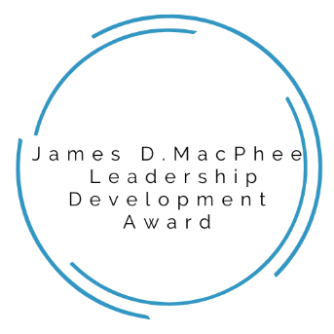
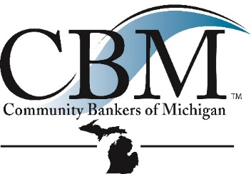

James D. MacPhee Leadership Development Award Application
About the award: The James D. MacPhee Leadership Development Award was created to develop the next generation of community bank leaders in honor of Jim MacPhee or “Mac”, a true community bank champion. Mac passed away in 2020 and left behind a legacy of success in community banking.
To honor the memory of Jim, the CBM, his family, friends and colleagues developed the James D. MacPhee Banking Leadership Center and Scholarship Fund. Thanks to generous donations, the scholarship fund has been created to help develop future community banking leaders who share the passion for community banking Jim had.
What the award will cover: The James D. MacPhee Leadership Development Award will cover tuition to one or more designated education events through the CBM, the ICBA and/or The Barret School of Banking Graduate School. Award winners will be provided tuition costs to one or more event. Please select the award you are submitting a nomination for below. More than one box may be selected. Awards may be given to more than one school or event. The “Official Rules”, explaining the application and selection process can be found at cbofm.org.
2026 Events Eligible for the Leadership Development Award
☐ Branch Leader Fundamentals – registration & materials for all sessions in 2026
Two full-day, in-person sessions, March 25th & April 22nd supplemented by two virtual de-brief and accountability sessions. This program is designed to equip new and aspiring retail branch leaders. Participants will learn about branch business and action planning, objective and expectation setting, feedback and coaching fundamentals, and tactics for developing team and individual skills in sales and customer service. Apply by January 23, 2026.
☐ Barret Graduate School of Banking – tuition & lodging covered for all 3 years of the school
The Barret Graduate School of Banking is a three-year graduate school that includes an annual one-week residency session. Included are 40 hours of classroom instruction per year by instructors with decades of experience. The 2026 session will be held May 17 – 22, 2026 at the Paul W. Barret, Jr. School of Banking in Memphis, TN. The Barret Graduate School of Banking is endorsed by the CBM and the ICBA. Apply by March 6, 2026.
☐ ICBA Capital Summit – registration and travel reimbursement (up to $1000)
Join community bankers from around the country as they gather in Washington, D.C. to meet with legislators and discuss issues critical to the future of community banking. The ICBA Capital Summit will be May 4 – 7, 2026. Apply by March 6, 2026.
☐ Commercial Lending School – registration & materials for all sessions in 2026
Designed for credit professionals seeking to deepen their expertise in Commercial, Industrial and Real Estate lending, the Commercial Lending School is a six-session class offered at the James D. MacPhee Banking Leadership Center. This intensive course focuses on leveraging credit ratios and advanced cash flow analysis to accurately assess borrower creditworthiness and structure loans effectively. Dates are June 16th & 17th, July 8th & 9th and August 12th & 13th. Apply by May 22, 2026.
☐ Credit Analyst Certification Program – registration & materials for all sessions in 2026
The Credit Analyst Certification Program (CACP) is a six-session class offered at the James D. MacPhee Banking Leadership Center. The CACP addresses the needs of beginning credit analysts and reinforces the credit skills of current credit analysts. The focus is primarily on commercial and industrial borrowers, utilizing case studies to reinforce the learning process. Dates are July 29th & 30th, August 26th & 27th and September 29th & 30th. Apply by May 22, 2026.
☐ Emerging Leader Program – registration & materials for all sessions in 2026/2027
Five full-day, in-person sessions, supplemented by three virtual de-brief and accountability sessions. The Emerging Leader Program is an annual leadership development program designed to build competencies and confidence for your next generation of community bank leaders. Participants will be guided through Five Exemplary Leadership Practices, DISC communication styles, Strength Finder and the basics of Performance Management and Development. Dates are September 1, October 14, November 17, 2026 and March 16 & April 13, 2027. Apply by July 2, 2026.
☐ Advanced Leadership Program – registration & materials for all sessions in 2026
This program is designed for senior leaders who oversee other leaders. As leader of leaders, your role is to guide, empower and develop your team’s next generation of leadership. Participants will explore advanced leadership strategies focused on cultivating leadership excellence, fostering accountability, and creating a culture of collaboration and innovation. Dates are September 2nd, September 29th, October 20th, November 5th & December 18th. Apply by July 2, 2026.

For detailed information on any of the above programs, please visit www.cbofm.org.
James D. MacPhee Leadership Development Award Application
Nominator Information:
Name: ____________________________________________________
Bank: _____________________________________________________
Email: ____________________________________________________
Direct phone number: _____________________________________

About the Nominee: Tell us about the person being nominated for the award.
Name: _________________________________________________________
Position/Title at the Bank: ______________________________________
Bank Name: ____________________________________________________
City/Branch: ____________________________________________________
Number of years employed at the bank: __________________________
Number of years as a community banker: ________________________
Direct Phone Number: ___________________________________________
Email Address: __________________________________________________
Questions for the nominator:
- Tell us about the nominee (e.g.: career path, goals, awards, hobbies, volunteer activities, etc.). Use this as an opportunity to provide insight into what makes the nominee a great candidate for this scholarship.

- Tell us why this award will make the nominee a better community banker: How will they use the knowledge and experience gained to improve your community bank and reach their own professional goals?

- Provide additional information that would set the nominee apart from the other candidates.

Completed applications may be mailed or sent by email to CBM.
830 W. Lake Lansing Rd, Suite 250, East Lansing, MI 48823
sarahcook@cbofm.org

