Arrival Information
Contents
Staying on-campus? 1
CBA AGM Registration Desk 1
Wi-Fi 1
Parking 2
Buildings Being Used 3
Airport Transportation 4

Staying on-campus?
Those staying on campus should report directly to Thea Bowman Hall to receive room assignments. Additional assistance is available at the AGM Registration Booth on the second floor of the Andrew White Student Center (AWSC).
- Check in: 4:00 PM
- Check out: 12:00 PM
- LATE ARRIVALS: Call 410-617-5176 for assistance.

CBA AGM Registration Desk
All registrants should report to the AGM Registration Booth, immediately outside McGuire Hall on the second floor of the Andrew White Student Center (AWSC), to pick up their name tag and conference tote.
Hours:
Friday: 5:00 AM- 7:00 PM
Saturday: 9:00 AM - 8:00 PM
Sunday: 8:00 AM - 12:00 PM
Wi-Fi
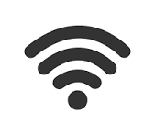
Guest Wi-Fi information will be available at the AGM Registration Booth

Parking
- Overnight guests will utilize Butler Lot for the entire duration of the AGM.
- Weekend (Saturday & Sunday): All participants should park in the Butler Parking Lot.
- Weekdays (Monday–Tuesday): Participants should park along Thomas More Loop Road.
For any guests requiring accessible parking, we recommend parking in the Butler Lot throughout the week. Your golf cart can then be used to transport those guests to and from the meeting locations as needed.
Participants parking on Thomas More Loop Road will use the pedestrian bridge to access the main campus. The walk is straightforward and leads directly into the central campus where your meeting spaces are located.
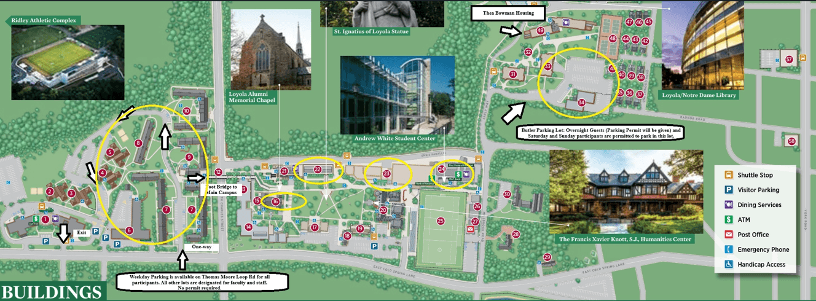
Click for large pdf version of Parking Map

Buildings Being Used
CBA will be using the following buildings on campus.
- Andrew White Student Center #25
  - McGuire Hall: Plenary, Simultaneous Sessions, Exhibits,
coffee breaks
  - 4th Floor Program Room: Meals and Socials
- DeChiaro College Center #23: Saturday meetings & Breakout sessions
- Maryland Hall #22: Breakout sessions
- Alumni Memorial Chapel #16: Liturgies
- Thea Bowman Hall #50: Housing
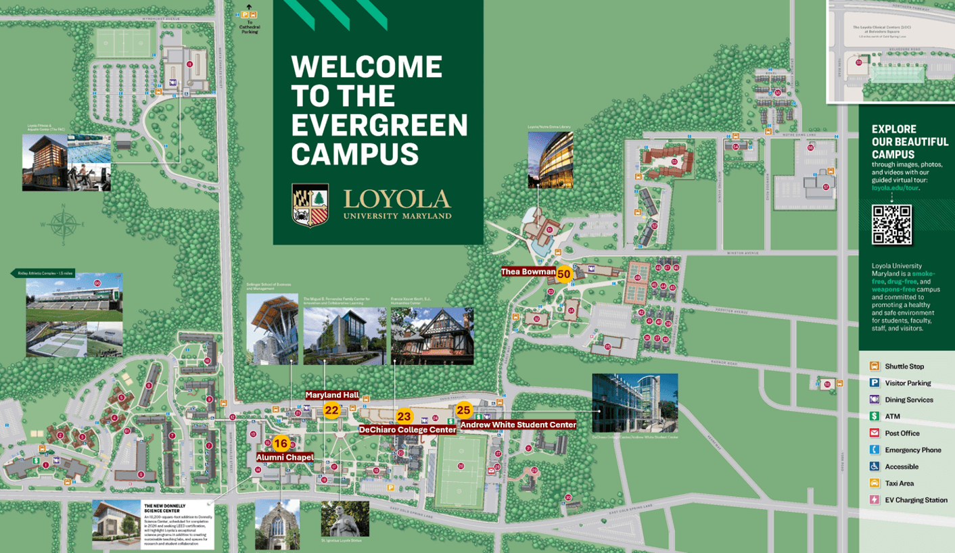
Click for large pdf version

Airport Transportation
Baltimore is most conveniently served by one primary airport, with two additional Washington-area options.
Loyola University Maryland identifies Baltimore/Washington International Thurgood Marshall Airport (BWI) as the closest airport to campus and recommends it as the preferred arrival airport.
Baltimore/Washington International Thurgood Marshall Airport (BWI)
- Distance/Time: BWI is the closest airport for access to Loyola University Maryland (4501 N. Charles Street, Baltimore, MD 21210). By car, it is typically the quickest airport option.
- Taxi/Rideshare: Taxi stands are located on the Arrivals/Lower Level terminal roadway, just outside baggage claim, and are most easily accessed from Doors 5 and 13. Uber, Lyft, and taxis are available for ground transportation to campus.
- Public Transportation: From BWI, travelers can use MDOT MTA Light Rail. Loyola notes that the Cold Spring Lane Light Rail stop serves BWI Airport, and from there, travelers can take the Loyola Ridley shuttle, the #33 bus, or walk about a mile to campus. Riders should pre-purchase a ticket at the platform before boarding.
Ronald Reagan Washington National Airport (DCA)
- Distance/Time: Reagan National is an additional airport option, but note that it is roughly 1 hour from Baltimore and may involve expensive or time-consuming travel depending on traffic conditions.
Taxi/Rideshare: Taxi and rideshare services are available from the airport’s designated ground transportation areas.
- Public Transportation: Reagan has a Metrorail station connected directly to Terminal 2. A practical public-transit route is to take Metro into Washington, travel to Union Station, then continue to Baltimore Penn Station by MARC or Amtrak, followed by a taxi or rideshare to Loyola’s campus. WMATA notes that airport Metrorail fares vary by time and distance, generally ranging from $2.25 to $6.75.
Washington Dulles International Airport (IAD)
- Distance/Time: Dulles is another possible airport option, but it is roughly 1 hour from Baltimore and may be more difficult and time-consuming than BWI.
- Taxi/Rideshare: Taxi, rideshare, and other ground transportation options are available from Dulles.
- Public Transportation: Dulles is connected to Washington Metrorail via the Silver Line. The walk from the terminal to Metro is about 600 feet / 5 minutes. From there, travelers can take Metro toward Washington, connect to Union Station, continue to Baltimore Penn Station by MARC or Amtrak, and then take a taxi or rideshare to Loyola. Dulles notes Metro fares generally range from $2.25 to $6.75, depending on time and distance.

