BUILD LOYALTY THROUGH CEREMONY

What Is CEREMONY?

In an organizational setting, ceremonies are intentional, repeated actions that express values, mark transitions, and reinforce belonging.

They can be solemn or playful, ancient or newly invented. What matters is meaning, not mystique.

Examples:
- The moment a new member signs your charter or oath
- A recurring toast, phrase, or gesture at events
- Giving a symbolic object (coin, pin, journal) to members
- Annual storytelling, milestones, or recognition ceremonies

Prompt:
Think of a time you felt like a “real member.” What happened, who was there, and what made it memorable?

Discovering Your Association’s Hidden Ceremonies

Every organization already has ceremonies, some of which are visible, and others unnoticed.
Category | Example | What does your Association do?
Joining | Orientation, welcome gift, pinning, oath | _____________________________
Gathering | Annual meeting, pre-event toast, shared song | _____________________________
Recognizing | Awards, anniversaries, leader transitions | _____________________________
Remembering | Memorials, retirements, founder tributes | _____________________________
Serving | Volunteer initiation, mentoring, giving back | _____________________________
Pair Exercise:
- Turn to a partner.
- Identify one existing ceremony in your organization.
- Ask: What emotion does it create? What story does it tell?

Designing a New or Enhanced Ceremony
Step | Question | Your Notes
1 | What member moment are you designing for?  (e.g., onboarding, recognition, renewal) | _______________________________________
2 | What emotion do you want to evoke? | _______________________________________
3 | What core value does it represent? | _______________________________________
4 | What symbol can be used to represent that core value? | _______________________________________
5 | What story connects it to your mission? | _______________________________________
6 | What symbolic action or token could embody it? | _______________________________________
7 | When and how often will it occur? | _______________________________________
8 | Who leads or facilitates it? | _______________________________________
9 | How will you tell or reinforce the story afterward? | _______________________________________

Tip: The best ceremonies are repeatable, simple, and emotionally resonant — not expensive or elaborate.

Pair Exercise:
- Turn to a partner.
- Share your new or enhanced ceremony
- Think about how its symbol, action or story can be enhanced or reinforced.

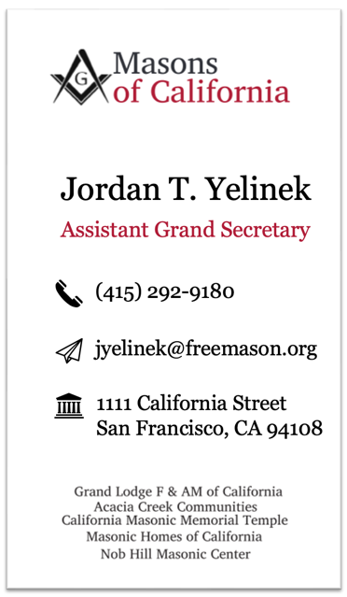

Resources & Further Reading
- The Power of Moments – Chip & Dan Heath
- Rituals for Work – Kursat Ozenc & Margaret Hagan
- Belonging: The Science of Creating Connection and Bridging Divides – Geoffrey Cohen

Bonus QUESTION
If your association disappeared tomorrow, what shared moment would your members miss most?
That’s your most powerful ceremony.

