**2022 CMBE Conference Abstract Submission Long Form Example**

Penney M. Gilbert, Ph.D.1, Brenton D. Hoffman, Ph.D.2, Wendy Liu, Ph.D3

1University of Toronto, Toronto, ON, Canada, 2Duke University, Durham, NC,

3University of California, Irvine, Irvine, CA

This is an example of the long form abstract. It fits on one page, uses 11-point font for the main text, is single-spaced, has half inch margins, and incorporates a relevant figure. Note that the title is in bold font, and that affiliations are in 9-point font and include the location. The title, authors and affiliations are not included in the word limit. For affiliations outside of the United States, please also include the country. The name of the presenting author is underlined. Citations are included and appear in 9-point font within the one page limit. The defined sections required of an abstract for the Annual BMES meeting are permitted, but not required

Hyatt Regency Indian Wells Resort & Spa is the ideal retreat where you can relax, play, and indulge - on your terms. Nestled in Greater Palm Springs, our resort offers a wonderful variety of leisure pursuits. Hyatt Regency Indian Wells Resort & Spa is a legacy in the world of professional tennis. As the former home of the Newsweek Champions Cup, now the sixth largest tennis tournament in the world, Hyatt Regency Indian Wells Resort & Spa has hosted tennis greats. As a part of our Resort Services Program, we offer all guests complimentary usage of one of our many beach cruisers and scooters. Take advantage of our 45 acres and enjoy a day in the sunshine peddling around the gorgeous resort. We are excited to introduce HyTides Plunge, the largest water features in Greater Palm Springs with two 30 ft dueling slides, a 450 ft lazy river and splash pad for kids (Fig. 1) [1]. Located in the heart of the resort, HyTides provides year-round fun for both kids and adults alike.

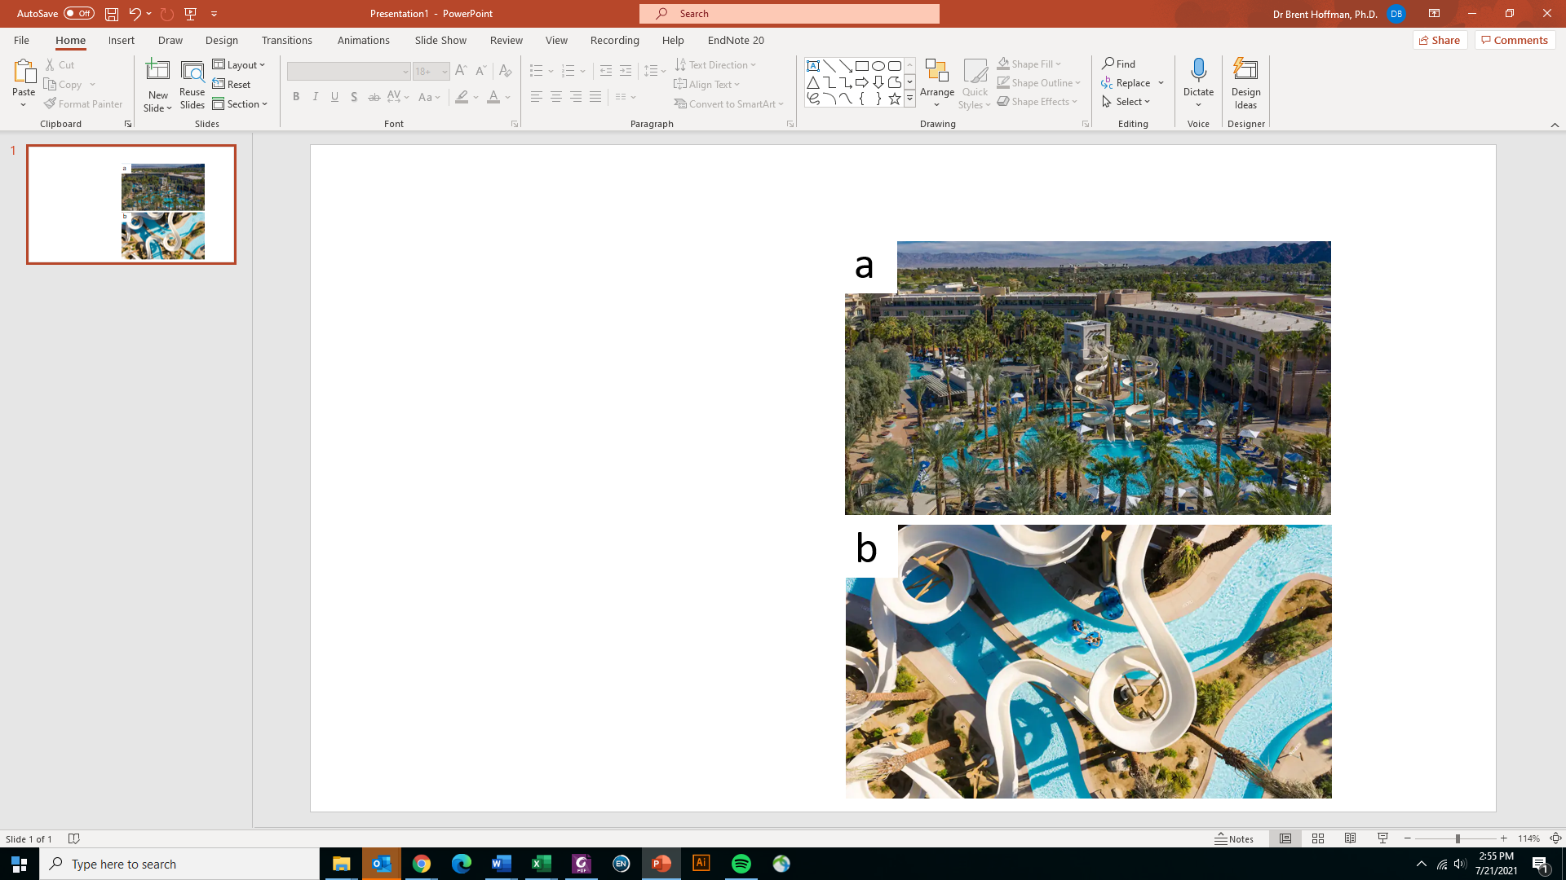

Fig. 1: a) Aerial shot of the water slide at the Hyatt Regecy. b) Zoom-in of topicl view of the water slide. A slight smaller font size was used in this caption.

Looking for fun things to do in Greater Palm Springs? You will find an array of arts and culture, including various art museums, an air museum, the Living Desert Zoo and Gardens, and the Children’s Discovery Museum. The Palm Springs Architecture + Design Center, explore the largest concentration of midcentury modern architecture, as highlighted by these exhibits, educational and community programs [2]. The Children’s discovery museum inspires and promotes intellectual curiosity and self-expression through inventive and interactive exhibits and programs. Children learn about themselves and the world around them by exploring the natural environment and the community in a creative and fun setting. At the Palm Spring Air museum, history flies through the skies and museum docents are the people who made that history. Enjoy flying demonstrations of aircraft, interesting exhibits, fun-filled kids' activities, and an ongoing lecture series featuring the significance of Air Power and veterans’ eyewitness accounts. If you are into some outdoor adventure, tee off on the 36-hole Indian Wells Golf Resort, adjacent to the property. Explore one of the desert’s hiking trails or test your need for speed at the BMW Performance Center nearby. For more information about local activities, check out the [Visit Greater Palms Spring](https://www.visitgreaterpalmsprings.com/) home page.

Citations (Note: In real abstracts, proper formatted citations to journal articles, not web links, are expected.)

1. <https://www.hyatt.com/en-US/hotel/california/hyatt-regency-indian-wells-resort-and-spa/champ/area-attractions>
2. https://www.visitgreaterpalmsprings.com/