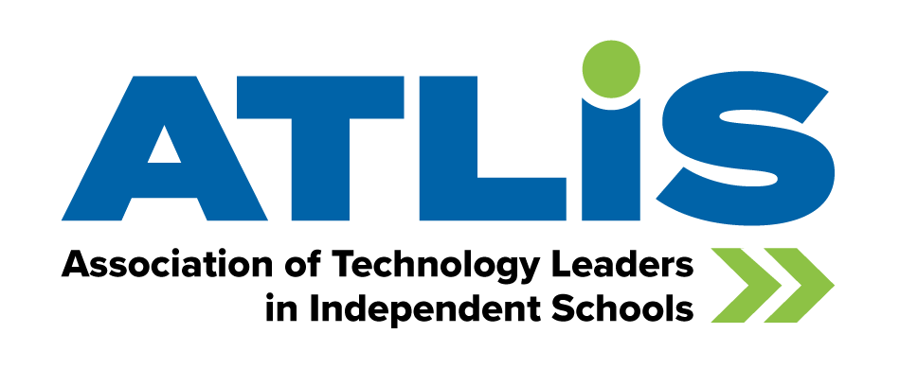
ATLIS Membership Justification Letter
Dear [SUPERVISOR’S NAME],
I would like for [NAME OF YOUR SCHOOL] to become a member of the Association of Technology Leaders in Independent Schools. ATLIS is a rapidly growing professional network for technology leaders in independent schools, providing professional development, community, and curated resources for members. ATLIS empowers its members to develop strategies, build relationships, and share best practices in technology and innovation for independent schools.

ATLIS membership will not only provide me with valuable professional support but will support our entire school’s technology strategy. With swift advancements in emerging technology like AI, increased cybersecurity threats, and constantly evolving ed tech resources, ATLIS can help provide our school with the support and resources we need to stay ahead of the curve and make more educated decisions.

After reviewing the list of member benefits, I have identified several resources that I would like to take advantage of in the coming year.

- Community discussion boards
- Monthly professional development opportunities, like webinars and virtual topical meetups
- Resource library with guides and templates
- ATLIS360 Self Study Guide, Rubric, and Companion Manual (for accreditation and strategic planning)
- Cybersecurity collection, including a K12 cybersecurity assessment, mock phishing assessment, and other cyber safety resources to help keep our school protected

ATLIS membership is school-wide, so all faculty and staff have access to the technology resources they need once they join. I strongly believe that joining ATLIS will not only benefit our tech team but our entire school, and as such, I’m requesting permission for our school to join. A one-year membership will cost [INSERT YOUR MEMBERSHIP RATE - $4.15 per K-12 student, with a maximum rate of $4,150]. Similarly to how NBOA offers critical resources for business officers, CASE for advancement professionals, the Enrollment Management Association for Directors of Advancement, and of course, NAIS for Heads of School, ATLIS has become the premier resource for technology leaders.
Thank you for your consideration. To learn more about ATLIS membership, please visit www.theatlis.org/membership.
Sincerely,
[INSERT YOUR NAME]

