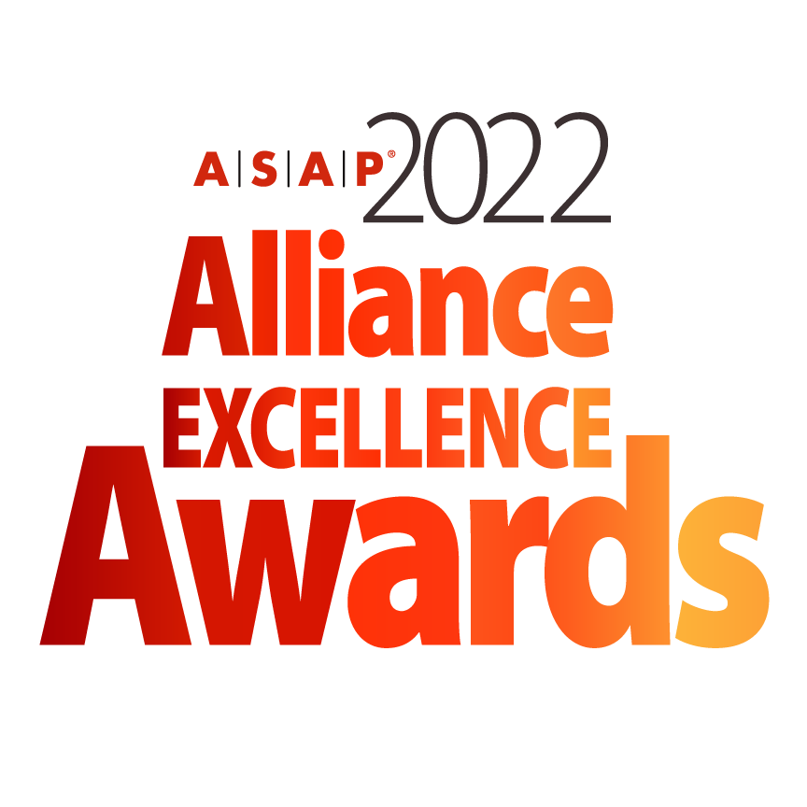**INNOVATIVE BEST ALLIANCE PRACTICE AWARD NOMINATION FORM**

*The deadline for submitting a nomination is January 18, 2022*

***Instructions for Submission of a Nomination***

* All nominations must be entered electronically using this Word form.
* Any nomination submitted will be reviewed at the discretion of the ASAP Awards Committee.
* All nominees are strongly encouraged to provide visuals (video, photo, charts) to support their submission.
* Supporting materials will not be returned unless a request is submitted in writing.
* Submitters should clearly mark materials with the specific award category.
* Nominations submitted in multiple categories should address the specific category. The ASAP Awards Committee may choose not to review submissions that are clearly copied and pasted without a clear distinction to a specific category.
* Incomplete nominations will be reviewed at the discretion of the ASAP Awards Committee. ASAP is not responsible for incomplete nominations.
* If you have any questions or need any guidance in your nomination submission, please contact ASAP Marketing Director, Kimberly Miller and awards committee chairman Ard-Pieter de Man at awards@strategic-alliances.org
* **All nominations and support material for 2022 ASAP Innovative Best Alliance Practice should be uploaded to <https://www.dropbox.com/request/krox0ow92OTsPwQ3N3G3>**
* All uploaded documents should be saved as **Company name_ 2022.Alliance.Excellence_ (indicate form, material)** . Please direct all questions or issues to Ard-Pieter de Man and Kimberly Miller at [awards@strategic-alliances.org](mailto:awards@strategic-alliances.org).

**Please initial below to verify you have read the above information.**

**____ I have read and understand the above.**

***The Fine Print***

* Multiple finalists will be chosen in each awards category. Finalists will be announced at the 2022 ASAP Global Alliance Summit in Tampa, Florida on April 20, 2022.
* Winners will be announced during the live virtual 2022 ASAP Alliance Excellence Awards Ceremony schedule for May 18, 2022 at 11AM EDT US.
* It is strongly encouraged that if a company is nominated, that a representative from the company attends the conference. There will be a conference roundtable session focused on each of the category submissions in addition to a celebration at the opening conference reception.
* If a company is announced to be a finalist, it is strongly encouraged that they attend the virtual live program scheduled for May 18, 2022.
* ASAP will distribute more detailed information regarding recognition for nominees, finalists, and winners following the acceptance of a company’s complete nomination.
* Finalists and winners agree that ASAP is permitted to use their image and company information within blog posts, email announcements, ads, and other marketing and editorial coverage of the awards.
* ASAP will not release information identified as “Confidential”. Nominees are asked to ensure confidential information (such as revenue impact) that is not to be released is clearly marked.

**Please initial below to verify you have read the above information.**

**____ I have read and understand the above.**

***Submitter Information***

**Are you an ASAP member?** *(select one)* Yes No Not Sure

**Submitter Name:**

**Title:**

**Function:**

**Direct Line Telephone Number:**

**Submitter Email Address:**

***Company Information***

**Company:**

**Company URL:**

**Address:**

**Address 1:**

**Address 2:**

**City:**

**State:**

**Postal Code:**

**Country:**

***Innovative Best Alliance Practice Basics***

1. **Name of Innovative Best Alliance Practice (enter N/A if not applicable):**
2. **Provide Key Highlights of the Innovative Best Alliance Practice:**

***Basis for Judging | Innovative Best Alliance Practice***

*This award recognizes an individual best practice, i.e., a single tool, process, function, or method developed to support your Company’s alliance management. A high-impact tool eases the management, saves cost, increases speed and/or grows revenue.*

**1. How is this Innovative Best Alliance Practice nomination high-impact? What specific metrics have helped it become high-impact?** *(In 400 words or less)*

*TIPS:*

* *Describe how this new best practice improves the management of alliances.*
* *A specific example of the practice and its effect in a particular situation must be provided.*

**2. How is this Innovative Best Alliance Practice Innovative?** *(In 400 words or less)*

*TIPS:*

* *Clarify why this alliance best practice was invented and what is unique about it.*
* *A major extension of an existing practice qualifies as well, if it improves the effectiveness of that practice considerably.*
* *A brief description of how you developed the new practice must be provided: Who is the inventor? How was it validated? What tests were conducted?*

**3. How is this Innovative Best Alliance Practice Embedded?** *(In 400 words or less)*

*TIPS:*

* *Must be embedded in the company’s alliance process.*
* *Must have become part of your company’s alliance management. Should not be a one-time solution for a specific problem. Or, have been applied at least to a significant subset of your alliances.*
* *Describe for which alliances the practice is applicable. Is the best practice used widely in your company?*

**4. How is the Innovative Best Alliance Practice Transferable?** *(In 300 words or less)*

*TIPS:*

* *It is a plus when the practice can also be used by other companies.*
* *What other organizations, if any, could also use this practice?*
* *Have you already made the practice available to others (for example your partners)?*
* *Has there been publicity in trade journals or presentations at conferences and ASAP meetings and web pages related to this nomination?*

**To Submit**

To submit your nomination with any additional support material, kindly upload to <https://www.dropbox.com/request/krox0ow92OTsPwQ3N3G3>**.** All uploaded documents should be saved as **Company name_ 2022.Alliance.Excellence_ (indicate form, material)** . Please direct all questions or issues to Ard-Pieter de Man and Kimberly Miller at [awards@strategic-alliances.org](mailto:awards@strategic-alliances.org).

The nomination form and any additional documents will be provided to the committee for review. ***The deadline for all nomination submissions and additional documents is January 18, 2022.***

***You have completed the nomination form.***

Thank you for your submission! Accepted submissions will be contacted with more information by the week of February 20, 2022.