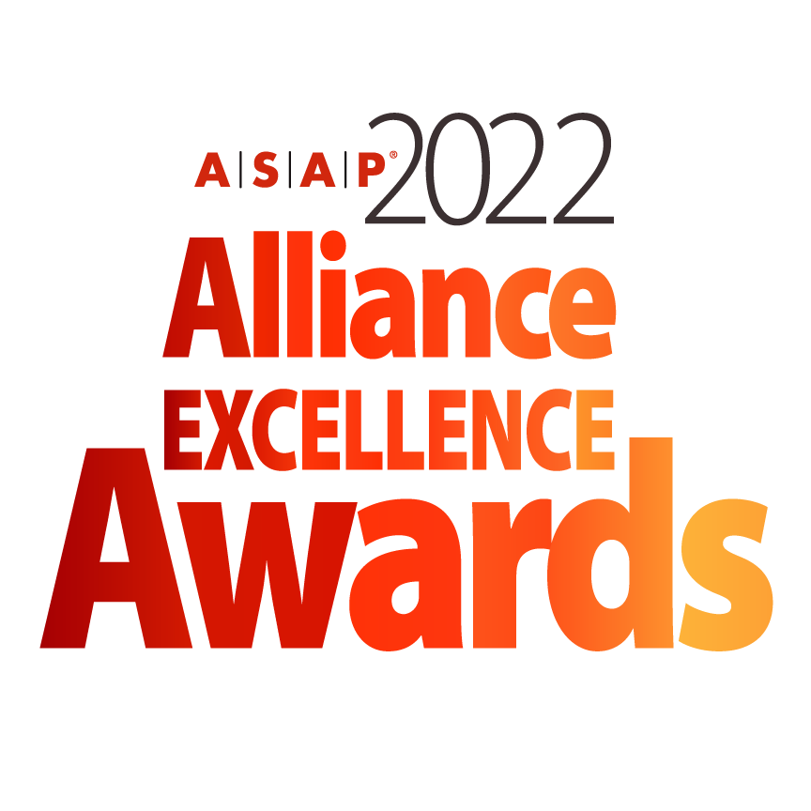

**INDIVIDUAL ALLIANCE EXCELLENCE AWARD**

**NOMINATION FORM**

*The deadline for submitting a nomination is January 18, 2022.*

***Instructions for Submission of a Nomination***

* All nominations must be entered electronically using this Word form.
* Any nomination submitted will be reviewed at the discretion of the ASAP Awards Committee.
* All nominees are strongly encouraged to provide visuals (video, photo, charts) to support their submission.
* Supporting materials will not be returned unless a request is submitted in writing.
* Submitters should clearly mark materials with the specific award category.
* Nominations submitted in multiple categories should address the specific category. The ASAP Awards Committee may choose not to review submissions that are clearly copied and pasted without a clear distinction to a specific category.
* Incomplete nominations will be reviewed at the discretion of the ASAP Awards Committee. ASAP is not responsible for incomplete nominations.
* If you have any questions or need any guidance in your nomination submission, please contact ASAP Marketing Director, Kimberly Miller and awards committee chairman Ard-Pieter de Man at [awards@strategic-alliances.org](mailto:awards@strategic-alliances.org)
* **All nominations and support material for 2022 ASAP Individual Alliance Excellence should be uploaded to** <https://www.dropbox.com/request/dMwRydwG2VmcR9LsvkT3>
* **Please include company name and name of the award within the file name.**

**Please initial below to verify you have read the above information.**

**____ I have read and understand the above.**

***The Fine Print***

* Multiple finalists will be chosen in each awards category. Finalists will be announced at the 2022 ASAP Global Alliance Summit in Tampa, Florida on April 20, 2022.
* Winners will be announced during the live virtual 2022 ASAP Alliance Excellence Awards Ceremony schedule for May 18, 2022 at 11AM EDT US.
* It is strongly encouraged that if a company is nominated, that a representative from the company attends the conference. There will be a conference roundtable session focused on each of the category submissions in addition to a celebration at the opening conference reception.
* If a company is announced to be a finalist, it is strongly encouraged that they attend the virtual live program scheduled for May 18, 2022.
* ASAP will distribute more detailed information regarding recognition for nominees, finalists, and winners following the acceptance of a company’s complete nomination.
* Finalists and winners agree that ASAP is permitted to use their image and company information within blog posts, email announcements, ads, and other marketing and editorial coverage of the awards.
* ASAP will not release information identified as “Confidential”. Nominees are asked to ensure confidential information (such as revenue impact) that is not to be released is clearly marked.

**Please initial below to verify you have read the above information.**

**____ I have read and understand the above.**

***Submitter Information***

**Are you an ASAP member?** *(select one)* Yes No Not Sure

**Submitter Name:**

**Title:**

**Function:**

**Direct Line Telephone Number:**

**Submitter Email Address:**

***Company Information***

**Company:**

**Company URL:**

**Address:**

**Address 1:**

**Address 2:**

**City:**

**State:**

**Postal Code:**

**Country:**

***Alliance Basics***

1. **Name of Alliance (enter N/A if not applicable):**
2. **Partner Companies (for purposes of this award - List all significant companies involved):**
3. **Individual Alliance Category (check one):**

**__ Small or Mid-Sized Company Alliance**

**__ Emerging Alliance**

**__ Long-Established Alliance**

**__ Other (please specify)**

1. **Provide key highlights of your alliance, including outcomes and metrics:**



6. **Industry or Focus of the Alliance:**

***Alliance Partners***

*List information for each significant partner for this award category; if there are more than two partners for this section, please copy and paste additional company profiles for each additional partner and label* ***Company Name 3:,*** *etc.*

***Company Information 1***

**Company:**

**Industry:**

**Headquarters Location:**

**Company URL:**

***Contact Information for the Lead Alliance-Related Executive:***

**Name:**

**Title:**

**Email:**

**Mobile:**

**Direct Line Telephone Number:**

***Company Information 2***

**Company:**

**Industry:**

**Headquarters Location:**

**Company URL:**

***Contact Information for the Lead Alliance-Related Executive:***

**Name:**

**Title:**

**Email:**

**Mobile:**

**Direct Line Telephone Number:**

***Basis for Judging | Individual Alliance Excellence***

*This award recognizes an alliance that:*

* *Targets a single, specific alliance. The alliance may be comprised of two or more discrete organizations.*
* *Has instituted practices, tools, and methodologies in support of successful formation and management (should be appropriate to size of the organizations involved and the maturity of the alliance).*

**1. How is this Individual Alliance Exemplary?** *(In 400 – 500 words or less)*

*TIPS: Summarize why the alliance is exemplary.*

* *Indicate how this alliance benefits from existing ASAP best practices*
* *Explain which elements of the alliance run particularly well*

**2. How is this Individual Alliance Distinctive?** *(In 400 – 500 words or less)*

*TIPS:*

* *What differentiates this alliance from more standard practice?*
* *Describe the practices, tools, methodologies or business model that are unique and distinctive to this alliance.*
* *What aspects offer new lessons to other companies?*
* *Are there creative combinations of and/or modifications of existing practices that have shown tangible success?*

**3. How is this Alliance High-Impact?** *(In 400 – 500 words or less)*

*TIPS:*

* *Please describe tangible measures of success – quantitative and qualitative.*
* *Focus is on a company’s program, these measures and metrics should highlight performance and success across multiple alliances.*
* *High Impact alliances are tightly aligned to company strategy and can be shown to create strategic value for the partner organizations and may even extend to changing how the industry does business.*
* *Show how alliance management contributes to success. What did alliance managers do that helped to create the impact?*

**4. How is this Alliance Program Open?** *(In 300 words or less)*

*TIPS:*

* *Particular value is placed on a company’s proven openness to share ideas and lessons from its alliance success with other organizations.*
* *Describe specific relevant examples of openness including publications and web pages, ASAP presentations and webinars, and other ways in which you shared your learning with other organizations.*

**To Submit**

To submit your nomination with any additional support material, kindly upload to <https://www.dropbox.com/request/dMwRydwG2VmcR9LsvkT3>**.** All uploaded documents should be saved as **Company name_ 2022.Alliance.Excellence_ (indicate form, material)** . Please direct all questions or issues to Ard-Pieter de Man and Kimberly Miller at [awards@strategic-alliances.org](mailto:awards@strategic-alliances.org).

The nomination form and any additional documents will be provided to the committee for review. ***The deadline for all nomination submissions and additional documents is January 18, 2022.***

***You have completed the nomination form.***

Thank you for your submission! Accepted submissions will be contacted with more information by the week of February 20, 2022.