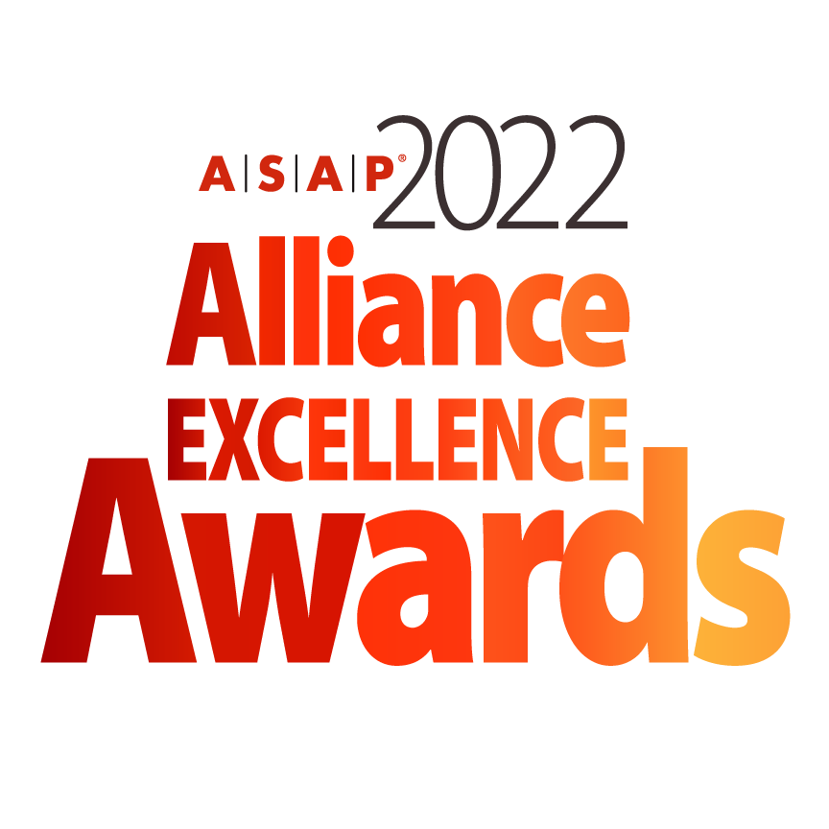

**BEST ECOSYSTEM SOLUTION AWARD NOMINATION FORM**

*The deadline for submitting a nomination is January 18, 2022*

***Instructions for Completing Awards Nomination***

* All nominations must be entered electronically using this Word form.
* Any nomination submitted will be reviewed at the discretion of the ASAP Awards Committee.
* All nominees are strongly encouraged to provide visuals (video, photo, charts) to support their submission.
* Supporting materials will not be returned unless a request is submitted in writing.
* Submitters should clearly mark materials with the specific award category.
* Nominations submitted in multiple categories should address the specific category. The ASAP Awards Committee may choose not to review submissions that are clearly copied and pasted without a clear distinction to a specific category.
* Incomplete nominations will be reviewed at the discretion of the ASAP Awards Committee. ASAP is not responsible for incomplete nominations.
* If you have any questions or need any guidance in your nomination submission, please contact ASAP Marketing Director, Kimberly Miller and awards committee chairman Ard-Pieter de Man at [awards@strategic-alliances.org](mailto:awards@strategic-alliances.org)
* **All nominations and support material for 2022 ASAP Best Ecosystem Solution should be uploaded to <https://www.dropbox.com/request/7G1m1VsqXhqHV8jjssEf>**
* **Please include company name and name of the award within the file name.**

**Please initial below to verify you have read the above information.**

**____ I have read and understand the above.**

***The Fine Print***

* Multiple finalists will be chosen in each awards category. Finalists will be announced at the 2022 ASAP Global Alliance Summit in Tampa, Florida on April 20, 2022.
* Winners will be announced during the live virtual 2022 ASAP Alliance Excellence Awards Ceremony schedule for May 18, 2022 at 11AM EDT US.
* It is strongly encouraged that if a company is nominated, that a representative from the company attends the conference. There will be a conference roundtable session focused on each of the category submissions in addition to a celebration at the opening conference reception.
* If a company is announced to be a finalist, it is strongly encouraged that they attend the virtual live program scheduled for May 18, 2022.
* ASAP will distribute more detailed information regarding recognition for nominees, finalists, and winners following the acceptance of a company’s complete nomination.
* Finalists and winners agree that ASAP is permitted to use their image and company information within blog posts, email announcements, ads, and other marketing and editorial coverage of the awards.
* ASAP will not release information identified as “Confidential”. Nominees are asked to ensure confidential information (such as revenue impact) that is not to be released is clearly marked.
* This is the first year this Award category is included in the ASAP Awards. With this category we intend to better align with how work is accomplished in the alliance space today. Because the Award is new, the Awards Committee reserves some latitude in applying the nomination criteria.

**Please initial below to verify you have read the above information.**

**____ I have read and understand the above.**

***Submitter Information***

**Are you an ASAP member?** *(Select one)* Yes No Not Sure

**Submitter Name:**

**Title:**

**Function:**

**Direct Line Telephone Number:**

**Submitter Email Address:**

***Company Information***

**Company:**

**Company URL:**

**Address:**

**Address 1:**

**Address 2:**

**City:**

**State:**

**Postal Code:**

**Country:**

***Program Basics***

1. **Provide key highlights of your program, including outcomes and metrics:**



6. **Industry or Focus of the Program:**

***Basis for Judging | Alliance Program Excellence***

*This award recognizes:*

* A group of at least four partners that jointly deliver an innovative solution for a specific client/customer or set of clients/customers.
* The focus is on the level of the solution.
* For an example see <https://www.cbtechinc.com/cbt-named-winner-for-teaming-award-by-ptc-partner-network/>

**1. How is this Ecosystem Solution Exemplary?** *(In 400 – 500 words or less)*

*TIPS: Summarize why the solution is exemplary.*

* *Which collaborative business models do you use i.e. which revenue, cost and/or profit sharing mechanisms were put in place to incentivize all partners?*
* *What management processes that go beyond traditional alliance management are put in place to guide the ecosystem?*
* *How did you manage the dynamics of working with a number of partners simultaneously?*
* *Do you have evidence of the ability to integrate products, services or knowledge coming from various partners?*

**2. How is this Ecosystem Solution Distinctive?** *(In 400 – 500 words or less)*

*TIPS:*

* *Which ground breaking value proposition did ecosystem deliver?*
* *Why is it unique?*
* *Why was an ecosystem necessary to deliver this?*
* *What was unique about the go-to-market?*

**3. How is this Ecosystem Solution High-Impact?** *(In 400 – 500 words or less)*

*TIPS:*

* *What is the impact on the client(s) or the market in terms?*
* *What is the impact on the ecosystem partners in terms of increased innovation or revenue?*
* *What is the impact on time to market?*
* *What other benefits are generated (these may also be societal or environmental benefits)?*

**4. How is this Ecosystem Solution Open?** *(In 300 words or less)*

*TIPS:*

* *Particular value is placed on a company’s proven openness to share ideas and lessons from its success with other organizations.*
* *Describe specific relevant examples of openness including publications and web pages, ASAP presentations and webinars, and other ways in which you shared your learning with other organizations.*

**To Submit**

To submit your nomination with any additional support material, kindly upload to <https://www.dropbox.com/request/7G1m1VsqXhqHV8jjssEf>.All uploaded documents should be saved as **Company name_ 2022.Alliance.Excellence_ (indicate form, material)** . Please direct all questions or issues to Ard-Pieter de Man and Kimberly Miller at [awards@strategic-alliances.org](mailto:awards@strategic-alliances.org).

The nomination form and any additional documents will be provided to the committee for review. ***The deadline for all nomination submissions and additional documents is January 18, 2022.***

***You have completed the nomination form.***

Thank you for your submission! Accepted submissions will be contacted with more information by the week of February 20, 2022.