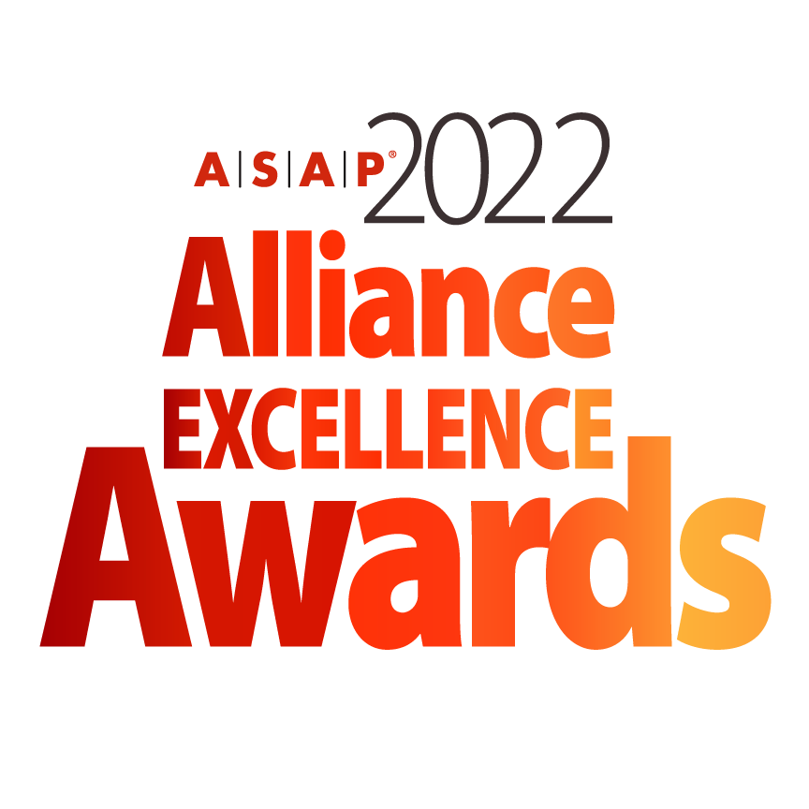

**ALLIANCE PROGRAM EXCELLENCE AWARD NOMINATION FORM**

*The deadline for submitting a nomination is January 18, 2022*

***Instructions for Completing Awards Nomination***

* All nominations must be entered electronically using this Word form.
* Any nomination submitted will be reviewed at the discretion of the ASAP Awards Committee.
* All nominees are strongly encouraged to provide visuals (video, photo, charts) to support their submission.
* Supporting materials will not be returned unless a request is submitted in writing.
* Submitters should clearly mark materials with the specific award category.
* Nominations submitted in multiple categories should address the specific category. The ASAP Awards Committee may choose not to review submissions that are clearly copied and pasted without a clear distinction to a specific category.
* Incomplete nominations will be reviewed at the discretion of the ASAP Awards Committee. ASAP is not responsible for incomplete nominations.
* If you have any questions or need any guidance in your nomination submission, please contact ASAP Marketing Director, Kimberly Miller and awards committee chairman Ard-Pieter de Man at [awards@strategic-alliances.org](mailto:awards@strategic-alliances.org)
* **All nominations and support material for 2022 ASAP Alliance Program Excellence should be uploaded to <https://www.dropbox.com/request/kTNSp0FQ9IFuTmtBsvVV>. Please include company name and name of the award within the file name.**

**Please initial below to verify you have read the above information.**

**____ I have read and understand the above.**

***The Fine Print***

* Multiple finalists will be chosen in each awards category. Finalists will be announced at the 2022 ASAP Global Alliance Summit in Tampa, Florida on April 20, 2022.
* Winners will be announced during the live virtual 2022 ASAP Alliance Excellence Awards Ceremony schedule for May 18, 2022 at 11AM EDT US.
* It is strongly encouraged that if a company is nominated, that a representative from the company attends the conference. There will be a conference roundtable session focused on each of the category submissions in addition to a celebration at the opening conference reception.
* If a company is announced to be a finalist, it is strongly encouraged that they attend the virtual live program scheduled for May 18, 2022.
* ASAP will distribute more detailed information regarding recognition for nominees, finalists, and winners following the acceptance of a company’s complete nomination.
* Finalists and winners agree that ASAP is permitted to use their image and company information within blog posts, email announcements, ads, and other marketing and editorial coverage of the awards.
* ASAP will not release information identified as “Confidential”. Nominees are asked to ensure confidential information (such as revenue impact) that is not to be released is clearly marked.

**Please initial below to verify you have read the above information.**

**____ I have read and understand the above.**

***Submitter Information***

**Are you an ASAP member?** *(Select one)* Yes No Not Sure

**Submitter Name:**

**Title:**

**Function:**

**Direct Line Telephone Number:**

**Submitter Email Address:**

***Company Information***

**Company:**

**Company URL:**

**Address:**

**Address 1:**

**Address 2:**

**City:**

**State:**

**Postal Code:**

**Country:**

***Program Basics***

1. **Provide key highlights of your program, including outcomes and metrics:**



6. **Industry or Focus of the Program:**

***Basis for Judging | Alliance Program Excellence***

*This award recognizes:*

* A single, specific company and their partnering capability, not an alliance.
* That the company has instituted practices, tools, and methodologies in support of successful formation and management of its alliances.
* These practices, tools, and methodologies should be scalable

i.e., is able to be applied to multiple alliances as needed – and repeatable

i.e., has led to consistent alliance performance across multiple alliances

**1. How is this Alliance Program Exemplary?** *(In 400 – 500 words or less)*

*TIPS: Summarize why the alliance program is exemplary.*

* *Describe the different elements of the program*
* *Show the use of ASAP best practices*
* *Describe the alliance portfolio it covers*

**2. How is this Alliance Program Distinctive?** *(In 400 – 500 words or less)*

*TIPS:*

* *Describe the practices, tools, and methodologies that are unique to your company.*
* *What differentiates this alliance program and partnering capability from more standard practices?*
* *What aspects offer new lessons to other companies?*
* *Are there creative combinations / modifications of existing practices that have shown tangible success?*

**3. How is this Alliance Program High-Impact?** *(In 400 – 500 words or less)*

*TIPS:*

* *Please describe tangible measures of success – quantitative and qualitative.*
* *Please make sure you provide specific metrics that have led to improvement in overall performance and the outcomes.*
* *As this award category focuses on the company’s program, these measures should highlight performance and success across multiple alliances or the organization’s alliance portfolio.*
* *The committee will focus in particular on improvements in overall performance that can be related to the alliance program.*

**4. How is this Alliance Program Open?** *(In 300 words or less)*

*TIPS:*

* *Particular value is placed on a company’s proven openness to share ideas and lessons from its alliance success with other organizations.*
* *Describe specific relevant examples of openness including publications and web pages, ASAP presentations and webinars, and other ways in which you shared your learning with other organizations.*

**To Submit**

To submit your nomination with any additional support material, kindly upload to <https://www.dropbox.com/request/kTNSp0FQ9IFuTmtBsvVV>**.** All uploaded documents should be saved as **Company name_ 2022.Alliance.Excellence_ (indicate form, material)** . Please direct all questions or issues to Ard-Pieter de Man and Kimberly Miller at [awards@strategic-alliances.org](mailto:awards@strategic-alliances.org).

The nomination form and any additional documents will be provided to the committee for review. ***The deadline for all nomination submissions and additional documents is January 18, 2022.***

***You have completed the nomination form.***

Thank you for your submission! Accepted submissions will be contacted with more information by the week of February 20, 2022.