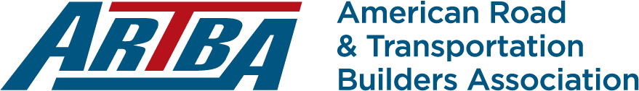

ARTBA Exhibit at the
National Work Zone Management Conference
October 27 – 29, 2026
Sheraton Reston
11810 Sunrise Valley Drive
Reston, VA 20191

EXHIBITORS & BENEFITS

Premium: $5,000

- Reserved exhibit space for outdoor product demonstration.
- Lead recognition in event program, and on conference signage.
- Indoor tabletop exhibit space.
- Lead recognition and reserved table for opening session luncheon.
- Access to contact information for registered attendees.
- Corporate logo projected on screen during general sessions.
- Opportunity for distribution of marketing materials at registration.
- 2 complimentary registrations.

Standard $3,500

- Recognition in event program, and on conference signage.
- Indoor tabletop exhibit space.
- Recognition as a lunch sponsor.
- Opportunity for distribution of marketing materials at registration.
- 1 complimentary registration.

SPONSORSHIPS

$3,000 - $5,000

- Opening Reception - $5,000 (x2)
- Break Snacks - $3,000 (x4) (Tuesday pm; Wednesday am and pm; Thursday am (
- Wednesday Breakfast - $5,000 (x1)
- Thursday Breakfast - $5,000 (x1)
- Corporate logo projected on screen during general sessions/events.
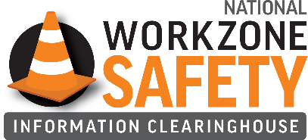
- Opportunity for distribution of marketing materials at registration.
- 1 complimentary registration.

If you are interested in an exhibitor booth and sponsorship, we can customize a package for you!

250 E Street S.W., Suite 900
Washington, DC 20024
T: 202.289.4434 www.artba.org

Washington, D.C. 20024

Washington, D.C. 2002
Washington, D.C. 20024

2026 ARTBA Exhibit at the
National Work Zone Management Conference
(Oct. 27 -29, 2026 | Reston, VA)

SPONSORSHIP FORM

Type of Sponsorship

- Premium ($5,000)
- Standard ($3,000)
- Sponsor ($3,000 - 5000) Event: _____________________________________________________

Primary Contact: Title: Company Name: Address: Phone: Fax: Email: Method of payment: Bill my company Credit Card
Credit Card #: Exp. Date: Name on card:

To become an exhibitor or sponsor, please email this form to ARTBA’s Catie Amsden at camsden@artba.org

