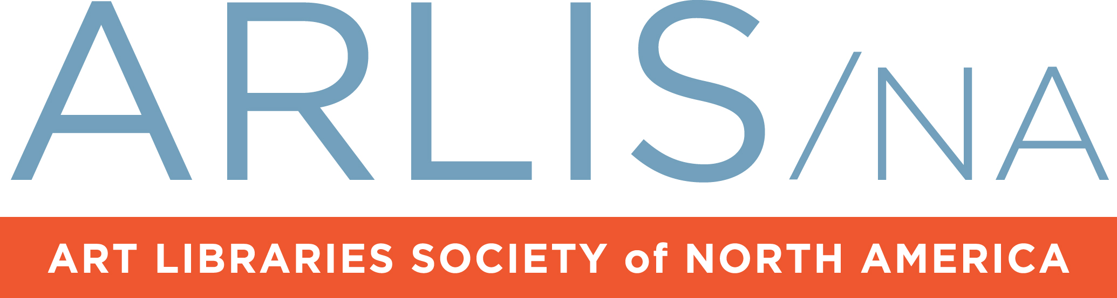Webinar Request Form

IMPORTANT: Please note that you must return this form at least four weeks prior the Webinar. All times must be in Central Standard Time.

Today’s date: Click here to enter a date.

**Webinar Information**

Webinar Date: Click here to enter a date. Time: 00:00 CST.

Webinar Title: 128 character limit

**PDC-ED Committee Contacts** This person provides overall coordination and may give additional help/backup the day of the event as needed. Also coordinates with ARLIS/NA Kaltura Channel contact.

Name: Click here to enter text.

E-mail: Click here to enter text. Phone: Click here to enter text.

**Moderator**

Name: Click here to enter text.

Institution: Click here to enter text. Title: Click here to enter text.

E-mail: Click here to enter text. Phone: Click here to enter text.

**Guest Panelist(s)** Please submit as an attachment to this form headshots of panelists.

*Panelist #1*

Title of Presentation: Click here to enter text.

Name: Click here to enter text.

Institution: Click here to enter text. Title: Click here to enter text.

E-mail: Click here to enter text. Phone: Click here to enter text.

*Panelist #2*

Title of Presentation: Click here to enter text.

Name: Click here to enter text.

Institution: Click here to enter text. Title: Click here to enter text.

E-mail: Click here to enter text. Phone: Click here to enter text.

Add additional panelists as needed:

**Webinar Description** Please provide a brief description of the Webinar. This description will appear in the invitation sent to all subscribers and in the ARLIS/NA Kaltura Channel. The description should include info about the topic/theme, panelist names, and other pertinent information. Additional information may be sent in the invitation if necessary.

An example is available from the PDC-ED contact and in the ARLIS/NA Kaltura Channel.

(Write description below. 2048 character limit.):

**Webinar policy**:The below statement* will be included in ALL webinar invitations. Optionally, one of the committee contacts may want to include their email address below. If you need to change this statement, please discuss it with the organizer.

*Only current ARLIS/NA members may attend this event. Additional access approvals may be made on a case-by-case basis. Registration will close two hours before the start of the webinar.

**Webinar recording permission and policy**:

When sending in this form, attach the panelists’ completed recordings permissions forms available as a PDF.

Note: Online chats that include speakers must also obtain a permission form.

**Please check one:**

Yes, the webinar will be recorded so include the below statements* in the invitation. (If there isn’t enough room in the invite, the organizer will let you know and you must add these statements in the email announcement.)

No, the webinar will not be recorded so don’t include the below statements* in the invitation.

*\*This webinar will be recorded, and the recording will be made available on the ARLIS/NA Kaltura Channel after the webinar.*

*\*By registering, I understand and acknowledge that this Webinar will be recorded by ARLIS/NA and/or those designated by ARLIS/NA. ARLIS/NA may record my name and questions I ask during the course of the Webinar presentation. As a condition of my participation in the Webinar, I agree to irrevocably grant to ARLIS/NA, its assigns, licensees and successors the right to publish, record, broadcast, exhibit, display, reproduce, edit or otherwise use perpetually throughout the world, in all media now and hereafter known or devised, in whole or in part, my name, questions, quotes and material otherwise provided by me (collectively, the “Material”) during my participation in the Webinar. I will retain any copyrights I may have in the Material. Nothing in this document shall limit my right to publish, present, or use my Material as I see fit in perpetuity.*

**Welcome message** Attendees will see this message while waiting for the webinar to start. The standard message will be used or you can create a custom message if you prefer.

This message is in addition to the PowerPoint slide that the moderator should create to display on the screen and on the ARLIS/NA Kaltura Channel.

*Standard welcome message:*

Welcome! Use the questions box at any point during the webinar to ask a question of a speaker or to get assistance from the webinar organizer.

*Custom welcome message (optional. 987 character limit):*

**Practice Session**

To insure everything works according to plan, a practice session is required. **Anyone with a speaking role in the webinar MUST attend**, as well as the webinar manager and committee organizer. The practice session should take place about a week before the webinar. Use the same equipment that will be used on the day of the webinar. You must check the panelist(s) availability for these training sessions.

Date:Click here to enter a date. Time: Click here to enter text.

**Added webinar functions**

There are additional polling, surveying, and uploading function available in GoToWebinar. If you would like to utilize these functions, please indicate this below and coordinate with the webinar manager.

**Registration Questions** First name, Last name, and Email address are the minimum default registration questions/fields, and these are required. We can add questions to the registration form either from a list of pre-defined questions/fields or by creating our own.

Please check here if you would like to collect additional information from registrants.

**Handouts** Up to 5 documents may be uploaded to the webinar or the ARLIS/NA Kaltura Channel

Please check this box if you intend to upload supplemental documents.

**In-webinar Polling** Polls can be single answer questions, or multiple answer questions, and the results can be displayed immediately during the webinar.

Please check this box if you intend to utilize in-webinar polling.

**Post Webinar Survey** Surveys can be scheduled to be presented to the participants as they exit the webinar or presented in a follow up email which can be scheduled to be sent out later. The questions can take the form of:

* Multiple Choice with One Answer
* Multiple Choice with Multiple Answer
* Rate on a Scale of 1 to 5
* Short Answer

Please check this box if you intend to utilize in-webinar polling.

**Additional Info**

Review the webinar ‘how to’ guidelines for a recommended timeline and technical tips. This is available from the PDC-ED committee. There are also tips available online: http://support.citrixonline.com/en_US/webinar/documents

After the webinar is scheduled, two links will be provided by the ARLIS manager. One is especially for organizers and panelists, and each individual has their own, you cannot forward this link to anyone else, or you won’t have access. The other link is an invitation to send to all possible attendees.

Once the details are all set and before the first invitation is sent, ask the PDC-ED committee contact about promoting the webinar on the ARLIS/NA website, social media channels and establishing a holding place on the ARLIS/NA Kaltura Channel.

The invitation/registration link should be sent to the ARLIS listserv at least two weeks before the webinar date, with a second reminder sent a few days before the webinar.

**Questions?**

Contact ARLIS/NA headquarters at [customercare@arlisna.org](mailto:customercare@arlisna.org) or 978-674-6211 or the PDC-ED committee.