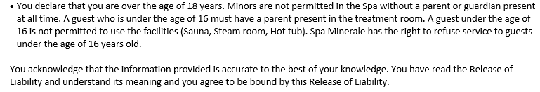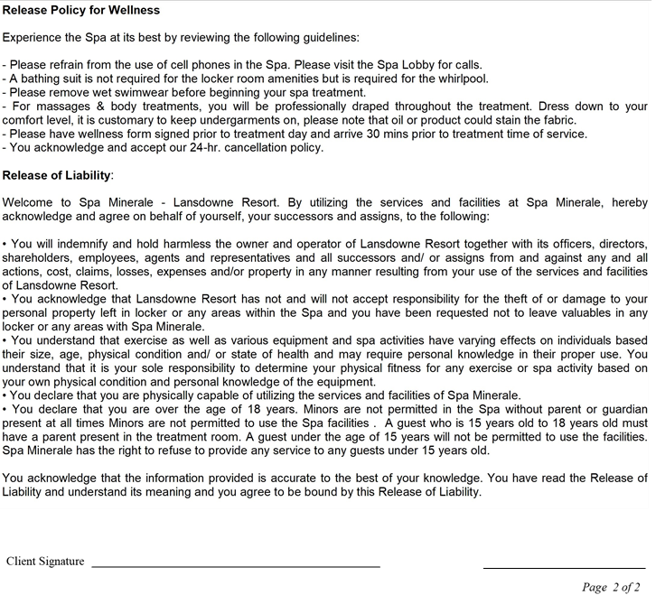

|  |  |  |  |
| --- | --- | --- | --- |
| **Do you have Asthma?** |  | **Do you have an active infection?** |  |
| **Do you have Diabetes?** |  | **Do you have varicose veins?** |  |
| **Do you have Epilepsy?** |  | **Are you susceptible to bruising?** |  |
| **Do you have Seizures?** |  | **Have you had Botox or fillers within the last two weeks?** |  |
| **Do you have Renal/ liver disease?** |  | **Do you have lower back pain?** |  |
| **Do you have autoimmune disease?** |  | **Do you have neck/shoulder or upper back pain?** |  |
| **Do you have Claustrophobia?** |  | **Do you have a joint condition?** |  |
| **Do you have dry skin?** |  | **Do you have a pacemaker?** |  |
| **Do you have acne?** |  | **Do you have a heart condition?** |  |
| **Do you have eczema/psoriasis?** |  | **Do you have high/low blood pressure?** |  |
| **Do you have skin sensitivity?** |  | **Are you pregnant or breastfeeding?** |  |
| **Do you have product allergies?** |  | **Do you have any health issues that prohibit you from receiving a Spa treatment?** |  |
| **Do you have allergies?** |  |  |  |
| **Do you have Rosacea?** |  | **Please list any specific areas you would like us to focus on:** |  |
| **Do you have Keloids?** |  | **________________________________________________** |  |
| **Do you use Accutane?** |  | **List of accidents or surgeries:** |  |
| **Do you have Plantar warts?** |  | **________________________________________________** |  |
| **Do you have Athletes Foot?** |  |  |  |

