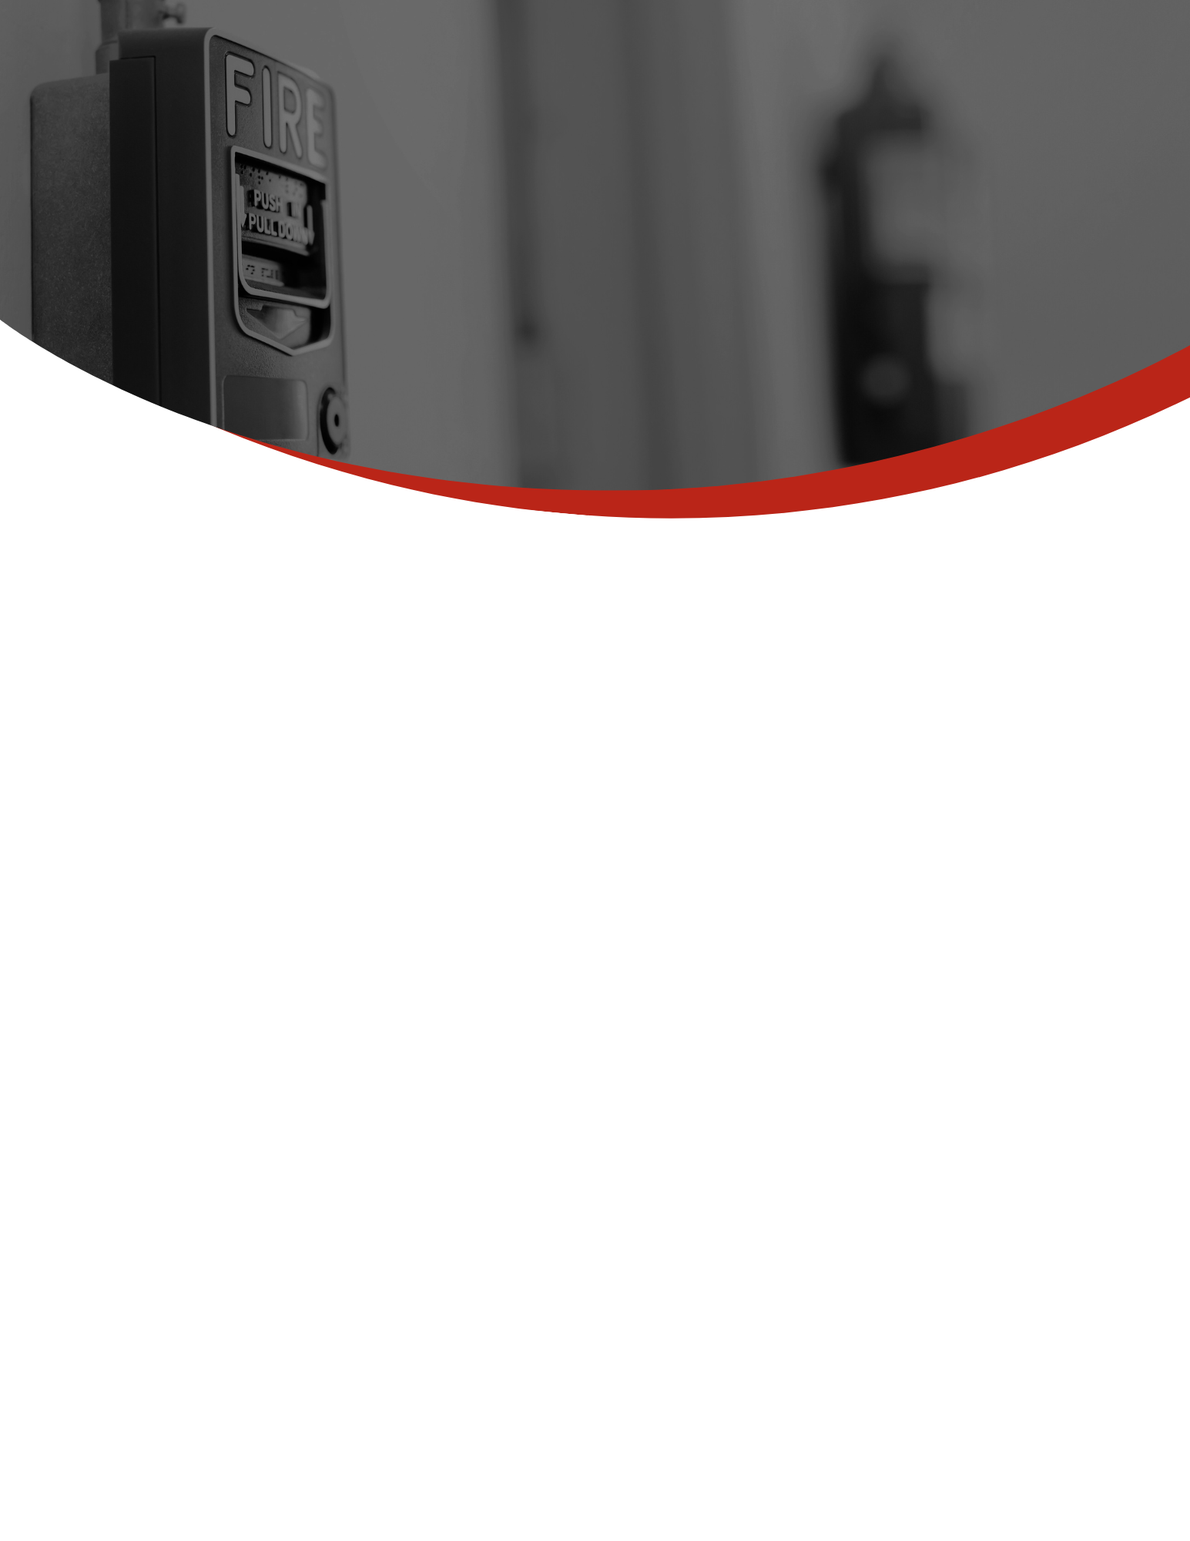­

**If you are unable to evacuate your apartment due to fire, smoke, or a disability**, stuff wet towels or sheets around the door and vents to keep smoke out. Call the fire department and tell them where you are. Open a window slightly and wave a bright cloth to signal your location. Be prepared to close the window, however, if it makes the smoke conditions worse.

**Use the stairs to get out** – never use the elevator unless you are directed to by the fire department. Code. Our buildings undergo regular inspection to ensure the proper operation of fire and life safety systems. But you too can play a role in ensuring your safety and that of your neighbors.

If an announcement is made throughout the building, **listen carefully, and follow directions.**

Code. Our buildings undergo regular inspection to ensure the proper operation of fire and life safety systems. But you too can play a role in ensuring your safety and that of your neighbors.

**If there is a fire, do not try to fight it. Call 911, evacuate immediately and pull the fire alarm on your way out** to notify the fire department and your neighbors. If the fire alarm sounds, feel the door before opening and close doors behind you as you leave to prevent smoke from spreading. If the door is cool, exit immediately. If the door is hot, use another way out. to ensure the proper operation of fire and life safety systems. But you too can play a role in ensuring your safety and that of your neighbors.

**IN THE EVENT OF A FIRE**

Code. Our buildings undergo regular inspection to ensure the proper operation of fire and life safety systems. But you too can play a role in ensuring your safety and that of your neighbors.

**\*INSERT COMPANY LOGO HERE\***

**All exit and stairwell doors should be kept closed, unlocked and clear of clutter.** Do not prop doors open. If any of these conditions exist, contact property management immediately.

Most fires start in the kitchen. **Never leave your cooking surface unattended and make sure that ovens and stove burners are turned off after use.** Similarly, candles should never be left unattended, and care should be taken to place them at an adequate distance from walls, cabinets, or flammable surfaces.

Check device charging cables and extension cords regularly for worn or frayed cables. Never overload extension cords and make sure that they are properly rated for their intended use.

**Smoke detectors and alarms have been installed for your protection. NEVER remove the batteries from these devices** unless to replace them in accordance with the manufacturer’s instructions. Code. Our buildings undergo regular inspection to ensure the proper operation of fire and life safety systems. But you too can play a role in ensuring your safety and that of your neighbors.

**Know the locations of all exit stairs from your floor** in case the nearest one is blocked by fire or smoke. Contact property management with any questions or concerns about fire alarms, sprinklers, voice communications procedures, evacuation plans and how to respond to an alarm.

Code. Our buildings undergo regular inspection to ensure the proper operation of fire and life safety systems. But you too can play a role in ensuring your safety and that of your neighbors.

**TAKE PRECAUTIONARY MEASURES**

Code. Our buildings undergo regular inspection to ensure the proper operation of fire and life safety systems. But you too can play a role in ensuring your safety and that of your neighbors.

**Maryland has seen a slew of recent high-profile fire incidents in multifamily rental properties. [Insert Company Name Here] is committed to working together with our residents to ensure the safety of our community.**

**Apartment buildings in Maryland are regulated under the International Building Code and the State of Maryland Fire Prevention Code. Our buildings undergo regular inspection to ensure the proper operation of fire and life safety systems. But you too can play a role in ensuring your safety and that of your neighbors.**

**FIRE SAFETY AND PREVENTION**

**Together we can keep our community safe. Contact property management with any questions.**

*Insert Contact Info Here