Show your Duckworth Pride on Challenge Day!
All orders are due by Friday, April 5, 2019
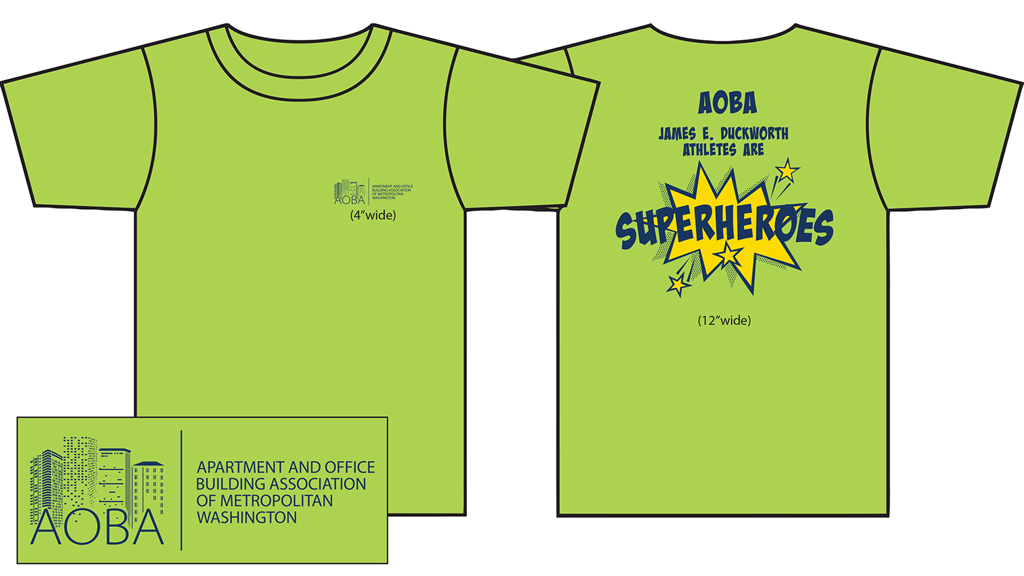
Challenge Day is on April 12! Support the students of the Duckworth School and show your Duckworth Pride by wearing an “AOBA Challenge Day Tee Shirt”. AOBA volunteers can all tell the world that they are proud of the Duckworth Athletes.

The cost of each shirt is $20.00 (including tax) for all sizes. Payment must accompany order. Payment can be by check (made payable to AOBA) or by Credit Card.
You can also order on line at:
www.aoba-metro.org.

MasterCard, Visa, or American Express (Circle One)
Card Number____________________________ Expiration Date_______________ CVV______
Name on Card___________________________ Signature________________________________
Billing Address of Credit Card_______________________________________________________
City/State/Zip Code _______________________________________________________________

Proceeds from the sale of these shirts will go directly to the James E. Duckworth PTO to be used for the Duckworth students.

I want to order _____shirts in the following sizes:

Adult Sizes Quantity
Small _____
Medium _____
Large _____
X Large _____
XX Large _____
XXX Large _____

Total number of shirts ordered: _______ x $20.00 each = $_____

Name/Email Address: _______________________________________________________________________________
Company: __________________________________________________________________________________________

Orders must be returned by Friday, April 5, 2019.

Any questions, please call Jeanne Clarke – 202-296-3390
Email order form to jclarke@aoba-metro.org or fax 202-296-3399

