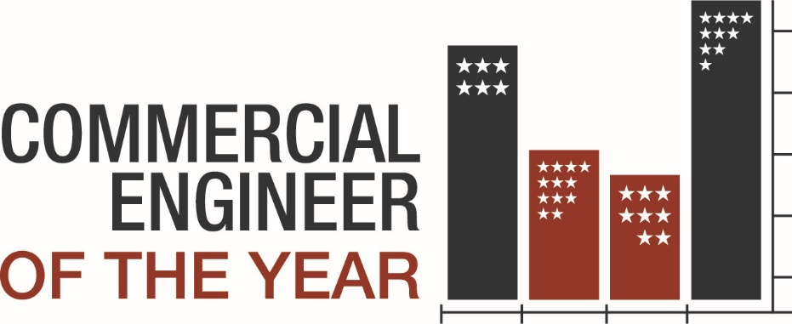

Engineer of the Year Nomination Form

We’re not just seeking good engineers—we’re looking for exceptional individuals who consistently exceed expectations and elevate the standard of building operations. These are the professionals who take ownership of their work, think proactively, and lead by example in everything they do.

Nomination details:
- All fields in this form are required.
- Submit proof of licenses and certifications
- Submit the letters of recommendation from the following:
  - Supervisor
  - Property Manager
  - Director of Engineering
  - Tenant
- Submit this form, proof of licenses and certifications, and all letter of recommendations via email to Brandy White, bwhite@aoba-metro.org, by December 15, 2025

Judging Process
- December 15, 2025: Submission Deadline
- January 5, 2026 - February 9, 2026: Judging Period
  - Review Process: Our Engineer of the Year committee will carefully evaluate all submitted materials.
  - Building Tour and Interview: Nominees will be interviewed and then lead judges on a building tour.
- February 12 or 19, 2026: Commercial Awards Celebration
  - Winners who achieve a minimum score of 70% will be announced and honored in front of their peers!

Demographic Information:

Nominator Details:
First Name, Last Name, Company, Email, Phone

Nominee Details
First Name, Last Name, Company, Email, Phone, Building or Portfolio Managed

What award are you nominating this person for?
Chief Engineer or Building Engineer

How many years of experience does the nominee have?
Minimum 3 years of experience required in current role

What is the highest level of education earned?
Example: High School, Undergraduate, Graduate, Technical School, etc.

What licenses / certifications do you currently hold?
Please submit proof of licenses/certifications.

Descriptive Information:
Tell us what makes your nominee truly exceptional. We’re looking for engineers who go beyond the job description—those who take initiative, demonstrate leadership, and contribute in ways that set them apart. In this section, provide specific examples that illustrate how your nominee consistently exceeds expectations. Consider including stories or accomplishments that highlight their dedication, creativity, and impact.

Statement of Qualifications by Nominee
What makes this person special? Why are you nominating them?

Please describe the nominee’s technical knowledge

Please describe the nominee’s expertise in environmental and energy conservation

Please describe the nominee’s customer service experience:

Please describe the nominee’s ability to work with, and lead, a team

What other information would you like the judges to know about the nominee (innovation, creativity, dealing with difficult circumstances, etc.)

