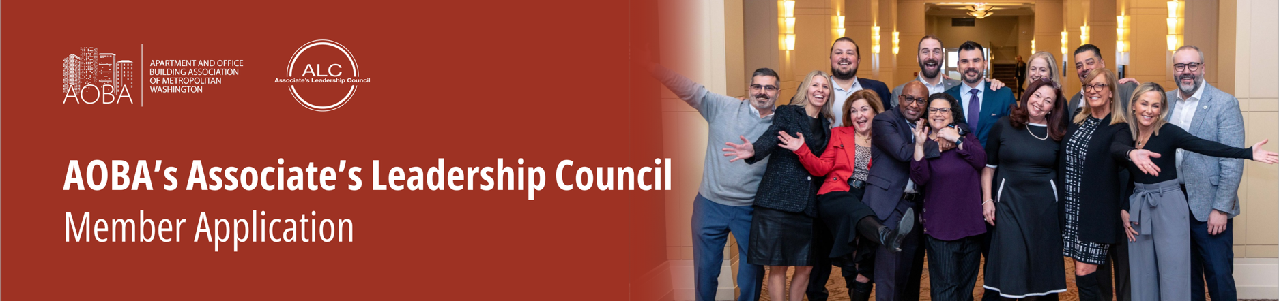

Qualifications for ALC Committee Applicants:

* Employed with Member company in good standing with AOBA for two or more consecutive years.

**Commitment to ALC if Selected:**

* Commit to attend 75% of pre-determined ALC meetings annually.
* Be active on at least one AOBA committee.
* Volunteer at 3-4 AOBA events per year (i.e. Duckworth School, Golf Event, Covenant House, Food Drives, Trash Pick-up, etc.).
* Ability to have approval from member company to participate in charitable activities including but not limited to financial investment of $1,000 per annum for AOBA/ALC sponsored events.
* Must be a team player with the desire to advance and enhance ALC’s social and philanthropic events.

**Applicant Information:**

Full Name: Phone:

Company: Years with Current Company:

Professional Designations: Years Active in AOBA:

Please describe your member experience with AOBA:

Other organizations you are involved with:

Please describe your volunteer experience with other organizations (committees, special projects etc.):

**Please provide at least 2 references** (must include at least one ALC Member and one Property Manager):

Name: Phone Number:

_____________________________________________ __________________________________

_____________________________________________ __________________________________

_____________________________________________ __________________________________

What would you bring to the ALC Committee?

How did you hear about the vacancy on ALC?

__ Word of mouth __ AT ISSUE __Committee work __Other (explain)______________________________

Please return this form to Jeanne Clarke at [jclarke@aoba-metro.org](mailto:jclarke@aoba-metro.org).

*A member of the nominating committee will contact you upon receipt of your questionnaire.*

Thank you!